WEEK 3
Python-Based Machine Learning Model
Development and Evaluation Plan
Hypothetical Project: Customer Churn Analysis and Prediction
Data Science Internship

Contents

1. Problem Definition and Justification
2. Data Preprocessing Plan
3. Model Selection and Training
4. Evaluation Metrics and Validation Strategy
5. Model Deployment and Maintenance
6. Challenges and Mitigation
7. Timeline (32 Hours) and Tools
8. Conclusion

1. Problem Definition and Justification

1.1 The Business Problem
A mid-sized telecom company, TeleNova (a hypothetical firm), has 50,000 postpaid customers. Every month about 18% of customers cancel their contract (churn). That is roughly 9,000 customers a year lost. Winning a new customer costs around five times more than keeping an existing one, so reducing churn is one of the cheapest ways to protect revenue.
The retention team currently phones customers at random, or contacts everyone. Random calling wastes budget and annoys loyal customers. The goal of this project is to build a machine learning model, using Python, that predicts which customers are likely to leave in the next 30 days so the team can contact only those who need attention.

1.2 Problem Type
This is a supervised binary classification problem. The target variable is churn (1 = customer left within 30 days, 0 = customer stayed). The dataset is imbalanced: 82% stay and 18% leave, which strongly affects the choice of metrics later on.

1.3 Why Machine Learning Is Justified
- Scale: one analyst cannot review 50,000 customer histories every month, but a model can score them in seconds.
- Complex patterns: churn depends on combinations of factors (for example, month-to-month contract plus three support calls plus a recent price rise). Simple rules miss these interactions.
- Measurable value: a worked cost-benefit example is shown in Section 4.5.

1.4 Success Criteria
Criterion | Target
Model quality (cross-validated ROC AUC) | 0.85 or higher
Recall on churners | At least 70% at the chosen threshold
Precision on churners | At least 55% at the chosen threshold
Business result | Higher net retention profit than contacting all customers
Prediction speed | Under 200 ms per customer through the API

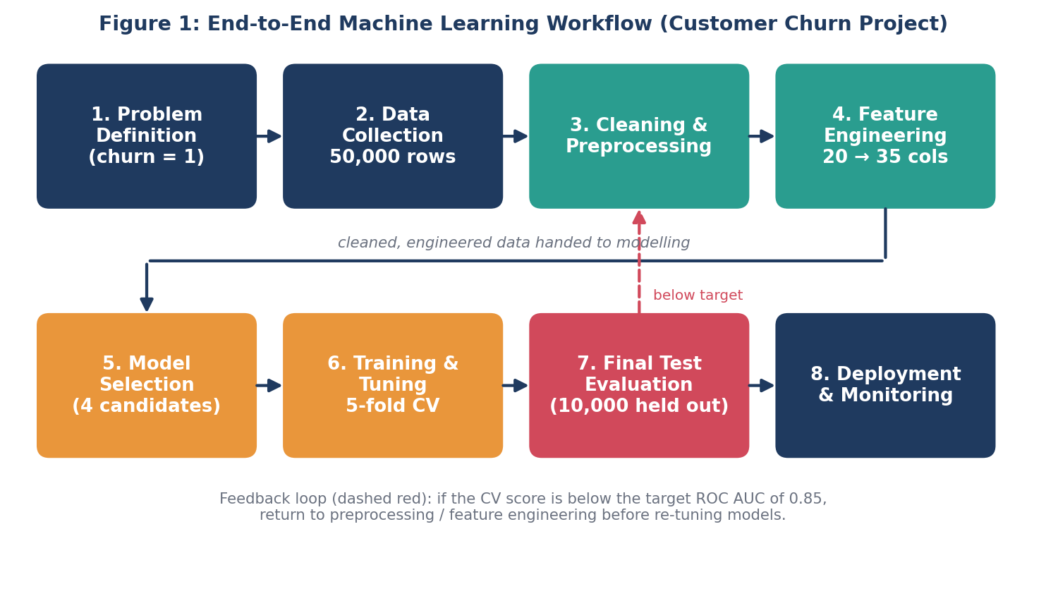
Figure 1: End-to-end machine learning workflow

2. Data Preprocessing Plan

2.1 Data Description
The planned dataset has 50,000 rows (one per customer) and 20 raw columns drawn from billing, usage, contract and support-ticket systems.
Group | Example columns | Type
Demographic | age, region, dependents | Numeric / categorical
Account | tenure_months, contract_type, payment_method | Numeric / categorical
Usage | monthly_minutes, data_gb, roaming_charges | Numeric
Billing | monthly_charge, total_charges, late_payments | Numeric
Service | support_calls_90d, complaints, plan_changes | Numeric
Target | churn (0/1) | Binary

2.2 Step-by-Step Cleaning
Step 1: Data quality audit. Use df.info(), df.describe() and df.isna().mean() to list missing values, wrong data types and duplicates.
Step 2: Remove duplicates. Drop repeated customer_id rows with df.drop_duplicates('customer_id').
Step 3: Missing values. Example: total_charges is blank for about 0.2% of rows (roughly 100 customers), all brand-new accounts with tenure 0. These are set to 0 because no bill has been issued yet. For age, missing in about 3% of rows, use the median and add a flag column age_missing so the model can learn if missingness matters. Numeric columns use SimpleImputer(strategy='median'); categorical columns use the most frequent value.
Step 4: Outliers. Example: if monthly_minutes has a maximum of 45,000 (a data-entry error, since one month has only about 43,200 minutes), it is removed. Genuine but extreme values such as very high roaming_charges are kept but capped at the 99th percentile (winsorising). Tree-based models are robust to outliers, but logistic regression is not.
Step 5: Fix types and inconsistencies. Convert dates, and standardise labels such as 'Month-to-month' and 'month to month'.

2.3 Encoding and Scaling
- One-hot encoding for low-cardinality categories (contract_type has 3 values, payment_method has 4).
- Target or frequency encoding for region (about 40 values) to avoid creating 40 sparse columns.
- StandardScaler (mean 0, standard deviation 1) for numeric features, applied only for logistic regression. Trees do not need scaling. For example, tenure (0 to 72 months) and total_charges (0 to 8,000) are on very different scales and would otherwise let total_charges dominate a linear model.

2.4 Feature Engineering
Feature engineering expands the 20 raw columns to about 35 by creating more informative variables:
New feature | Formula | Reason
charge_per_minute | monthly_charge / (monthly_minutes + 1) | Detects overpaying customers
support_intensity | support_calls_90d / (tenure_months + 1) | Calls relative to how long they have been a customer
price_change_pct | (this_month - last_month) / last_month | Price rises trigger churn
is_new_customer | 1 if tenure_months < 6 | First six months are highest risk
late_payment_rate | late_payments / max(tenure_months,1) | Financial stress signal
usage_drop_pct | (usage_3m_avg - usage_last_month) / usage_3m_avg | Declining usage often precedes leaving

Worked example: Customer A has tenure 4 months, 3 support calls in 90 days, and monthly charge of $80 that rose from $70. Then support_intensity = 3 / 5 = 0.60, price_change_pct = (80 - 70) / 70 = 14.3%, and is_new_customer = 1. Compare this with Customer B, tenure 48 months, 1 call, no price change: support_intensity = 0.02 and price_change_pct = 0. The engineered values make A's higher risk obvious.

2.5 Feature Selection
- Remove features with correlation above 0.90 (for example, total_charges is nearly monthly_charge x tenure), keeping only one of each pair.
- Drop near-constant columns using VarianceThreshold.
- Rank features by random-forest importance and permutation importance, then keep those covering about 95% of cumulative importance (expected to be about 25 to 28 features).
- Use SHAP values later to confirm the selected features make business sense.

2.6 Data Leakage Prevention
All preprocessing steps are placed inside a scikit-learn Pipeline so that imputation, scaling and encoding are learnt only from training folds and never from validation or test data. The dataset is split before any transformation:
from sklearn.model_selection import train_test_split
from sklearn.pipeline import Pipeline
from sklearn.compose import ColumnTransformer

X_train, X_test, y_train, y_test = train_test_split(
X, y, test_size=0.20, stratify=y, random_state=42)
# 40,000 train (7,200 churners) / 10,000 test (1,800 churners)

3. Model Selection and Training

3.1 Candidate Models
Model | Strengths | Weaknesses | Role
Logistic Regression | Fast, interpretable coefficients | Assumes linear relationships; needs scaling | Baseline
Decision Tree | Easy to visualise rules | Overfits easily (single tree) | Interpretable comparison
Random Forest | Robust, handles non-linearity, little tuning | Slower, less interpretable | Strong ensemble candidate
XGBoost (gradient boosting) | Usually best on tabular data; handles imbalance with scale_pos_weight | More hyperparameters; overfits if untuned | Expected final model

3.2 Justification of the Chosen Model
XGBoost is the planned final model. On structured tabular data with mixed feature types, boosted trees consistently outperform other families. They capture non-linear interactions automatically, work with missing values natively, and offer built-in class weighting. A logistic regression baseline is trained first, because if XGBoost only improves ROC AUC by 0.01 the simpler model may be preferred. The model with the best cross-validated ROC AUC that also meets the recall target will be chosen.
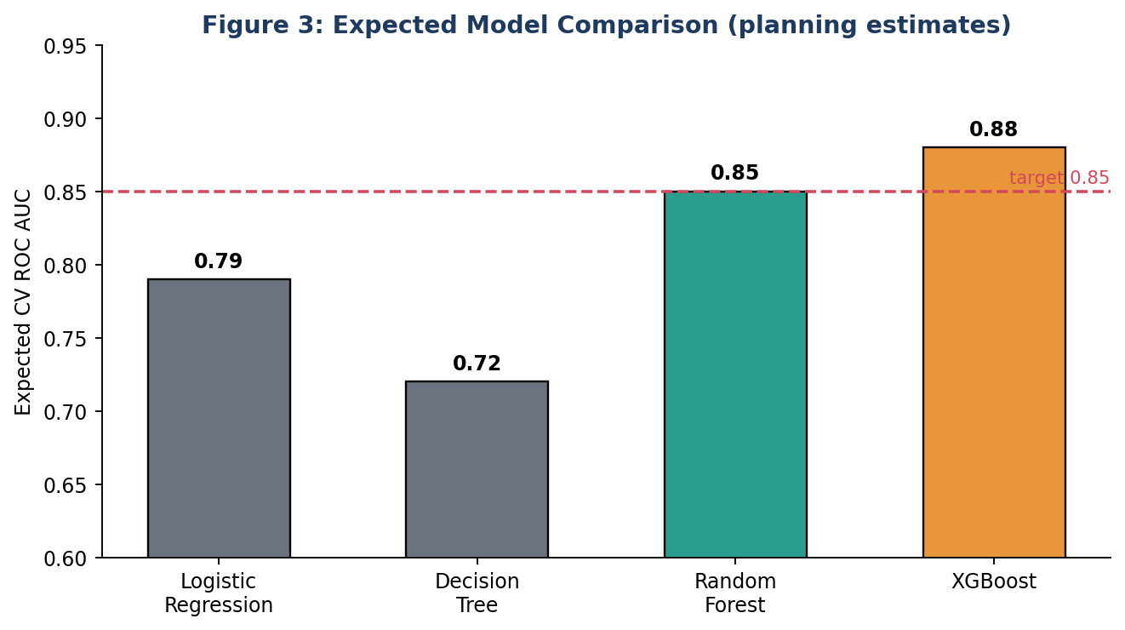
Figure 3: Expected model comparison (planning estimates, to be confirmed by experiments)

3.3 Handling Class Imbalance
With only 18% churners, a model that predicts 'stay' for everyone scores 82% accuracy but catches zero churners. Options, in order of preference:
- Class weights: scale_pos_weight = 82 / 18 = about 4.6 in XGBoost, class_weight='balanced' in other models.
- Threshold tuning: choose the probability cut-off from the precision-recall curve instead of 0.50.
- SMOTE oversampling (only inside the training folds, via imblearn Pipeline) if class weights are not enough.

3.4 Training Process
- Fit the Pipeline (preprocessing + model) on the 40,000 training rows.
- Train all four models with default settings using 5-fold stratified CV to get baseline scores.
- Tune the top two models (expected: Random Forest and XGBoost).
- Refit the best configuration on the full training set, then evaluate once on the 10,000-row test set.
- Use early stopping (stop after 50 rounds without validation improvement) for XGBoost to prevent overfitting.

3.5 Hyperparameter Tuning Strategy
Parameter (XGBoost) | Search range | Purpose
n_estimators | 200 to 800 | Number of trees
max_depth | 3 to 8 | Tree complexity
learning_rate | 0.01 to 0.2 | Step size
subsample | 0.6 to 1.0 | Row sampling to reduce overfit
colsample_bytree | 0.6 to 1.0 | Feature sampling
min_child_weight | 1 to 10 | Minimum leaf size

Cost estimate: a full grid over even 4 values of each of these 6 parameters would need 4^6 = 4,096 combinations x 5 folds = 20,480 model fits. If one fit takes about 20 seconds, that is roughly 114 hours, which is not practical. Instead, RandomizedSearchCV with 60 iterations x 5 folds = 300 fits takes about 100 minutes. Random search usually reaches close to the best score with a small fraction of the effort. After that, a narrow grid around the best values (for example, 3 values each of max_depth and learning_rate = 9 combinations x 5 folds = 45 fits) fine-tunes the result. Optuna (Bayesian optimisation) is an optional alternative.
from sklearn.model_selection import RandomizedSearchCV, StratifiedKFold
from xgboost import XGBClassifier

cv = StratifiedKFold(n_splits=5, shuffle=True, random_state=42)
search = RandomizedSearchCV(
XGBClassifier(scale_pos_weight=4.6, eval_metric='auc'),
param_distributions=param_dist, n_iter=60,
scoring='roc_auc', cv=cv, n_jobs=-1, random_state=42)
search.fit(X_train, y_train)

4. Evaluation Metrics and Validation Strategy

4.1 Why Accuracy Alone Is Misleading
Because 82% of customers stay, a useless model that always predicts 'stay' achieves 82% accuracy. Accuracy is therefore reported only for reference. The main metrics are below.

4.2 Chosen Metrics
Metric | Formula | Why it is used here
Precision | TP / (TP + FP) | Of customers we contact, how many really would leave? Protects retention budget.
Recall | TP / (TP + FN) | Of all churners, how many did we catch? Missed churners are lost revenue.
F1-score | 2PR / (P + R) | Single balance of precision and recall, suitable for imbalanced data.
ROC AUC | Area under TPR vs FPR curve | Threshold-independent ranking quality; used for model comparison.
PR AUC | Area under precision-recall curve | More informative than ROC AUC when positives are rare.
Log loss / Brier score | Probability error | Checks that predicted probabilities are well calibrated.

4.3 Worked Example: Confusion Matrix
Suppose the tuned model is applied to the 10,000-customer test set (1,800 real churners) with the decision threshold set to 0.35 rather than 0.50 to favour recall. The result is shown in Figure 4.
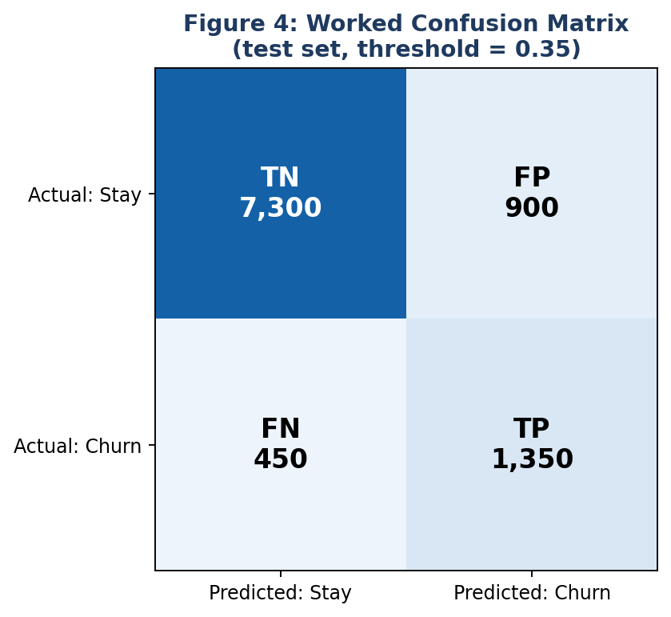
Figure 4: Worked confusion matrix on the test set
Metric | Calculation | Result
Accuracy | (1,350 + 7,300) / 10,000 | 86.5%
Precision | 1,350 / (1,350 + 900) | 60.0%
Recall | 1,350 / (1,350 + 450) | 75.0%
F1-score | 2 x 0.60 x 0.75 / (0.60 + 0.75) | 0.667

Interpretation: the model finds 3 out of every 4 churners, and 6 out of every 10 customers flagged really would have left. Both meet the targets in Section 1.4 (recall at least 70%, precision at least 55%).

4.4 Threshold Selection
The default threshold of 0.50 assumes false positives and false negatives cost the same, which is untrue here. A missed churner costs a customer's lifetime value (assumed $200 in this example), while an unnecessary retention call costs only about $10. The threshold is therefore chosen by plotting precision and recall against threshold values from 0.1 to 0.9 and picking the point that maximises expected profit.

4.5 Worked Example: Business Value
Assumptions: a retention offer costs $10 per contacted customer, succeeds 40% of the time, and saving a churner is worth $200.
Strategy | Customers contacted | Cost | Net profit
No action | 0 | $0 | $0
Contact everyone | 10,000 | $100,000 | $144,000 - $100,000 = $44,000
Use model (threshold 0.35) | 2,250 | $22,500 | $108,000 - $22,500 = $85,500

Explanation: contacting everyone saves 1,800 x 40% = 720 churners x $200 = $144,000. The model saves 1,350 x 40% = 540 churners x $200 = $108,000 while spending far less. On this test group the model nearly doubles profit ($85,500 vs $44,000). The numbers are assumptions for planning; real values will come from finance data.

4.6 Cross-Validation Strategy
A single train/validation split can give a lucky or unlucky score depending on which customers land in which part. Stratified 5-fold cross-validation solves this. The 40,000 training rows are divided into 5 folds of 8,000 rows, each keeping the 18% churn ratio (about 1,440 churners per fold). The model is trained on 4 folds (32,000 rows) and validated on the remaining fold, 5 times, and the scores are averaged.
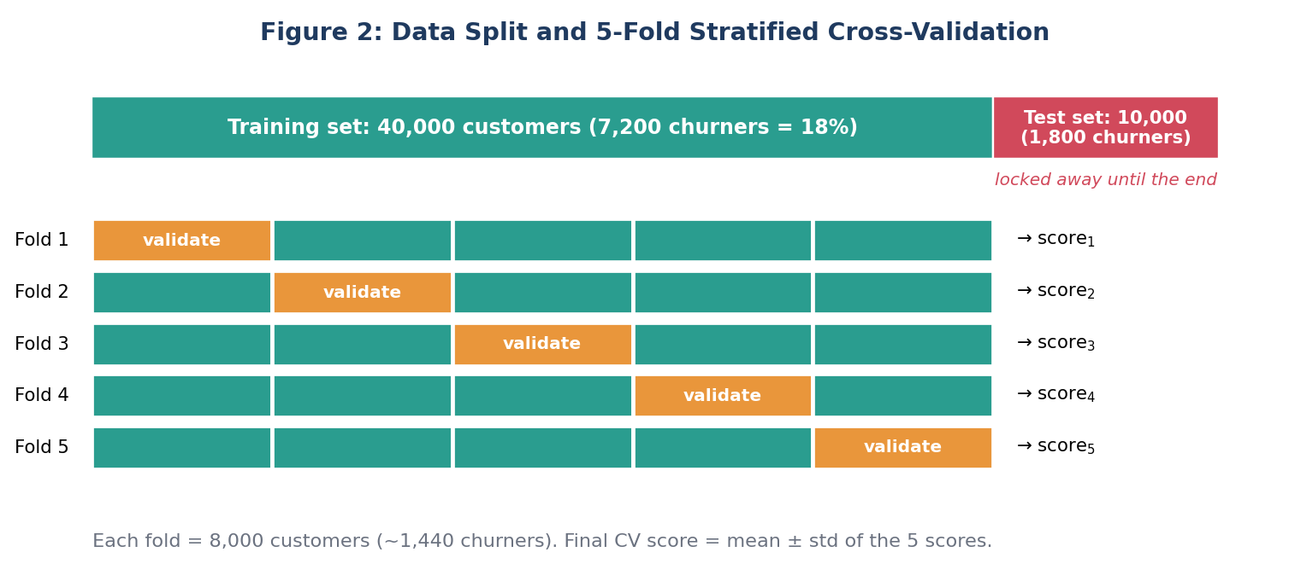
Figure 2: Train/test split and 5-fold stratified cross-validation
Example: five ROC AUC scores of 0.871, 0.884, 0.879, 0.868 and 0.883 give a mean of 0.877 and a standard deviation of about 0.007. A small standard deviation shows the model is stable. If the standard deviation were 0.03 or more, it would signal instability and the model would be simplified. The test set is used only once, at the very end, to give an honest estimate of real-world performance.

4.7 Additional Validation Checks
- Learning curves: plot training vs validation score against training-set size. A large gap indicates overfitting; both low indicates underfitting.
- Time-based validation: because churn is time dependent, also train on months 1 to 9 and test on months 10 to 12 to confirm the model works on future data.
- Calibration curve: checks that a predicted 30% probability corresponds to about 30% real churn.
- Subgroup fairness check: compare recall across regions and age bands to make sure no group is systematically missed.
- Explainability: SHAP summary plot to confirm top drivers (for example, contract type, tenure, support calls) are plausible.

5. Model Deployment and Maintenance

5.1 Deployment Plan
- Save the full pipeline (preprocessing + model) with joblib so that exactly the same transformations run in production.
- Wrap it in a FastAPI service with a /predict endpoint returning a churn probability; package with Docker.
- Run a batch job monthly to score all 50,000 customers and send the top 20% (10,000 customers) to the retention team's dashboard.
- Track experiments and model versions with MLflow (model_v1, model_v2, and so on).

5.2 Monitoring
What is monitored | How | Alert threshold (example)
Model performance | Compare predictions with actual churn 30 days later | ROC AUC drops below 0.80
Data drift | Population Stability Index (PSI) per feature | PSI above 0.2
Data quality | Missing-value rate and range checks | Missing rate above 5%
System health | API latency and error rate | Latency above 200 ms

5.3 Retraining Policy
The model is retrained every quarter as standard, and immediately when an alert fires (for example, after a price-plan change that alters customer behaviour). The new model must beat the live model on a recent hold-out set before replacing it. An A/B test is used: 50% of the retention team's calls use the new model, and profit per contacted customer is compared before full rollout. The previous version is kept for instant rollback.
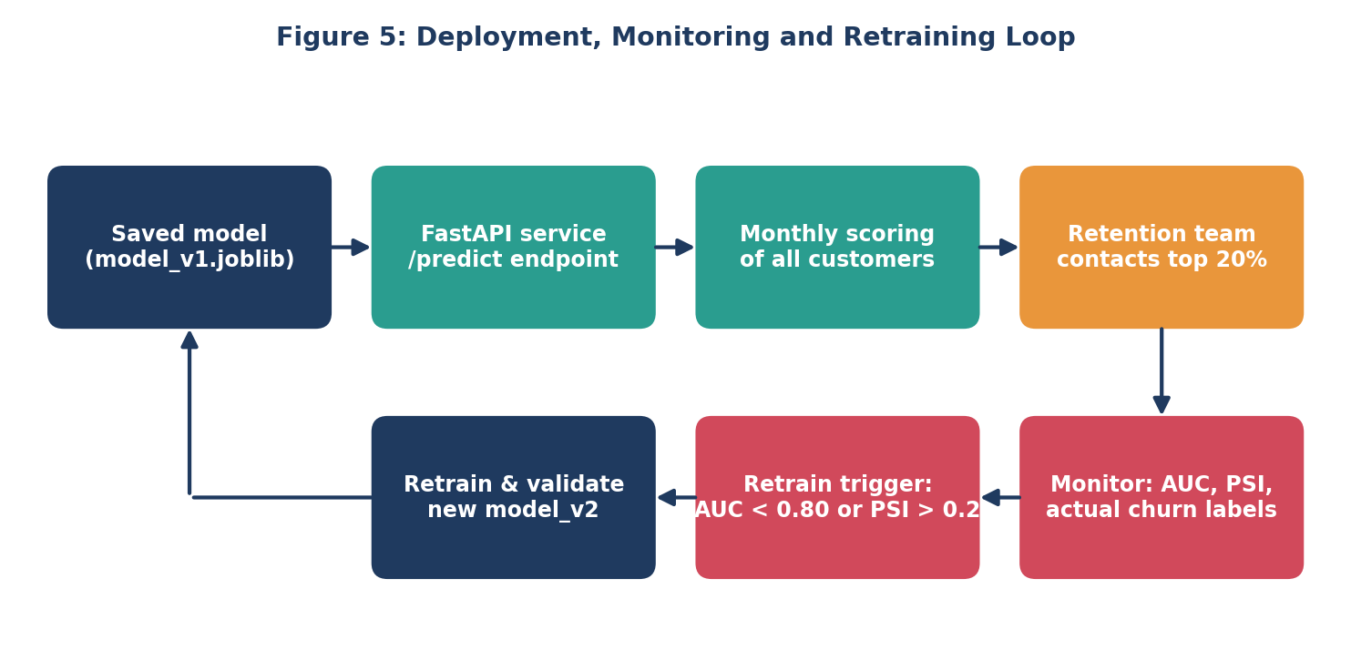
Figure 5: Deployment, monitoring and retraining loop

6. Challenges and Mitigation
Challenge | Realistic scenario | Mitigation
Class imbalance | Only 18% churners; model predicts 'stay' for all | Class weights, PR AUC, threshold tuning, SMOTE inside CV
Data leakage | A column such as cancellation_reason is only known after the customer leaves | Review each column with domain experts; drop post-outcome fields; use Pipelines
Overfitting | Training AUC 0.99 but validation 0.80 | Early stopping, limit max_depth, regularisation, cross-validation
Concept drift | A competitor launches a cheaper plan and behaviour changes | Monitoring with PSI, quarterly retraining
Missing / dirty data | Billing system outage leaves 5% of usage blank | Imputation plus missing flags, data-quality alerts
Interpretability | Managers refuse to trust a black box | SHAP explanations, compare with logistic regression baseline
Limited time / compute | 300 tuning fits exceed laptop capacity | Use random search, n_jobs=-1, subsample data for early experiments

7. Timeline (32 Hours) and Tools

7.1 Time Allocation
Phase | Activities | Hours
1. Problem definition | Business goal, target variable, success criteria | 3
2. Data understanding | Data dictionary, quality audit, class balance | 3
3. Preprocessing | Cleaning, encoding, scaling, pipeline set-up | 5
4. Feature engineering and selection | New features, correlation filter, importance ranking | 4
5. Model selection and training | Baseline plus 3 candidate models | 5
6. Tuning and cross-validation | Random search, narrow grid, learning curves | 4
7. Evaluation and interpretation | Metrics, threshold, SHAP, business value | 4
8. Deployment plan and documentation | API design, monitoring plan, diagrams, report | 4
Total |  | 32

7.2 Python Tools and Libraries
Library | Use in this project
pandas, numpy | Loading, cleaning, aggregating and feature calculations
matplotlib, seaborn | Plots: distributions, ROC and PR curves, confusion matrix
scikit-learn | Pipelines, imputation, scaling, models, cross-validation, metrics
xgboost | Gradient boosting model
imbalanced-learn | SMOTE inside cross-validation
shap | Model explanation
optuna (optional) | Bayesian hyperparameter search
joblib, FastAPI, Docker | Saving and serving the model
MLflow | Experiment tracking and model versioning
Jupyter Notebook, Git/GitHub | Development and version control

8. Conclusion
This plan describes how a churn-prediction model would be built from start to finish with Python: a clearly defined problem with measurable targets, a leak-free preprocessing pipeline, four compared models with XGBoost as the expected best, imbalance-aware training, and validation using stratified 5-fold cross-validation plus a locked test set. The worked examples show how metrics translate into money: at a 0.35 threshold the model reaches 75% recall and 60% precision, and about $85,500 net profit compared with $44,000 for contacting everyone. Finally, the deployment and monitoring loop keeps the model reliable as customer behaviour changes. The same structure can be applied to other classification problems such as fraud detection or loan default. All figures are planning assumptions that would be confirmed once real data is available.

