DATA SCIENCE INTERNSHIP
WEEK 2
Exploratory Data Analysis (EDA)
and Visualization Framework Design
Hypothetical Project: Customer Churn Analysis and Prediction
Week 2 Project Planning and Documentation Report

1. Introduction to Exploratory Data Analysis (EDA)
Exploratory Data Analysis (EDA) is an important initial stage of a data science project in which data is examined, summarized, and visualized to understand its structure, quality, distributions, and relationships. EDA helps a data scientist identify patterns, missing values, unusual observations, duplicate records, inconsistent values, and possible relationships between variables before further analysis or modeling.
For this Week 2 task, no dataset is provided. Therefore, the objective is not to perform actual analysis but to design a comprehensive and reusable framework that can be applied to any suitable dataset. The framework uses the hypothetical Customer Churn Analysis and Prediction project as a consistent example. The planned process covers data understanding, data-quality checks, univariate, bivariate and multivariate analysis, missing-data and outlier handling, visualization, tools, and reporting.

2. Objective of the Week 2 Task
The objective is to create a comprehensive plan for conducting EDA and developing visualization frameworks. The plan identifies the steps, techniques, plot types, Python libraries, and documentation methods that would be used when analyzing a dataset. It is designed to be logical, adaptable, and suitable for the initial stages of a data science project.

3. Project Context
Customer churn refers to customers discontinuing their use of a company's products or services. For a future churn analysis project, EDA would be used to understand customer characteristics and identify patterns that may be associated with churn. Possible variables could include customer tenure, contract type, payment method, service usage, monthly charges, total charges, and churn status. These examples are hypothetical because the internship task does not provide a dataset.

4. EDA Process Overview
- Understand the dataset structure and the meaning of variables.
- Identify potential numerical, categorical, binary, date/time, and text fields.
- Check data quality, including missing values, duplicates, invalid values, and inconsistent categories.
- Summarize individual variables using univariate analysis.
- Study relationships between pairs of variables using bivariate analysis.
- Explore multiple variables together using multivariate analysis.
- Detect and review outliers rather than removing them automatically.
- Select suitable charts and visualizations to communicate patterns.
- Document observations, limitations, and questions for further analysis.

5. Potential Data Types
Data Type | Example Variables | Analysis Method | Possible Visualization
Numerical | Age, tenure, monthly charges, total charges | Mean, median, range, standard deviation, distribution | Histogram, box plot, scatter plot
Categorical | Contract type, payment method, service plan | Frequency and category comparison | Bar chart, count plot
Binary | Churn: Yes/No, active/inactive | Class proportions and grouped comparison | Count plot, bar chart
Date/Time | Signup date, transaction date | Trends and time-based grouping | Line chart
Text | Customer comments or feedback | Inspection and possible future text analysis | Text summary or future text visualization

6. Data Understanding and Initial Quality Checks
Before detailed EDA, the planned analysis will establish a clear understanding of the dataset. The following checks will be performed when a dataset becomes available:
- Inspect the number of rows and columns.
- Review column names and variable descriptions.
- Check the data type of every variable.
- Calculate basic descriptive statistics for numerical variables.
- Review unique values and category frequencies.
- Identify missing values and summarize their extent.
- Check duplicate records.
- Check invalid, inconsistent, or unexpected values.
- Review the distribution of a target variable such as churn when applicable.

7. Missing Data Handling Framework
Missing data can affect summary statistics, visualizations, and later modeling. The planned approach is to first measure missingness rather than immediately replacing or deleting values.
Step | Approach | Purpose
Identify | Calculate missing counts and percentages by column | Understand the extent of missingness
Investigate | Check whether missingness appears concentrated in particular groups or variables | Understand possible causes or patterns
Choose method | Consider removal, imputation, category-based handling, or a missing indicator depending on context | Select a suitable treatment
Document | Record the chosen approach and its reason | Maintain transparency and reproducibility

8. Outlier Detection and Handling Framework
Outliers are observations that differ substantially from the general pattern of a variable. The planned EDA will identify them using visual and statistical approaches. Common checks may include box plots, distribution inspection, percentiles, and the Interquartile Range (IQR) method.
An outlier will not automatically be deleted. It will first be reviewed to determine whether it is an error, a valid extreme observation, or a potentially useful case. If treatment is necessary, possible approaches include correction, transformation, capping, or removal when justified. The selected method and reason should be documented.

9. Univariate Analysis
Univariate analysis examines one variable at a time. Its purpose is to understand the distribution, frequency, central tendency, spread, and unusual values of individual variables.
Variable Type | Techniques | Example Plots
Numerical | Mean, median, min/max, quartiles, standard deviation | Histogram, KDE plot, box plot
Categorical | Frequency counts and proportions | Bar chart, count plot
Binary | Class count and percentage | Bar/count plot
Date/Time | Distribution over time | Line chart, time-based frequency plot

10. Bivariate Analysis
Bivariate analysis examines the relationship between two variables. For the hypothetical churn project, it can help compare churn status with customer characteristics and identify relationships that may deserve further investigation.
Variable Combination | Technique | Plot | Example
Numerical + Numerical | Relationship/correlation | Scatter plot | Tenure vs total charges
Categorical + Numerical | Group comparison | Box plot / grouped bar chart | Monthly charges by contract type
Categorical + Categorical | Frequency/proportion comparison | Count plot / grouped bar chart | Churn by contract type
Time + Numerical | Trend analysis | Line chart | Monthly charges or churn trend

11. Multivariate Analysis
Multivariate analysis examines several variables together. It is useful when individual relationships do not fully explain a pattern. The planned methods include correlation analysis, pair plots, grouped visualizations, and selected multi-variable views.
- Correlation heatmap to review relationships among numerical variables.
- Pair plot to compare selected numerical variables simultaneously.
- Faceted or grouped plots to compare patterns across categories.
- Combined feature summaries to identify possible interaction patterns.
- Careful interpretation because association in EDA does not establish causation.

12. Visualization Strategies
Visualization will be selected according to the type of data and the analytical question. The purpose of a chart is not only to display data but also to make important patterns, differences, distributions, and relationships easier to understand.
Visualization | Used For | What It Reveals | Example
Histogram | Numerical distribution | Frequency, shape and spread | Distribution of monthly charges
Bar/Count Plot | Categorical data | Category frequency or comparison | Customers by contract type
Box Plot | Numerical distribution/group comparison | Median, spread and potential outliers | Charges by churn status
Scatter Plot | Two numerical variables | Relationship and possible trend | Tenure vs total charges
Line Chart | Time-related data | Trend or change over time | Monthly churn trend
Heatmap | Multiple numerical variables | Correlation patterns | Customer feature correlation
Pair Plot | Multiple numerical variables | Pairwise relationships and distributions | Selected customer features
Plotly Interactive Chart | Interactive exploration | Filtering and detailed exploration | Interactive churn analysis view

13. EDA and Visualization Workflow
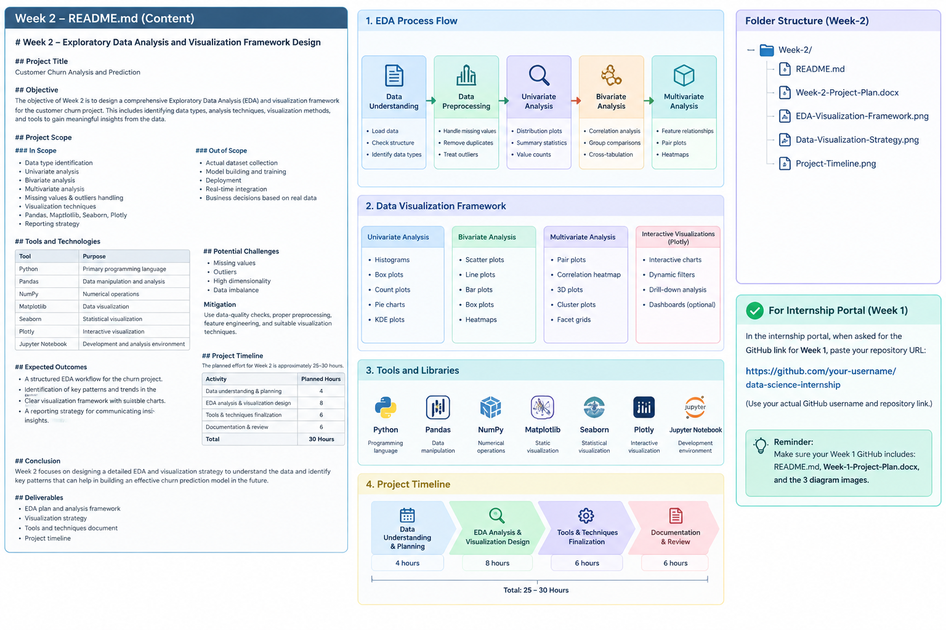
Figure 1. Planned EDA and visualization framework for the project.

14. Python Tools and Libraries
Tool / Library | Role | Contribution to EDA
Python | Primary programming language | Provides the environment for implementing the planned analysis.
Pandas | Data manipulation and analysis | Loading, inspecting, filtering, grouping, summarizing, and transforming data.
NumPy | Numerical operations | Supports numerical calculations and array-based operations.
Matplotlib | Data visualization | Creates customizable static plots and charts.
Seaborn | Statistical visualization | Creates statistical charts such as count plots, box plots, distributions, and heatmaps.
Plotly | Interactive visualization | Creates interactive charts that support exploration and presentation.
Jupyter Notebook | Analysis and documentation | Combines analysis steps, visualizations, notes, and findings in one document.

15. Reporting and Documentation Plan
The final EDA findings should be documented in a structured report or presentation. The report should explain what was examined, what patterns were observed, how data-quality issues were handled, and what limitations apply. Each important visualization should have a clear title, relevant labels, and a short explanation.
- Introduction – purpose of the analysis and project context.
- Dataset Overview – size, variables, data types, and relevant assumptions.
- Data Quality – missing values, duplicates, invalid values, and outliers.
- Univariate Analysis – important individual-variable patterns.
- Bivariate Analysis – important relationships and comparisons.
- Multivariate Analysis – combined patterns and correlations.
- Visualization Summary – key charts and why they were selected.
- Key Observations – concise description of important findings.
- Limitations – data constraints, assumptions, and interpretation limits.
- Next Steps – questions or variables that may be considered in future analysis or modeling.

16. Example of Result Documentation
Report Element | Content | Expected Output
Data Quality Summary | Missing values, duplicates, invalid values, outliers | Quality table
Distribution Findings | Important numerical and categorical patterns | Histograms, box plots, count plots
Relationship Findings | Important two-variable relationships | Scatter, grouped and comparison plots
Multivariate Findings | Correlations and combined patterns | Heatmap, pair plot, grouped views
Key Insights | Short evidence-based observations | Bullet points with supporting charts
Limitations | Constraints and assumptions | Dedicated limitations section
Next Steps | Future analysis/modeling direction | Action list

17. Challenges and Mitigation
Missing or inconsistent data: Use systematic data-quality checks and document the selected treatment.
Large number of variables: Group related variables and prioritize charts relevant to the analytical objective.
Outliers: Review unusual observations before transformation or removal.
Imbalanced target classes: Show class proportions clearly and consider suitable methods in future modeling.
Overcrowded visualizations: Use appropriate chart types, meaningful labels, and focused views.
Misinterpretation of relationships: Describe observed associations carefully and do not treat correlation as proof of causation.

18. Adaptability to Various Datasets
The framework is designed to be adaptable to different datasets. The exact EDA techniques and visualizations will depend on the available data types, number of variables, presence of time information, data quality, target variable, and project objective. For example, a time-series dataset may require more trend visualizations, while a categorical business dataset may require more frequency and grouped comparison charts. The overall process remains consistent while the individual techniques are selected according to the dataset.

19. Planned Work Timeline
Activity | Planned Hours
EDA introduction, objective and project context | 4
Data types and initial data-quality framework | 4
Missing data and outlier handling plan | 4
Univariate, bivariate and multivariate analysis | 7
Visualization strategies and plot-selection framework | 5
Tools, libraries and reporting plan | 3
Diagrams, documentation and final review | 5
Total | 32 Hours
The planned effort is 32 hours, which is within the approximately 30–35 hours specified for the task.
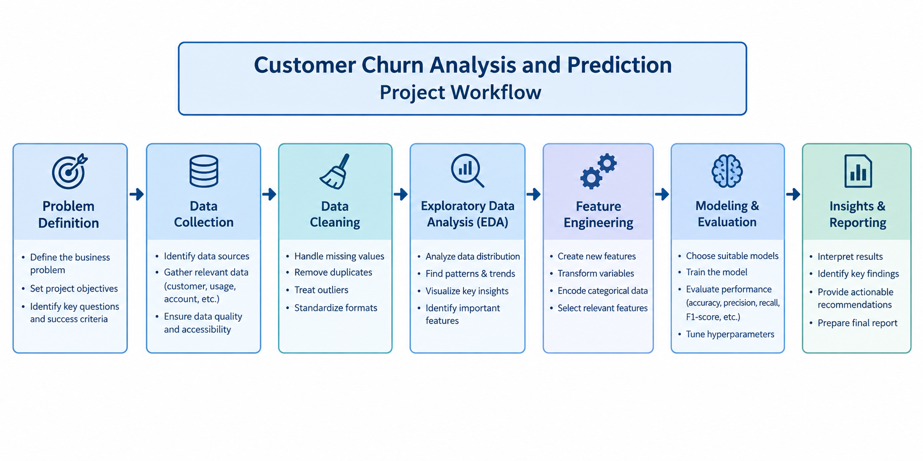
Figure 2. Week 2 planned project timeline.

20. Expected Outcomes
- A complete EDA and visualization framework that can be applied to a future dataset.
- Clear identification of potential data types and data-quality checks.
- A structured approach for univariate, bivariate, and multivariate analysis.
- Appropriate visualization strategies for revealing patterns and relationships.
- A clear plan for documenting and presenting findings.
- Improved readiness for practical data handling and future modeling tasks.

21. Conclusion
This Week 2 task develops a structured framework for the initial stages of data analysis. Since no dataset is provided, the report focuses on planning rather than performing actual EDA. It covers the EDA process, potential data types, data-quality checks, missing values, outliers, univariate, bivariate and multivariate analysis, visualization strategies, Python tools and libraries, and reporting and documentation. The framework is designed to be clear, logical, and adaptable to various datasets and provides a strong foundation for future practical data analysis.

