**JAVA**

Java is a programming language and platform. Java is high level ,object oriented and secure programming language.

* Java was developed by Sun MicroSystems in 1995.
* James Gosling is known as the Father of Java.
* Before Java ,its name was Oak.

**What is platform?**

Any hardware or software in which a program runs is known as a platform.

* Java is a runtime enviorment (JRE) and Its called as a platform.
* Java is a platform independent knowledge.
* Java is a compiler.
* Extension of a java program. <program_name>.java
* The class name and the java file name have to be same.

**Object in Java:**

An entity that has state and behaviour is known as an object. It can be physical or logical.

* Object has three characteristics:

State, behaviour, identity.

* Object is an instance of a class.
* A class is a template or blueprint from which objects are created.
* Object is a real world entity, runtime entity .

**Class in Java:**

A class is a group of objects which have common properties .It is a template or blueprint from which objects are created

It’s a logical Entity ,It cant be physical.

CLASS in Java contains:

* Fields.
* Methods.
* Construction.
* Blocks.
* Nested Class and interface.

**Naming Convension:**

Java flollows camel-case syntax.

Ex-FirstName,JavaCode etc.

* Class name starts with capital letter.

Human.java

Class Human

{

}

* Method/Object name starts with small letter.

Human1= new Human();

* Class Human

{

void run()

{

System.out.println(“Running”);

}

**Operators in Java:**

**Operator**  is a symbol that is used to perform operations. For example: +, -, *, / etc.

There are many types of operators in Java which are given below:

* Unary Operator,
* Arithmetic Operator,
* Shift Operator,
* Relational Operator,
* Bitwise Operator,
* Logical Operator,
* Ternary Operator and
* Assignment Operator.

|  |  |  |
| --- | --- | --- |
| **Operator Type** | **Category** | **Precedence** |
| Unary | postfix | *expr*++ *expr*-- |
| prefix | ++*expr* --*expr* +*expr* -*expr* ~ ! |
| Arithmetic | multiplicative | * / % |
| additive | + - |
| Shift | shift | << >> >>> |
| Relational | comparison | < > <= >= == =! |
| equality | == != |
| Bitwise | bitwise AND | & |
| bitwise exclusive OR | ^ |
| bitwise inclusive OR | | |
| Logical | logical AND | && |
| logical OR | || |
| Ternary | ternary | ? : |
| Assignment | assignment | = += -= *= /= %= &= ^= |= <<= >>= >>>= |

**Datatypes in Java:**

Data types specify the different sizes and values that can be stored in the variable. There are two types of data types in Java:

1. **Primitive data types:** The primitive data types include boolean, char, byte, short, int, long, float and double.
2. **Non-primitive data types:** The non-primitive data types include [Classes](https://www.javatpoint.com/object-and-class-in-java), [Interfaces](https://www.javatpoint.com/interface-in-java), and [Arrays](https://www.javatpoint.com/array-in-java).

There are 8 types of primitive data types:

* boolean data type
* byte data type
* char data type
* short data type
* int data type
* long data type
* float data type
* double data type

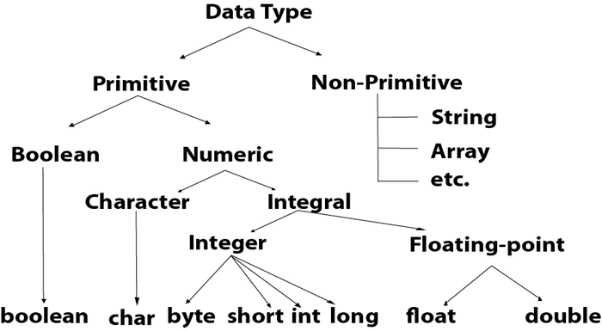

|  |  |  |  |
| --- | --- | --- | --- |
| **Data Type** |  | | **Size** |
| boolean |  | 1 bit | |
| char |  | 2 byte | |
| byte |  | 1 byte | |
| short |  | 2 byte | |
| int |  | 4 byte | |
| long |  | 8 byte | |
| float |  | 4 byte | |
| double |  | 8 byte | |

* Java provides three types of control flow statements.

1. Decision Making statements
   * if statements
   * switch statement
2. Loop statements
   * do while loop
   * while loop
   * for loop
3. Jump statements
   * break statement
   * continue statement

**Java if-else statement**

The [Java](https://www.javatpoint.com/java-tutorial) *if statement* is used to test the condition. It checks [boolean](https://www.javatpoint.com/boolean-keyword-in-java) condition: *true* or *false*. There are various types of if statement in Java.

* if statement

**Syntax:**

**if**(condition){

//code to be executed

}

* if-else statement

**if**(condition){

//code if condition is true

}**else**{

//code if condition is false

}

* if-else-if ladder

**if**(condition1){

//code to be executed if condition1 is true

}**else** **if**(condition2){

//code to be executed if condition2 is true

}

**else** **if**(condition3){

//code to be executed if condition3 is true

}

...

**else**{

//code to be executed if all the conditions are false

}

* nested if statement

**if**(condition){

     //code to be executed

**if**(condition){

             //code to be executed

    }

}

# Loops in Java

* For loop:

There are three types of for loops in Java.

* Simple for Loop
* [For-each](https://www.javatpoint.com/for-each-loop) or Enhanced for Loop
* Labeled for Loop
* Simple for loop:

**Syntax:**

**for**(initialization; condition; increment/decrement){

//statement or code to be executed

}

* For-each Loop:

**Syntax:**

**for**(data_type variable : array_name){

//code to be executed

}

* Labeled For Loop:

**Syntax:**

labelname:

**for**(initialization; condition; increment/decrement){

//code to be executed

}

* While Loop:

**Syntax:**

**while** (condition){

//code to be executed

I ncrement / decrement statement

}

* Do-While Loop:

**Syntax:**

**do**{

//code to be executed / loop body

//update statement

}**while** (condition);

# Java Arrays

**Java array** is an object which contains elements of a similar data type. Additionally, The elements of an array are stored in a contiguous memory location. It is a data structure where we store similar elements. We can store only a fixed set of elements in a Java array.

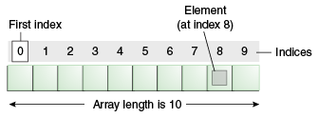

### **Advantages**

* **Code Optimization:** It makes the code optimized, we can retrieve or sort the data efficiently.
* **Random access:** We can get any data located at an index position.

### **Disadvantages**

* **Size Limit:** We can store only the fixed size of elements in the array. It doesn't grow its size at runtime. To solve this problem, collection framework is used in Java which grows automatically.

### **Types of Array in java**

There are two types of array.

* Single Dimensional Array
* Multidimensional Array

## Single Dimensional Array in Java

**Syntax to Declare an Array in Java**

dataType[] arr; (or)

dataType []arr; (or)

dataType arr[];