Html code generate by Django from ORM code:

 <div class="container m-3">

    <form action="" method="post">

        <input type="hidden" name="csrfmiddlewaretoken" value="2wMY3y8RYHxUrsRkt2cUj9FgoS0C7scbHOgoYxN4q0tRobutnRsoPVAjJu1S6VbZ">

       <table>

        <tr>

    <th><label for="id_name">Name:</label></th>

    <td>

      <input type="text" name="name" id="id_name">

    </td>

  </tr>

  <tr>

    <th><label for="id_age">Age</label></th>

    <td>

      <input type="number" name="age" required id="id_age"

    </td>

  </tr>

  <tr>

    <th><label for="id_mark">Mark:</label></th>

    <td>

      <input type="number" name="mark" required id="id_mark">

    </td>

  </tr>

  <tr>

    <th><label for="id_email">Mail-Id:</label></th>

    <td>

      <input type="text" name="email" id="id_email">

 </td>

  </tr>

  <tr>

    <th><label for="id_country">Country:</label></th>

    <td>

      <input type="text" name="country" value="India" required disabled id="id_country">

    </td>

  </tr>

  <tr>

    <th><label for="id_bio">Bio:</label></th>

    <td>

      <textarea name="bio" cols="40" rows="10" maxlength="120" required aria-describedby="id_bio_helptext" id="id_bio">

</textarea>

        <br>

        <span class="helptext" id="id_bio_helptext">maximun 120 char</span>

    </td>

  </tr>

  <tr>

    <th><label for="id_upload_cv">Upload cv:</label></th>

    <td>

   <input type="file" name="upload_cv" required id="id_upload_cv">

    </td>

  </tr>

  <tr>

    <th><label for="id_upload_photo">Upload photo:</label></th>

    <td>

      <input type="file" name="upload_photo" accept="image/*" required id="id_upload_photo">

    </td>

  </tr>

  <tr>

    <th><label for="id_iagree">Iagree:</label></th>

    <td>

      <input type="checkbox" name="iagree" required id="id_iagree">

    </td>

  </tr>

        <tr>

            <td><input type="submit" value="submit"></td>

        </tr>

       </table>

    </form>

   </div>

ORM CODE for form:

from django import forms

class StudentForm(forms.Form):

    name=forms.CharField(required=False)

    age=forms.IntegerField(label_suffix="")

    mark=forms.IntegerField()

    email=forms.CharField(required=False,label="Mail-Id")

    country=forms.CharField(initial='India',disabled=True)

    bio=forms.CharField(widget=forms.Textarea,help_text='maximun 120 char',max_length=120)

    upload_cv=forms.FileField()

    upload_photo=forms.ImageField()

    iagree=forms.CharField(widget=forms.CheckboxInput)

**OUTPUT:**

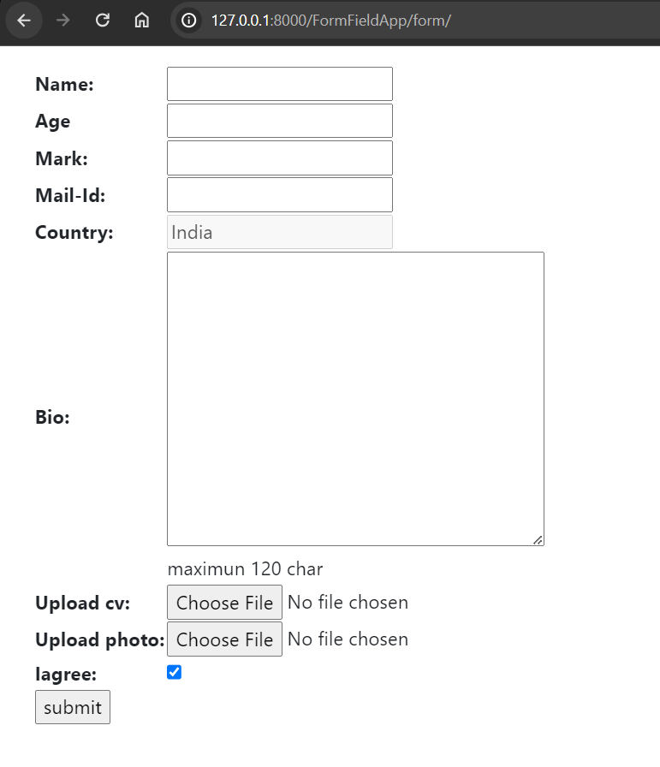

App installations: ***FormField/settings.py***

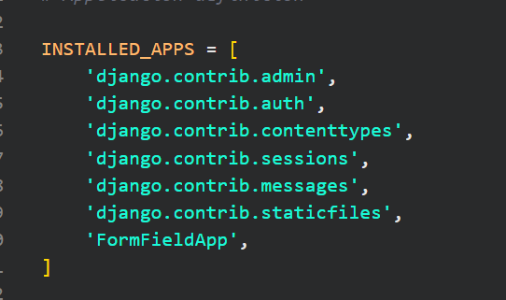

**Template configuratins:**

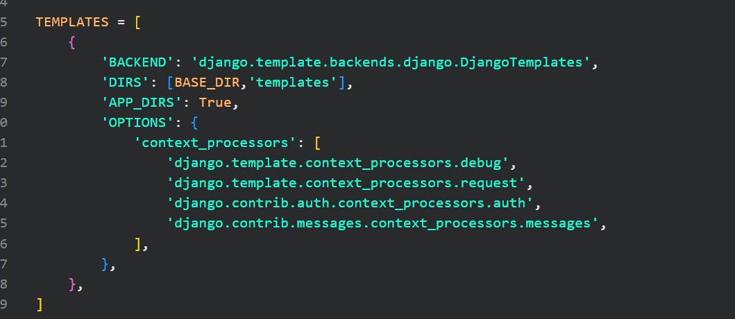

Project level url: FormField/FormField/urls.py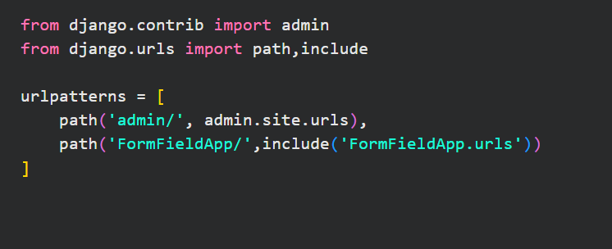

Application level url: FormField/FormFieldApp/urls.py

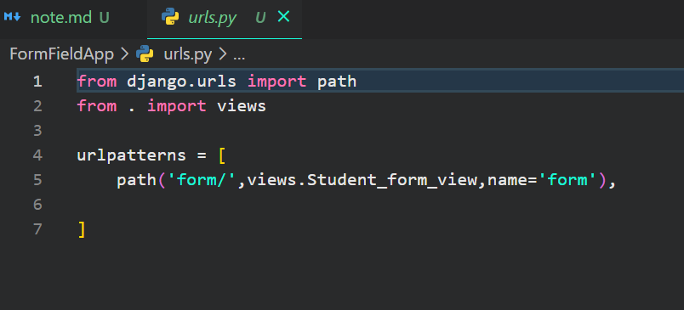

FormField/FormFieldApp/views.py

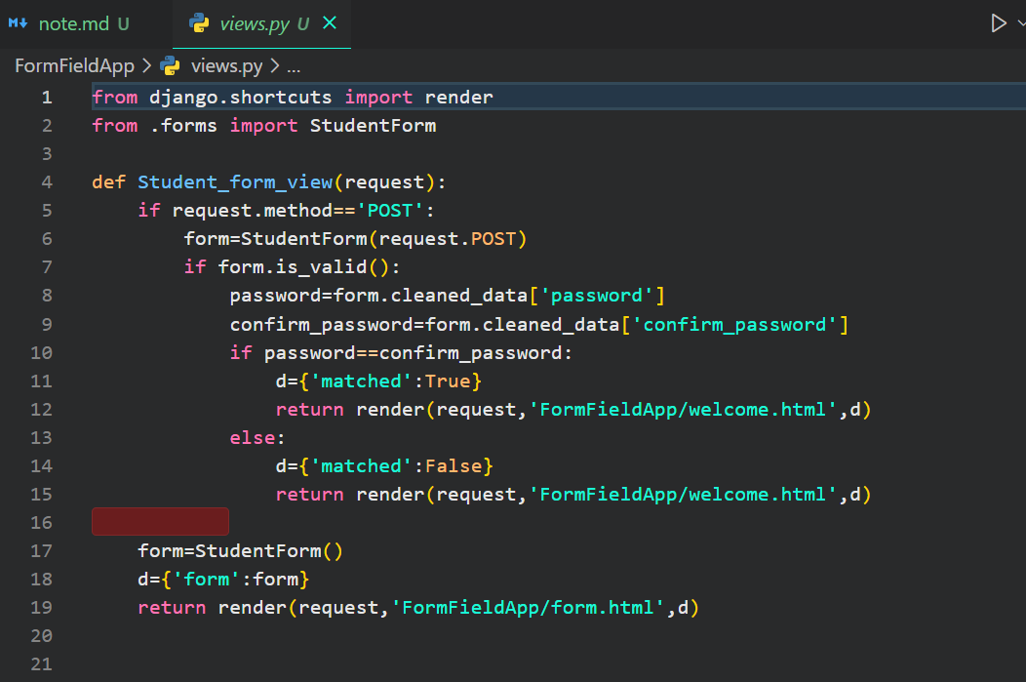

FormField/templates/FormFieldApp/form.html

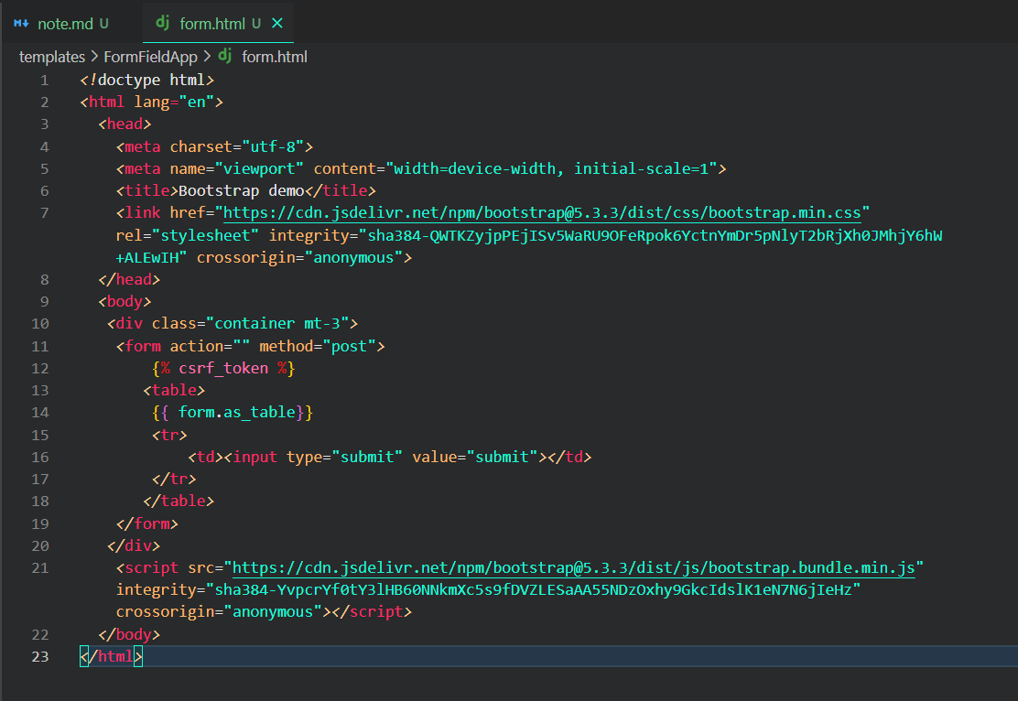

FormField/templates/FormFieldApp/welcome.html

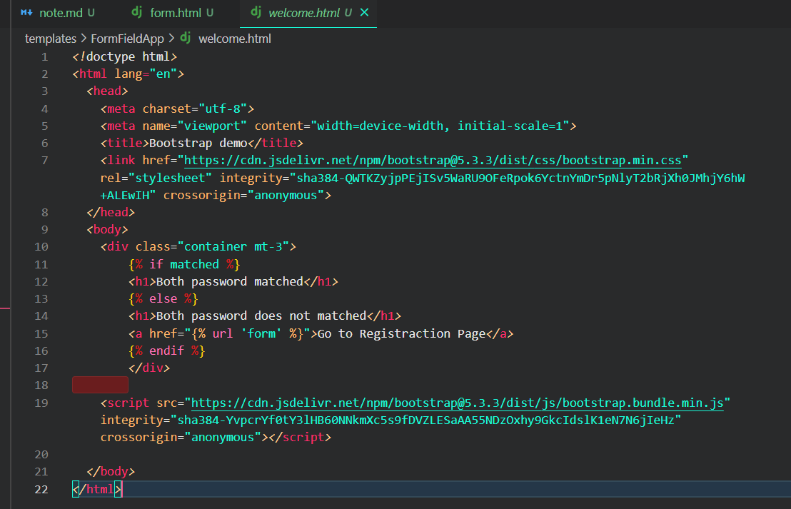

**OUTPUT:**

