**TASK (18/06/24*): TAKE 6 FIELDS AND APPLY VALIDATIONS TO EACH FIELD***

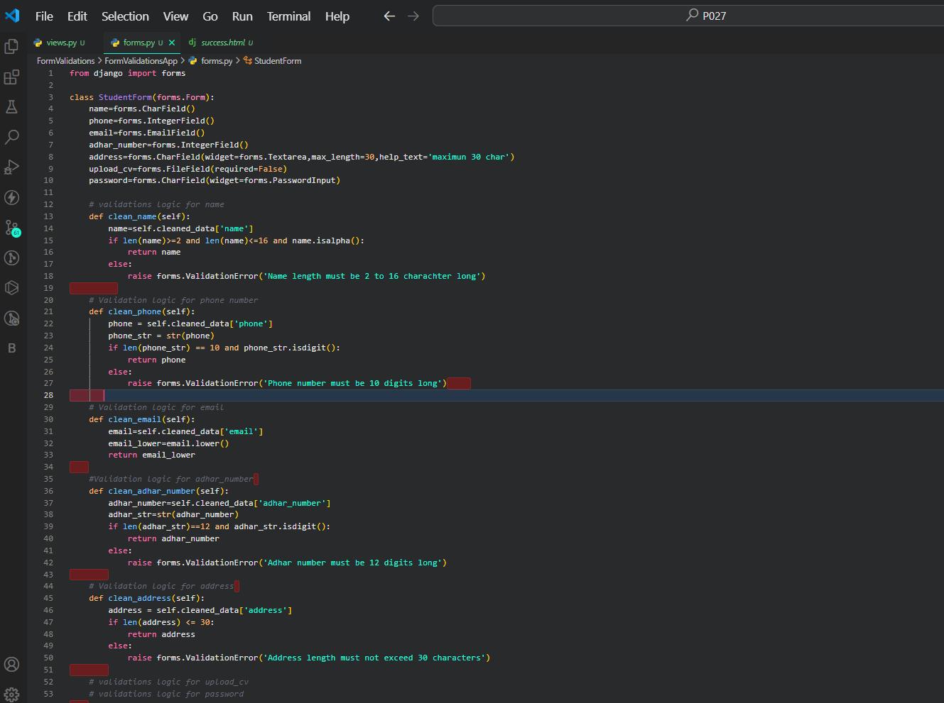

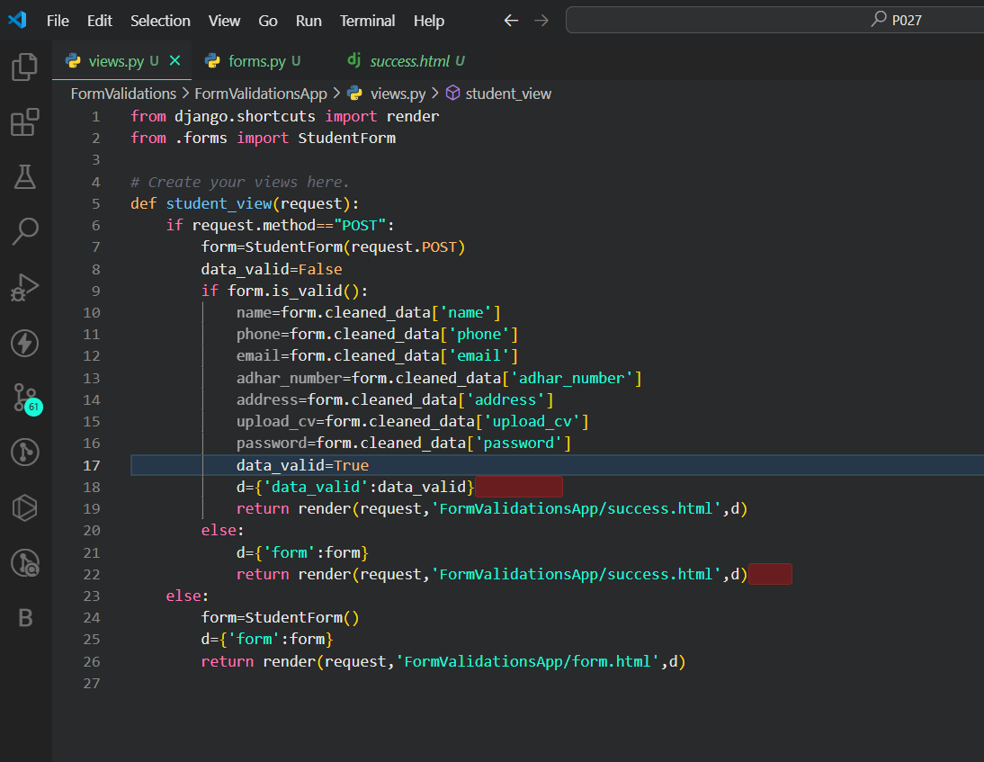

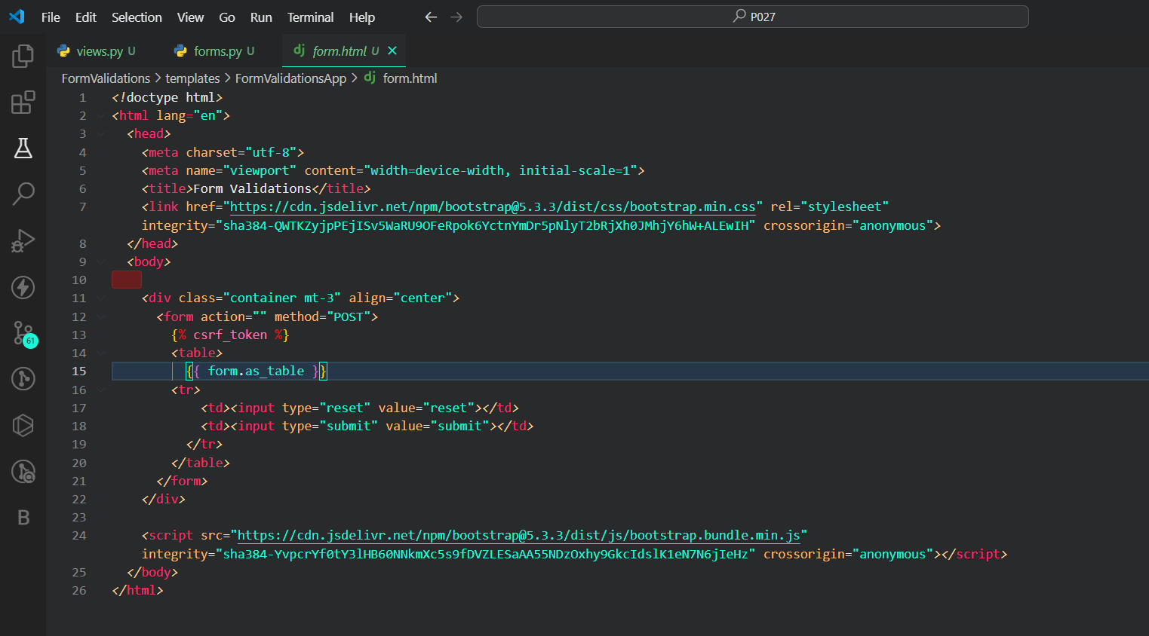

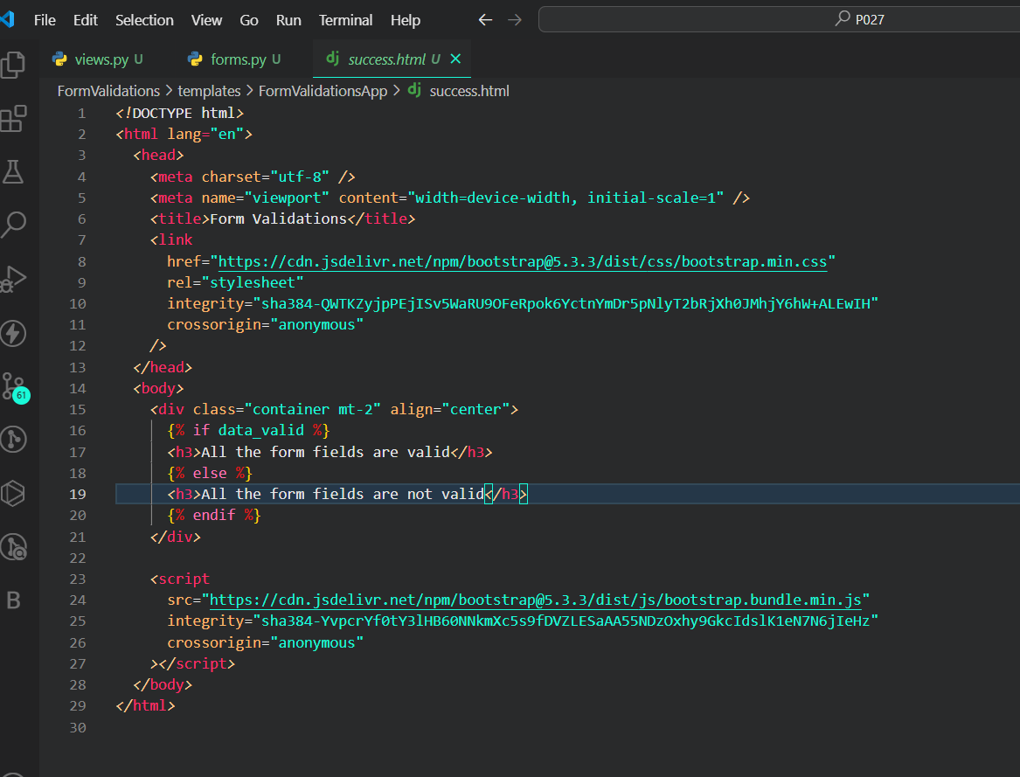

So here I have taken 5 digit for adhar number but it should be 12 digit . so it will not valid.

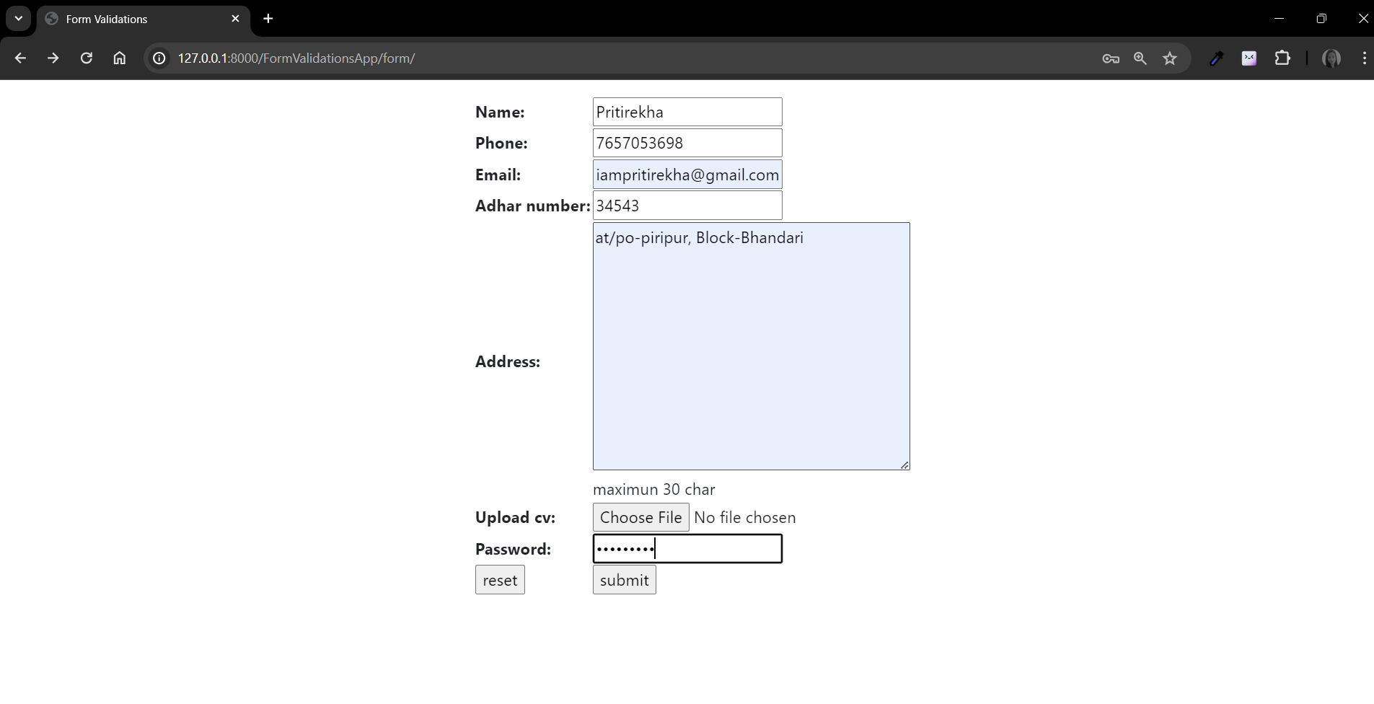

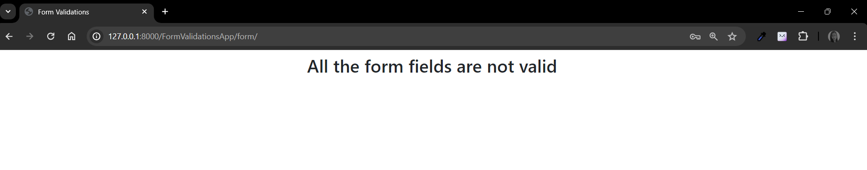

**SO here In name field I have taken digits it should be alphabets only.**

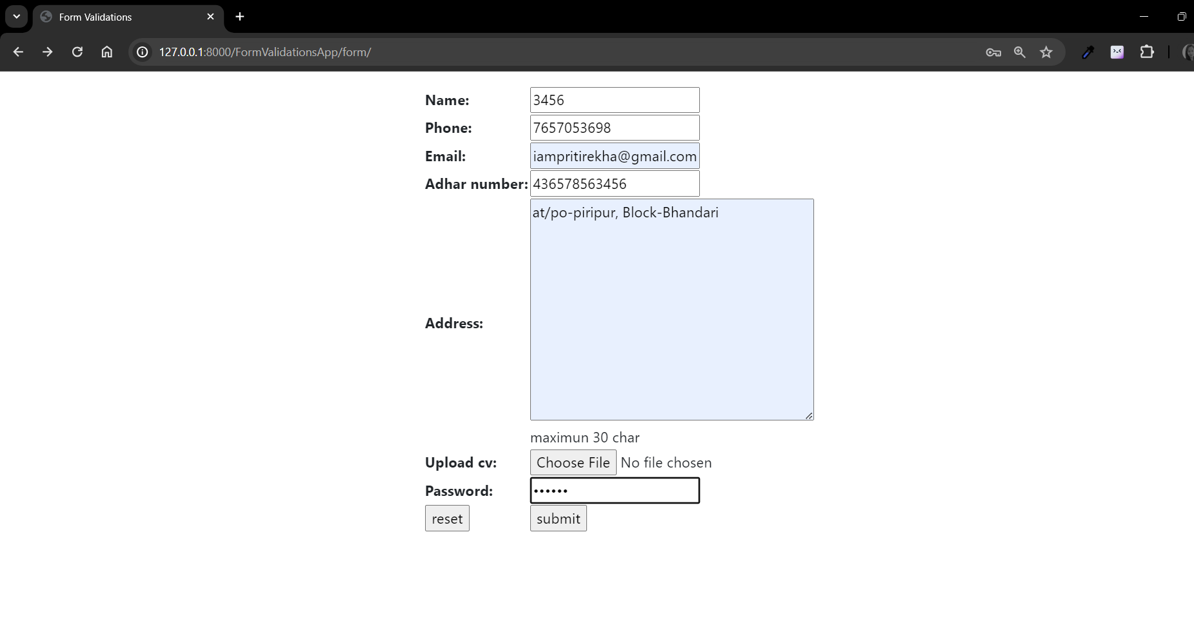



**So here in phone filed I have taken 7 digits it should be 10 digits.**

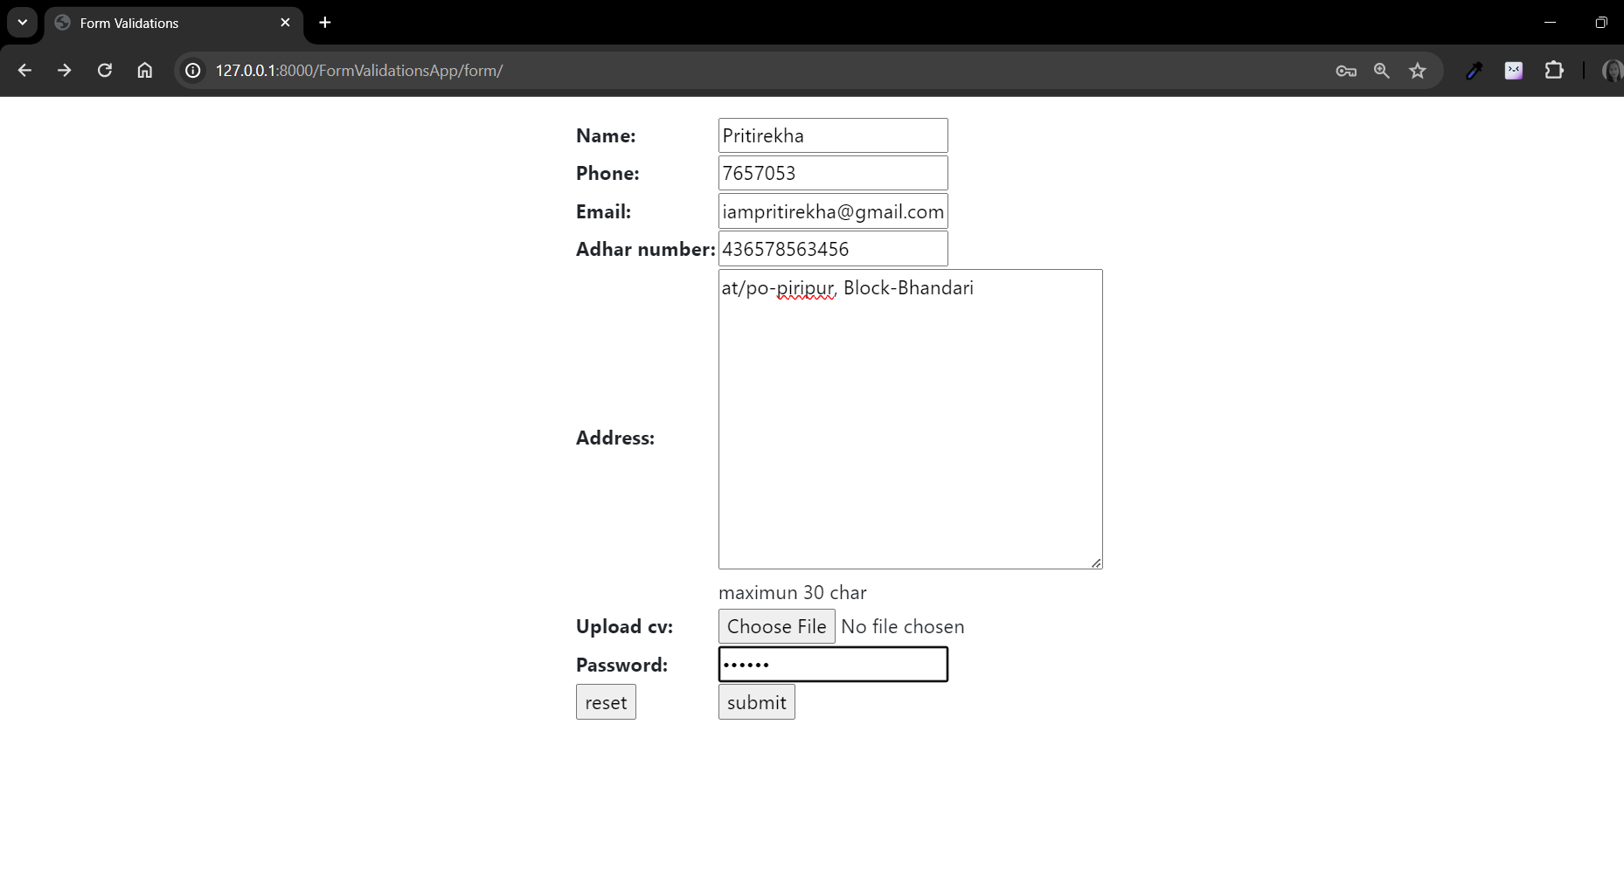

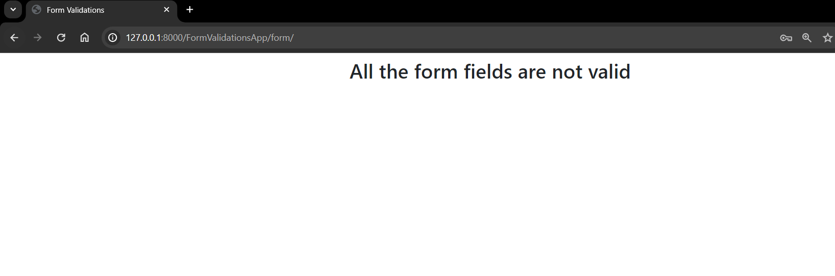

**VALIDATIONS SUCCESSS:**

