Credit Scoring System
Machine Learning Project Report

Generated: September 24, 2026

1. Introduction
This report presents a complete end-to-end Machine Learning solution for Credit Score Prediction. The system classifies customers into three credit score categories — Good, Standard, and Poor — based on their financial profile and behavioral patterns. The dataset comprises 100,000 training records and 50,000 test records with 28 features covering income, debts, payment history, credit utilization, and more.

1.1 Objectives
- Perform comprehensive Exploratory Data Analysis (EDA) on 100K financial records
- Engineer meaningful features from raw financial history data
- Train and evaluate Logistic Regression, Decision Tree, and Random Forest models
- Deploy a Flask REST API for real-time credit score prediction
- Build an interactive Streamlit dashboard for business users

2. Dataset Overview

2.1 Dataset Statistics
Property | Value
Training records | 100,000
Test records | 50,000
Original features | 28
Target variable | Credit_Score (Good / Standard / Poor)

2.2 Target Variable Distribution
The Credit Score has three classes with a moderate class imbalance: Standard (53.2%), Poor (29.0%), and Good (17.8%).
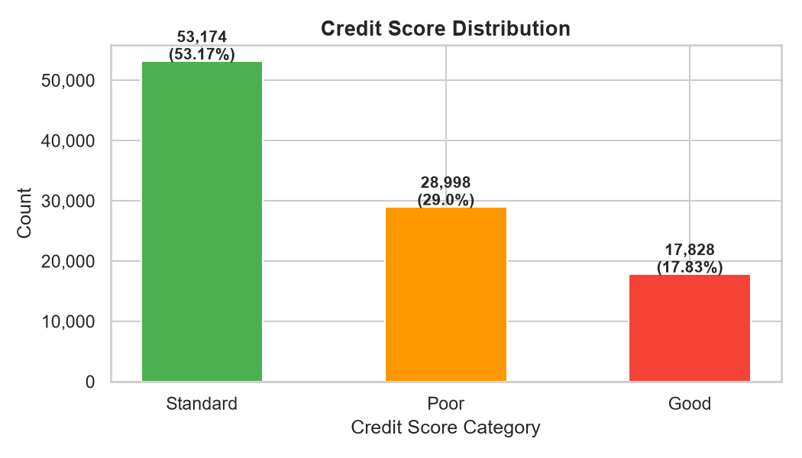
Figure 1: Credit Score Distribution (Training Set)

2.3 Missing Values
The dataset contains missing values in several key columns. The most affected are Credit Mix (20.2%), Monthly Inhand Salary (15.0%), and Type of Loan (11.4%). Missing values were imputed using training-set medians to prevent data leakage.

3. Exploratory Data Analysis

3.1 Numerical Feature Distributions
Numerical features show diverse distributions — Age is roughly normal, Annual Income and Outstanding Debt are right-skewed with extreme outliers. Interest Rate shows unusual multimodal distribution indicating data quality issues in the raw data that were corrected during cleaning.
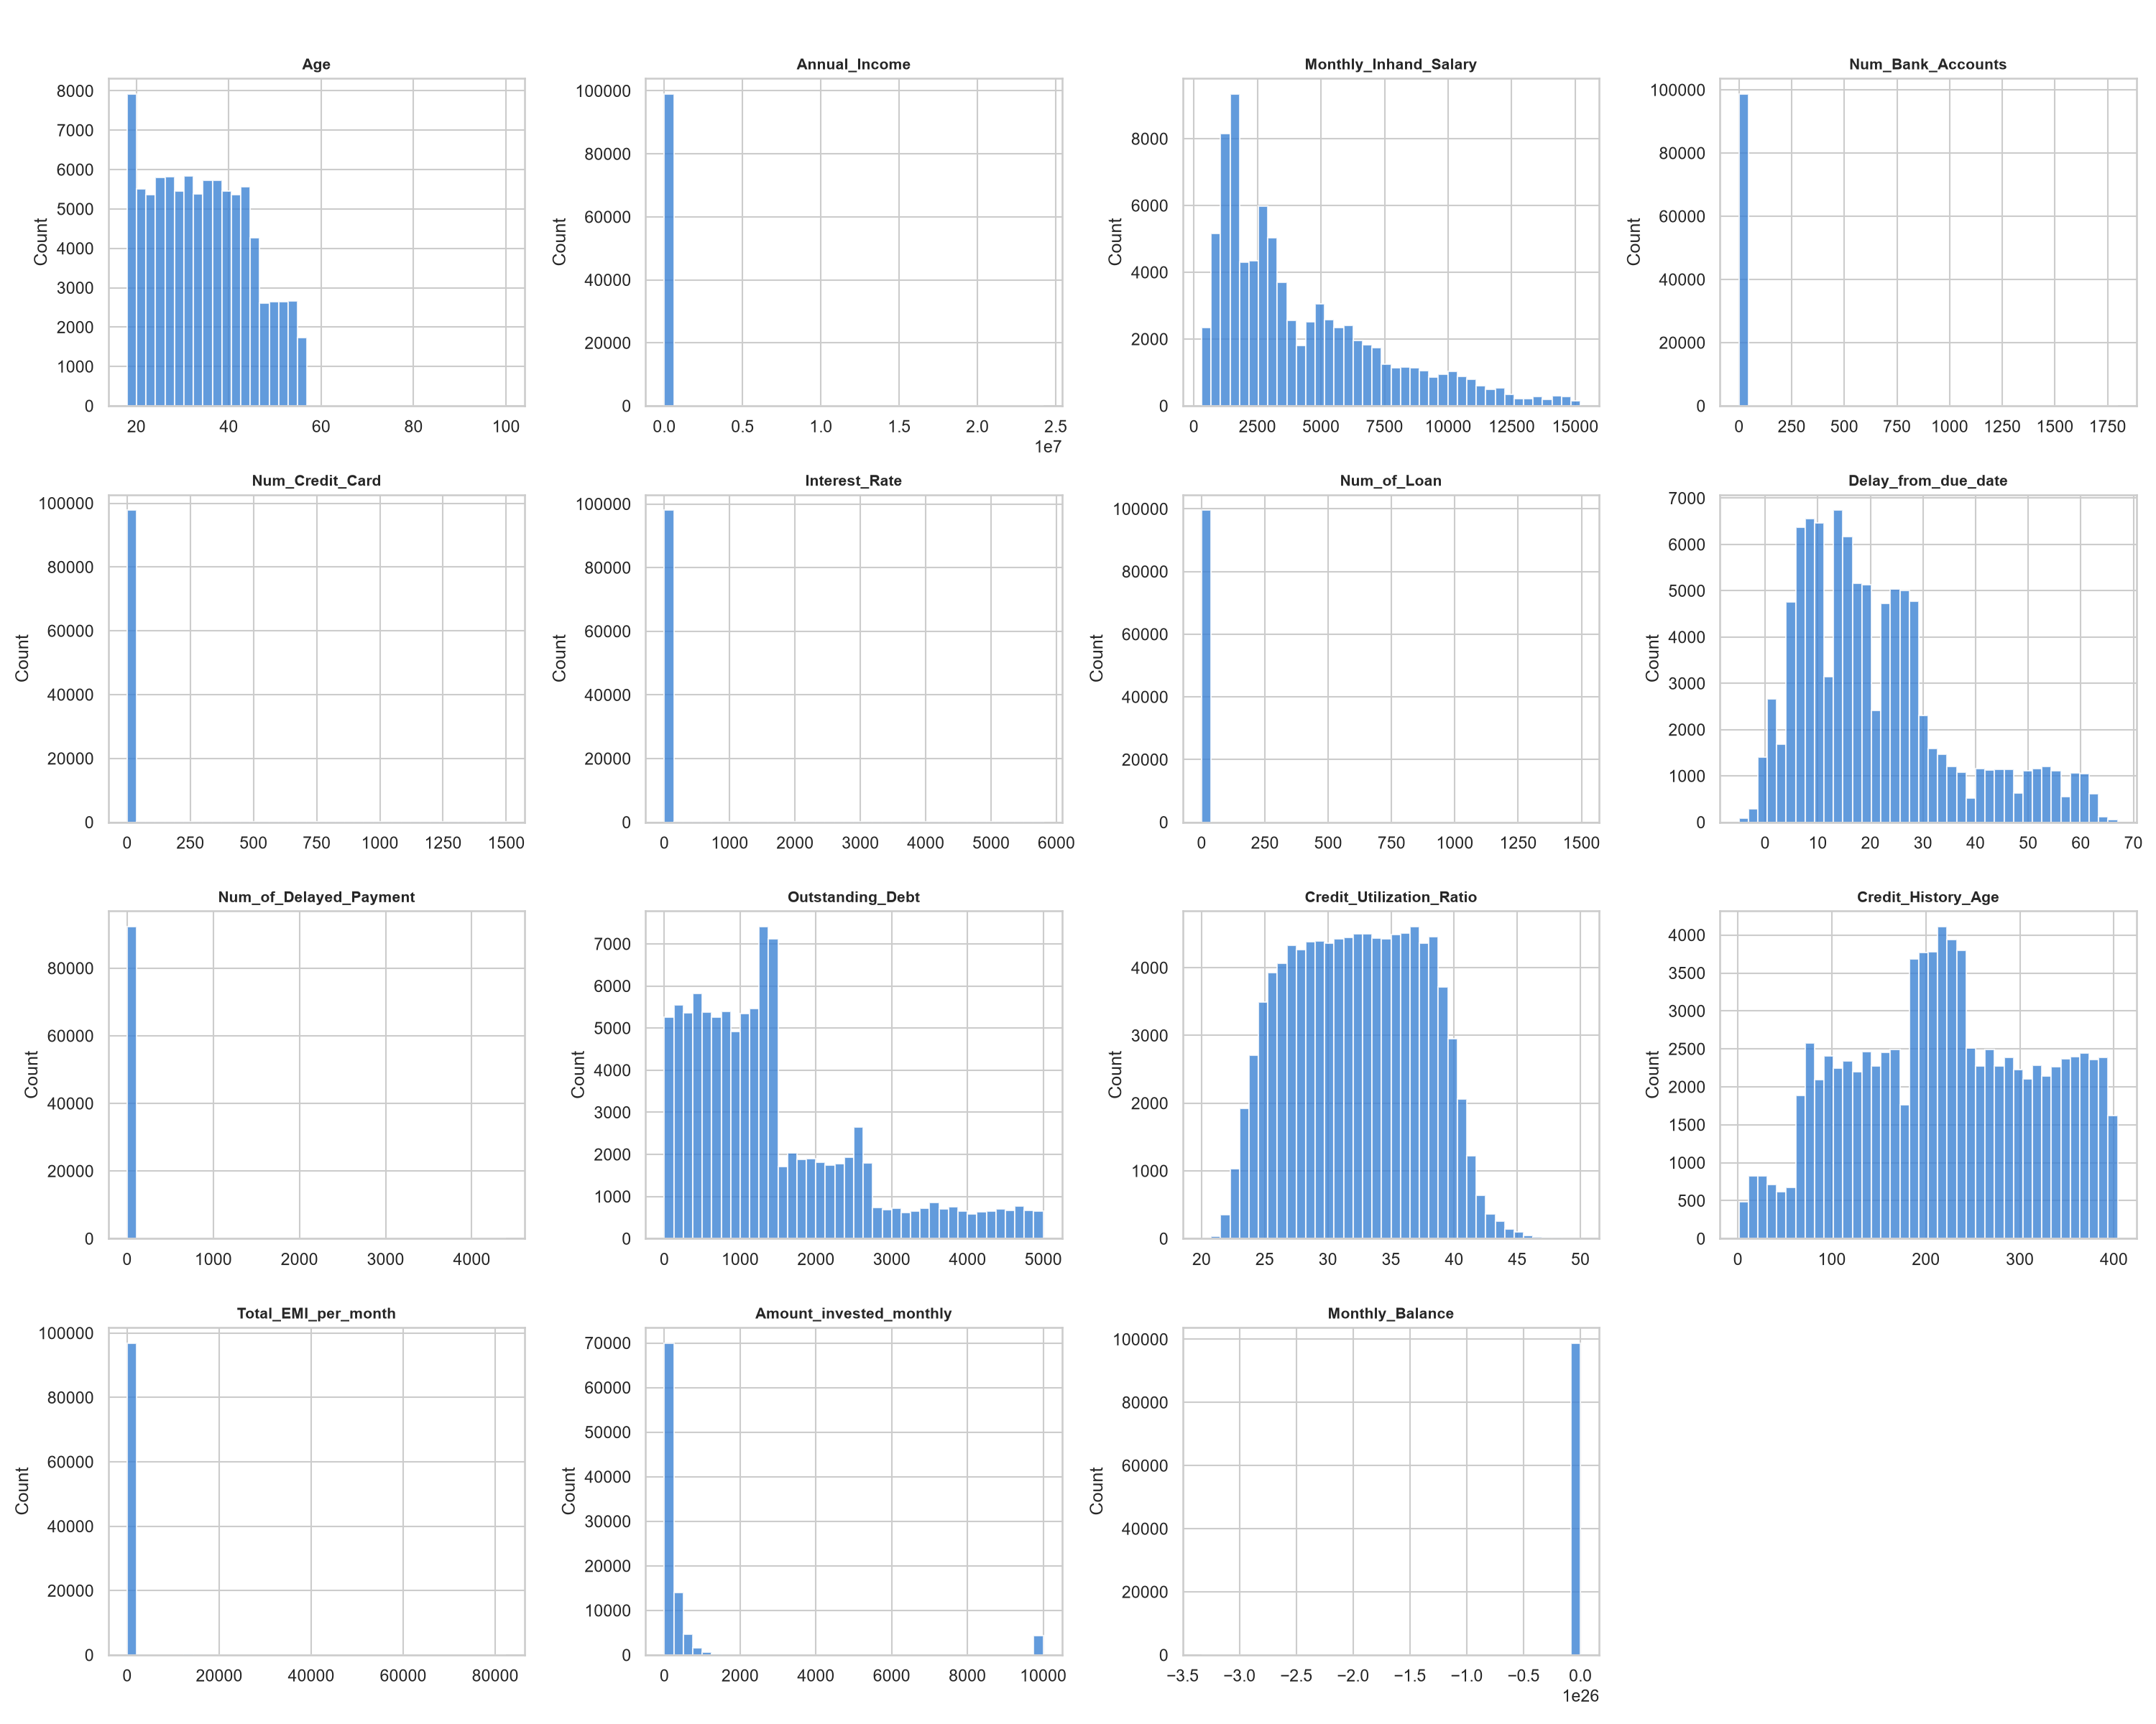
Figure 2: Numerical Feature Distributions

3.2 Categorical Feature Distributions
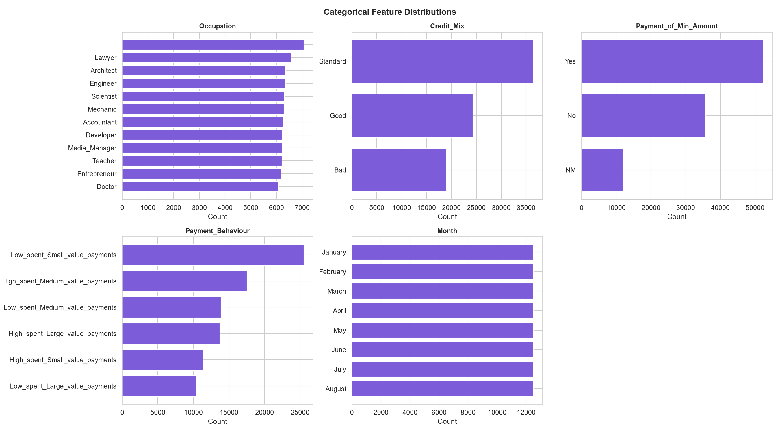
Figure 3: Categorical Feature Distributions

3.3 Key Features vs Credit Score
Clear separation is visible between credit score classes across key financial features. Good credit customers consistently show lower debt, lower interest rates, fewer delayed payments, and higher monthly balance.
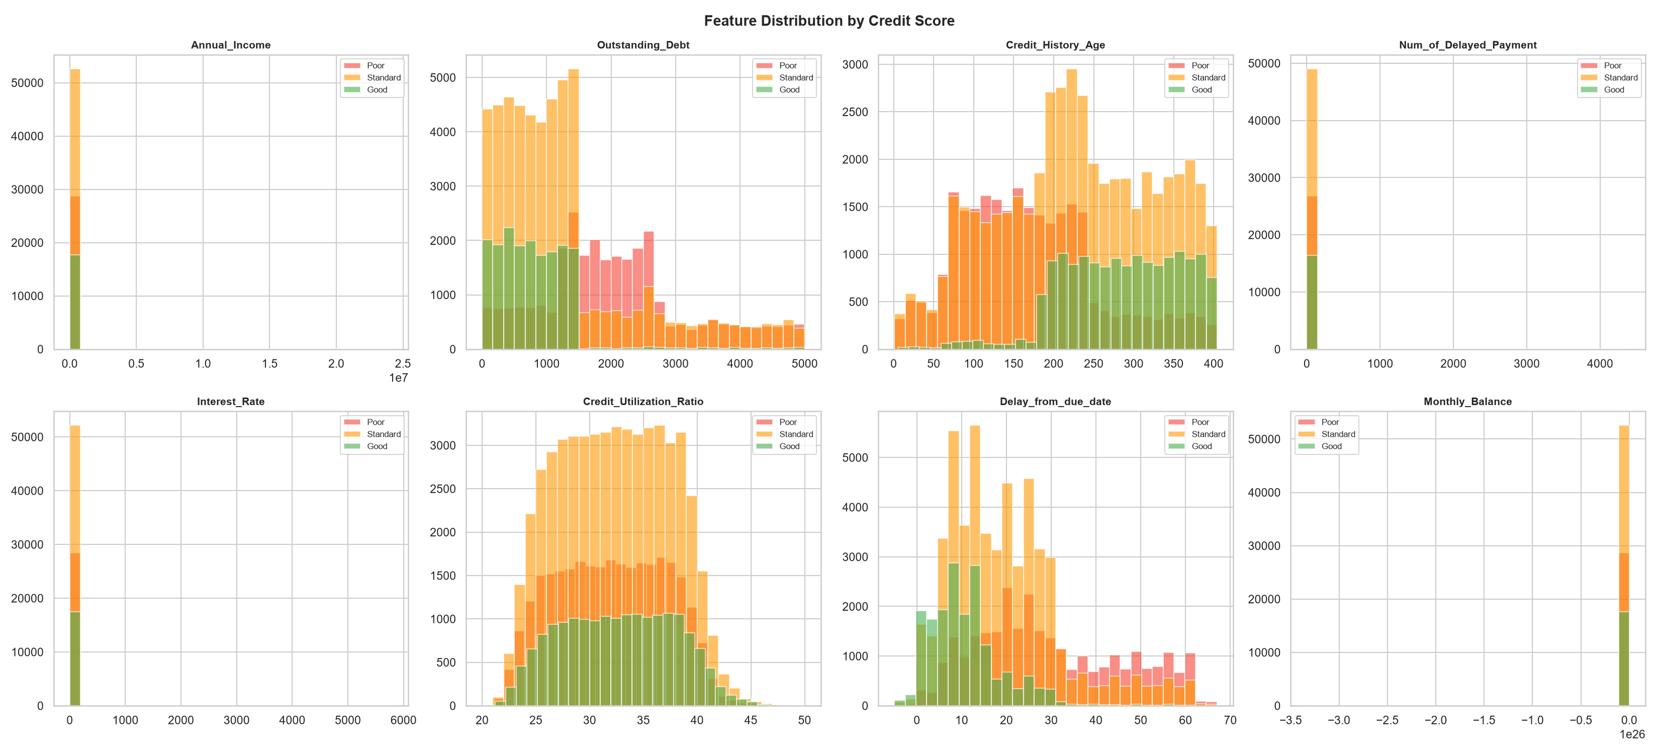
Figure 4: Feature Distributions by Credit Score Class
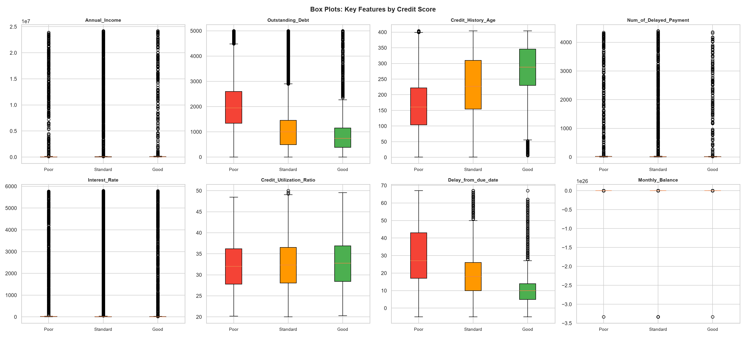
Figure 5: Box Plots — Key Features by Credit Score

3.4 Correlation Analysis
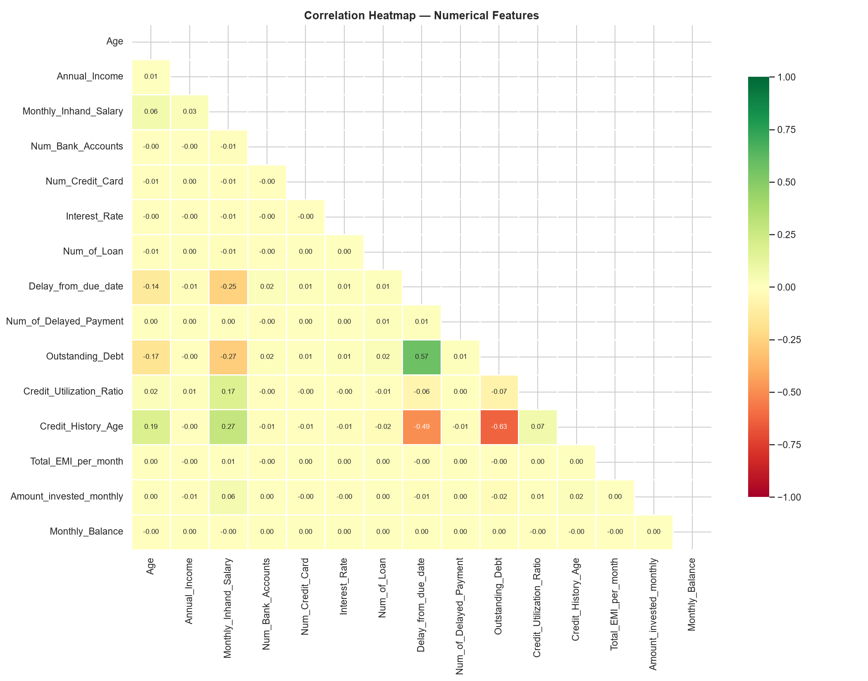
Figure 6: Correlation Heatmap — Numerical Features

3.5 Payment Behaviour Analysis
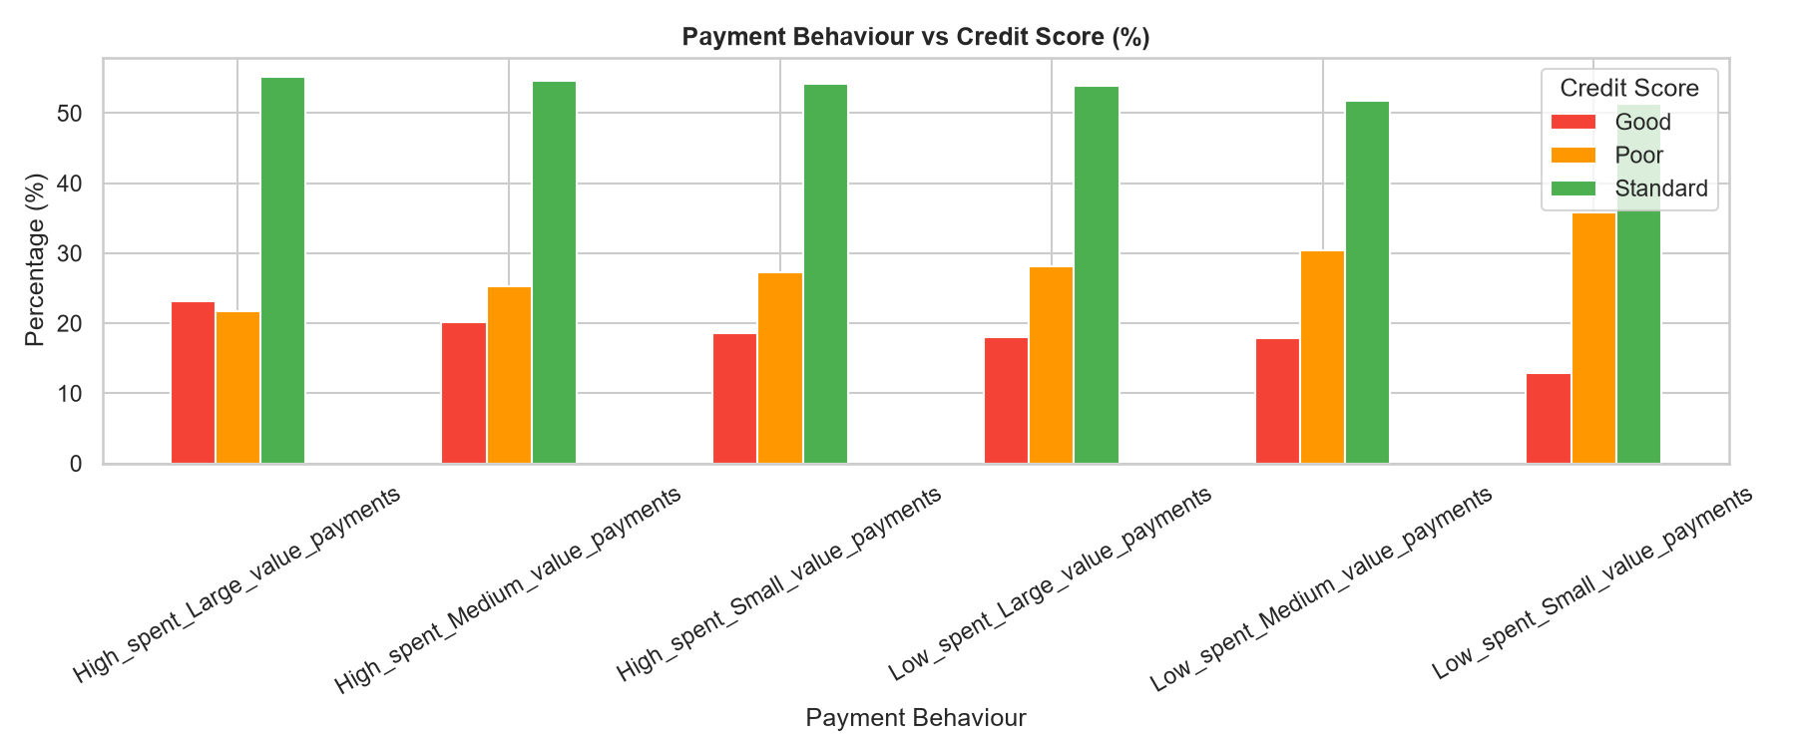
Figure 7: Payment Behaviour vs Credit Score

3.6 Income & Debt Analysis
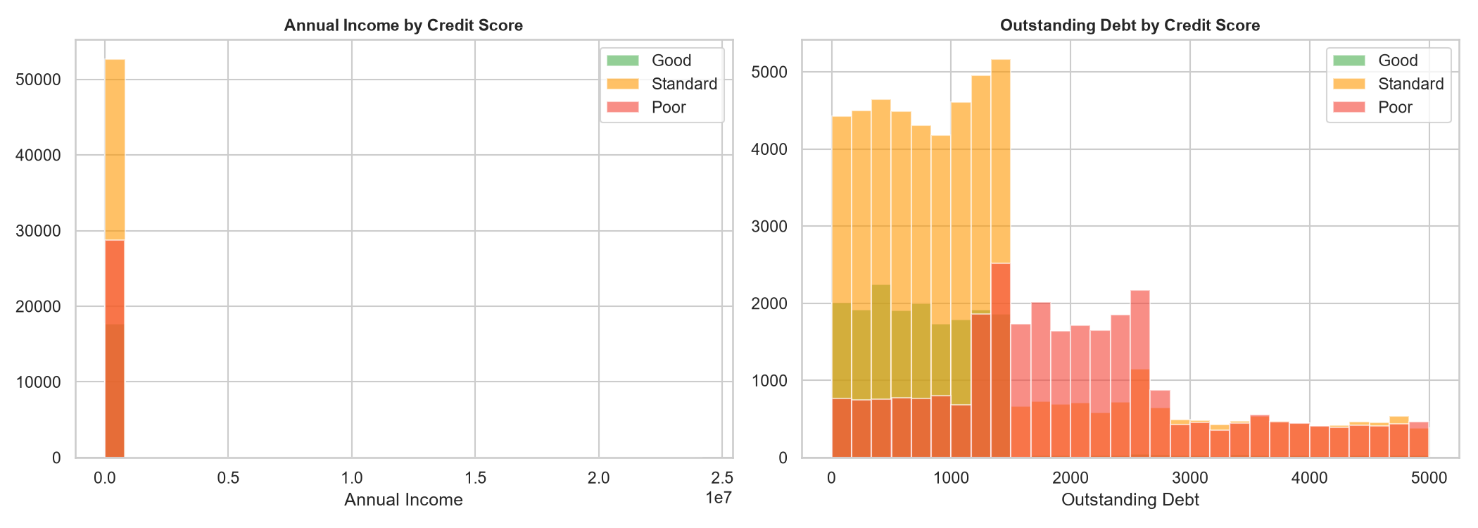
Figure 8: Annual Income and Outstanding Debt Distribution by Credit Score

4. Feature Engineering
The following features were derived from raw financial data:
Feature | Description
Debt_to_Income | Outstanding Debt / Annual Income — measures debt burden
EMI_to_Income | Total EMI / Monthly Salary — measures monthly payment burden
Investment_Rate | Monthly Investment / Monthly Salary — savings behavior
Has_Delayed_Payment | Binary: has the customer ever delayed a payment
High_Utilization | Binary: Credit Utilization Ratio > 30%
Pays_Min_Only | Binary: customer pays only the minimum amount (encoded from text)
Credit_History_Age | Converted from 'X Years Y Months' text to integer months

5. Model Training & Evaluation

5.1 Models Trained
- Logistic Regression: Multinomial logistic regression, L2 regularization, LBFGS solver
- Decision Tree: Max depth=12, Min samples per leaf=30, entropy criterion
- Random Forest: 200 trees, max depth=20, class_weight='balanced', n_jobs=-1

5.2 Performance Results
Model | Accuracy | Precision | Recall | F1-Score | ROC-AUC
Logistic Regression | 0.6089 | 0.6068 | 0.6089 | 0.5939 | 0.7429
Decision Tree | 0.7123 | 0.7163 | 0.7123 | 0.7137 | 0.8359
Random Forest | 0.7216 | 0.7635 | 0.7216 | 0.7257 | 0.8740

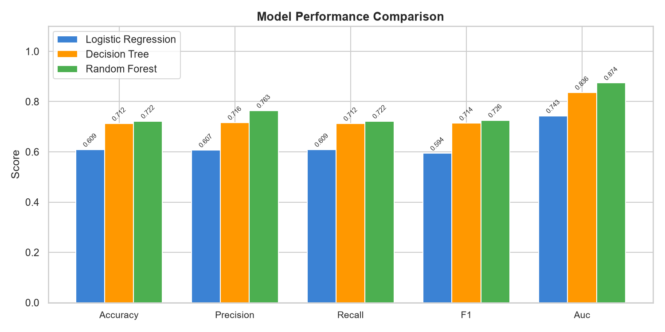
Figure 9: Model Performance Comparison

5.3 Confusion Matrices
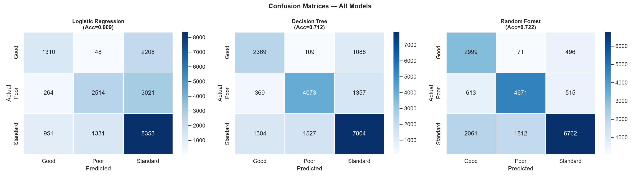
Figure 10: Confusion Matrices — All Models

5.4 ROC Curves
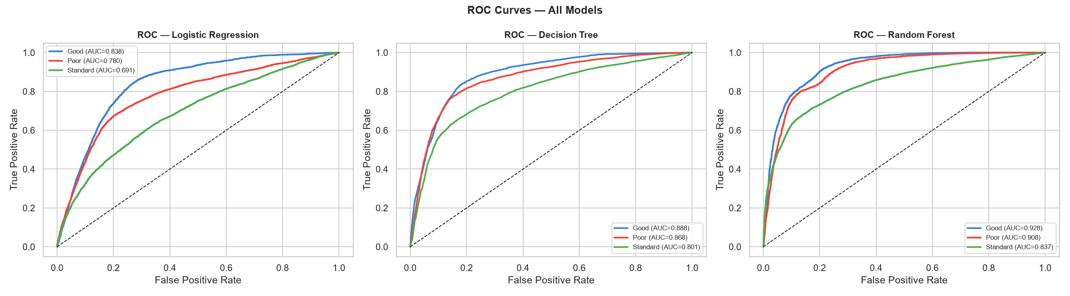
Figure 11: ROC Curves — All Models

6. Feature Importance
Random Forest feature importances reveal the most influential predictors for credit score classification:
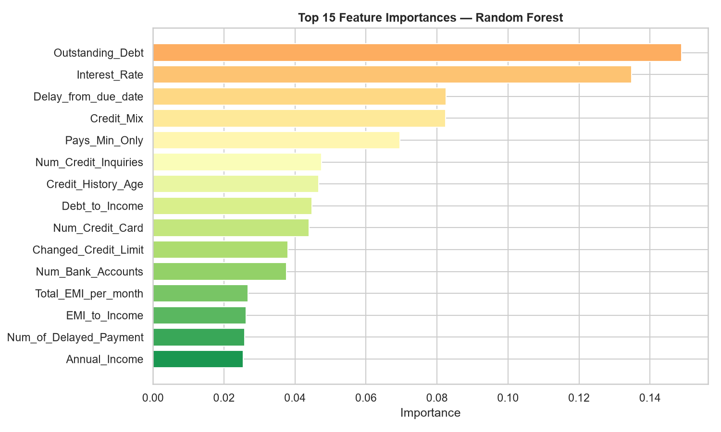
Figure 12: Top 15 Feature Importances — Random Forest
Rank | Feature | Importance | Insight
1 | Outstanding_Debt | 14.89% | Total current debt is the strongest predictor
2 | Interest_Rate | 13.48% | Higher rates correlate with poor creditworthiness
3 | Delay_from_due_date | 8.25% | Payment delays strongly indicate poor credit
4 | Credit_Mix | 8.24% | Diversified credit indicates responsible borrowing
5 | Pays_Min_Only | 6.96% | Paying only minimum indicates financial stress
6 | Num_Credit_Inquiries | 4.75% | Multiple inquiries suggest credit-seeking behavior
7 | Credit_History_Age | 4.66% | Longer history indicates stable financial behavior
8 | Debt_to_Income | 4.48% | Engineered ratio captures overall debt burden

7. System Architecture
The credit scoring system follows a three-tier architecture:
Component | Description
Data Layer | train.csv / test.csv + data/ directory
ML Pipeline | scripts/analysis.py — cleans, engineers, trains, saves models
Backend API | app.py (Flask) — serves predictions via POST /predict on port 5000
Frontend UI | ui.py (Streamlit) — interactive web app with prediction & dashboard
Model Storage | models/ — serialized Random Forest, scaler, encoders, medians
Output | outputs/figures/ (12 charts), outputs/reports/metrics.json

8. Key Findings & Insights
- Random Forest outperforms all models with 72.2% accuracy and 0.874 ROC-AUC
- Outstanding Debt (14.9%) and Interest Rate (13.5%) are the two strongest predictors
- Customers paying only the minimum amount are ~3x more likely to have Poor credit
- Good credit customers have longer credit histories on average than Poor credit customers, with approximately 285 months compared with 170 months.
- Higher credit utilization (>30%) strongly correlates with Standard or Poor scores
- Payment Behaviour category is highly informative — Low_spent_Small_value_payments patterns appear among Good scorers
- Debt-to-Income ratio (engineered) captures financial health better than raw debt alone
- Class imbalance (Standard 53% vs Good 18%) was handled via class_weight='balanced'

9. Conclusion
This project successfully built a complete credit scoring prediction system from raw financial data to a deployed web application. The Random Forest model achieved 72.2% accuracy and 0.874 ROC-AUC, demonstrating strong predictive capability across all three credit score categories. The engineered features — particularly Debt-to-Income ratio and the Pays_Min_Only flag — significantly improved model performance over using raw features alone. The system provides a complete end-to-end prototype with a Flask REST API and Streamlit frontend for real-time credit score predictions.

Credit Scoring Project | Machine Learning Report

