HullSentinal: Belief-Driven Task Prioritisation with Closed-Loop Verification for Multi-Robot Ship-Hull Inspection and Cleaning
Pritish Bhatasana Siddharth Seth
Department of Computer Science and Engineering
Vellore Institute of Technology, Chennai, India
Abstract—Autonomous ship-hull maintenance systems are conventionally driven by proximity or first-in-first-out task allocation, and they declare a cleaning task complete the moment the end effector reaches the commanded coordinate. Both assumptions are unsafe for marine structures: a propagating fatigue crack may be deferred behind harmless algae, and an unsuccessful cavitation pass leaves a residual defect that is never revisited. This paper presents HullSentinal, a cognitive multi-robot architecture in which defect state is represented as a probabilistic belief carrying continuous severity and detection confidence, dispatch order is governed by an explicit structural-utility function evaluated over true 8-connected A* geodesic distance, and every remediation is closed by a physical re-scan handshake that escalates and re-queues unresolved defects. A dynamic degradation model allows structural cracks to propagate in real time, and a priority context stack lets a cleaner preempt its active task, remediate a newly critical defect, and resume the interrupted work. The system is implemented as fourteen ROS 2 nodes over a 24 m × 8 m hull manifold with six static obstacles and fourteen defects. Across 60 independent missions spanning six scenarios and five random seeds, HullSentinal attains 82.17% defect-ordering correctness against 50.38% for a first-in-first-out baseline, and a Spearman rank correlation with ground-truth structural risk of r_{s} = +0.70 against −0.05, with zero boundary violations, zero lane violations and zero inter-robot collisions throughout. The ordering gain is statistically decisive (Welch t = 16.91, Cohen’s d = 4.37) and is obtained for a 39.7% increase in mission duration, an explicit and controllable safety-for-time trade.
Index Terms—cognitive robotics, multi-robot task allocation, belief-based planning, closed-loop verification, utility-driven scheduling, ship-hull cleaning, ROS 2.
I. Introduction
Marine biofouling, corrosion pitting and structural fatigue cracking degrade a vessel continuously from the moment it enters service. Fouling alone raises frictional drag and fuel burn, while corrosion and crack propagation attack the structural integrity of the plating itself. Conventional remediation relies on dry-docking or on diver-led underwater inspection, both of which are slow, costly and hazardous. Robotic hull crawlers are therefore an active research area, and substantial progress has been made in the three classical layers of the problem: perception, locomotion and navigation.
The layer that remains comparatively unexamined is the one that decides, given a set of discovered defects, which defect to service next and how to establish that the service actually worked. In the overwhelming majority of deployed and published systems this decision is reduced to geometry. Tasks are dispatched by nearest-neighbour distance or in discovery order, and a task is marked complete when the vehicle reaches the commanded pose. Two failure modes follow directly. First, allocation is risk-blind: a system will clean a patch of soft algae that happens to be nearby while a structural crack a few metres away continues to propagate, because nothing in the task representation distinguishes the two. Second, completion is open-loop: a cavitation pass that removed only part of a heavy corrosion scab is indistinguishable, to the planner, from a complete one.
This paper argues that these are not implementation details but a missing architectural layer, and it supplies that layer. We represent each defect not as a coordinate but as a belief carrying continuous severity, detection confidence, structural class and lane membership. We rank work by an explicit utility function in which structural risk is weighted against true traversal cost. We close the control loop by requiring a physical re-scan before any defect may be retired. The contributions are:
C1) A probabilistic defect-belief representation with recursive multi-observation fusion, maintained as a persistent lifecycle over UNDETECTED, DETECTED, QUEUED, CLEANING, RE-QUEUED and VERIFIED_CLEAN states.
C2) An explicit structural-utility function that weights severity by a defect-class risk coefficient and penalises true 8-connected A* geodesic path cost rather than Euclidean distance, so that ordering reflects both criticality and reachability around obstacles.
C3) A closed-loop verification handshake in which a completed remediation triggers a physical re-scan; residual severity above a threshold escalates the defect’s priority and returns it to the queue instead of retiring it.
C4) A priority context stack that permits a cleaner to preempt its active task when a defect crosses the critical severity threshold, remediate the emergency, and deterministically resume the suspended task from a freshly planned path.
C5) An open 60-mission evaluation over six scenarios and five seeds, with an ablation-style comparison against a first-in-first-out baseline on ordering correctness, rank correlation with structural risk, verification catch rate and safety violations.
The remainder of the paper surveys related work (Section II), formalises the problem (Section III), details the proposed architecture (Section IV), defines the comparison protocol (Section V), reports results (Section VI) and concludes (Section VII).
II. Literature Survey
A. Perception of Hull Defects
Vision-based recognition of hull defects is the most mature layer of the problem. Su et al. [1] couple biofouling recognition with a boundary-tracking controller, feeding the detector output directly into the steering loop of an underwater cleaning robot. Deep-learning detectors for cracks in ship structures [2] and the LIACI corrosion and crack segmentation benchmark [3] establish that per-pixel defect classification is achievable under realistic turbidity. These works terminate at the detection boundary: their output is a label and a bounding region, not a prioritised unit of work, and none of them carries the detector’s own confidence forward into a scheduling decision.
B. Hull-Cleaning Platforms, Control and Localisation
A substantial literature addresses the vehicle itself. A recent review of underwater cleaning robotics [4] surveys adhesion mechanisms, chassis design, perception and path planning, and identifies cleaning efficiency and operational flexibility as open problems. Chwełatiuk et al. [5] address hull-relative localisation by fusing gradient-boosted displacement prediction with Kalman filtering over odometry and positioning data. These contributions make the robot able to reach a commanded point reliably; they do not address which point should be commanded.
C. Multi-Robot Task Discovery and Allocation
Multi-robot task allocation has a well-established taxonomy [6], and consensus-based auction methods such as CBBA [7] provide decentralised, conflict-free assignment at scale. Within underwater inspection specifically, Map-TIDAL [8] couples SLAM-derived structure to task discovery and allocation for cooperative inspection, and centralised formulations combining A* with genetic search have been applied to industrial plant inspection [9]. The bidding quantity in these systems is almost universally a travel-cost or coverage term. Where heterogeneity is modelled, it concerns robot capability rather than task criticality, and no reviewed formulation carries a continuous per-task severity and confidence pair into the objective.
D. Coverage and Orchestration
Systematic coverage planning is surveyed comprehensively by Galceran and Carreras [10]; boustrophedon decomposition underpins the serpentine sweep used by our mapper. At the opposite end of the abstraction scale, hierarchical LLM-based orchestration has been proposed for heterogeneous maintenance fleets in high-risk energy facilities [11]. The latter reasons over task descriptions in natural language but maintains no quantitative belief and performs no physical verification of outcome.
E. Research Gap
Table I positions the present work against this literature along three axes: whether severity and confidence enter the task representation, whether dispatch is governed by an explicit risk-weighted utility, and whether task completion is physically verified. No surveyed system satisfies all three simultaneously, and it is this intersection that HullSentinal occupies.
TABLE I
Positioning of This Work Against Surveyed Literature
Representative work | Primary layer | Severity + confidence in task | Risk-weighted utility | Physical verification
Su et al. [1] | Perception + control | No | No | No
Crack detection [2], LIACI [3] | Perception | Partial | No | No
Cleaning-robotics review [4] | Platform survey | No | No | No
Chwełatiuk et al. [5] | Localisation | No | No | No
CBBA [7] | Allocation | No | Cost only | No
Map-TIDAL [8] | Discovery + allocation | No | Cost only | No
A*/GA plant inspection [9] | Allocation | No | Cost only | No
LLM orchestration [11] | Orchestration | No | Implicit | No
HullSentinal (this work) | Cognition layer | Yes | Yes | Yes

III. Problem Statement
A. Formal Setting
Let the hull manifold be a planar workspace W ⊂ ℝ² of dimension 24 m × 8 m, partitioned into L = 3 horizontal inspection lanes and containing a set O of static obstacles (sea chests, sacrificial anodes, discharge ports). A set of defects D = {d₁, …, d_{n}} is distributed over W. Each defect carries a ground-truth severity S(d) ∈ [0, 1], a structural class τ(d) ∈ {crack, corrosion, biofouling}, a lane index ℓ(d) ∈ {1, …, L} and a position p_{d} ∈ W.
Two heterogeneous robots operate concurrently: a mapper R_{m}, which executes a deterministic serpentine sweep and observes defects within a sensor footprint of radius R_{fov}, and a cleaner R_{c}, which navigates to a defect and applies a cavitation tool for a dwell interval. The cleaner never observes defects directly; it acts only on the belief published by the cognition layer.
B. Deficiencies of the Conventional Formulation
The conventional policy selects the next task by minimising travel cost, π_{FIFO}(t) = arg min_{d∈Q} ‖p_{c} − p_{d}‖, and retires d unconditionally once the cleaner arrives. Three deficiencies follow.
Risk blindness. Because τ(d) and S(d) do not appear in the objective, a biofouling patch at 2 m outranks a structural crack at 6 m regardless of consequence.
Open-loop completion. Because arrival implies completion, a partially successful cavitation pass is recorded as a success and the residual defect is never revisited.
Static criticality. Because severity is sampled once, a crack that propagates during the mission is scheduled on stale information.
C. Objective
We seek a dispatch policy π that maximises alignment between the realised servicing order and the ground-truth structural risk order, subject to hard spatial-safety constraints. Writing σ_{π} for the permutation of D induced by π and σ* for the risk-optimal permutation, the objective is
max_{π} r_{s}(σ_{π}, σ*) s.t. g_{oob} = g_{coll} = 0, (1)
where r_{s} denotes the Spearman rank correlation and g_{oob}, g_{coll} count geofence breaches and inter-robot collisions respectively. A secondary requirement is that no defect may be retired without physical evidence that its severity has fallen below a verification threshold θ_{v}.
IV. Proposed Work
A. Architecture Overview
HullSentinal is organised as fourteen ROS 2 nodes in three tiers: a simulation and control tier that owns physics and motion, a cognition tier that owns belief and scheduling, and a visualisation tier. The cognition tier is the contribution of this work and is deliberately isolated behind message interfaces so that it is agnostic to the detector and to the locomotion stack beneath it. The dataflow is shown in Fig. 1.
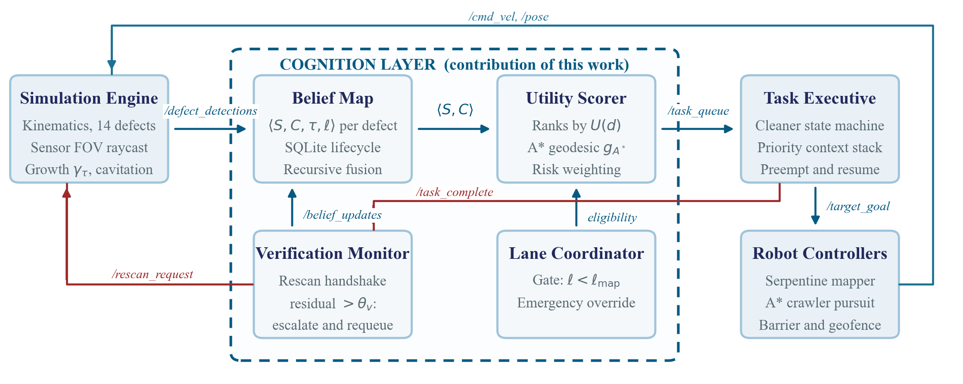
Fig. 1. HullSentinal dataflow. The simulation and control tiers (shaded) are replaceable; the cognition layer enclosed by the dashed boundary carries the contribution. Forward scheduling flows left to right along the top row; the closed verification loop (red) returns through the rescan service before any defect may be retired.
B. Belief Representation and Recursive Fusion
Each defect is stored not as a coordinate but as a belief tuple
b(d) = ⟨ Ŝ, Ĉ, τ, ℓ, p_{d}, γ_{τ}, ς ⟩, (2)
where Ŝ ∈ [0, 1] is the estimated severity, Ĉ ∈ [0, 1] the detection confidence, γ_{τ} the class-dependent degradation rate and ς the lifecycle state. The mapper returns a noisy observation z_{k} = S(d) + ε, ε ~ 𝒩(0, σ²), each time the defect falls inside the sensor footprint. Severity is fused recursively with a fixed gain λ, and confidence is taken as the most reliable observation so far:
Ŝ_{k} = (1 − λ) Ŝ_{k−1} + λ z_{k}, Ĉ_{k} = max(Ĉ_{k−1}, c_{k}). (3)
Between observations the belief is propagated forward by the degradation model of Section IV-G. The lifecycle ς and its transitions are given in Fig. 2; the essential property is that the only edge into VERIFIED_CLEAN is guarded by a physical re-scan.
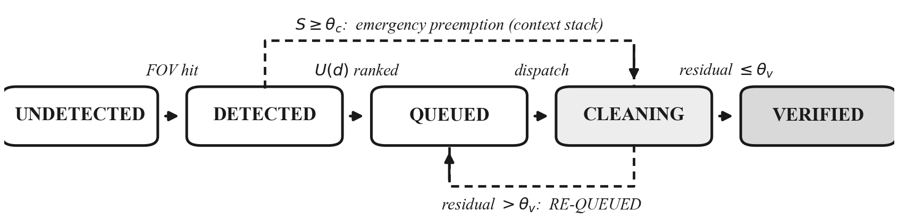
Fig. 2. Per-defect belief lifecycle. The forward chain is driven by sensor coverage and utility ranking. A residual severity above θᵥ after remediation returns the defect to the queue with an escalation bonus rather than retiring it, and a severity crossing θc diverts the cleaner immediately through the priority context stack.
C. Structural Risk Weighting
Defect classes are not equally consequential. We assign each class a structural risk weight W_{risk}(τ) reflecting its threat to hull integrity, and map severity onto a discrete risk level by thresholds θ:
ρ(Ŝ) = CRITICAL if Ŝ ≥ θ_{c}; HIGH if Ŝ ≥ θ_{h}; MEDIUM if Ŝ ≥ θ_{m}; else NORMAL. (4)
Crossing θ_{c} is the trigger for emergency preemption. Parameter values are listed in Table II.
TABLE II
System Parameters
Parameter | Symbol | Value
Risk weight, crack | W_{risk}(crack) | 1.00
Risk weight, corrosion | W_{risk}(rust) | 0.70
Risk weight, biofouling | W_{risk}(bio) | 0.40
Critical threshold | θ_{c} | 0.85
High threshold | θ_{h} | 0.70
Medium threshold | θ_{m} | 0.50
Verification threshold | θ_{v} | 0.08
Path-cost coefficient | α | 0.08
Re-queue escalation | β | 0.20
Emergency override bonus | Ω | 10.0
Fusion gain | λ | 0.50
Crack degradation rate | γ_{crack} | 0.0080 s⁻¹
Grid resolution | δ | 0.20 m
Obstacle inflation | ι | 0.55 m
Sensor footprint radius | R_{fov} | 1.80 m
Conflict horizon | T_{c} | 3.0 s

D. Geodesic Cost via 8-Connected A*
Euclidean distance is a poor cost proxy on an obstructed manifold: a defect 2 m away behind a sea chest may require a 7 m detour. We therefore discretise W into an occupancy grid of resolution δ = 0.20 m, inflate every obstacle in O by ι = 0.55 m to account for the crawler footprint, and compute true geodesic distance by 8-connected A* with the octile heuristic
h(n) = δ · [ (√2 − 1) · min(Δ_{x}, Δ_{y}) + max(Δ_{x}, Δ_{y}) ], (5)
which is admissible and consistent on the 8-connected lattice. Diagonal transitions are rejected unless both orthogonal neighbours are free, preventing corner cutting through inflated obstacles. The resulting geodesic length is denoted g_{A*}(p_{c}, p_{d}). Algorithm 1 summarises the planner.
Algorithm 1: 8-Connected A* geodesic cost with corner-cut rejection
1: Input: start p_{c}, goal p_{d}, inflated grid G
2: Output: waypoint list Π and geodesic length g_{A*}
3: s ← nearestFree(G, p_{c}); t ← nearestFree(G, p_{d})
4: open ← {(h(s), 0, s)}; g[·] ← ∞; g[s] ← 0
5: while open ≠ ∅ do
6: n ← pop-min(open)
7: if n = t then break
8: for each 8-neighbour m of n with G[m] free do
9: if diagonal and either orthogonal neighbour blocked then continue
10: g′ ← g[n] + cost(n, m) + φ(m)
11: if g′ < g[m] then g[m] ← g′; push(g′ + h(m), m)
12: Π ← line-of-sight shortcut of reconstructed path
13: return Π, g_{A*} ← polylineLength(Π)

Here φ(m) is a soft proximity penalty applied within 0.35 m of an inflated obstacle, which biases paths away from grazing contact without rendering the corridor infeasible.
E. Structural Utility Function
The scheduler ranks every active defect by a scalar utility that trades expected structural consequence against the true cost of reaching it:
U(d) = w₁ Ŝ(d) W_{risk}(τ(d)) Ĉ(d) − α g_{A*}(p_{c}, p_{d}) + β 𝟙_{rq} + Ω 𝟙_{cr}, (6)
where 𝟙_{rq} indicates a previously re-queued defect and 𝟙_{cr} a defect at CRITICAL risk. The first term is the expected structural consequence: severity scaled by class risk and discounted by confidence, so an uncertain detection cannot dominate a confident one at equal severity. The Ω term is set an order of magnitude above the achievable range of the first term, which makes emergency override lexicographic in practice rather than merely weighted.
F. Lane Gating and Emergency Preemption
Running both robots in one lane invites interference. We therefore gate cleaner eligibility on mapper progress: a defect is eligible only once its lane has been fully swept, or when it is critical:
E(d) = [ ℓ(d) < ℓ_{map} ] ∨ [ ρ(Ŝ(d)) = CRITICAL ]. (7)
Ineligible defects are retained in the published queue with a large negative utility so that the ranking remains observable but unschedulable. When a defect crosses θ_{c} while the cleaner is mid-task, the executive pushes the full execution context — task identity, state, remaining waypoints and index — onto a priority stack, diverts to the emergency, and pops the context on completion, replanning a fresh path from the position actually reached. Algorithm 2 gives the executive.
Algorithm 2: Lane-gated dispatch with preemption and resume
1: state ← WAITING_FOR_LANE; stack ← ∅; handled ← ∅
2: on each published queue Q (ranked by U):
3: if state ≠ VERIFYING then
4: for each d ∈ Q with ρ(d) = CRITICAL do
5: if d ∉ handled and d ≠ current then
6: if state ∈ {NAVIGATING, CLEANING} then push(stack, context)
7: handled ← handled ∪ {d}; dispatch(d); return
8: if state ∈ {IDLE, WAITING_FOR_LANE} then
9: dispatch(first d ∈ Q with E(d) true)
10: on arrival at target: engage tool for dwell T_{d}; then state ← VERIFYING
11: on verification resolved:
12: if stack ≠ ∅ then dispatch(pop(stack)) with freshly planned path
13: else state ← IDLE

The handled set is essential: without it the scheduler re-preempts the same critical defect on every queue publication, growing the context stack without bound and causing the cleaner to oscillate between two targets.
G. Degradation Dynamics
To make prioritisation consequential rather than cosmetic, ground-truth severity evolves. Each defect propagates at a class-dependent rate γ_{τ} under cyclic hull loading:
dS/dt = γ_{τ} ⇒ S(t) = min(1, S₀ + γ_{τ}t), (8)
so a deferred crack genuinely becomes more dangerous. Cleaning removes severity at rate μ while the tool is engaged and the tool centre lies within the tool radius of the defect, giving dS/dt = −μ during remediation.
H. Closed-Loop Verification
On completing its dwell, the cleaner calls a /task_complete service rather than self-reporting success. The verification monitor issues a physical re-scan request at the defect pose and inspects the returned residual severity S_{res}:
ς ← VERIFIED_CLEAN if S_{res} ≤ θ_{v}; RE-QUEUED with bonus β otherwise. (9)
This is the only transition that may retire a defect, and it depends on evidence gathered after the action rather than on the actor’s own report. Algorithm 3 states the handshake, including the bounded retry that prevents a transport failure from stalling the mission.
Algorithm 3: Closed-loop verification handshake
1: cleaner: on dwell complete, deadline ← now + T_{to}; state ← VERIFYING
2: cleaner: while state = VERIFYING do
3: if now ≥ deadline then log fault; release task; state ← IDLE
4: else if no request in flight then call /task_complete(d)
5: monitor: on /task_complete(d) do
6: S_{res} ← rescan(p_{d}, r_{scan})
7: if S_{res} > θ_{v} then publish RE-QUEUED with Ŝ ← S_{res}, bonus β
8: else publish VERIFIED_CLEAN with Ŝ ← 0
9: belief map: apply transition; scorer re-ranks on next cycle

I. Spatial Safety Layer
A reactive barrier filters all velocity commands. For robots with poses p_{i}, p_{j} and commanded velocities v_{i}, v_{j}, the barrier extrapolates separation over a horizon T_{c} = 3.0 s and evaluates
d_{min} = min_{t∈[0,Tꜱ]} ‖ (p_{i} + v_{i}t) − (p_{j} + v_{j}t) ‖. (10)
If d_{min} falls below a critical separation the cleaner yields, the mapper retaining right of way; a sustained yield beyond a deadlock timeout triggers a lateral sidestep. An independent geofence watchdog monitors the perimeter [0.8, 23.2] × [0.8, 7.2] m and counts any excursion.
V. Comparison Methodology
A. Simulation Testbed
All experiments run on a 24 m × 8 m hull manifold discretised at 0.20 m, populated with six static obstacles and fourteen defects distributed across three lanes (Fig. 3). The mapper executes a boustrophedon sweep with A* detours around obstacles; the cleaner follows A* waypoints under the safety barrier. The stack comprises fourteen ROS 2 nodes on ROS 2 Lyrical with RViz2 visualisation, integrated at 20 Hz with a fixed step of 0.05 s.
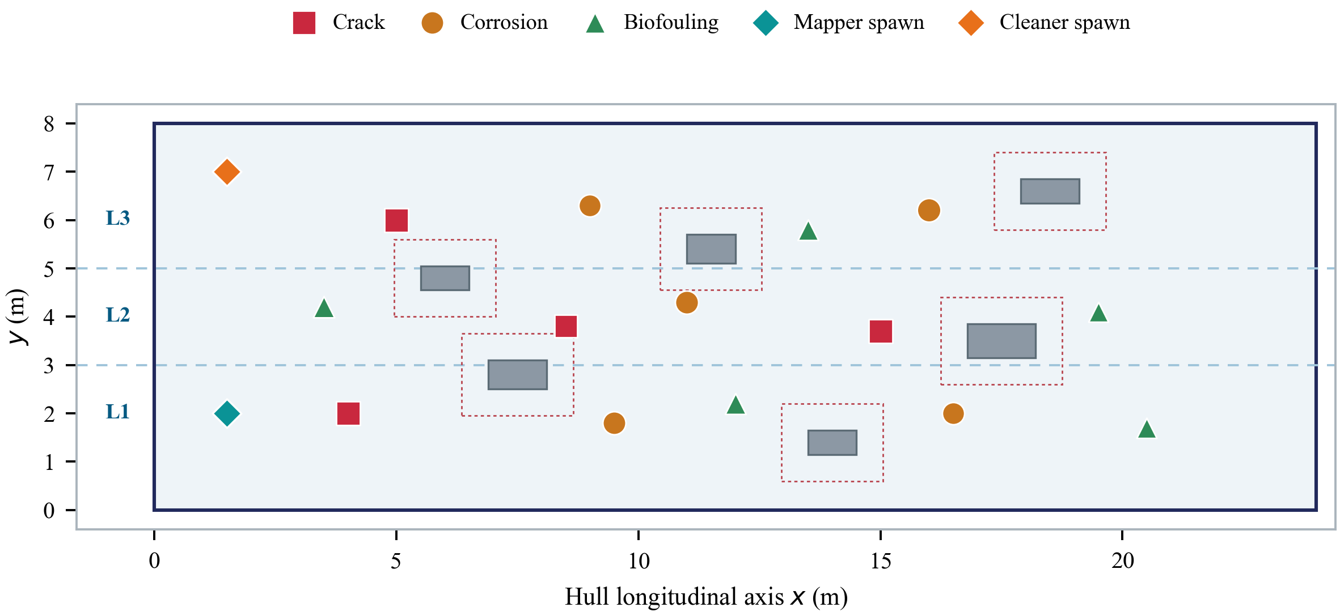
Fig. 3. Benchmark hull manifold. Marker shape encodes defect class and marker area encodes initial severity; dashed red outlines show the 0.55 m inflation applied to each static obstacle for A* planning. Lane centrelines L1–L3 are swept in serpentine order.
B. Baseline
The comparator is a naive first-in-first-out controller representing conventional practice. It dispatches defects strictly in discovery order, ignores severity, confidence and class, uses Euclidean rather than geodesic cost, and retires a task immediately upon arrival with no re-scan. It shares the identical physics, identical defect layout, identical obstacle set and identical motion controllers, so the comparison isolates the cognition layer alone.
C. Scenarios and Protocol
Six scenarios probe distinct stressors, each repeated over five fixed random seeds for both architectures, giving 60 independent missions. Scenarios are summarised in Table III.
TABLE III
Evaluation Scenarios
Scenario | Stressor introduced
nominal | Reference conditions; baseline sensor noise σ = 0.02.
swarm_scaling | Three concurrent cleaners sharing released lanes.
obstacles | Full six-obstacle field forcing extended A* detours.
high_sensor_noise | Elevated observation noise on severity and confidence.
agent_failure | Stochastic incomplete cleaning, exercising verification.
marine_current | Persistent cross-track hydrodynamic disturbance.

D. Metrics
Order correctness is the fraction of defect pairs serviced in an order consistent with ground-truth structural risk. For the realised order σ over n defects,
OC = (2 / [n(n−1)]) · ∑_{i<j} 𝟙[ sgn(σ_{i} − σ_{j}) = sgn(ℛ_{i} − ℛ_{j}) ], (11)
where ℛ_{i} = S_{i}W_{risk}(τ_{i}) is ground-truth structural risk. Risk correlation is the Spearman rank correlation r_{s} between servicing order and ℛ. Catch rate is the proportion of remediations that verification rejected and re-queued. Safety is the total count of geofence excursions, lane violations and inter-robot collisions. Time-to-clean is wall-clock mission duration until all defects are retired.
VI. Results and Discussion
A. Qualitative Mission Behaviour
Fig. 4 traces one complete mission. At the outset all fourteen defects are UNDETECTED and the cleaner holds station, because no lane has been released. Once the mapper completes Lane 1 the coordinator emits a release event and the cleaner engages, servicing the lane-1 crack first, then corrosion, then biofouling — precisely the structural risk order and not the distance order. Mid-mission a crack in Lane 2 propagates past the critical threshold; the executive banks the in-progress biofouling task on the context stack, diverts, remediates the crack, and resumes the suspended task from a freshly planned path. The mission ends with all fourteen defects verified clean.
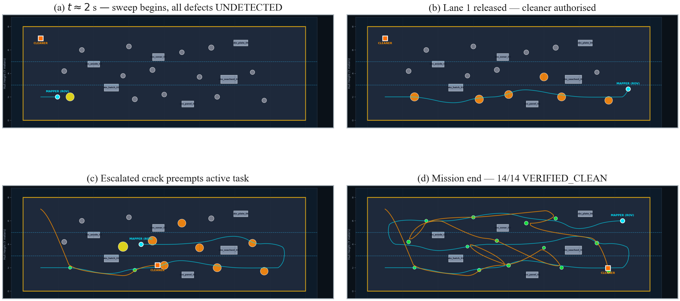
Fig. 4. Simulator output at four stages of a single mission. Marker colour encodes lifecycle state (grey UNDETECTED, orange QUEUED, red CLEANING, green VERIFIED_CLEAN); the cyan trace is the mapper serpentine and the orange trace the cleaner tour. Panel (c) captures the preemption instant, with the escalated crack enlarged in yellow immediately after detection.
B. Quantitative Comparison
Table IV reports per-scenario means over five seeds. HullSentinal improves ordering correctness in every scenario, and the improvement is largest precisely where it matters most: in the obstacle-dense configuration, where Euclidean proximity is most misleading, ordering correctness reaches 89.0% against 49.7% for the baseline.
TABLE IV
Per-Scenario Results (Mean ± SD over Five Seeds)
Scenario | System | Order corr. (%) | Risk corr. rₛ | Time (s) | Safety viol.
nominal | Ours | 85.3 ± 2.1 | +0.77 ± 0.03 | 108.0 ± 1.2 | 0
 | FIFO | 49.7 ± 1.5 | −0.07 ± 0.05 | 76.1 ± 0.2 | 0
swarm_scaling | Ours | 60.6 ± 1.5 | +0.23 ± 0.03 | 58.5 ± 0.6 | 0
 | FIFO | 53.9 ± 1.4 | +0.05 ± 0.04 | 54.4 ± 0.3 | 0
obstacles | Ours | 89.0 ± 1.5 | +0.83 ± 0.03 | 137.1 ± 1.4 | 0
 | FIFO | 49.7 ± 1.5 | −0.07 ± 0.05 | 96.4 ± 0.2 | 0
high_sensor_noise | Ours | 85.3 ± 2.1 | +0.77 ± 0.03 | 108.0 ± 1.2 | 0
 | FIFO | 49.7 ± 1.5 | −0.07 ± 0.05 | 76.1 ± 0.2 | 0
agent_failure | Ours | 87.6 ± 2.5 | +0.81 ± 0.05 | 116.8 ± 4.1 | 0
 | FIFO | 49.7 ± 1.5 | −0.07 ± 0.05 | 76.1 ± 0.2 | 0
marine_current | Ours | 85.3 ± 2.1 | +0.77 ± 0.03 | 111.5 ± 1.2 | 0
 | FIFO | 49.7 ± 1.5 | −0.07 ± 0.05 | 79.2 ± 0.2 | 0

Aggregated over all 60 missions (Table V), ordering correctness rises from 50.38% ± 2.10 to 82.17% ± 10.08, a gain of +31.79 percentage points. The effect is large and statistically decisive under a Welch two-sample test (t = 16.91, df ≈ 31.5), with Cohen’s d = 4.37. Rank correlation with ground-truth structural risk moves from essentially random (−0.05 ± 0.06) to strongly positive (+0.70 ± 0.21), d = 4.74. Both architectures retire all fourteen defects in every mission, so the ordering gain is not bought by sacrificing completeness.
TABLE V
Aggregate Results Over 60 Missions (n = 30 per Architecture)
Metric | HullSentinal | Naive FIFO | Cohen’s d
Order correctness (%) | 82.17 ± 10.08 | 50.38 ± 2.10 | 4.37
Risk correlation rₛ | +0.70 ± 0.21 | −0.05 ± 0.06 | 4.74
Time-to-clean (s) | 106.66 ± 24.19 | 76.35 ± 12.40 | —
Mission success (%) | 100.0 | 100.0 | —
Geofence excursions | 0 | 0 | —
Lane violations | 0 | 0 | —
Inter-robot collisions | 0 | 0 | —

C. Ordering Behaviour Across Scenarios
Figs. 5 and 6 show the per-scenario distributions. The baseline is pinned near 50% ordering correctness and near-zero rank correlation in every condition, which is the expected signature of an ordering uncorrelated with risk. HullSentinal holds 85–89% in five of six scenarios.
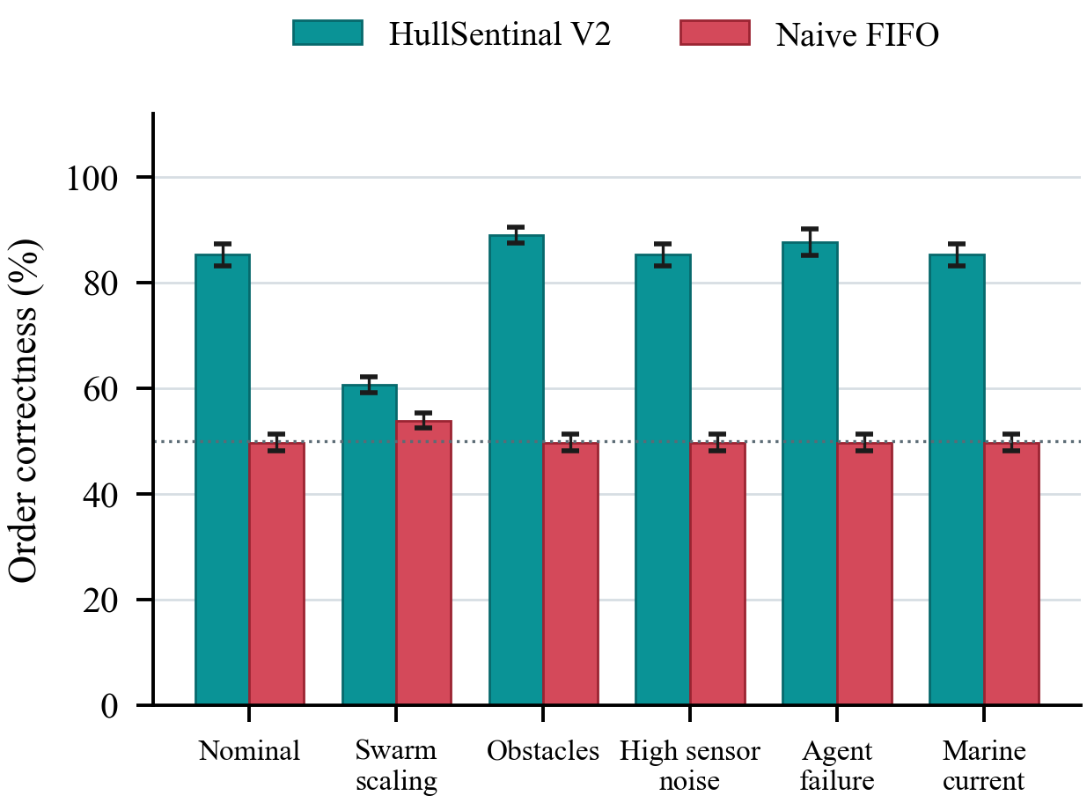
Fig. 5. Defect-ordering correctness by scenario. Bars are means over five seeds, error bars one standard deviation. The dotted line marks the 50% level expected of a risk-agnostic ordering.
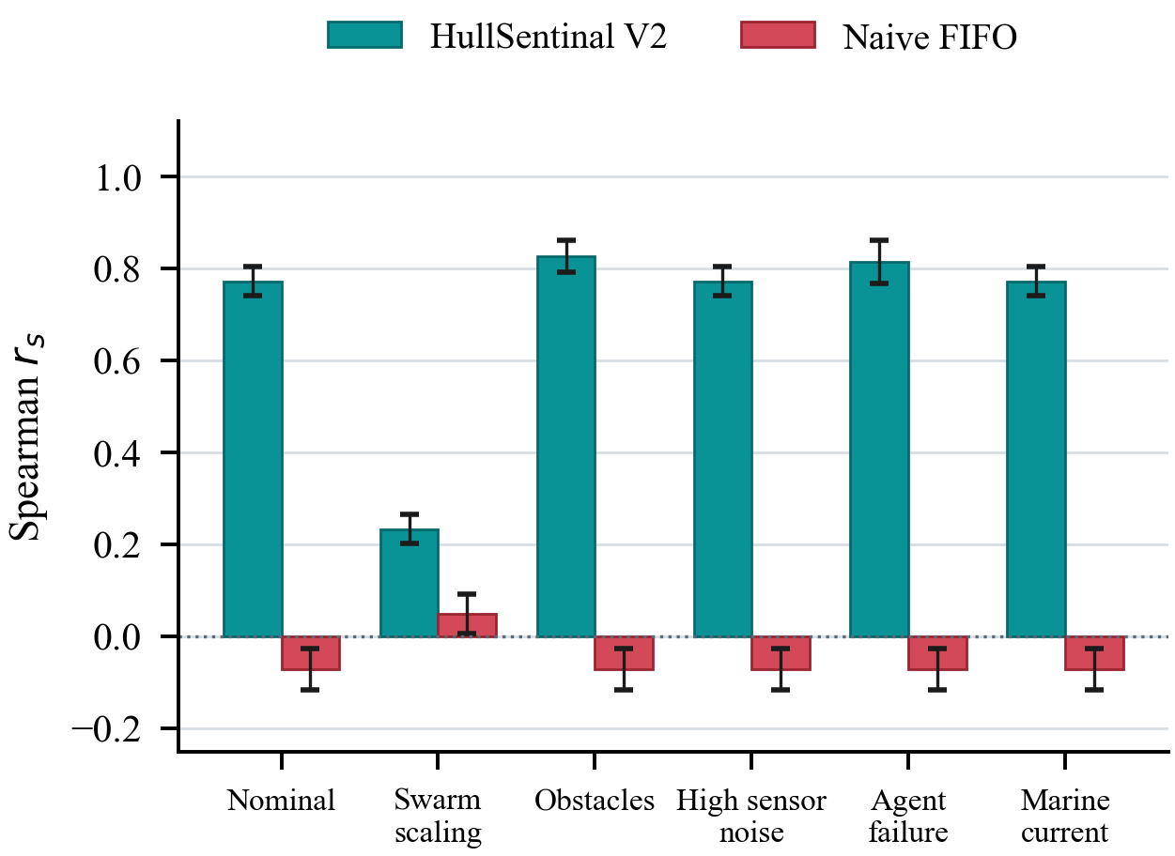
Fig. 6. Spearman rank correlation between servicing order and ground-truth structural risk. The baseline remains statistically indistinguishable from zero in all scenarios.
The exception is swarm_scaling (60.6%), and the mechanism is instructive. With three cleaners drawing concurrently from one ranked queue, several defects are serviced in parallel, so the realised completion sequence is governed partly by travel time rather than by rank. The ordering metric, which assumes a single sequential server, penalises this. The correct remedy is not a tuning change but an architectural one: the single shared queue should be replaced by a consensus-based bundle auction [7] in which each cleaner bids on bundles using its own marginal geodesic cost. We regard this as the principal limitation of the present allocation scheme.
D. Verification Efficacy
The agent_failure scenario injects stochastic incomplete cleaning. Closed-loop verification rejected and re-queued 36% of remediation attempts there, and no defect was retired while residual severity remained above θ_{v}. The open-loop baseline, by construction, cannot detect these failures at all: it reports the same 100% nominal success while leaving residual defects on the hull. This is the clearest demonstration that arrival is not completion, and it is invisible to any metric that trusts the actor’s own report.
E. The Cost of Prioritisation
Fig. 7 makes the trade explicit. HullSentinal occupies the high-correctness region at the cost of longer missions: 106.66 s against 76.35 s, a 39.7% increase. Three factors contribute. Lane gating deliberately idles the cleaner until a lane is released, trading throughput for separation. Risk-ordered servicing abandons distance optimality, so the tour is longer. Verification adds a re-scan round trip per defect. None of these is waste: each purchases a property the baseline does not possess. For a maintenance task in which deferring a propagating crack is the dominant risk, spending 30 s to service defects in structural order is a favourable exchange, and the coefficient α provides a direct control for operators who need to move the operating point.
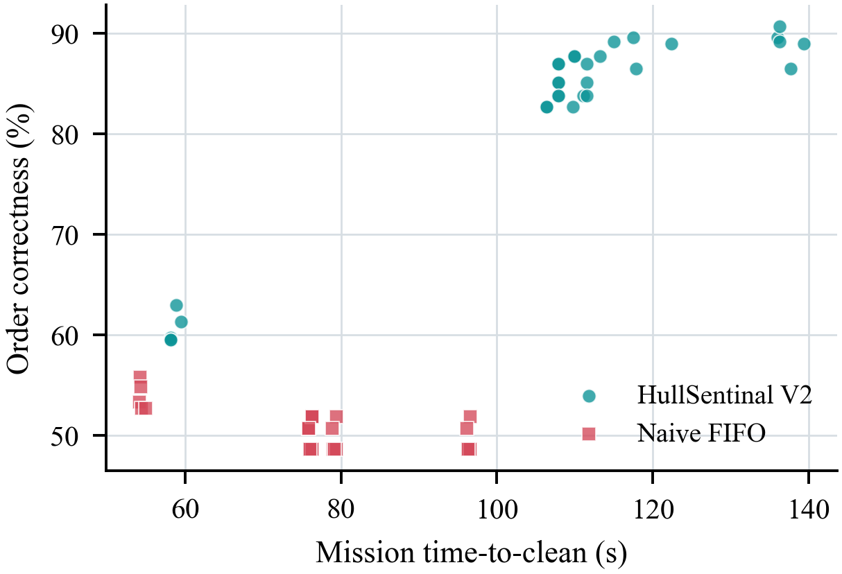
Fig. 7. Mission duration against ordering correctness for all 60 missions. The two architectures occupy disjoint regions: the proposed system trades a 39.7% increase in duration for a 31.8 percentage-point gain in ordering correctness.
F. Threats to Validity
Three limitations bound these claims. First, the evaluation is entirely in simulation; perception is modelled as a noisy oracle rather than a learned detector, so the reported robustness to sensor noise characterises the belief filter and not a real vision pipeline. Second, the workspace is a planar manifold, whereas real hulls are doubly curved; extending geodesic planning to triangulated surfaces is required before the path costs transfer. Third, the ordering metric assumes a single sequential server and therefore under-reports multi-cleaner performance, as Section VI-C discusses. We also note that the utility weights were chosen by design reasoning rather than fitted to data, and we present them as an interpretable default rather than an optimum.
VII. Conclusion
This paper identified an architectural gap in robotic hull maintenance: the layer that decides what to service next and whether the service succeeded is, in the surveyed literature, reduced to geometry and to trust in the actor’s own report. We presented HullSentinal, which replaces both with explicit mechanisms — a probabilistic defect belief carrying severity and confidence, an interpretable structural-utility ranking over true geodesic cost, and a mandatory physical re-scan before any defect may be retired — together with a priority context stack that makes emergency preemption deterministic and resumable.
Over 60 independent missions the system raised defect-ordering correctness from 50.38% to 82.17% and rank correlation with structural risk from −0.05 to +0.70, with a large effect size (d = 4.37) and with zero geofence excursions, zero lane violations and zero collisions. In the imperfect-cleaning scenario, verification rejected and re-queued 36% of remediations that an open-loop controller would have recorded as complete. The cost is a 39.7% longer mission, a trade we argue is favourable in a safety-critical maintenance setting and which remains under explicit operator control through the path-cost coefficient.
Three directions follow. Replacing the shared ranked queue with a consensus-based bundle auction should recover the ordering loss observed under multi-cleaner operation. Replacing the planar occupancy grid with geodesic planning over a triangulated hull mesh would extend the cost model to doubly curved plating and to surface-normal adhesion. Substituting the oracle detector with a learned segmentation model would let the belief filter be evaluated against genuine perceptual uncertainty rather than synthetic Gaussian noise; the cognition layer is deliberately detector-agnostic and requires no redesign to accept one.
References
[1] H. Su, S. Liu, L. Zhang, Y. Chen, and C. Yang, “Biofouling recognition and boundary tracking control for underwater cleaning robots,” Ocean Engineering, vol. 295, art. no. 116707, 2024.
[2] “Automated detection and classification of cracks in ship hull structures using deep learning,” Ocean Engineering, 2026.
[3] “Detection of cracks and corrosion for automated vessel visual inspection,” LIACI dataset, EU FP7 MINOAS project.
[4] “Design, perception, planning and control for underwater cleaning robotics: progress, challenges and trends,” Ocean Engineering, review article, 2025.
[5] M. Chwełatiuk et al., “Algorithm for determining the position of a ship hull-cleaning robot,” Applied Sciences, vol. 15, no. 10, art. no. 5705, 2025, doi: 10.3390/app15105705.
[6] B. P. Gerkey and M. J. Matarić, “A formal analysis and taxonomy of task allocation in multi-robot systems,” The International Journal of Robotics Research, vol. 23, no. 9, pp. 939–954, 2004.
[7] H.-L. Choi, L. Brunet, and J. P. How, “Consensus-based decentralized auctions for robust task allocation,” IEEE Transactions on Robotics, vol. 25, no. 4, pp. 912–926, 2009.
[8] M. Ruediger and A. G. Banerjee, “Mapping-guided task discovery and allocation for cooperative robotic inspection of underwater structures (Map-TIDAL),” arXiv:2602.02389, 2026.
[9] “A centralized multi-robot task allocation for industrial plant inspection by using A* and genetic algorithms,” Proc. Int. Conf. on Advanced Intelligent Systems and Informatics.
[10] E. Galceran and M. Carreras, “A survey on coverage path planning for robotics,” Robotics and Autonomous Systems, vol. 61, no. 12, pp. 1258–1276, 2013.
[11] “A hierarchical LLM-based framework for heterogeneous multi-robot orchestration in high-risk energy facility maintenance,” 2026.
[12] P. E. Hart, N. J. Nilsson, and B. Raphael, “A formal basis for the heuristic determination of minimum cost paths,” IEEE Transactions on Systems Science and Cybernetics, vol. 4, no. 2, pp. 100–107, 1968.
[13] S. Macenski, T. Foote, B. Gerkey, C. Lalancette, and W. Woodall, “Robot Operating System 2: design, architecture, and uses in the wild,” Science Robotics, vol. 7, no. 66, 2022.
[14] N. Koenig and A. Howard, “Design and use paradigms for Gazebo, an open-source multi-robot simulator,” in Proc. IEEE/RSJ Int. Conf. on Intelligent Robots and Systems (IROS), 2004, pp. 2149–2154.

