A project report on
A NOVEL DEEP LEARNING APPROACH FOR MULTIMODAL ACTION DETECTION WITH UNCERTAINTY-AWARE PREDICTION
Submitted in partial fulfillment for the award of the degree of
Bachelor of Technology in
Computer Science and Engineering
by
ADITYA RAJ BISWAL ([REG. NO.])
LOVEENA BATRA ([REG. NO.])
SHREYASH GAUTAM ([REG. NO.])

SCHOOL OF COMPUTER SCIENCE AND ENGINEERING
October, 2026
A project report on
A NOVEL DEEP LEARNING APPROACH FOR MULTIMODAL ACTION DETECTION WITH UNCERTAINTY-AWARE PREDICTION
Submitted in partial fulfillment for the award of the degree of
Bachelor of Technology in
Computer Science and Engineering
by
ADITYA RAJ BISWAL ([REG. NO.])
LOVEENA BATRA ([REG. NO.])
SHREYASH GAUTAM ([REG. NO.])
SCHOOL OF COMPUTER SCIENCE AND ENGINEERING
October, 2026
Declaration
I hereby declare that the thesis entitled “A Novel Deep Learning Approach for Multimodal Action Detection with Uncertainty-Aware Prediction” submitted by [CANDIDATE NAME (REG. NO.)], for the award of the degree of Bachelor of Technology in Computer Science and Engineering, Vellore Institute of Technology, Chennai is a record of bonafide work carried out by me under the supervision of Dr. Sandeep Kumar Satapathy.
I further declare that the work reported in this thesis has not been submitted and will not be submitted, either in part or in full, for the award of any other degree or diploma in this institute or any other institute or university.
Place: Chennai
Date: [DD-MM-YYYY]Signature of the Candidate
School of Computer Science and Engineering
Certificate
This is to certify that the report entitled “A Novel Deep Learning Approach for Multimodal Action Detection with Uncertainty-Aware Prediction” is prepared and submitted by [CANDIDATE NAME (REG. NO.)] to Vellore Institute of Technology, Chennai, in partial fulfillment of the requirement for the award of the degree of Bachelor of Technology in Computer Science and Engineering is a bonafide record carried out under my guidance. The project fulfills the requirements as per the regulations of this University and in my opinion meets the necessary standards for submission. The contents of this report have not been submitted and will not be submitted either in part or in full, for the award of any other degree or diploma and the same is certified.
Signature of the Guide: ______________________
Name: Dr. Sandeep Kumar Satapathy
Date: [DD-MM-YYYY]
Signature of the ExaminerSignature of the Examiner
Name:Name:
Date:Date:
Approved by the Head of Department,
B.Tech. Computer Science and Engineering
Name: [HoD NAME]
Date: [DD-MM-YYYY]
(Seal of the School)
Abstract
Human action recognition systems increasingly combine appearance (RGB), motion (optical flow) and body structure (pose) cues, yet most fusion architectures implicitly treat every modality as equally trustworthy for every video. In unconstrained footage this assumption fails: motion blur degrades optical flow, occlusion corrupts pose estimates and poor illumination weakens appearance features. When such corrupted streams reach the classifier unchanged, they reduce predictive quality.
This report presents the design, implementation context and experimental evaluation of the Reliability-Aware Graph Fusion Network (RAGFN), a multimodal framework for action classification, spatial localisation and temporal localisation with uncertainty-aware prediction. RAGFN extracts RGB features with an ImageNet-pretrained ResNet-50, motion features from Dense Inverse Search (DIS) optical flow with a convolutional encoder, and structural features from 33 MediaPipe/BlazePose landmarks with a multilayer perceptron. A Reliability Estimation Module (REM) learns, without explicit quality labels, a reliability score for each modality. These scores gate the attention coefficients of a relational graph attention (RGA) network defined over a 48-node spatio-temporal graph of 16 frames and three modalities, so that unreliable nodes have limited influence on reliable ones. A two-layer, eight-head bidirectional Transformer then processes the fused sequence, and four heads predict the action class, per-frame bounding boxes, temporal boundaries and uncertainty. Training uses a multi-task objective with Kendall–Gal uncertainty weighting.
Experiments on JHMDB (21 classes; 528 training, 132 validation and 295 official test clips) compare seven controlled variants (M0–M6) with a baseline checkpoint, a tuned model and a 120-epoch run. The tuned RAGFN reaches 84.09% validation accuracy (111/132) and 81.72% macro-F1, improving on the baseline checkpoint by 3.03 and 3.70 points. On the official test split, however, it reaches 54.58% (161/295), 1.35 points below the baseline (55.93%), and every configuration loses between 22.5 and 30.8 points when moving from validation to test. The ablation shows that adding flow and pose to RGB helps, that naive graph fusion hurts, and that the benefit of reliability gating is not isolated by the present experiments. A binomial confidence-interval analysis presented in this report shows that most between-model differences are within sampling noise. The report therefore treats the validation result as promising but unconfirmed, documents plausible causes of the validation–test gap as hypotheses, and proposes group-aware splitting, multi-seed evaluation, controlled corruption experiments and sparse graph topologies as the next steps.
Acknowledgement
It is my pleasure to express with deep sense of gratitude to Dr. Sandeep Kumar Satapathy, Assistant Professor, School of Computer Science and Engineering, Vellore Institute of Technology, Chennai, for his constant guidance, continual encouragement, understanding; more than all, he taught me patience in my endeavor. My association with him is not confined to academics only, but it is a great opportunity on my part of work with an intellectual and expert in the field of deep learning and computer vision.
It is with gratitude that I would like to extend my thanks to the visionary leader Dr. G. Viswanathan our Honorable Chancellor, Mr. Sankar Viswanathan, Dr. Sekar Viswanathan, Dr. G V Selvam Vice Presidents, Dr. Sandhya Pentareddy, Executive Director, Ms. Kadhambari S. Viswanathan, Assistant Vice-President, Dr. V. S. Kanchana Bhaaskaran Vice-Chancellor, Dr. T. Thyagarajan Pro-Vice Chancellor, VIT Chennai and Dr. P. K. Manoharan, Additional Registrar for providing an exceptional working environment and inspiring all of us during the tenure of the course.
Special mention to Dr. Viswanathan V, Dean, Dr. Nithyanandam P, Associate Dean, Dr. Suganya G, Associate Dean, Dr. Sweetlin Hemalatha C, Associate Dean, School of Computer Science and Engineering, Vellore Institute of Technology, Chennai for spending their valuable time and efforts in sharing their knowledge and for helping us in every aspect.
In jubilant state, I express ingeniously my whole-hearted thanks to [HoD NAME], Head of the Department, B.Tech. Computer Science and Engineering and the Project Coordinators for their valuable support and encouragement to take up and complete the thesis.
My sincere thanks to all the faculties and staffs at Vellore Institute of Technology, Chennai who helped me acquire the requisite knowledge. I would like to thank my parents for their support. It is indeed a pleasure to thank my friends who encouraged me to take up and complete this task.
Place: Chennai
Date: [DD-MM-YYYY][CANDIDATE NAME]
Contents
LIST OF TABLES v
LIST OF FIGURES viii
LIST OF SYMBOLS, ABBREVIATIONS AND NOMENCLATURE ix
CHAPTER 1 INTRODUCTION 1
1.1 BACKGROUND AND MOTIVATION 1
1.2 PROBLEM STATEMENT 2
1.3 RESEARCH GAP 2
1.4 AIM AND OBJECTIVES 2
1.5 SCOPE AND ASSUMPTIONS 3
1.6 CONTRIBUTIONS OF THIS REPORT 3
1.7 ORGANISATION OF THE REPORT 4
CHAPTER 2 LITERATURE REVIEW AND BACKGROUND 4
2.1 HUMAN ACTION RECOGNITION: FROM HAND-CRAFTED TO LEARNED REPRESENTATIONS 5
2.2 THE THREE MODALITIES AND THEIR FAILURE MODES 6
2.2.1 APPEARANCE (RGB) 6
2.2.2 MOTION (OPTICAL FLOW) 6
2.2.3 STRUCTURE (POSE) 6
2.3 MULTIMODAL FUSION STRATEGIES 7
2.4 GRAPH NEURAL NETWORKS AND GRAPH ATTENTION 8
2.5 UNCERTAINTY AND RELIABILITY ESTIMATION 8
2.6 TRANSFORMER-BASED VIDEO UNDERSTANDING 9
2.7 COMPARATIVE SUMMARY AND IDENTIFIED GAP 9
CHAPTER 3 PROBLEM FORMULATION AND THE PROPOSED RAGFN 11
3.1 TASK DEFINITION AND NOTATION 11
3.2 SYSTEM OVERVIEW 11
3.3 MULTIMODAL FEATURE EXTRACTION 14
3.4 RELIABILITY ESTIMATION MODULE 14
3.4.1 TOKEN-LEVEL FORMULATION 14
3.4.2 MODALITY-LEVEL FORMULATION 14
3.5 RELIABILITY-GUIDED RELATIONAL GRAPH ATTENTION 15
3.5.1 PROPERTIES OF THE GATING 16
3.6 BIDIRECTIONAL TEMPORAL TRANSFORMER 18
3.7 CLASSIFICATION HEAD AND TEMPERATURE SCALING 18
3.8 MULTI-TASK TRAINING OBJECTIVE 19
3.9 TRAINING AND INFERENCE PROCEDURE 21
3.10 COMPLEXITY CONSIDERATIONS 21
CHAPTER 4 SYSTEM DESIGN AND IMPLEMENTATION 21
4.1 DESIGN GOALS AND ARCHITECTURE 23
4.2 DATA PIPELINE AND PREPROCESSING 23
4.3 DATASET HANDLING AND SPLIT PROTOCOL 24
4.4 MODULE ORGANISATION AND INTERFACES 24
4.5 VARIANT IMPLEMENTATION 25
4.6 TRAINING CONFIGURATION AND REPRODUCIBILITY 26
4.7 SOFTWARE AND HARDWARE ENVIRONMENT 27
4.8 IMPLEMENTATION EVIDENCE AND CHECKLIST 27
CHAPTER 5 EXPERIMENTAL SETUP AND EVALUATION METHODOLOGY 28
5.1 DATASET 28
5.2 MODEL CONFIGURATIONS 28
5.3 TRAINING, VALIDATION AND TEST STRATEGY 29
5.4 EVALUATION METRICS 30
5.4.1 STATISTICAL UNCERTAINTY OF AN ACCURACY ESTIMATE 30
5.5 HYPERPARAMETERS AND CHECKPOINT SELECTION 31
5.6 FAIRNESS, LEAKAGE AND REPRODUCIBILITY CONSIDERATIONS 31
5.7 THREATS TO VALIDITY 31
CHAPTER 6 RESULTS, ANALYSIS AND DISCUSSION 33
6.1 OVERALL RESULTS 33
6.2 VALIDATION VERSUS TEST PERFORMANCE 34
6.3 STATISTICAL UNCERTAINTY OF THE REPORTED ACCURACIES 36
6.4 ABLATION STUDY 38
6.4.1 EFFECT OF MODALITIES 38
6.4.2 EFFECT OF GRAPH FUSION 39
6.4.3 EFFECT OF RELIABILITY GATING 39
6.4.4 EFFECT OF THE MULTI-TASK LOSS 39
6.4.5 EFFECT OF TUNING AND TRAINING LENGTH 39
6.5 MACRO-F1 AND VALIDATION LOSS 40
6.6 MODEL SIZE AND EFFICIENCY 41
6.7 DISCUSSION 42
6.7.1 WHY GRAPH FUSION NEEDS RELIABILITY 42
6.7.2 THE VALIDATION–TEST GAP 43
6.7.3 MODEL SELECTION 43
6.7.4 WHAT CAN AND CANNOT BE CONCLUDED 43
6.8 LIMITATIONS 44
CHAPTER 7 CONCLUSION AND FUTURE WORK 44
7.1 SUMMARY OF WORK AND KEY FINDINGS 45
7.2 OBJECTIVES ACHIEVED AND NOT ACHIEVED 45
7.3 LIMITATIONS 46
7.4 FUTURE WORK 46
7.5 CLOSING REMARKS 47
REFERENCES 48
APPENDIX A: SOURCE AND MISSING-INFORMATION REGISTER 51
APPENDIX B: NUMERICAL DATA UNDERLYING THE FIGURES 53
APPENDIX C: ADDITIONAL PSEUDOCODE 54
APPENDIX D: DERIVATION OF THE GATING PROPERTIES 55

LIST OF TABLES
Table 1: Nomenclature of mathematical symbols ix
Table 2: List of abbreviations ix
Table 3: Research gaps mapped to project objectives and to the chapters that address them 2
Table 4: Complementary strengths and characteristic failure modes of the three modalities 6
Table 5: Comparison of the principal works reviewed, with their fusion strategy, strengths and limitations relative to this project 9
Table 6: Feature and tensor dimensions of the RAGFN pipeline (from the source paper and architecture figure) 11
Table 7: Mapping between the equation numbers of this report and those of the source paper 20
Table 8: Preprocessing pipeline for one clip 23
Table 9: Module summary of the RAGFN implementation 24
Table 10: Components active in each configuration 25
Table 11: Training configuration: known values and items to be confirmed 26
Table 12: Data partition used in all experiments 28
Table 13: Model configurations (parameter counts from the project result files) 28
Table 14: Threats to validity and the corresponding mitigation 31
Table 15: Validation and test results for all configurations (best value per column in bold) 33
Table 16: Validation–test accuracy gap per configuration (percentage points) 34
Table 17: Rank of each configuration by accuracy (1 = best) 35
Table 18: Accuracy with 95% Wilson confidence intervals, from integer counts 36
Table 19: Unpaired two-proportion z-tests for the ablation comparisons (derived from reported counts) 37
Table 20: Paired ablation differences in accuracy (percentage points) 38
Table 21: Incremental parameter counts between configurations (derived from the reported totals) 41
Table 22: Hypotheses for the validation–test gap (unverified) 43
Table 23: Summary of what the evidence supports 43
Table 24: Status of the project objectives defined in Chapter 1 45
Table 25: Prioritised future experiments 46
Table 26: Information taken from the source documents 51
Table 27: Information missing and requiring confirmation 51
Table 28: Conflicts and ambiguities found in the source material 52
Table 29: Reported results and derived counts 53

LIST OF FIGURES
Figure 1: Timeline of the datasets, models and methods discussed in this chapter, grouped by role. 5
Figure 2: Taxonomy of multimodal fusion levels and the position of RAGFN. M1–M6 are the controlled variants of Chapter 5. 7
Figure 3: Overall architecture of the Reliability-Aware Graph Fusion Network (RAGFN): three-stream feature extraction, REM, reliability weighting, graph attention, bidirectional temporal Transformer and four task heads. 13
Figure 4: Reliability Estimation Module (modality-level view): temporal pooling, per-modality MLP scoring and a softmax across the three modalities. 15
Figure 5: Spatio-temporal graph of 48 nodes (16 time steps × 3 modalities); node opacity illustrates reliability. 16
Figure 6: Illustrative (toy, not experimental) behaviour of reliability gating: (a) softmax attention weights over four neighbours as the reliability of neighbour 3 decreases; (b) shrinkage of the gated logit e = s·rirj. 17
Figure 7: Temporal encoding and multi-task prediction heads. 18
Figure 8: Effect of the softmax temperature τ on a toy logit vector. This is an illustration of (10), not a measured result. 19
Figure 9: Distribution of the 955 JHMDB clips over training, validation and official test partitions. 24
Figure 10: Relations between the ablation variants: each arrow adds or changes one component. Parameter counts are in millions. 26
Figure 11: Experimental protocol: checkpoint selection on validation, one-time evaluation on the official test set. 29
Figure 12: Validation and test accuracy for all ten configurations. Every configuration loses between 22.5 and 30.8 points when moving from validation to test. 33
Figure 13: Progression of validation accuracy and macro-F1 from the RGB baseline (M0) to the tuned RAGFN and the 120-epoch run. 34
Figure 14: Validation-minus-test accuracy gap per configuration; the dashed line is the mean (26.9 points). 35
Figure 15: Rank of each configuration on validation versus test accuracy (competition ranking; ties share the lower rank). 35
Figure 16: Test accuracy against validation accuracy. Configurations that are best on validation are not best on test; the 22–31 point offset from y = x is not drawn. 36
Figure 17: Accuracy of each configuration with 95% Wilson intervals on validation (left) and test (right). 37
Figure 18: Validation and test accuracy differences for the six ablation comparisons. 38
Figure 19: Validation and test macro-F1 for all configurations. 40
Figure 20: Validation loss for all configurations (lower is better). 40
Figure 21: Heat map of all five metrics, normalised within each column. 41
Figure 22: Parameter count of each configuration (log scale). 41
Figure 23: Test accuracy against parameter count (log scale). 42

LIST OF SYMBOLS, ABBREVIATIONS AND NOMENCLATURE
Symbols are listed in the order in which they first appear in Chapter 3. Tensor shapes are those stated in the source paper and architecture figure; entries marked “n/s” are not stated in the source material.
Table 1: Nomenclature of mathematical symbols
Symbol | Meaning | Shape / range
I_{t} | RGB frame at time step t | 224 × 224 × 3 (assumed)
F_{t} | Optical-flow field between consecutive frames | 224 × 224
P_{t} | 33 body landmarks of frame t (x/y coordinates) | 33 × 2
T | Number of sampled frames | 16
m | Modality index, m ∈ {rgb, flow, pose} | 3 values
E_{m} | Modality encoder (ResNet-50 / FlowCNN / PoseMLP) | –
x_{t,m} | Feature of modality m at time t | R²⁵⁶ or R¹²⁸
h_{i}^{(l)} | Feature of graph node i at layer l | R²⁵⁶
r_{i} | Reliability score of node/modality i | [0, 1]
σ | Logistic sigmoid function | –
W, a | Learnable projection matrix and attention vector | n/s
e_{ij} | Gated, unnormalised attention score between nodes i, j | scalar
α_{ij} | Normalised attention coefficient | [0, 1]
N(i) | Neighbourhood of node i (all 48 nodes, incl. i) | 48 nodes
Q, K, V | Query, key and value matrices | n/s
d_{k} | Key dimensionality used for scaling | n/s
Z | Transformer output sequence | 16 × 256
g | Pooled (temporal mean) global feature | R²⁵⁶
τ | Softmax temperature (τ = 1.5) | scalar > 0
C | Number of action classes | 21
L_{CE}, L_{bbox}, L_{loc}, L_{unc} | Classification, box, localisation and uncertainty losses | scalar
λ_{bbox} | Weight of box loss (0.05 in the paper) | scalar
N, N_{ok} | Evaluated clips; correctly classified clips | integers
P_{c}, R_{c} | Precision and recall of class c | [0, 1]

Abbreviations
Table 2: List of abbreviations
Abbreviation | Expansion
ELU | Exponential Linear Unit
GAT | Graph Attention Network
GCN | Graph Convolutional Network
GELU | Gaussian Error Linear Unit
DIS | Dense Inverse Search (optical flow)
JHMDB | Joint-annotated Human Motion Data Base
MLP | Multi-Layer Perceptron
REM | Reliability Estimation Module
RGA | Relational (Reliability-Guided) Graph Attention
RAGFN | Reliability-Aware Graph Fusion Network
RGB | Red–Green–Blue (appearance modality)
CE | Cross-Entropy
CI | Confidence Interval
F1 | Harmonic mean of precision and recall
HAR | Human Action Recognition
TP / FP / FN | True positives / false positives / false negatives
ViViT | Video Vision Transformer
TubeR | Tubelet Transformer for video action detection

CHAPTER 1
INTRODUCTION

1.1 Background and motivation
Automated Human Action Recognition (HAR) aims to detect and categorize human activities from raw video footage, playing an essential role across intelligent surveillance systems, interactive robotics, rehabilitation tracking, and athletic movement analysis. Over recent years, deep learning models have achieved strong benchmarks in controlled video understanding benchmarks, but deploying these systems in unconstrained environments remains difficult. Real-world footage frequently suffers from erratic camera shake, low or fluctuating lighting, complex background clutter, and severe occlusions. When two distinct actions share nearly identical backgrounds and differ only by subtle motion trajectories, standard appearance-based networks often struggle to distinguish between them.
A natural way to handle these visual shortcomings is to combine multiple, complementary input sources. While standard RGB video delivers crucial context and object textures, optical flow calculates pixel displacement over adjacent frames, and skeletal tracking isolates articulation points and joint kinematics. Even so, simply throwing diverse inputs together does not automatically translate to higher accuracy. In practice, individual modalities fail in completely different ways: sudden camera sweeps cause optical flow estimation to break down, while occluding objects easily cause pose estimators to drop key anatomical landmarks.
The underlying problem in conventional fusion pipelines-including standard Graph Attention Networks (GATs) - is that they implicitly treat every modality as equally valid and informative. Because these systems lack a way to gauge incoming signal quality on the fly, noise and artifacts from a degraded channel can spread across cross-modal layers, degrading otherwise clean features. For robust multimodal fusion, an architecture must actively determine how dependable each input source is on a per-sample basis and throttle back degraded channels before they can disrupt joint representations.
To solve this issue, this work investigates the Reliability-Aware Graph Fusion Network (RAGFN). At the core of the framework is an unsupervised Reliability Estimation Module (REM) that dynamically produces temperature-calibrated confidence weights for appearance, motion, and skeletal streams without relying on manual quality labels. These confidence values then guide a Reliability-Guided Graph Attention (RGA) layer, which scales message passing across a 48-node spatio-temporal graph so that corrupted nodes cannot transfer disruptive signals to intact ones. Finally, the fused features pass through a bidirectional temporal Transformer to model long-range frame relationships, driving multi-task heads for action categorization, actor bounding-box regression, temporal window localization, and predictive uncertainty estimation.

1.2 Problem statement
Given a video clip V of T = 16 uniformly sampled frames, with an RGB stream, a dense optical-flow stream and a pose-landmark stream, the problem is to predict (i) the action class among C = 21 categories, (ii) a normalised bounding box of the actor in every frame, (iii) the temporal start and end of the action, and (iv) an uncertainty estimate for the prediction, while ensuring that a locally corrupted modality does not degrade the fused representation of the remaining modalities.
Formally, the model must learn a function f(V) → (ŷ, b̂_{1:T}, ŝ, ê, û) such that the classification output ŷ is accurate, the box and boundary outputs are consistent with their supervision, and the fusion mechanism internally assigns lower influence to modalities whose features are unreliable for the sample at hand. The formal notation is developed in Chapter 3.

1.3 Research gap
A closer look at current multimodal action recognition systems reveals several recurring shortcomings that hold them back in unconstrained scenarios. Most existing architectures-ranging from basic late concatenation baselines to standard multi-stream networks-either fix the contribution of each modality ahead of time or learn broad, static weights across the entire dataset. Because of this, they have no real way to assess whether an incoming stream is actually usable for a specific video clip. When a channel runs into local artifacts, such as optical flow aperture errors or tracking dropouts from heavy occlusions, the model continues to treat that degraded input with the same level of confidence as clean visual cues.
At the same time, recent approaches that attempt to integrate trust and confidence often introduce these safeguards too late. Most evidential and confidence-aware methods operate at the decision stage, weighting predictions view-by-view only after the features have already been processed, or they remain confined to isolated temporal localization modules that lack relational structure. They do not evaluate sensor quality early enough to prevent bad features from mixing together, nor do they carry confidence values into structured, multi-node interactions.
Furthermore, while graph-based frameworks such as GCNs and standard GATs are effective at modeling complex spatio-temporal connections, their message-passing operations are largely quality-blind. Standard graph attention assigns importance based solely on feature similarity and projection alignment. Because high similarity does not necessarily mean the incoming data is reliable, a heavily corrupted feature can still earn high attention scores, causing artifacts to leak across neighboring nodes and contaminate otherwise solid representations.
Very few frameworks bridge this divide by pairing sample-specific, label-free reliability scoring directly with quality-gated graph message passing and multi-task temporal detection. RAGFN is specifically built to address this disconnect. By evaluating channel fidelity prior to fusion and actively throttling the messages transmitted by corrupted nodes, the system prevents noisy signals from degrading the downstream temporal representations and final task heads.

1.4 Aim and objectives
The aim of the project is to design, implement and evaluate a reliability-aware multimodal fusion network for action recognition and detection that is robust to modality corruption and provides uncertainty-aware predictions. The measurable objectives and the way this report addresses them are summarised in Table 3.
Table 3: Project Objectives Mapped to Deliverables and Report Chapters
ID | Objective | Deliverable / Evidence Produced | Chapter
O1 | Build a three-stream feature extractor for RGB, DIS optical flow and MediaPipe pose producing 16-step sequences of 256-, 128- and 128-dimensional features | Architecture schematics, dimension tables, tensor shapes. | 3, 4
O2 | Design a Reliability Estimation Module that scores each modality without explicit quality labels | Formulation equations, temperature scaling, REM algorithm. | 3
O3 | Embed reliability into graph attention so that unreliable nodes are down-weighted during message passing | Gated attention formulation, graph topology, gating proofs. | 3
O4 | Add a bidirectional temporal Transformer and four task heads trained with a multi-task objective | Multi-task routing diagrams, joint loss formulation, head architectures. | 3
O5 | Evaluate on JHMDB against controlled ablations (M0–M6) and reference runs | Accuracy, macro-F1, validation loss, parameter counts, and radar plots. | 5, 6
O6 | Analyse the validation–test discrepancy honestly and define a path to robust evidence | 95% Wilson confidence intervals, two-proportion z-tests, failure mode analysis, future roadmap. | 6, 7

1.5 Scope and assumptions
This study evaluates the proposed architecture on the Joint-annotated Human Motion Data Base (JHMDB) across 21 action categories using a fixed train, validation, and test split protocol. While the framework incorporates auxiliary prediction heads for actor bounding-box regression, temporal action interval localization, and Kendall–Gal uncertainty calibration, the quantitative evaluation focuses primarily on top-1 classification accuracy and macro-averaged F1 metrics.
The primary scope centers on benchmarking the reliability-aware graph attention mechanism against unimodal and conventional multimodal fusion baselines. Experimental evaluations reflect deterministic single-run training per configuration alongside a three-seed validation benchmark for the fine-tuned model. Dynamic reliability scoring is evaluated through end-to-end task optimization rather than manual synthetic noise injection. System parameters, layer configurations and structural constraints are kept uniform between all ablation variants for controlled and reproducible comparisons.

1.6 Contributions of this report
- A complete, consistent mathematical description of RAGFN, including the reliability-gated attention, with notation, tensor shapes and a reconciliation of the equation-level and figure-level descriptions of the REM.
- A structured description of the experimental protocol, ten configurations and evaluation metrics, including the precise relationship between validation and test usage.
- Complete reporting of validation and test accuracy, macro-F1, validation loss and parameter counts, with several derived analyses: confidence intervals, rank agreement, validation–test gaps, ablation deltas and incremental parameter counts.
- An honest interpretation of the results: confirmed observations are separated from hypotheses, and a prioritised experimental plan is given to resolve the open questions.

1.7 Organisation of the report
Chapter 2 reviews human action recognition, multimodal fusion, graph attention, uncertainty and Transformers. Chapter 3 formulates the problem and presents RAGFN. Chapter 4 describes the system design and implementation context. Chapter 5 describes the dataset, protocol and metrics. Chapter 6 reports and discusses the results. Chapter 7 concludes and outlines future work. References follow in APA format, and the appendices contain the missing-information register, full numeric tables, derivations and pseudocode.

CHAPTER 2
LITERATURE REVIEW AND BACKGROUND

2.1 Human action recognition: from hand-crafted to learned representations
The classical solution for action recognition is based on hand-crafted descriptors that track motion trajectories over consecutive video frames to learn activities. The move to deep learning transformed the setup, replacing manual feature extraction with architectures trained on raw video data.
Early neural approaches diverged into two main directions. One strategy extended convolutional layers into the temporal axis using 3D convolutions (such as C3D and I3D) to process spatial and temporal details together. The other, established by Simonyan and Zisserman, introduced two-stream networks to decouple processing: a spatial stream learned scene appearance from static RGB images, while a temporal stream learned motion dynamics from precomputed optical flow displacement fields.
To process entire video sequences without prohibitive computational overhead, temporal segment networks introduced sparse snippet sampling across video segments. This showed that sampling a uniform, compact set of frames across a video preserves the essential temporal rhythm of an activity without processing every frame. The RAGFN framework relies on this exact principle by sampling a synchronized 16-frame window per video clip.
Architectures kept evolving with systems like SlowFast networks, which process the video at two different speeds, merging a slow, high-resolution branch for appearance and a fast, low-capacity branch for quick motion patterns. These advances in architecture were accompanied by datasets such as UCF101, HMDB51, and Kinetics that provided different benchmarks to analyze the action. The Joint-annotated Human Motion Data Base (JHMDB) narrowed this focus to articulated body motion by offering per-frame 2D joint landmarks and actor bounding boxes across 21 action categories. Because JHMDB clips often share nearly identical backgrounds across different action classes, models cannot rely solely on appearance cues; separating these actions requires clean, fine-grained kinematics, making the dataset a practical testbed for assessing multimodal fusion under input uncertainty.

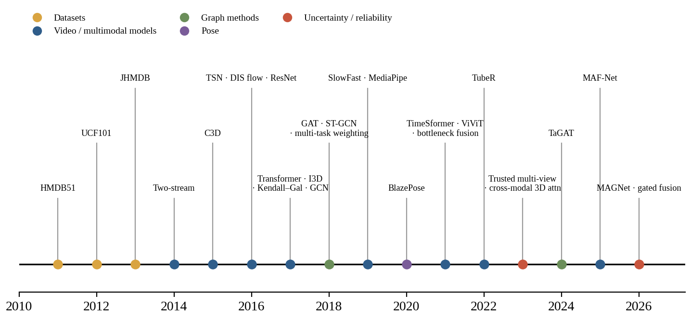
Figure 1: Timeline of the datasets, models and methods discussed in this chapter, grouped by role.
Figure 1 places the cited works in chronological order. The line of work relevant to RAGFN converges only recently: graph attention (2018), efficient pose estimation (2020), Transformer-based video models (2021–2022) and confidence-aware multimodal fusion (2023–2026).

2.2 The three modalities and their failure modes
Effective action recognition in complex videos relies on capturing multiple aspects of an activity, as no single data stream provides a complete picture on its own. While appearance, motion, and structural body postures complement each other, each modality also encounters specific visual breakdowns in real-world environments.

2.2.1 Appearance (RGB)
Standard RGB video supplies essential cues regarding scene context, interacting objects, and general actor appearance. To extract transferable, high-level visual representations, deep residual networks such as ResNet-50 pretrained on ImageNet serve as the standard appearance backbone. In our architecture, the initial convolutional blocks are held fixed while the final stage is fine-tuned, projecting frame-wise visual features into a 256-dimensional embedding space. Despite its utility, visual appearance is highly susceptible to context bias. When different activities share the exact same setting—such as multiple outdoor sports occurring on an identical grass field—an appearance-based model frequently misclassifies the action because the background context overwhelms subtle actor differences. Furthermore, sudden shifts in lighting, severe underexposure, and cluttered visual environments degrade visual boundaries and obscure actor contours.

2.2.2 Motion (optical flow)
Optical flow measures the apparent velocity and displacement vectors of pixels between neighboring frames and thus decouples dynamic motion from static appearance. Rather than computationally expensive extraction algorithms, the RAGFN framework calculates two-channel flow fields using Dense Inverse Search (DIS) that preserves fine displacement boundaries with fast processing speeds. These displacement fields are then passed through a three-layer FlowCNN to generate a 128-dimensional motion representation per timestep. Nevertheless, optical flow degrades rapidly during sudden camera pans, lens shake, or mechanical vibration, which generate widespread background velocity noise that drowns out the localized movement of the human subject. Severe motion blur similarly wipes out high-frequency texture boundaries, and actions characterized by subtle or slow articulations fail to produce velocity signatures strong enough to register above background noise.

2.2.3 Structure (pose)
Body pose isolates human kinematics by converting articulated limb configurations into a sparse set of coordinate landmarks, delivering a compact and appearance-invariant structural representation. Using the MediaPipe framework powered by BlazePose, the pipeline tracks 33 skeletal keypoints in three dimensions along with an associated visibility mask, which are mapped through a two-layer Multi-Layer Perceptron (PoseMLP) with Layer Normalization into a 128-dimensional structural vector. Even though pose coordinates remain largely unaffected by complex background clutter, landmark estimators collapse during severe self-occlusion or when the actor is obstructed by external scene objects. Extreme camera perspectives, high-speed acrobatic movements, and framing boundaries that partially crop the subject out of the frame lead to missing joints, erratic coordinate jumps, and total tracking collapse.
Because these three modalities fail under largely independent physical and environmental conditions, an effective fusion framework must actively detect which stream has degraded for a particular video sample. Dynamically down-weighting the corrupted channel makes it possible to preserve the integrity of the remaining healthy signals and prevent noise propagation across the network.
Table 4: Complementary strengths and characteristic failure modes of the three modalities
Modality | Information provided | Typical failure condition | Feature in RAGFN
RGB | Appearance, objects, scene context | Poor illumination, clutter, context bias | 16 × 256 (ResNet-50)
Optical flow | Pixel-level motion | Camera pan, motion blur, small motion | 16 × 128 (CNN on DIS flow)
Pose | Body configuration, articulation | Occlusion, truncation, odd viewpoints | 16 × 128 (MLP on 33 landmarks)

Table 4 summarises the motivation for the project: because the failure conditions are largely independent across modalities, a mechanism that detects which modality has failed for a given clip and discounts it can, in principle, retain the information of the others.

2.3 Multimodal fusion Approaches
The literature on multimodal machine learning has a well-defined taxonomy for the combination of heterogeneous data streams, classifying architectures into early, late, hybrid and graph-structured fusion paradigms . In the context of video-based human action recognition, early fusion concatenates raw inputs or low-level feature representations prior to passing them through a shared network backbone. In contrast, late fusion processes each modality independently up to the final layer, aggregating either deep feature embeddings or post-softmax class probability scores via linear concatenation or averaging. While late fusion avoids the high-dimensional input space of early fusion, both paradigms largely treat each modality's contribution as static, lacking the capacity for intermediate, cross-modal reasoning.
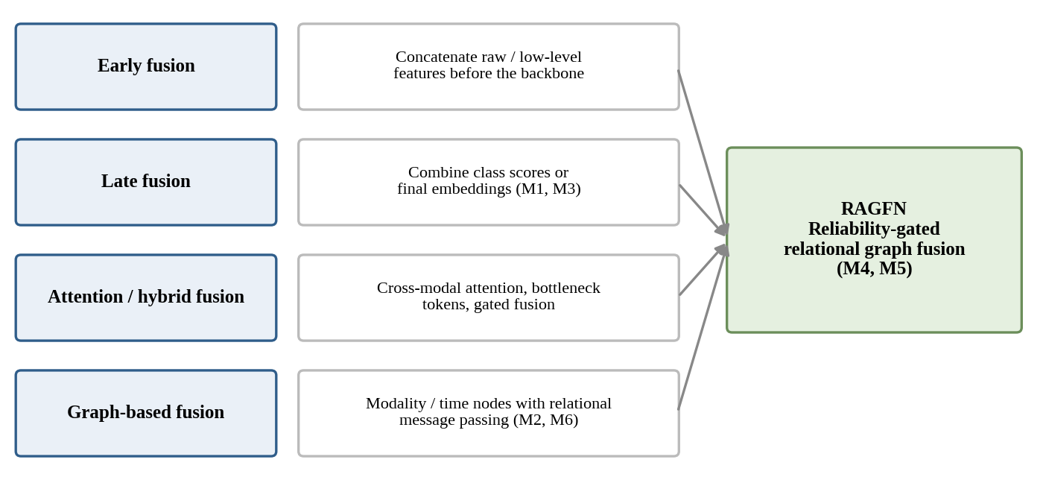
Figure 2: Taxonomy of multimodal fusion levels and the position of RAGFN. M1–M6 are the controlled variants of Chapter 5.
To allow more flexible inter-stream communication, intermediate and hybrid fusion strategies have been explored. Approaches such as MAF-Net examine multimodal data fusion across multiple sensor inputs, while MAGNet couples multimodal fusion with adaptive graph convolutions to learn dynamic connectivity across representations. In parallel, attention-driven architectures have shown considerable promise. Cross-modal learning with 3D deformable attention enables selective spatial and temporal interactions between distinct streams, and cross-modal attention bottlenecks enforce compact, efficient communication by restricting inter-stream information exchange through a small set of shared tokens. These developments confirm that the mechanism governing inter-stream interaction directly influences the quality of the learned multimodal representation.
Despite these structural advancements, existing fusion architectures remain fundamentally quality-agnostic. When a system combines multiple data streams, its overall performance depends directly on whether the incoming information from each channel is clean and dependable. While confidence-aware gated fusion has been introduced for temporal action localization in occluded environments, such techniques typically handle joint reliability in isolation rather than propagating dynamic confidence across a unified, multi-stream relational network. Most current architectures continue to assume that all active modalities are equally valid across all samples. As a result, they lack an explicit mechanism to quantify sample-wise modality degradation and actively restrict information flow from corrupted feature streams within a relational graph structure.

2.4 Graph Based Learning and Relation Fusion
Graph neural networks (GNNs) are an effective way to model relational dependencies by treating features as interconnected nodes rather than isolated vectors. While early Graph Convolutional Networks (GCNs) relied on fixed neighborhood aggregation, Graph Attention Networks (GATs) introduced masked self-attention to dynamically weigh neighbor importance. In action recognition, this attention mechanism allows distinct streams—such as appearance, motion, and skeletal posture—to interact selectively across space and time. Models like ST-GCN and Fusion-GCN have demonstrated the value of this relational layout for tracking human kinematics, while architectures like TaGAT further prove that graph attention successfully unifies heterogeneous modalities across visual domains.
However, standard GATs have a major blind spot: their attention weights depend purely on learned feature similarities without factoring in data quality. If an optical flow vector is distorted by camera shake or a pose landmark collapses due to occlusion, that corrupted node can still align mathematically with neighboring features. Because the network cannot tell noise apart from clean evidence, it assigns high attention weights to compromised inputs, allowing corruption to spread across the graph. This risk makes quality-agnostic attention fragile in real-world settings and highlights why message passing must be regulated by sender reliability before uncorrupted features are contaminated.

2.5 Uncertainty and reliability estimation
Quantifying uncertainty gives a network a realistic way to assess what it does not know, keeping it from making blindly confident mistakes on messy video inputs. Kendall and Gal set up this distinction by separating epistemic uncertainty, which stems from gaps in the training data or model architecture, from aleatoric uncertainty, which comes from noise embedded directly within the sensor signals. In action recognition, aleatoric noise is everywhere: erratic camera motion muddles optical flow fields, physical obstructions drop skeletal landmarks, and uneven lighting washes out appearance details. Standard fusion setups struggle when handling missing or degraded inputs (Wu et al.; Zhang et al.) because they assume every active stream is fully reliable. While methods like evidential learning (Sensoy et al.) and dynamic trusted fusion (Han et al.) try to gauge source credibility, they usually apply their trust weights at the decision level—long after features have already mingled and contaminated one another. RAGFN avoids this by assessing channel quality early: its unsupervised Reliability Estimation Module (REM) infers sample-specific weights directly from pooled temporal features, gating graph message passing so that corrupted tokens are throttled before they can spread noise across the system.

Uncertainty also offers a principled solution for balancing multiple training objectives simultaneously. Instead of relying on manual trial-and-error to balance classification, bounding-box regression, and temporal localization losses, multi-task frameworks can interpret each task's relative variance as homoscedastic uncertainty to adjust gradient contributions automatically (Kendall et al.). RAGFN takes advantage of this uncertainty-driven loss formulation to calibrate categorical cross-entropy against Smooth L1 bounding-box and boundary objectives without letting one task dominate the gradients. On top of that, to keep the network from outputting overly sharp probability distributions during inference, the final logits pass through a temperature-scaled softmax ($τ=1.5$) (Guo et al.; Hinton et al.), softening raw confidence levels while leaving the rank order of the predictions completely untouched.

2.6 Transformer-based video understanding
The Transformer, built on scaled dot-product attention (Vaswani et al., 2017), has become a dominant architecture for video. Bertasius et al. (2021) show that factorising self-attention into separate temporal and spatial components models video efficiently without convolutions. Arnab et al. (2021) propose ViViT, a pure-Transformer model operating on spatio-temporal tokens, and compare factorised designs to control cost. For localisation, Zhao et al. (2022) introduce TubeR, a tubelet Transformer that directly predicts action tubes, that is, sequences of bounding boxes with class labels. RAGFN’s multi-task objective, which jointly predicts boxes, temporal boundaries and class, follows this detection formulation, but its Transformer operates on a 16-step fused sequence rather than on raw video tokens, so the number of tokens is small and the computational cost is low.

2.7 Comparative summary and identified gap
Table 5: Comparison of the principal works reviewed, with their fusion strategy, strengths and limitations relative to this project
Work | Fusion / mechanism | Strength | Limitation relative to RAGFN
(Takami & Fukuda, 2026) | Confidence-aware gated fusion | Handles occlusion; confidence controls fusion | Temporal localisation; no relational graph
(Dong et al., 2026) | Multimodal + adaptive graph convolution | Graph structure improves recognition | Reliability not modelled explicitly
(Xie et al., 2025) | Multimodal data fusion (MAF-Net) | Combines several data types | Equal treatment of modalities
(Kim et al., 2023) | 3D deformable cross-modal attention | Selective spatio-temporal interaction | Quality-agnostic attention
(Nagrani et al., 2021) | Attention bottleneck tokens | Efficient cross-modal exchange | No per-sample reliability
(Han et al., 2023) | Dynamic evidential fusion of views | Per-view uncertainty weighting | Decision-level fusion only
(Tian et al., 2024) | Topology-aware graph attention | Graph attention fuses heterogeneous modalities | Medical imaging; not video; no reliability
(Veličković et al., 2018) | Graph attention | Learned neighbour weights | Ignores input quality
(Bertasius et al., 2021) | Divided space-time attention | Efficient video Transformer | Single (RGB) modality
(Arnab et al., 2021) | Factorised video Transformers | Pure-Transformer video model | Single (RGB) modality
(Zhao et al., 2022) | Tubelet Transformer | Direct action-tube detection | Single modality; no reliability
(Yan et al., 2018) | Spatio-temporal GCN | Skeleton graph modelling | Pose only
RAGFN | Reliability-gated relational graph attention + temporal Transformer | Explicit per-modality reliability inside the fusion graph; multi-task outputs | Validated on one small dataset; gating effect not yet isolated

Table 5 summarises how the reviewed works relate to RAGFN. Three conclusions follow. (i) Multimodal fusion is well established, but most designs are quality-agnostic. (ii) Confidence and trust have been modelled at the decision level or for temporal localisation, but not as an explicit signal that is propagated through a feature-level relational graph. (iii) Graph attention provides precisely the primitive (learnable neighbour weights) into which a reliability signal can be injected. The gap that RAGFN targets is therefore the combination of explicit per-modality reliability estimation, reliability-gated relational graph fusion and joint spatio-temporal detection.

CHAPTER 3
PROBLEM FORMULATION AND THE PROPOSED RAGFN

3.1 Task definition and notation
A clip is a sequence of T = 16 frames sampled uniformly from the video. For frame t, let I_{t} denote the RGB image, F_{t} the optical-flow field between consecutive frames, and P_{t} the set of 33 body landmarks. The model outputs, for each clip, a class distribution over C = 21 categories, a normalised bounding box for every frame, a temporal start/end pair and an uncertainty estimate. All symbols are collected in the List of Symbols; the main tensor shapes are in Table 6.
Table 6: Feature and tensor dimensions of the RAGFN pipeline (from the source paper and architecture figure)
Stage | Shape | Comment
RGB frames | 16 × 224 × 224 | Uniformly sampled; ResNet-50 input
Optical flow | 16 × 224 × 224 | DIS flow between consecutive frames
Pose landmarks | 16 × 33 × 2 | 33 joints, x/y coordinates (MediaPipe)
RGB feature | 16 × 256 | ResNet-50, last layer fine-tuned
Flow feature | 16 × 128 | CNN encoder
Pose feature | 16 × 128 | MLP with LayerNorm
Common graph feature | 48 × 256 | 16 frames × 3 modalities, projected to 256-d
Reliability vector | 3 (or 48) | Softmax over modalities (figure) / per-token (Eq. 2)
Fused sequence | 16 × 256 | Mean over modality nodes per time step
Transformer output Z | 16 × 256 | 2 layers, 8 heads, no causal mask
Global vector g | 256 | Temporal mean pool
Class logits | 21 | Divided by τ = 1.5

3.2 System overview
The architecture has four stages: (1) independent feature extraction for the three streams, (2) dynamic reliability estimation, (3) reliability-guided graph fusion and (4) multi-task temporal processing. Figure 3 shows the complete data flow; it is reproduced from the project architecture diagram and is placed on a landscape page for legibility. Reading from left to right, the RGB stream passes through a ResNet-50 to a 16 × 256 feature, the motion stream passes through DIS optical flow and a CNN encoder to a 16 × 128 feature, and the pose stream passes through MediaPipe landmarks and an MLP to a 16 × 128 feature. The REM scores each feature stream and applies a softmax over the three scores; the scores weight the features and gate the graph attention, whose output is aggregated into a global temporal representation. A bidirectional Transformer with forward and backward temporal context feeds four prediction heads for action classification, bounding-box regression, temporal localisation and uncertainty estimation.
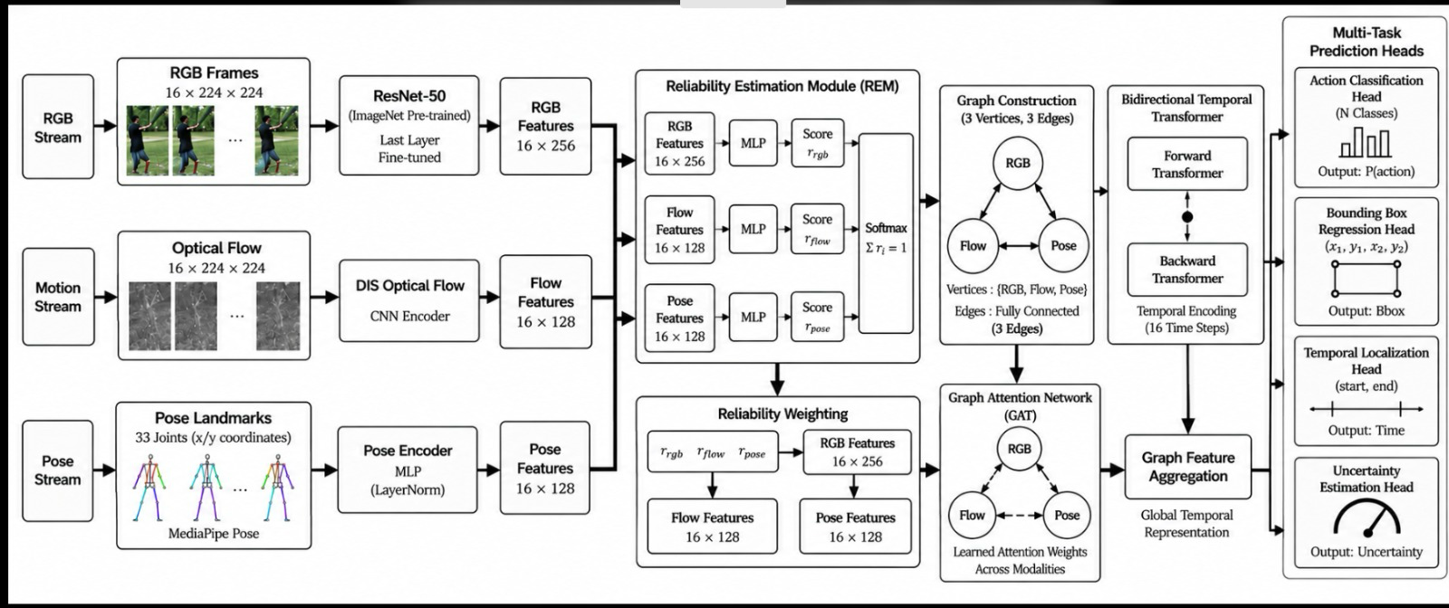
Figure 3: Overall architecture of the Reliability-Aware Graph Fusion Network (RAGFN): three-stream feature extraction, REM, reliability weighting, graph attention, bidirectional temporal Transformer and four task heads.
In the remainder of this chapter each stage is formalised. Equation numbers in this report are assigned in order of appearance; Table 7 relates them to the numbering of the source paper.

3.3 Multimodal feature extraction
Each stream is encoded into a per-frame feature by a modality-specific encoder E_{m}, where m ∈ {rgb, flow, pose}:
 | $x_{t,m}=E_{m}\left(u_{t,m}\right), E_{rgb}=ResNet50, E_{flow}=FlowCNN, E_{pose}=PoseMLP$ | (1)
where u_{t,rgb} = I_{t}, u_{t,flow} = F_{t} and u_{t,pose} = P_{t}, giving x_{t,rgb} ∈ R²⁵⁶, x_{t,flow} ∈ R¹²⁸ and x_{t,pose} ∈ R¹²⁸ (1). The ResNet-50 backbone is initialised from ImageNet and only its last layer is fine-tuned (He et al., 2016; Deng et al., 2009). Optical flow between consecutive frames is computed with DIS (Kroeger et al., 2016). The 33 landmarks are obtained from MediaPipe, which builds on BlazePose (Bazarevsky et al., 2020; Lugaresi et al., 2019). Because the encoders have different output widths, a modality-specific linear projection later maps all tokens to a common 256-dimensional space before graph construction.

3.4 Reliability Estimation Module
The REM is the component that lets RAGFN judge the quality of each modality for the current clip. The source paper describes it in two complementary ways, both of which are reproduced here because they appear in its text, equation and architecture figure.

3.4.1 Token-level formulation
Equation (2) maps every token to a scalar confidence in [0, 1] with a two-layer perceptron:
 | $r_{t,m}=σ\left({w_{2}}^{⊤} ReLU\left(W_{1}h_{t,m}^{(0)}+b_{1}\right)+b_{2}\right)$ | (2)
where h_{t,m}⁽⁰⁾ is the projected 256-dimensional token, W₁, b₁, w₂, b₂ are learnable parameters and σ is the logistic function. A token from a blurred frame or an occluded skeleton is expected to receive a low r_{t,m}. For readability, the 48 nodes are subsequently indexed by a single index i and the score is written r_{i}.

3.4.2 Modality-level formulation
The text and the architecture figure describe a modality-level variant. The temporal dimension of each modality is mean-pooled over the 16 frames, each pooled vector passes through its own MLP with GELU activation (Hendrycks & Gimpel, 2016) to give a raw scalar, and a softmax over the three scalars gives a discrete distribution that sums to one:
 | $r_{m}=\frac{exp\left(s_{m}\right)}{\sum_{m′∈\{rgb,flow,pose\}}{}exp\left(s_{m′}\right)}, s_{m}={w_{m}}^{⊤} GELU\left(W_{m}x_{m}^{avg}+b_{m}\right), x_{m}^{avg}=\frac{1}{T}\sum_{t=1}^{T}{}x_{t,m}$ | (3)
Here x_{m}^{avg} is the temporal mean of the modality-m features. This formulation is a direct counterpart of the “Softmax, Σr_{i} = 1” block in Figure 3. Equation (3) is not numbered in the source paper; it is reconstructed from the paper’s verbal description and the figure, and is flagged for confirmation in Appendix A. Neither formulation uses supervision about data quality: the REM is trained purely by back-propagation of the task losses, which is why the paper describes the reliability estimation as unsupervised.
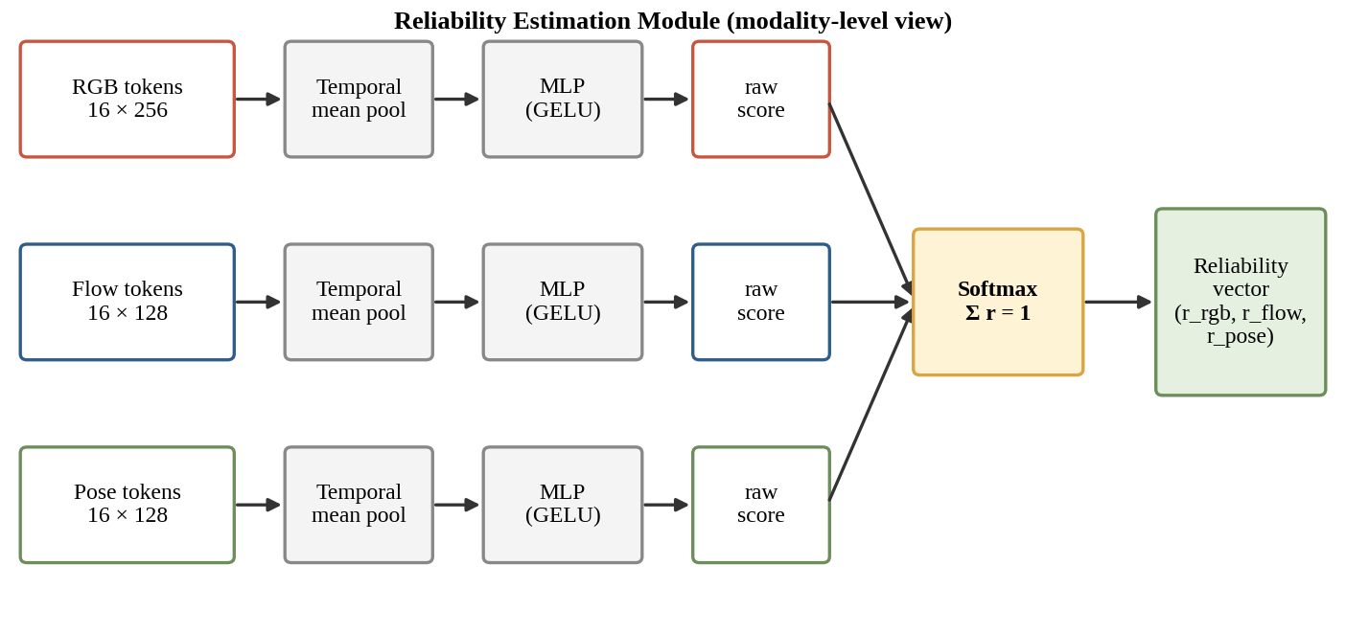
Figure 4: Reliability Estimation Module (modality-level view): temporal pooling, per-modality MLP scoring and a softmax across the three modalities.
Figure 4 summarises the flow. A softmax across modalities makes the scores relative: raising the reliability of one modality necessarily lowers that of another. A per-token sigmoid, in contrast, scores each token absolutely. The two have different consequences for the graph gating of the next section, and the choice has to be confirmed against the implementation.

3.5 Reliability-guided relational graph attention
After the reliability scores have been computed, all modality features are projected to a common 256-dimensional semantic subspace and arranged as a 48-node spatio-temporal graph with 16 time steps × 3 modalities (Figure 5). The topology models intra-frame cross-modal interaction (for example, RGB with flow at time t) and inter-frame continuity (for example, pose at t with pose at t + 1).
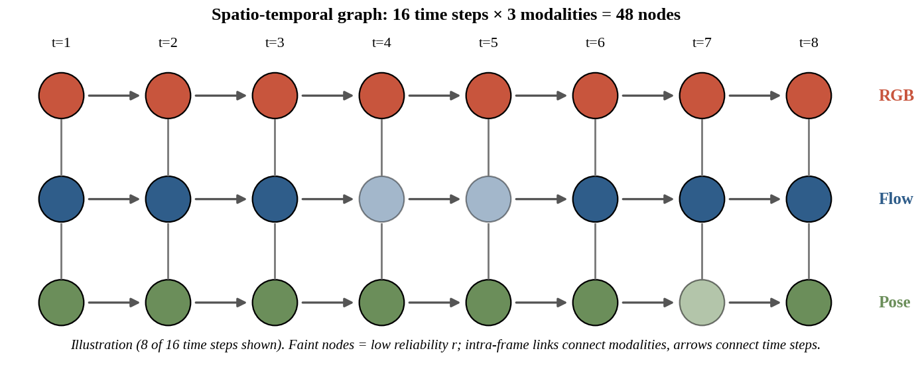
Figure 5: Spatio-temporal graph of 48 nodes (16 time steps × 3 modalities); node opacity illustrates reliability.
Information is propagated with a customised graph attention network (Veličković et al., 2018) with relation-aware message passing. In a standard GAT the target node aggregates messages from its neighbours according to a learned structural score. RAGFN modifies this score by the product of the reliabilities of the two nodes involved:
 | $e_{ij}=LeakyReLU\left(a^{⊤}\left[Wh_{i} ∥ Wh_{j}\right]\right)·r_{i}r_{j}$ | (4)
where a is a learnable attention vector, W a shared projection matrix and ∥ denotes concatenation. The attention coefficients are obtained by a softmax over the neighbourhood N(i), which in the source paper comprises all nodes including i:
 | $α_{ij}=\frac{exp\left(e_{ij}\right)}{\sum_{k∈N(i)}{}exp\left(e_{ik}\right)}$ | (5)
and node features are updated by aggregating transformed neighbour features with these coefficients followed by an ELU non-linearity:
 | $h_{i}^{(l+1)}=ELU\left(\sum_{j∈N(i)}{}α_{ij}W^{(l)}h_{j}^{(l)}\right)$ | (6)
The source text extraction omitted the summation operators in (5) and (6); they are restored here from the standard GAT definition (Veličković et al., 2018) and from the paper’s verbal description (softmax over the neighbourhood; aggregation of neighbour messages). After message passing, the 48 nodes are grouped by time step and mean-pooled, which collapses them to a fused 16 × 256 sequence:
 | $z_{t}=\frac{1}{3}\sum_{m}{}h_{(t,m)}^{(L)}$ | (7)
where L is the number of graph layers (not stated in the source) and h_{(t,m)}^{(L)} is the final feature of the node for modality m at time t.

3.5.1 Properties of the gating
Because r_{i}, r_{j} ∈ [0, 1], the product r_{i}r_{j} ≤ 1 and therefore |e_{ij}| ≤ |s_{ij}|, where s_{ij} = LeakyReLU(a⊤[Wh_{i} ∥ Wh_{j}]) is the ungated score. Gating shrinks the attention logit of a low-reliability pair towards zero (Figure 6, panel b). Two consequences deserve to be stated precisely, because they qualify the description of the mechanism as “hard gating” in the source text.
- The gated node is down-weighted relative to confident neighbours, not removed. When r_{j} → 0, e_{ij} → 0 and exp(e_{ij}) → 1, so the node still receives a non-zero attention weight. In the toy example of Figure 6(a) the weight of the degraded neighbour falls from 0.20 to 0.09, but not to zero.
- The effect depends on the sign of the ungated scores. If the remaining neighbours have positive scores, shrinking a pair’s logit toward zero lowers its share; if they have negative scores, the shrunk logit is larger than theirs and the share of the unreliable node can increase. A gate that multiplies the message h_{j} by r_{j} before aggregation, as the source text also describes, would remove the contribution entirely when r_{j} = 0; Equation (6) as printed does not include such a factor. Which of the two (or both) is implemented must be confirmed.
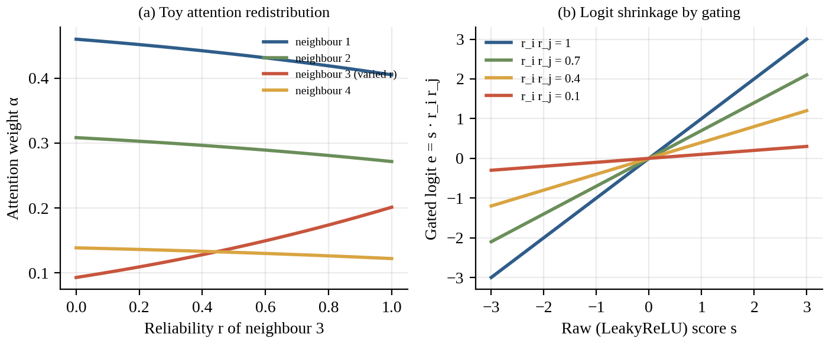
Figure 6: Illustrative (toy, not experimental) behaviour of reliability gating: (a) softmax attention weights over four neighbours as the reliability of neighbour 3 decreases; (b) shrinkage of the gated logit e = s·r_{i}r_{j}.
Figure 6 is computed from fixed illustrative scores (1.6, 1.2, 0.9, 0.4) and is intended only to show the mechanism. It is not an experimental result. The algebraic derivation of the two properties is given in Appendix D.
Algorithm 1: Reliability-gated relational graph attention layer
Input : node features H = {h_i} (i = 1..48), reliabilities r_i, parameters W, a
Output: updated node features H'
1 for each node i:
2 for each j in N(i): # all 48 nodes, including i
3 s_ij = LeakyReLU( a^T [ W h_i || W h_j ] )
4 e_ij = s_ij * r_i * r_j # reliability gating (Eq. gate)
5 alpha_ij = softmax_j( e_ij ) # Eq. alpha
6 h_i' = ELU( sum_j alpha_ij * W h_j ) # Eq. upd
7 return H'
8 after the last layer: z_t = mean over modalities of h_(t,m) # Eq. pool

3.6 Bidirectional temporal Transformer
The fused 16 × 256 sequence is processed by a Transformer encoder with two layers and eight attention heads, without causal masking, so that every time step can attend to the full context of the action (Vaswani et al., 2017; Arnab et al., 2021; Bertasius et al., 2021). The core operation is scaled dot-product attention:
 | $Attn\left(Q,K,V\right)=softmax\left(\frac{QK^{⊤}}{\sqrt{d_{k}}}\right)V$ | (8)
with queries Q, keys K and values V obtained by linear projections of the input sequence and d_{k} the key dimension. If the model width is 256 and the eight heads split it equally, then d_{k} = 32; this is an inference from the stated widths, not a value quoted in the source paper. Two properties of (8) matter here. First, the scaling by 1/√d_{k} keeps the dot products at a magnitude that avoids saturating the softmax. Second, with only 16 tokens, the attention matrix is 16 × 16 per head, so the temporal stage is inexpensive in comparison with the 48 × 48 graph stage.
The Transformer output Z ∈ R^{16×256} follows two routes. The sequence is kept per frame and fed to the bounding-box head, which predicts normalised coordinates (x₁, y₁, x₂, y₂) for the actor in every frame, following the detection formulation of TubeR (Zhao et al., 2022). In parallel, Z is mean-pooled in time to a global vector, which drives the classification, temporal-localisation and uncertainty heads (Figure 7):
 | $g=Pool\left(Z\right)=\frac{1}{T}\sum_{t=1}^{T}{}z_{t}$ | (9)
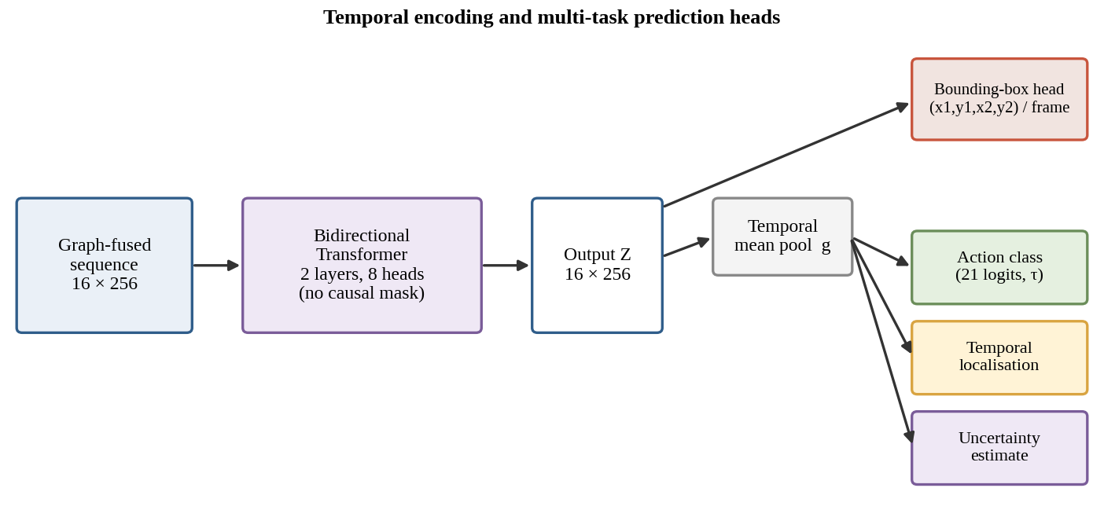
Figure 7: Temporal encoding and multi-task prediction heads.

3.7 Classification head and temperature scaling
The classification head produces 21 logits w_{c}⊤g. Class probabilities use a softmax with temperature τ:
 | $p\left(c|x\right)=\frac{exp\left(\frac{{w_{c}}^{⊤}g}{τ}\right)}{\sum_{c′=1}^{C}{}exp\left(\frac{{w_{c′}}^{⊤}g}{τ}\right)}$ | (10)
The source paper uses τ = 1.5. A temperature above one flattens the output distribution, reducing over-confidence; temperature scaling is a standard device for calibration (Guo et al., 2017) and for softening teacher distributions in distillation (Hinton et al., 2015). Figure 8 shows its effect on a toy logit vector: for logits (3.0, 2.0, 1.0, 0.2), the top-class probability falls from 0.64 at τ = 1 to 0.52 at τ = 1.5 and 0.38 at τ = 3 (computed from (10)). The temperature does not change the arg-max, so accuracy is unaffected at inference; its effect is on the loss landscape during training and on the confidence values.
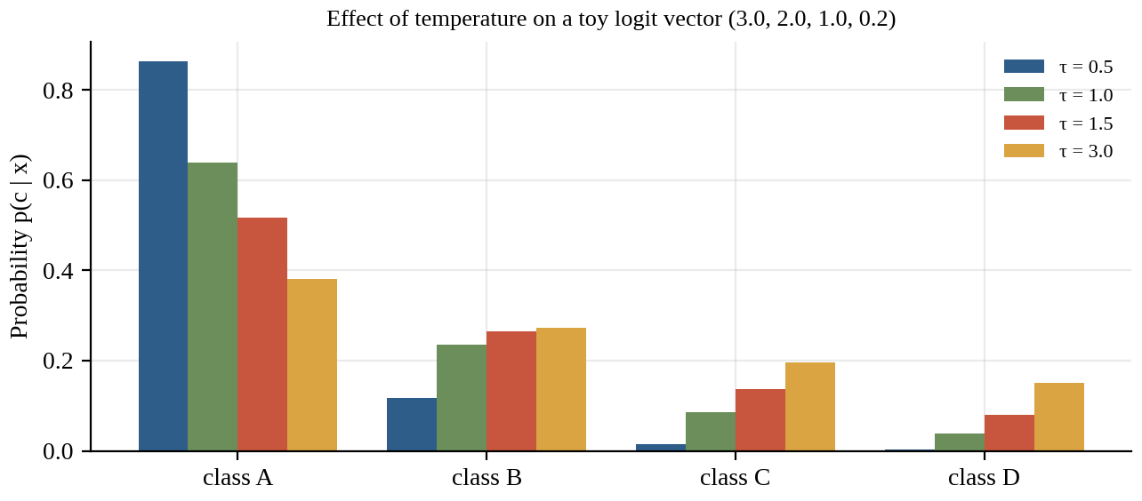
Figure 8: Effect of the softmax temperature τ on a toy logit vector. This is an illustration of (10), not a measured result.

3.8 Multi-task training objective
The classification term is the cross-entropy over C = 21 classes, and bounding-box regression uses the smooth-L₁ loss (Girshick, 2015):
 | $L_{CE}=−\sum_{c=1}^{C}{}y_{c}log p\left(c|x\right)$ | (11)
 | $L_{bbox}=\sum_{k}{}smoothL_{1}\left(b_{k}^{pred}−b_{k}\right)$ | (12)
where y_{c} is the one-hot label, b̂_{k} and b_{k} are the predicted and ground-truth box coordinates, and the sum runs over the coordinates (and frames) of the box supervision. For a residual u, the smooth-L₁ function equals 0.5u² when |u| < 1 and |u| − 0.5 otherwise; it behaves quadratically near zero (stable gradients) and linearly for large errors (robust to outliers). The total loss combines the tasks:
 | $L=L_{CE}+λ_{bbox}L_{bbox}+λ_{loc}L_{loc}+λ_{unc}L_{unc}$ | (13)
The source paper specifies λ_{bbox} = 0.05; the values of λ_{loc} and λ_{unc}, and the exact definitions of L_{loc} and L_{unc}, are not stated and are marked “to be confirmed”. Variant M5 sets all auxiliary weights to zero and therefore trains with (11) only. The source also states that a Kendall–Gal uncertainty weighting (Kendall et al., 2018) dynamically balances the classification, spatial and temporal objectives. In its standard form, each task loss L_{k} is scaled by a learned noise parameter σ_{k}:
 | $L_{total}=\sum_{k}{}\left(\frac{1}{2{σ_{k}}^{2}}L_{k}+log σ_{k}\right)$ | (14)
Equation (14) is the general form from the cited work and is included for completeness; whether RAGFN uses it in place of, or in addition to, the fixed weights of (13) has to be confirmed from the implementation. The intuition is that a task with high learned noise σ_{k} is down-weighted, while the log σ_{k} term prevents the trivial solution of making all σ_{k} large.
Table 7: Mapping between the equation numbers of this report and those of the source paper
This report | Content | Source paper | Status
(1) | Modality encoders | Eq. (1) | As in source
(2) | Token-level REM (sigmoid) | Eq. (2) | As in source
(3) | Modality-level REM (softmax) | – (text, figure) | Reconstructed; confirm
(4) | Reliability-gated score | Eq. (3) | As in source
(5) | Attention coefficients | Eq. (4) | Summation restored
(6) | Node update | Eq. (5) | Summation restored
(7) | Modality pooling per frame | – (text) | Reconstructed
(8) | Scaled dot-product attention | Eq. (6) | Denominator √d_{k} restored
(10) | Temperature softmax | Eq. (7) | Summation restored
(11) | Cross-entropy | Eq. (8) | Summation restored
(12) | Smooth-L1 box loss | Eq. (9) | Summation restored
(13) | Total loss | Eq. (10) | As in source
(14) | Kendall–Gal weighting (standard form) | – (cited) | Standard form; confirm use

Table 7 makes the provenance of every equation explicit. Equations marked “summation restored” had their summation or denominator lost in the text extraction of the source document; they are restored from the standard definitions that the source cites. The evaluation equations (accuracy and macro-F1, Equations (11) and (12) in the source) are presented in Chapter 5.

3.9 Training and inference procedure
Algorithm 2: RAGFN forward pass for one clip
Input : clip V (16 frames)
Output: class probabilities p, boxes b_1..b_16, boundaries (s,e), uncertainty u
1 sample 16 frames uniformly; compute DIS flow F_t; extract 33 landmarks P_t
2 x_rgb = ResNet50(I); x_flow = FlowCNN(F); x_pose = PoseMLP(P) # Eq. enc
3 r = REM(x_rgb, x_flow, x_pose) # Eq. rem / remmod
4 H = project all tokens to 256-d; build 48-node graph
5 for l = 1..L: H = RGA_layer(H, r) # Algorithm rga
6 Z_in = mean over modalities per time step # Eq. pool
7 Z = BiTransformer(Z_in) # Eq. attn
8 g = mean_t(Z) # Eq. gpool
9 p = softmax(W_c g / tau); b = BoxHead(Z); (s,e) = LocHead(g); u = UncHead(g)
10 return p, b, (s,e), u

Algorithm 3: Training and checkpoint selection
Input : training clips (528), validation clips (132), configuration M
Output: selected checkpoint
1 initialise parameters (random / transferred from an earlier run, if applicable)
2 best_val = -inf
3 for epoch = 1..E:
4 for each mini-batch of training clips:
5 forward pass; L = L_CE + lambda_bbox L_bbox + ... # Eq. total
6 back-propagate and update parameters
7 val_acc = accuracy on the 132 validation clips
8 if val_acc > best_val: best_val = val_acc; save checkpoint
9 return saved checkpoint # evaluated once on the 295 test clips

Algorithm 2 and Algorithm 3 summarise inference and training. Checkpoint selection on validation accuracy (line 8 of Algorithm 3) means that the validation accuracy is an optimistic estimate of generalisation, a point developed in Chapter 5. The algorithms are descriptive; the epoch count E, optimiser, learning rate and batch size are not stated in the source and are listed as items to be confirmed in Chapter 4.

3.10 Complexity considerations
The graph stage has 48 nodes and, with a neighbourhood that comprises all nodes, 48² = 2,304 attention pairs per head and layer, compared with 16² = 256 pairs for each Transformer head. The graph stage therefore dominates the attention cost, but both are tiny compared with the ResNet-50 forward pass over 16 frames at 224 × 224 resolution. Parameter counts reflect this: the complete RAGFN (tuned) has 1,975,583 trainable parameters, which is far below the roughly 25.6 million parameters of a full ResNet-50. This suggests that the ResNet-50 backbone is either not counted among the trainable parameters or is applied to pre-extracted features, a detail that must be confirmed against the code. The 31.3 million parameter count of the baseline checkpoint indicates a different, much larger configuration whose composition is not documented in the source. A sparse topology, restricted to intra-frame and adjacent-frame edges, would contain 16 × 3 = 48 intra-frame edges and 3 × 15 = 45 temporal edges (93 undirected edges, or 186 directed edges plus 48 self-loops = 234 pairs), roughly ten times fewer than 2,304; this is proposed as future work.

CHAPTER 4
SYSTEM DESIGN AND IMPLEMENTATION

4.1 Design goals and architecture
The system is designed around four goals derived from the objectives of Chapter 1: (i) modularity, so that each modality encoder, the REM, the graph stage and the heads can be replaced or removed for ablation (this is what makes the variants M0–M6 possible); (ii) a compact trainable core, so that a model with about two million parameters can be trained on a few hundred clips; (iii) explicit exposure of the reliability scores, so that they can be inspected; and (iv) multi-task outputs that share a single temporal representation. The end-to-end architecture is the one shown in Figure 3; this chapter describes how its components are organised for implementation and which details remain to be confirmed.

4.2 Data pipeline and preprocessing
The data pipeline converts each JHMDB clip into the three synchronised streams consumed by the network. The steps documented in the source paper are listed in Table 8.
Table 8: Preprocessing pipeline for one clip
Step | Operation | Detail from source | Output
1 | Frame sampling | 16 frames sampled uniformly over the clip | 16 frames
2 | RGB preparation | Frames resized to 224 × 224 for the ResNet-50 backbone (resolution shown in the architecture figure) | 16 × 224 × 224
3 | Optical flow | Dense Inverse Search flow between consecutive frames, as a 16 × 224 × 224 tensor | 16 × 224 × 224
4 | Pose extraction | MediaPipe/BlazePose, 33 landmarks per frame (x/y) | 16 × 33 × 2
5 | Feature encoding | ResNet-50 (RGB), CNN (flow), MLP with LayerNorm (pose) | 16×256, 16×128, 16×128
6 | Labels | Action class; bounding box per frame (auxiliary); temporal boundaries | Targets

Uniform sampling of a fixed number of frames follows the segment-sampling principle of Wang et al. (2016) and gives every clip the same graph size (48 nodes), which keeps batching simple. The normalisation constants, data augmentation and handling of frames in which no person is detected by the pose estimator are not described in the source paper and are listed in Appendix A. This last point is important for the REM: a missing detection is the clearest example of a corrupted modality, and how it is encoded (zeros, interpolation, mask) determines what the REM can learn.

4.3 Dataset handling and split protocol
The 955 JHMDB clips used in the experiments were divided into 528 training, 132 validation and 295 test clips. The test partition is described as the official test split, whereas the validation partition was carved out of the remaining clips and used for checkpoint selection and tuning (Figure 9). The mechanism by which the training and validation clips were separated (random, stratified or grouped by source video) is not stated, and it is central to the discussion of near-duplicate leakage in Chapter 6.
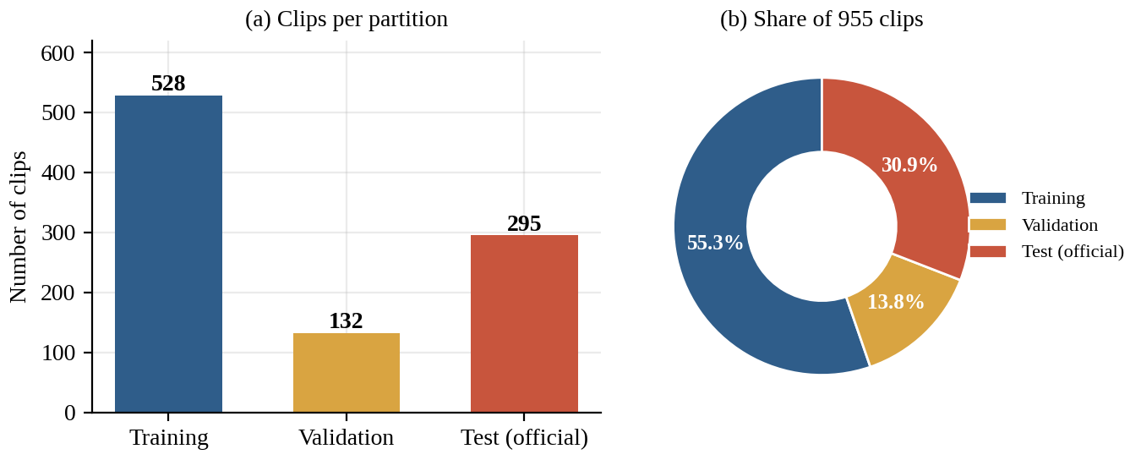
Figure 9: Distribution of the 955 JHMDB clips over training, validation and official test partitions.

4.4 Module organisation and interfaces
Table 9 lists the modules, their inputs and outputs and the origin of each specification. Parameter counts of individual modules are not reported in the source; only the totals per configuration are available (Table in Chapter 5).
Table 9: Module summary of the RAGFN implementation
Module | Input | Output | Specification
RGB encoder | 16 × 224 × 224 × 3 | 16 × 256 | ImageNet ResNet-50, last layer fine-tuned
Flow encoder | 16 × 224 × 224 | 16 × 128 | CNN on DIS flow
Pose encoder | 16 × 33 × 2 | 16 × 128 | MLP + LayerNorm (Ba et al., 2016)
REM | 3 pooled vectors (or 48 tokens) | 3 (or 48) scores | MLP, GELU / ReLU; softmax / sigmoid
Projection | 16×256, 16×128, 16×128 | 48 × 256 | Linear projections to common space
RGA graph | 48 × 256 and r | 16 × 256 | Gated GAT, ELU, mean pooling by frame
Temporal Transformer | 16 × 256 | 16 × 256 | 2 layers, 8 heads, bidirectional
Classification head | 256 | 21 logits | Softmax with τ = 1.5
Box head | 16 × 256 | 16 × 4 | Smooth-L1, λ_{bbox} = 0.05
Localisation head | 256 | 2 (start, end) | Loss and weight to be confirmed
Uncertainty head | 256 | scalar | Loss and weight to be confirmed

4.5 Variant implementation
The controlled variants are obtained by switching modules on and off rather than by writing separate models, which keeps the comparison fair. Table 10 lists each variant by the components that are active, and Figure 10 shows the relations between them. M0 keeps only the RGB stream with a projection; M1 adds the flow and pose streams and fuses them by linear concatenation; M2 replaces the concatenation by a standard GAT; M3 keeps the concatenation but weights each modality by its REM score; M4 is the complete RAGFN; M5 is M4 trained with cross-entropy only; and M6 keeps the graph but removes the reliability gating. The tuned model has the architecture of M4 and differs only in its training configuration (tf_mult 0.2, τ = 1.5).
Table 10: Components active in each configuration
ID | Flow + pose | Graph | REM | Gating | Aux. loss | Params (M) | Notes
M0 | – | – | – | – | – | 1.68 | RGB baseline
M1 | ✓ | – | – | – | ✓? | 1.75 | Linear concatenation
M2 | ✓ | ✓ (GAT) | – | – | ✓? | 1.81 | Uniform edges
M3 | ✓ | – | ✓ | – | ✓? | 1.81 | Scalar-weighted concat.
M4 | ✓ | ✓ (RGA) | ✓ | ✓ | ✓ | 1.98 | Full RAGFN
M5 | ✓ | ✓ (RGA) | ✓ | ✓ | – | 1.98 | CE only
M6 | ✓ | ✓ | –? | – | ✓? | 1.91 | RGA without gating
Base | ✓ | ✓ | ✓ | ✓ | ✓? | 31.29 | Baseline checkpoint
Tuned | ✓ | ✓ (RGA) | ✓ | ✓ | ✓ | 1.98 | tf_mult 0.2, τ 1.5
120-ep | ✓ | ✓ (RGA) | ✓ | ✓ | ✓ | 1.98 | 120 epochs

Cells marked “?” are inferred from the descriptions in the source and are not explicitly stated (for example, whether M1–M3 and M6 were trained with the auxiliary box loss). They are listed in Appendix A for confirmation. Figure 10 shows the same relations graphically.
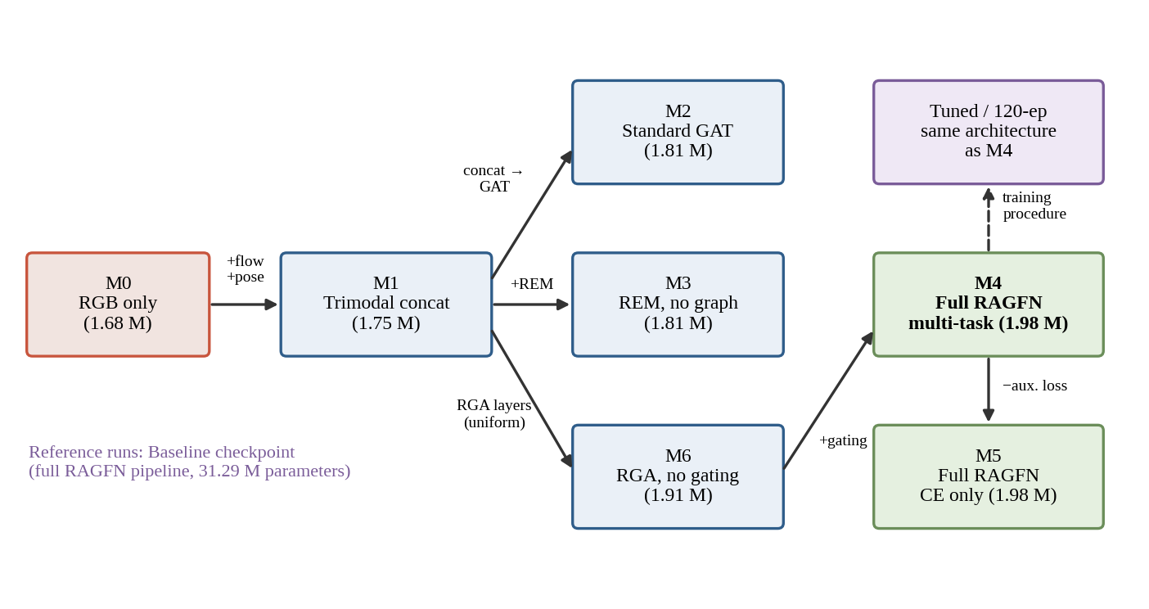
Figure 10: Relations between the ablation variants: each arrow adds or changes one component. Parameter counts are in millions.

4.6 Training configuration and reproducibility
Table 11 lists the training information available in the source paper and the information that must be supplied before the work can be reproduced. The distinction is deliberate: the report does not fill unknown cells with plausible defaults.
Table 11: Training configuration: known values and items to be confirmed
Item | Value | Status
Dataset / classes | JHMDB, 21 classes | Stated
Partition | 528 / 132 / 295 clips | Stated
Frames per clip | 16 (uniform) | Stated
Graph size | 48 nodes (16 × 3) | Stated
Transformer | 2 layers, 8 heads, bidirectional | Stated
Softmax temperature τ | 1.5 | Stated
Box-loss weight λ_{bbox} | 0.05 | Stated
Tuned setting tf_mult | 0.2 | Stated; meaning to be confirmed
Hyperparameter search | 101 trials on validation split | Stated; search space to be confirmed
Weight transfer | 18, 71, 41 and 55 layers transferred in M3–M6 / tuned | Stated; source runs to be confirmed
Seeds | Three-seed mean validation 81.82% | Stated; per-seed values to be confirmed
Optimiser, learning rate, schedule | – | Not stated – to be confirmed
Batch size, epochs (non-120-ep runs) | – | Not stated – to be confirmed
Graph layers L, hidden sizes, dropout | – | Not stated – to be confirmed
λ_{loc}, λ_{unc}, definitions of L_{loc}, L_{unc} | – | Not stated – to be confirmed
Deep-learning framework, GPU, software versions | – | Not stated – to be confirmed

Two points deserve emphasis. First, the weight-transfer entries show that several variants were initialised from earlier runs, which means that they did not all start from the same state. Comparisons between such variants, for example M3–M6 against M0–M2, are therefore partially confounded by initialisation history. Second, the search of 101 trials on a 132-clip validation set is a considerable amount of selection pressure, as discussed in Chapter 6.

4.7 Software and hardware environment
The source paper names the following components: ResNet-50 with ImageNet weights (He et al., 2016; Deng et al., 2009), Dense Inverse Search optical flow (Kroeger et al., 2016), the MediaPipe pose framework with BlazePose (Lugaresi et al., 2019; Bazarevsky et al., 2020), graph attention (Veličković et al., 2018) and a Transformer encoder (Vaswani et al., 2017). The programming language, deep-learning library, library versions, operating system and the GPU used for training are not stated; the entries are intentionally left for the project team to complete so that the report does not assert an environment that cannot be verified from the project evidence.

4.8 Implementation evidence and checklist
For the report to be fully verifiable, the following items should be attached as screenshots, logs or code excerpts in the appendices once available: the training logs of the tuned and baseline models (epoch-level loss and accuracy), the confusion matrices on validation and test, the per-class F1 scores, the REM scores for a few representative clips, and the hyperparameter search log. These items are not available in the material supplied for this report, and therefore no training curves, confusion matrices or reliability examples are shown; showing synthetic ones would misrepresent the results.

CHAPTER 5
EXPERIMENTAL SETUP AND EVALUATION METHODOLOGY

5.1 Dataset
All the experiments performed uses Joint-annotated Human Motion Database (JHMDB) (Jhuang et al., 2013), a video benchmark with 21 human-action categories, among them golf, swing_baseball and climb_stairs. The dataset provides three official train/test splits. The source paper reports 955 clips; the original JHMDB publication is usually cited with 928 clips, so the clip count should be confirmed against the actual files used (the discrepancy may arise from a different release or a different counting convention). For the experiments in this report the clips were divided into 528 training, 132 validation and 295 test clips (Table 12).
Table 12: Data partition used in all experiments
Partition | Clips | Share of 955 | Classes | Role
Training | 528 | 55.3% | 21 | Parameter learning
Validation | 132 | 13.8% | 21 | Checkpoint selection, tuning
Test (official) | 295 | 30.9% | 21 | Final reporting
Total | 955 | 100% | 21 | –

JHMDB is a small-data benchmark. With 528 training clips over 21 classes, the average is about 25 training clips per class (528 / 21 ≈ 25.1), which is little for a model that must combine three streams. Several classes share scenes and visual context, so appearance alone can be ambiguous; this is the motivation for adding motion and pose. Each clip contributes 16 frames and therefore 48 graph nodes. The chance level for 21 balanced classes is 1/21 ≈ 4.8%, so every configuration in Chapter 6 is far above chance even on the test split.

5.2 Model configurations
Seven controlled variants (M0–M6) were trained, together with three reference configurations: the baseline checkpoint, the tuned model and a 120-epoch continuation run. Table 13 defines them together with their parameter counts.
Table 13: Model configurations (parameter counts from the project result files)
ID | Fusion mechanism | Modalities | Description | Parameters
M0 | None (projection only) | RGB | Appearance baseline | 1,680,917
M1 | Linear concatenation | RGB + Flow + Pose | Trimodal late fusion | 1,746,965
M2 | Standard GAT, no REM | RGB + Flow + Pose | Graph fusion, uniform edges | 1,814,037
M3 | Scalar-weighted concatenation | RGB + Flow + Pose | REM without graph | 1,808,920
M4 | Reliability graph (RGA) | RGB + Flow + Pose | Full RAGFN, multi-task | 1,975,583
M5 | RGA, cross-entropy only | RGB + Flow + Pose | Full RAGFN, no multi-task | 1,975,583
M6 | Uniform graph attention | RGB + Flow + Pose | RGA without gating | 1,913,628
Base | Full RAGFN pipeline | RGB + Flow + Pose | Baseline checkpoint | 31,288,866
Tuned | Full RAGFN (tf_mult 0.2, τ 1.5) | RGB + Flow + Pose | Proposed best | 1,975,583
120-ep | Full RAGFN, extended | RGB + Flow + Pose | 120 continuous epochs | 1,975,583

Each variant isolates one design decision. The comparison M0 → M1 measures the value of additional modalities; M1 → M2 the effect of replacing concatenation by graph attention; M2/M6 → M4 the effect of reliability; M4 → M5 the effect of the auxiliary losses; and Tuned versus M4 the effect of training procedure with identical architecture. The 31.3 million-parameter baseline checkpoint has a different size from every other configuration, so the Tuned–Base comparison also differs in model capacity.

5.3 Training, validation and test strategy
Every configuration was trained once on the 528 training clips. The checkpoint with the best validation accuracy was kept and then evaluated on the 295 test clips (Figure 11). Validation accuracy therefore serves two purposes, selection and reporting, so it is an optimistic estimate of performance on unseen data; the test figures are the less biased of the two. Several variants (M3 to M6 and the tuned model) were initialised by transferring weights from earlier runs, and the number of transferred layers differs between them (18, 71, 41 and 55).
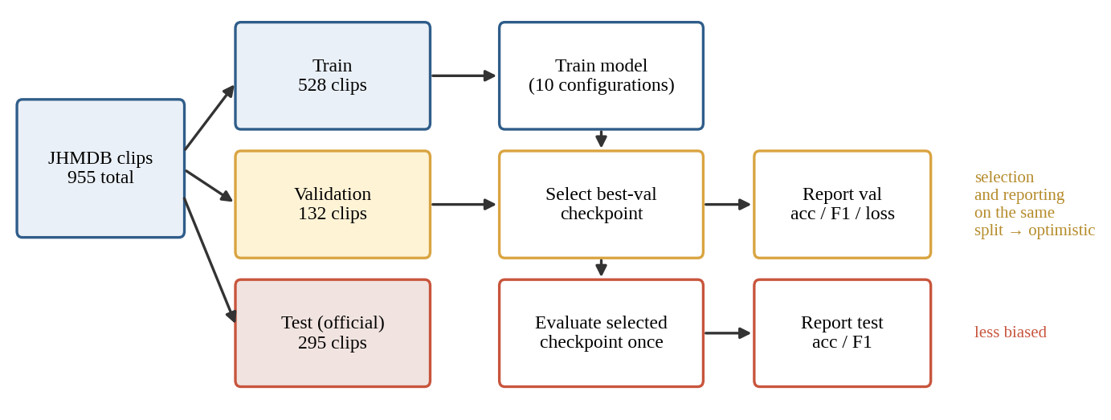
Figure 11: Experimental protocol: checkpoint selection on validation, one-time evaluation on the official test set.

5.4 Evaluation metrics
We report top-1 accuracy, macro-averaged F1 and cross-entropy loss. Accuracy is dominated by the larger classes, whereas macro-F1 is the unweighted mean of the per-class F1 scores and is therefore sensitive to weak performance on small classes. Accuracy and macro-F1 are reported on both validation and test partitions; validation loss is reported for the validation partition only. With N evaluated clips and N_{ok} correct predictions:
 | $Acc=\frac{N_{ok}}{N}$ | (15)
For each class c, let TP_{c}, FP_{c} and FN_{c} be the numbers of true positives, false positives and false negatives. Precision and recall are
 | $P_{c}=\frac{{TP}_{c}}{{TP}_{c}+{FP}_{c}}, R_{c}=\frac{{TP}_{c}}{{TP}_{c}+{FN}_{c}}$ | (16)
The F1-score of a class is the harmonic mean of its precision and recall, and macro-F1 averages it over the C = 21 classes:
 | ${F1}_{c}=\frac{2P_{c}R_{c}}{P_{c}+R_{c}}$ | (17)
 | ${F1}_{macro}=\frac{1}{C}\sum_{c=1}^{C}{}{F1}_{c}$ | (18)
Equations (15) and (18) correspond to Equations (11) and (12) of the source paper; the summation in the latter was lost in the text extraction and is restored here. The harmonic mean penalises imbalance between precision and recall: a class with precision 1.0 and recall 0.1 has F1 = 0.18, not 0.55. Cross-entropy, used both as training loss ((11)) and as reported validation loss, is averaged over the evaluated clips:
 | $L_{CE}=−\frac{1}{N}\sum_{i=1}^{N}{}log p_{i,y_{i}}$ | (19)
where p_{i,y(i)} is the probability assigned to the true class y_{i} of clip i. Lower validation loss indicates better-calibrated confidence in addition to better ranking; it is not monotonically related to accuracy, which is why the two can disagree in Chapter 6.

5.4.1 Statistical uncertainty of an accuracy estimate
The source paper reports point estimates only. Because accuracy is the proportion of correct predictions among N clips, it carries binomial sampling uncertainty that depends on N. This report adds the 95% Wilson score interval (Wilson, 1927), which behaves well for small samples and proportions away from 0.5:
 | ${CI}_{±}=\frac{\left(p_{obs}+\frac{z^{2}}{2N}±z\sqrt{\frac{p_{obs}\left(1−p_{obs}\right)}{N}+\frac{z^{2}}{4N^{2}}}\right)}{1+\frac{z^{2}}{N}}$ | (20)
where p_{obs} = N_{ok}/N and z = 1.96. For example, the tuned model’s 111/132 validation correct predictions give 84.09% with a 95% interval of 76.9%–89.4%, and 161/295 on the test set gives 54.58% with an interval of 48.9%–60.2%. Every reported accuracy was checked against integer counts: all ten validation and ten test percentages in the source correspond exactly to a whole number of clips, which also confirms the sample sizes of 132 and 295. Differences between two models can be summarised by Δ = Acc_{A} − Acc_{B} in percentage points; the source paper also defines a gain over a reference model, but the reference (“CMCA”) is not defined in the paper and no such comparison is reported here.

5.5 Hyperparameters and checkpoint selection
The checkpoint with the best validation accuracy was kept for each configuration. The tuned configuration was chosen after 101 hyperparameter trials evaluated on the validation split, which results in the tuned values tf_mult = 0.2 and τ = 1.5. The baseline checkpoint and the 120-epoch run are reference points: the former is a larger model (31.3 million parameters) whose training is not described in the source, and the latter continues the tuned configuration for 120 continuous epochs. All hyperparameter values not listed above are shown as “to be confirmed” in Table 11.

5.6 Fairness, leakage and reproducibility considerations
Three aspects of the protocol influence how the results should be read. Selection on the reporting split: picking the best checkpoint and the best hyperparameters on the same 132 clips on which validation accuracy is reported biases that figure upwards, and the effect grows with the number of trials. Possible leakage: JHMDB clips are derived from a smaller set of source videos, and if clips from the same source video fall in both the training and validation partitions, the validation score measures memorisation of scenes as much as generalisation. Whether this occurred is unknown and is treated as a hypothesis. Unequal initialisation: weight transfer from earlier runs (18, 71, 41 and 55 layers) means that variants did not start from the same state.
For reproducibility, the minimum requirements are the exact split lists, random seeds, the optimiser and schedule, the transferred-weight sources and the code revision. These are listed in Appendix A.

5.7 Threats to validity
Table 14: Threats to validity and the corresponding mitigation
Threat | Why it matters here | Mitigation / next step
Small validation set (132 clips) | One clip equals 0.76 percentage points; 95% intervals are about ±7 points | Report intervals; use cross-validation or multiple official splits
Selection bias | 101 trials and checkpoint selection on the same split | Hold out a second split; nested validation
Possible source-video leakage | Near-duplicate clips would inflate validation accuracy | Group-aware splitting by source video
Single seed per variant | Between-variant differences of 1–3 points are within noise | Repeat over several seeds; report mean ± s.d.
Unequal initialisation | Weight transfer differs between variants | Re-train all variants from a common initialisation
Unvalidated reliability scores | REM behaviour under corruption not tested | Inject controlled blur, occlusion and keypoint dropout
Single dataset | Generalisation to other domains unknown | Evaluate on larger multimodal benchmarks

CHAPTER 6
RESULTS, ANALYSIS AND DISCUSSION

6.1 Overall results
Table 15 reports validation and test results for all ten configurations. The tuned RAGFN attains 84.09% validation accuracy (111/132) and 81.72% macro-F1, an increase of 3.03 and 3.70 points over the baseline checkpoint (81.06% and 78.02%). On the official test split it reaches 54.58% (161/295), compared with 55.93% (165/295) for the baseline. Validation and test results are therefore not aligned: the configuration chosen on validation is not better on test, and the best test accuracy (56.27%) belongs to M5, a smaller model trained with cross-entropy only.
Table 15: Validation and test results for all configurations (best value per column in bold)
ID | Description | Val acc (%) | Val macro-F1 (%) | Val loss | Test acc (%) | Test macro-F1 (%) | Params (M)
M0 | RGB baseline | 77.27 | 73.73 | 0.8686 | 46.44 | 47.19 | 1.68
M1 | Trimodal late fusion | 81.82 | 79.27 | 0.7504 | 52.20 | 49.55 | 1.75
M2 | Standard graph fusion | 79.55 | 76.01 | 0.9125 | 50.51 | 48.25 | 1.81
M3 | REM without graph | 78.03 | 75.21 | 0.8364 | 52.88 | 50.72 | 1.81
M4 | Full RAGFN | 78.79 | 74.88 | 0.7854 | 53.90 | 51.39 | 1.98
M5 | Full RAGFN, no multi-task | 78.79 | 74.87 | 0.7678 | 56.27 | 53.97 | 1.98
M6 | RGA without gating | 79.55 | 75.92 | 0.8188 | 51.86 | 49.99 | 1.91
Base | Baseline checkpoint | 81.06 | 78.02 | 0.7054 | 55.93 | 53.81 | 31.29
Tuned | Full RAGFN, tuned | 84.09 | 81.72 | 0.8774 | 54.58 | 52.13 | 1.98
120-ep | 120-epoch final | 80.30 | 76.73 | 0.7435 | 55.25 | 53.16 | 1.98

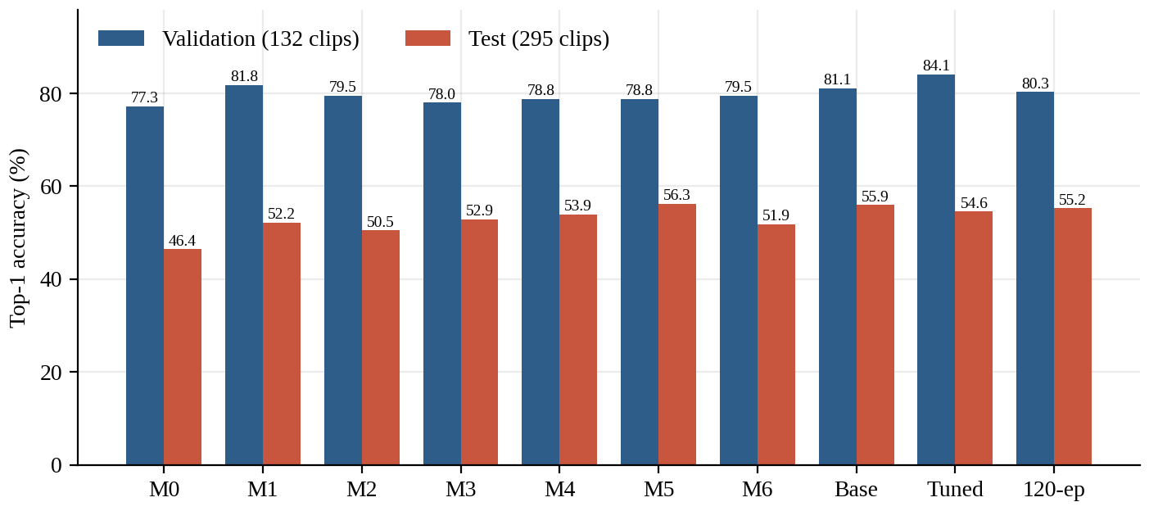
Figure 12: Validation and test accuracy for all ten configurations. Every configuration loses between 22.5 and 30.8 points when moving from validation to test.
Figure 12 shows the central empirical fact of this project: for every configuration the test accuracy is far below the validation accuracy. Figure 13 traces the validation metrics along the sequence of configurations; the rise to 84.09% at the tuned model is visible, as is the fall for the 120-epoch run.
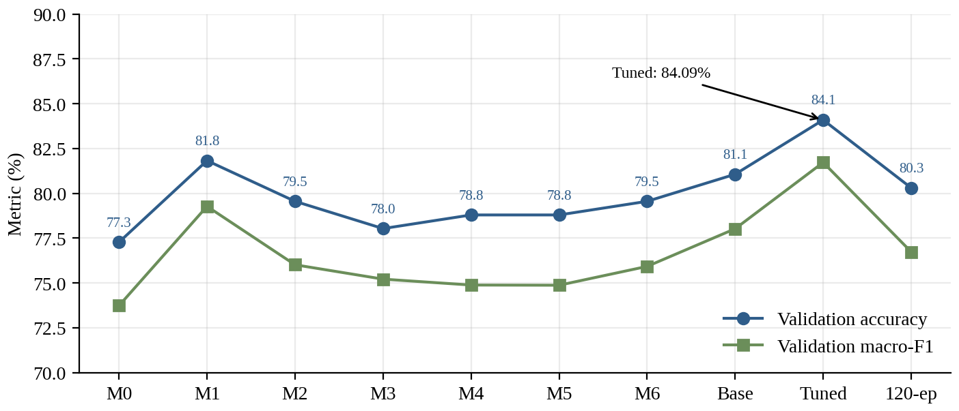
Figure 13: Progression of validation accuracy and macro-F1 from the RGB baseline (M0) to the tuned RAGFN and the 120-epoch run.

6.2 Validation versus test performance
Table 16 lists the difference between validation and test accuracy for each configuration, and Figure 14 plots it. The gap ranges from 22.52 points (M5) to 30.83 points (M0), with a mean of 26.94 points. It is present for the simplest baseline (RGB only) and for the most elaborate model alike, which shows that it is not specific to the proposed architecture. This is the key observation, and the main interpretation consistent with it is that something about the validation partition makes it easier than the test partition for all models.
Table 16: Validation–test accuracy gap per configuration (percentage points)
Config. | Val acc (%) | Test acc (%) | Gap (val − test)
M0 | 77.27 | 46.44 | 30.83
M1 | 81.82 | 52.20 | 29.62
M2 | 79.55 | 50.51 | 29.04
M3 | 78.03 | 52.88 | 25.15
M4 | 78.79 | 53.90 | 24.89
M5 | 78.79 | 56.27 | 22.52
M6 | 79.55 | 51.86 | 27.69
Base | 81.06 | 55.93 | 25.13
Tuned | 84.09 | 54.58 | 29.51
120-ep | 80.30 | 55.25 | 25.05

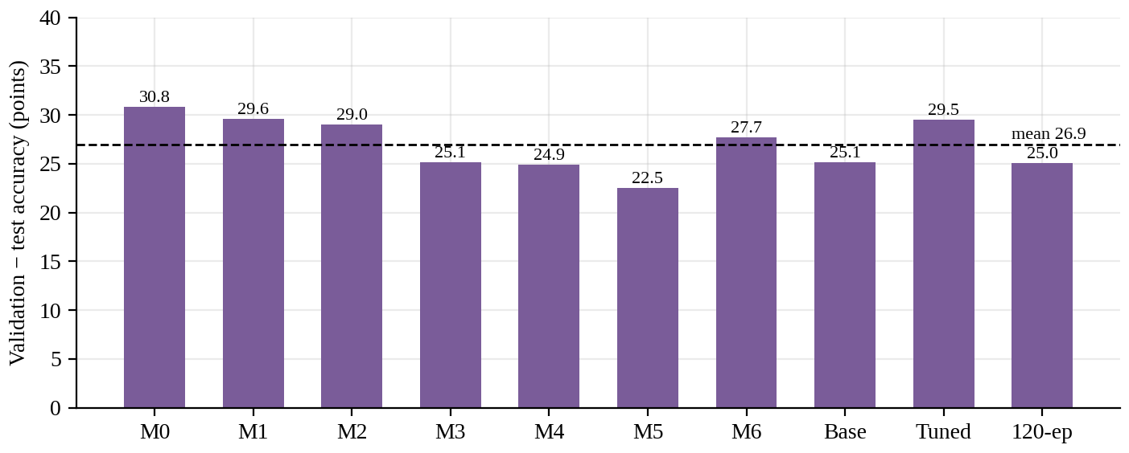
Figure 14: Validation-minus-test accuracy gap per configuration; the dashed line is the mean (26.9 points).
The configurations are also ranked differently by the two partitions (Figure 15, Table 17). The best configuration on validation (Tuned) is fourth on test; the best on test (M5) is seventh (tied) on validation. The Spearman rank correlation between the ten validation and ten test accuracies is 0.32 (two-sided p = 0.37, computed with average ranks for ties), which is not distinguishable from zero with only ten configurations. Validation accuracy is thus a poor predictor of the ordering of models on test, and model selection by validation accuracy alone cannot be relied upon in this data regime.
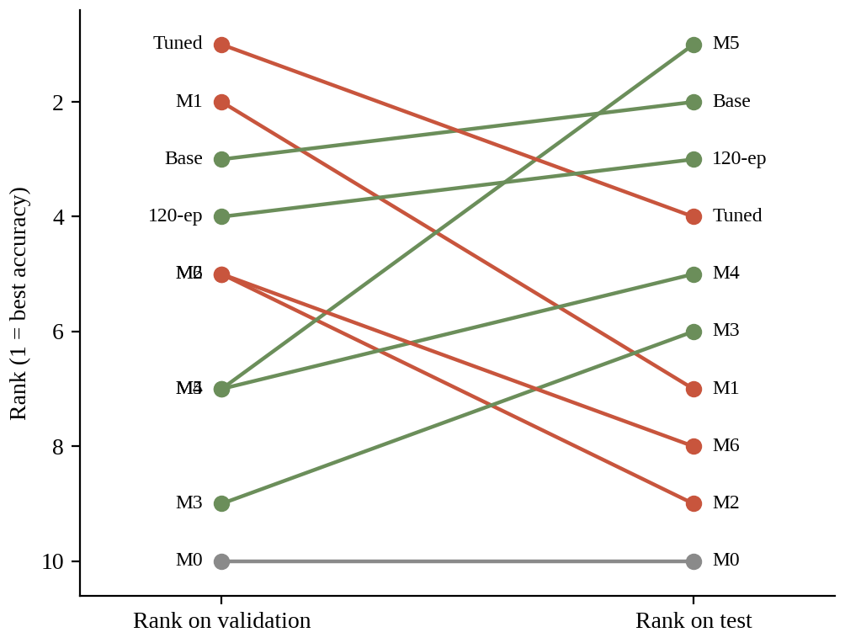
Figure 15: Rank of each configuration on validation versus test accuracy (competition ranking; ties share the lower rank).
Table 17: Rank of each configuration by accuracy (1 = best)
Config. | Validation rank | Test rank | Change in rank
M0 | 10 | 10 | 0
M1 | 2 | 7 | 5
M2 | 5 | 9 | 4
M3 | 9 | 6 | -3
M4 | 7 | 5 | -2
M5 | 7 | 1 | -6
M6 | 5 | 8 | 3
Base | 3 | 2 | -1
Tuned | 1 | 4 | 3
120-ep | 4 | 3 | -1

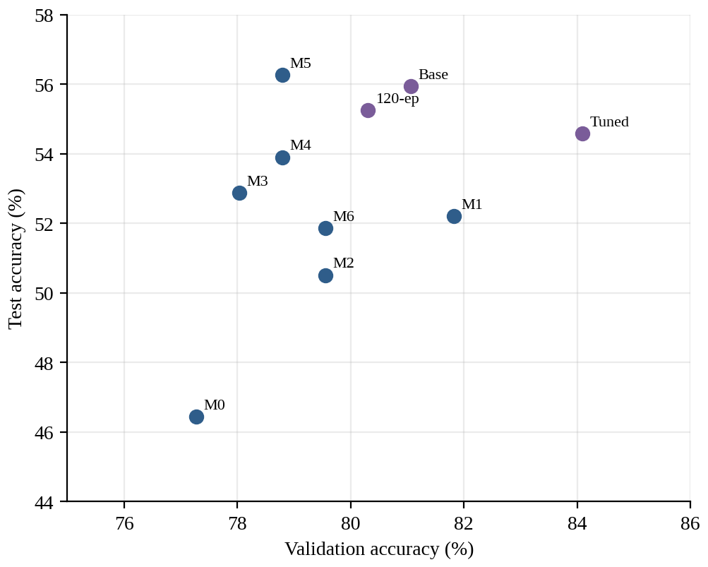
Figure 16: Test accuracy against validation accuracy. Configurations that are best on validation are not best on test; the 22–31 point offset from y = x is not drawn.

6.3 Statistical uncertainty of the reported accuracies
Because the evaluation sets are small, the reported accuracies carry sampling uncertainty. Table 18 gives the 95% Wilson intervals ((20)) computed from the integer counts that correspond to each reported percentage, and Figure 17 plots them. The intervals are about 13–14 points wide on validation (132 clips) and about 11 points wide on test (295 clips). Practically all configurations have overlapping intervals on both partitions; the validation interval of the tuned model (76.9–89.4%) contains the point estimates of every other configuration.
Table 18: Accuracy with 95% Wilson confidence intervals, from integer counts
Config. | Val correct | Val acc (%) | Val 95% CI (%) | Test correct | Test acc (%) | Test 95% CI (%)
M0 | 102/132 | 77.27 | 69.4–83.6 | 137/295 | 46.44 | 40.8–52.1
M1 | 108/132 | 81.82 | 74.4–87.5 | 154/295 | 52.20 | 46.5–57.8
M2 | 105/132 | 79.55 | 71.9–85.5 | 149/295 | 50.51 | 44.8–56.2
M3 | 103/132 | 78.03 | 70.2–84.2 | 156/295 | 52.88 | 47.2–58.5
M4 | 104/132 | 78.79 | 71.1–84.9 | 159/295 | 53.90 | 48.2–59.5
M5 | 104/132 | 78.79 | 71.1–84.9 | 166/295 | 56.27 | 50.6–61.8
M6 | 105/132 | 79.55 | 71.9–85.5 | 153/295 | 51.86 | 46.2–57.5
Base | 107/132 | 81.06 | 73.5–86.8 | 165/295 | 55.93 | 50.2–61.5
Tuned | 111/132 | 84.09 | 76.9–89.4 | 161/295 | 54.58 | 48.9–60.2
120-ep | 106/132 | 80.30 | 72.7–86.2 | 163/295 | 55.25 | 49.5–60.8

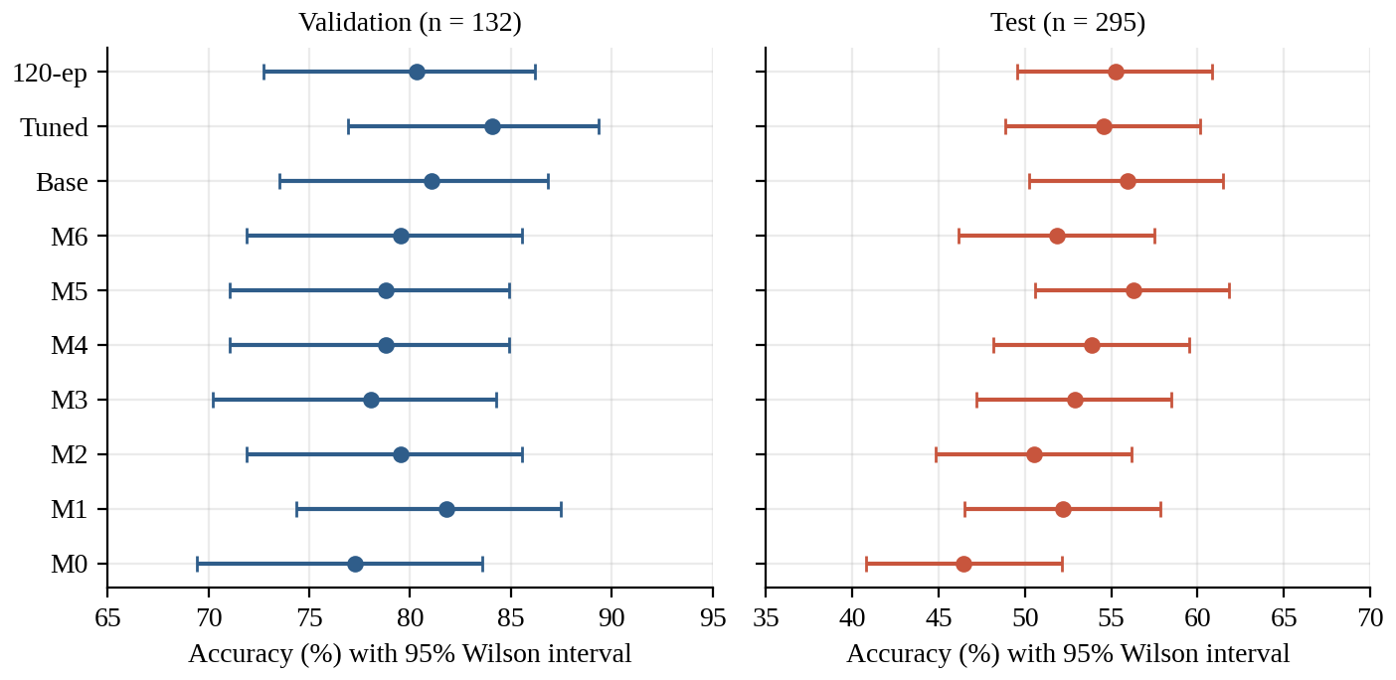
Figure 17: Accuracy of each configuration with 95% Wilson intervals on validation (left) and test (right).
To make the comparison more concrete, Table 19 reports an unpaired two-proportion z-test for the six comparisons that the ablation is designed to answer. The test is conservative because the same clips are used for both models, so paired predictions would give a smaller standard error (a McNemar test on the per-clip predictions is recommended once these are available). Even so, none of the differences reaches the conventional 5% level in either partition. The clearest effect, the addition of flow and pose (M1 vs M0), has p = 0.16 on test and p = 0.36 on validation under this conservative test.
Table 19: Unpaired two-proportion z-tests for the ablation comparisons (derived from reported counts)
Comparison | z (val) | p (val) | z (test) | p (test)
M1 vs M0 | 0.92 | 0.36 | 1.40 | 0.16
M2 vs M1 | -0.47 | 0.64 | -0.41 | 0.68
M4 vs M6 | -0.15 | 0.88 | 0.49 | 0.62
M5 vs M4 | 0.00 | 1.00 | 0.58 | 0.56
Tuned vs Base | 0.65 | 0.52 | -0.33 | 0.74
120-ep vs Tuned | -0.81 | 0.42 | 0.17 | 0.87
Conservative: models are evaluated on the same clips, so a paired test would be more sensitive. p-values are two-sided, normal approximation.
Three consequences follow. First, the statement that “modalities help” is directionally supported but not individually significant. Second, the 3.03-point validation gain of the tuned model over the baseline (z = 0.65) is well within sampling noise, and the 1.35-point test loss (|z| = 0.33) is as well. Third, the differences between M2, M3, M4, M5 and M6 (at most 1.5 points on validation and 5.8 on test) cannot be ranked reliably with the present evidence. Larger evaluation sets, multiple seeds and paired tests are needed before architectural conclusions are drawn.

6.4 Ablation study
Table 20 and Figure 18 summarise the paired differences that the ablation is designed to expose.
Table 20: Paired ablation differences in accuracy (percentage points)
Comparison | What changes | Δ validation | Δ test
M1 vs M0 | add flow + pose | +4.55 | +5.76
M2 vs M1 | concat → standard GAT | -2.27 | -1.69
M4 vs M6 | add reliability gating | -0.76 | +2.04
M5 vs M4 | remove auxiliary losses | +0.00 | +2.37
Tuned vs Base | tuning (and capacity) | +3.03 | -1.35
120-ep vs Tuned | longer training | -3.79 | +0.67

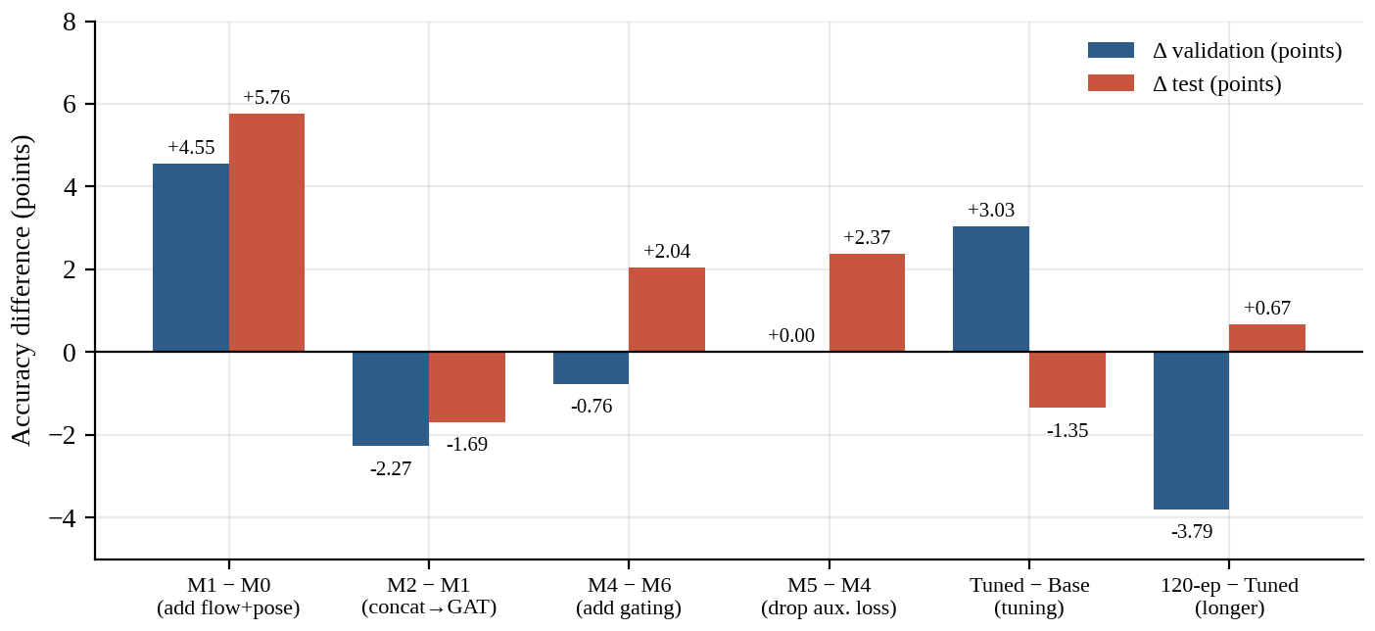
Figure 18: Validation and test accuracy differences for the six ablation comparisons.

6.4.1 Effect of modalities
Adding flow and pose to RGB (M1 vs M0) improves accuracy by 4.55 points on validation and 5.76 points on test, the only comparison in which both partitions show a gain of more than four points. It is also the largest and most consistent effect in the ablation, and agrees with the premise that appearance alone is ambiguous when classes share scenes. The effect is directional rather than statistically established (see above).

6.4.2 Effect of graph fusion
Replacing concatenation with standard, uniformly weighted graph attention (M2 vs M1) lowers validation accuracy from 81.82% to 79.55% and test accuracy from 52.20% to 50.51%. This is consistent with the mechanism the project assumes: unweighted graph attention lets every node influence every other, including corrupted ones. It is also consistent with a simpler explanation, namely that a more flexible fusion module is harder to train on 528 clips. The experiments do not separate these explanations.

6.4.3 Effect of reliability gating
The comparison that isolates reliability gating is M4 against M6 (the same graph with and without gating). On validation, M4 (78.79%) does not exceed M6 (79.55%), a difference of −0.76 points; on test it is better (53.90% vs 51.86%, +2.04 points). The two partitions disagree in sign, and both differences are within noise. Therefore the ablation does not show that reliability gating is responsible for the validation advantage of the tuned model. This conclusion agrees with the source paper’s statement that the benefit of REM/RGA is visible only after tuning and is confounded. In addition, the REM outputs were never checked against known corruptions, so the mechanism itself (low reliability for corrupted modalities) is unverified.

6.4.4 Effect of the multi-task loss
M5, trained with cross-entropy only, matches M4 on validation (78.79% both) and is 2.37 points better on test (56.27% vs 53.90%). The auxiliary box loss therefore did not help classification at this data scale; given the small number of clips, the additional gradients may even compete with the classification gradient. The auxiliary heads are nevertheless needed for the detection outputs, which are not evaluated in this report.

6.4.5 Effect of tuning and training length
Tuning improves validation accuracy by 3.03 points relative to the baseline checkpoint, but lowers test accuracy by 1.35 points. The tuned model also has a higher validation loss (0.8774) than the baseline checkpoint (0.7054) and than M1 (0.7504), despite its higher accuracy, which indicates that the tuned model is more confident when it is wrong. Training for 120 epochs does not help: the 120-epoch run is at 80.30% validation accuracy, 3.79 points below the tuned model, with a test accuracy 0.67 points higher.

6.5 Macro-F1 and validation loss
Macro-F1 (Figure 19) follows the same pattern as accuracy: the tuned model leads on validation (81.72%) and M5 leads on test (53.97%). On validation, macro-F1 is below accuracy for every configuration (by 2.4 to 3.9 points); on test it is below accuracy by 1.9 to 2.7 points for all configurations except M0, whose test macro-F1 (47.19%) exceeds its accuracy (46.44%). This indicates that performance is not uniformly distributed over classes; per-class F1 values are needed to identify which classes are hard, but they are not available in the supplied material. Figure 20 shows the validation loss, where the baseline checkpoint is best (0.7054) and M2 is worst (0.9125); Figure 21 combines all five metrics in one view.
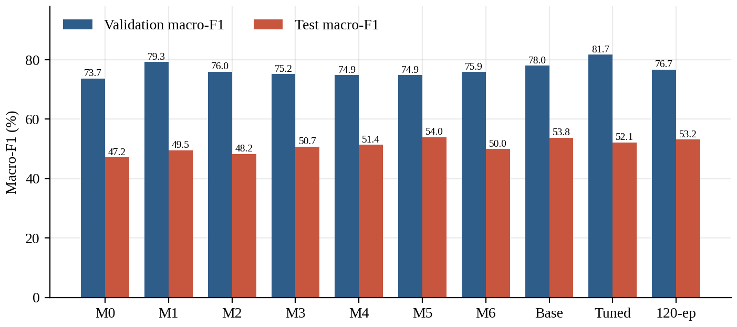
Figure 19: Validation and test macro-F1 for all configurations.
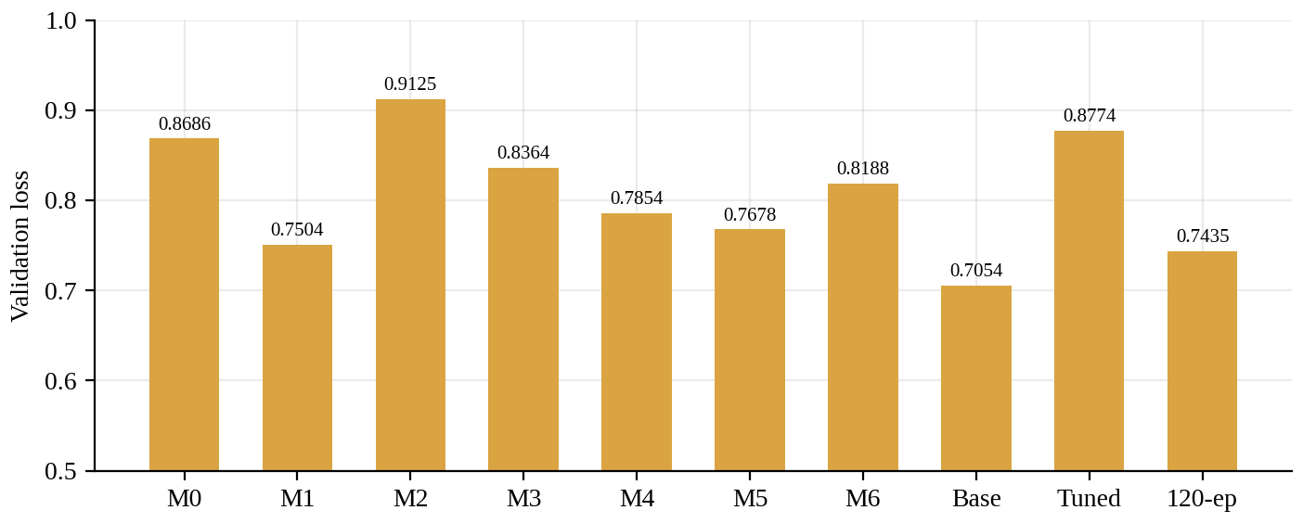
Figure 20: Validation loss for all configurations (lower is better).
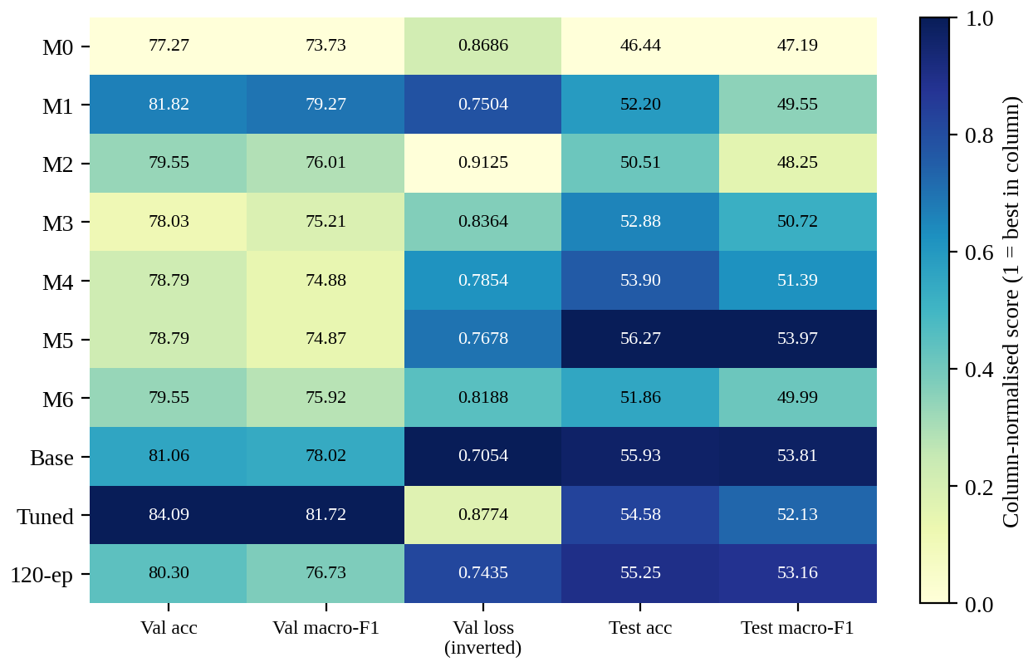
Figure 21: Heat map of all five metrics, normalised within each column.

6.6 Model size and efficiency
All configurations other than the baseline checkpoint have between 1.68 and 1.98 million parameters (Figure 22). The baseline checkpoint has 31.29 million. Moving from M0 to the full model adds about 0.29 million parameters (17.5%). Table 21 gives the incremental parameter counts between configurations; the REM adds the same 61,955 parameters whether it is combined with concatenation (M3 − M1) or with the graph (M4 − M6), which supports the view that the REM is a small, self-contained module. The 66,048-parameter step from M0 to M1 equals the size of two 128→256 linear layers with bias; this is consistent with, but does not prove, that structure.
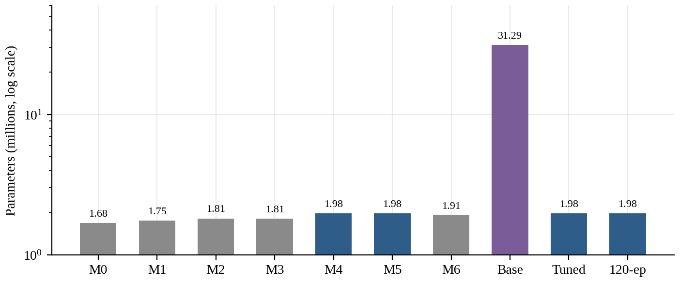
Figure 22: Parameter count of each configuration (log scale).
Table 21: Incremental parameter counts between configurations (derived from the reported totals)
Difference | Parameters | Interpretation
M1 − M0 | 66,048 | Flow and pose branches added (two 128→256 linear layers with bias have 2 × (128 × 256 + 256) = 66,048 parameters)
M2 − M1 | 67,072 | Graph attention replaces concatenation
M3 − M1 | 61,955 | REM added to concatenation
M6 − M2 | 99,591 | Relational graph variant without gating vs standard GAT
M4 − M6 | 61,955 | REM and gating added to the graph (same increment as M3 − M1)
M4 − M3 | 166,663 | Graph stage added to REM-weighted concatenation
Base − M4 | 29,313,283 | Larger baseline checkpoint; composition not documented

Figure 23 relates size to test accuracy. The 31.3 million-parameter baseline checkpoint is no more accurate on test than the 1.98 million-parameter M5 (55.93% vs 56.27%), which means that, on this benchmark, the additional parameters do not buy test accuracy. This favours compact models and supports the design goal of a small trainable core.
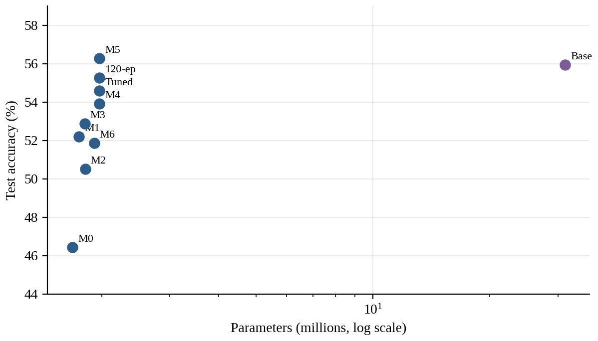
Figure 23: Test accuracy against parameter count (log scale).

6.7 Discussion

6.7.1 Why graph fusion needs reliability
Unweighted graph attention allows every node to influence every other, so a corrupted flow or pose token can contaminate appearance tokens; this is consistent with the drop from M1 to M2. Reliability-modulated attention is designed to reduce this effect, in the spirit of confidence-aware gating (Takami & Fukuda, 2026) and evidential weighting (Han et al., 2023). The analysis in Chapter 3 adds a qualification: gating on the logits shrinks, but does not eliminate, the influence of an unreliable node, and for nodes with negative ungated scores it can even increase it (Appendix D). Whether message-level gating (multiplying h_{j} by r_{j}) is also applied should be confirmed. The evidence is partly supportive (the tuned RAGFN is the best model on validation) but not clean: M6 without gating is not worse than M4 on validation, and the REM outputs were not validated against known corruptions.

6.7.2 The validation–test gap
Test accuracy (46–56%) is about 22–31 points below validation accuracy for every model, including the simple baselines, so the gap is not specific to the proposed architecture. The plausible causes, none of which has been verified, are listed in Table 22, together with the observation each would explain and the experiment that would test it.
Table 22: Hypotheses for the validation–test gap (unverified)
Hypothesis | Rationale | Decisive test | Status
Near-duplicate clips across train and validation | JHMDB clips come from a limited set of source videos; random splitting can place related clips on both sides | Group-aware split by source video; compare val scores | Unverified
Distribution shift between validation and official test | Validation was carved from non-test data; official test follows different source scenes | Evaluate on all three official splits | Unverified
Small training set | 528 clips for 21 classes (~25 per class) limit generalisation | Learning curves; augmentation; pretraining | Plausible
Selection bias | 101 trials and best-checkpoint selection on the same 132 clips | Evaluate chosen settings on a fresh partition | Likely, partial
Feature-extraction defect | Audited in the source paper; gap remained | Already examined | Not supported

The first hypothesis is attractive because it would explain why even a very simple model (M0) loses 30.8 points, but it can only be tested with the source-video identifiers. The fifth hypothesis was examined in the source paper, which reports that the gap remained after the feature-extraction audit. A reasonable reading is that the validation set is not a trustworthy proxy for the test set, and that the headline validation figures should therefore be reported with this caveat.

6.7.3 Model selection
The tuned model gains on validation but loses 1.35 points on test relative to the baseline checkpoint. Tuning on a 132-clip split with 101 trials is prone to selection bias, and multi-seed averages are the more reliable summary; the three-seed mean validation accuracy quoted in the source paper is 81.82%, which is 2.27 points below the 84.09% headline figure and is itself essentially equal to the validation accuracy of M1 (81.82%). Reporting the mean rather than the maximum is the more defensible headline.

6.7.4 What can and cannot be concluded
Table 23: Summary of what the evidence supports
Statement | Evidence | Strength
Multimodal input outperforms RGB alone | M1 vs M0: +4.55 val, +5.76 test | Directional; not significant
Naive graph fusion is harmful | M2 vs M1: −2.27 val, −1.69 test | Directional; confounded
Reliability gating improves classification | M4 vs M6: −0.76 val, +2.04 test | Not supported
Auxiliary box loss helps classification | M5 vs M4: 0.00 val, +2.37 test (in favour of M5) | Not supported
Tuned RAGFN is best on validation | 84.09% (three-seed mean 81.82%) | Within noise; selection-biased
Tuned RAGFN generalises better than the baseline | −1.35 test | Not supported
The model is far above chance | All test accuracies ≥ 46% vs 4.8% chance | Strong

6.8 Limitations
The principal limitations of the study are the following. (1) A single dataset and one train/validation/test partition. (2) Single training runs per configuration (apart from a three-seed validation summary for the tuned model). (3) A dense graph; the effect of sparser, structure-aware edges was not studied. (4) The auxiliary heads (localisation, uncertainty) and the REM scores are not evaluated. (5) No per-class results, confusion matrices or training curves are available, so error analysis at the class level is not possible. (6) Several implementation details are unknown (Chapter 4). These limitations bound the claims that can be made, and they define the agenda for Chapter 7.

CHAPTER 7
CONCLUSION AND FUTURE WORK

7.1 Summary of work and key findings
This project introduced RAGFN, a reliability-aware multimodal fusion network that estimates the reliability of RGB, optical-flow and pose streams without explicit quality labels and uses these estimates to gate the attention of a relational graph defined over 48 spatio-temporal nodes, followed by a bidirectional Transformer and four prediction heads. The report formalised the architecture with numbered equations for feature encoding, reliability estimation, gated attention, Transformer attention, classification, the losses and the evaluation metrics, described the experimental protocol and evaluated ten configurations on JHMDB.
The main empirical findings are the following. The tuned RAGFN reaches 84.09% validation accuracy and 81.72% macro-F1, but 54.58% on the official test split, and a validation–test gap of 22.5–30.8 points appears for every configuration. Multimodal input helps relative to RGB alone; naive graph fusion hurts relative to concatenation; the benefit of reliability gating is not isolated; the multi-task auxiliary loss did not improve classification at this data scale; longer training did not help. A binomial analysis shows that most of the differences between configurations are within the sampling noise of the 132-clip validation and 295-clip test sets.

7.2 Objectives achieved and not achieved
Table 24: Status of the project objectives defined in Chapter 1
ID | Objective | Status | Comment
O1 | Three-stream feature extractor | Achieved | Dimensions 16 × 256 / 128 / 128 specified
O2 | Label-free reliability estimation (REM) | Designed; unverified | Scores not yet validated against injected corruption
O3 | Reliability-gated graph attention | Designed; effect not isolated | M4 vs M6 inconclusive
O4 | Transformer and four heads with multi-task objective | Designed; partly evaluated | Only classification metrics reported
O5 | Evaluation on JHMDB with ablations | Achieved | 10 configurations, 5 metrics
O6 | Honest analysis of the validation–test discrepancy | Achieved | Hypotheses listed; not yet tested

Table 24 avoids the claim that all objectives have been met. The architecture and evaluation framework are in place; the central scientific claim, that reliability gating improves robustness, has not been established.

7.3 Limitations
The limitations are those of Section 6.8: one dataset, one partition, single runs, unverified reliability scores, no class-level diagnostics, and incomplete implementation documentation. A further limitation of this report itself is that the training curves, confusion matrices and per-class results could not be included because the underlying logs were not available.

7.4 Future work
The planned experiments are ordered by how directly they resolve the open questions (Table 25).
Table 25: Prioritised future experiments
# | Experiment | Purpose | Success criterion
1 | Group clips by source video and re-split | Remove possible train/validation leakage; re-test the validation–test gap | Gap substantially reduced
2 | Repeat all variants over multiple seeds and the three official JHMDB splits | Replace single-run values by mean ± s.d. with confidence intervals | Stable rankings with non-overlapping intervals
3 | Inject controlled blur, occlusion and keypoint dropout | Test whether REM scores fall for corrupted modalities | Monotone drop of reliability with corruption severity
4 | Compare logit gating, message gating and both | Isolate the mechanism of reliability gating | Consistent improvement of M4 over M6
5 | Sparse or learned graph topologies | Reduce the 2,304 attention pairs and the risk of over-smoothing | Equal accuracy with fewer pairs
6 | Evaluate box, boundary and uncertainty heads | Validate the detection and uncertainty outputs | Box IoU, boundary error and calibration (e.g. ECE) reported
7 | Re-train all variants from a common initialisation | Remove initialisation confound | Rankings unchanged or clarified
8 | Evaluate on larger multimodal benchmarks | Assess generalisation | Gains replicate

Beyond these, three extensions are natural: a calibration study of the temperature τ using reliability diagrams (Guo et al., 2017), an evidential variant of the uncertainty head (Sensoy et al., 2018), and the use of the reliability score as a diagnostic output for a human operator, for example to flag a clip whose pose stream is deemed unreliable.

7.5 Closing remarks
RAGFN addresses a genuine and under-studied problem, namely the explicit, sample-wise treatment of modality reliability inside the fusion stage. The present evidence supports a modest conclusion: multimodal fusion helps, the design is compact, and the framework is ready to be tested under the controlled conditions that would turn a promising validation result into a reliable scientific finding.

REFERENCES
References are given in APA (7th edition) style and ordered alphabetically. References marked † were added by the report author as standard background literature and are not in the source paper’s reference list; their details should be verified before submission.
[1] M. Takami and T. Fukuda, “Confidence-aware gated multimodal fusion for robust temporal action localization in occluded environments,” Sensors, vol. 26, no. 8, Art. no. 2454, 2026, doi: 10.3390/s26082454.
[2] D. Xie, X. Zhang, X. Gao, H. Zhao, and D. Du, “MAF-Net: A multimodal data fusion approach for human action recognition,” PLOS ONE, vol. 20, no. 4, Art. no. e0319656, 2025, doi: 10.1371/journal.pone.0319656.
[3] H. Dong, F. Zhang, C. Liu, and L. Mu, “MAGNet: Enhancing action recognition with multimodal fusion and adaptive graph convolution,” Scientific Reports, vol. 16, Art. no. 15100, 2026, doi: 10.1038/s41598-026-45601-2.
[4] M. Duhme, R. Memmesheimer, and D. Paulus, “Fusion-GCN: Multimodal action recognition using graph convolutional networks,” arXiv preprint arXiv:2109.12946, 2021.
[5] R. Wu, H. Wang, H.-T. Chen, and G. Carneiro, “Deep multimodal learning with missing modality: A survey,” arXiv preprint arXiv:2409.07825, 2024.
[6] Q. Zhang, Y. Wei, Z. Han, H. Fu, X. Peng, Q. Hu, C. Deng, C. Xu, J. Wen, D. Hu, and C. Zhang, “Multimodal fusion on low-quality data: A comprehensive survey,” Information Fusion, vol. 135, Art. no. 104437, 2026.
[7] S. Kim, D. Ahn, and B. C. Ko, “Cross-modal learning with 3D deformable attention for action recognition,” in Proc. IEEE/CVF Int. Conf. Comput. Vis. (ICCV), 2023.
[8] Z. Han, C. Zhang, H. Fu, and J. T. Zhou, “Trusted multi-view classification with dynamic evidential fusion,” IEEE Transactions on Pattern Analysis and Machine Intelligence, vol. 45, no. 2, pp. 2551–2566, 2023.
[9] A. Kendall and Y. Gal, “What uncertainties do we need in Bayesian deep learning for computer vision?” in Advances in Neural Information Processing Systems (NeurIPS), 2017.
[10] P. Veličković et al., “Graph attention networks,” in Proc. Int. Conf. Learn. Represent. (ICLR), 2018.
[11] Z. Sun, Q. Ke, H. Rahmani, M. Bennamoun, G. Wang, and J. Liu, “Human action recognition from various data modalities: A review,” IEEE Transactions on Pattern Analysis and Machine Intelligence, vol. 45, no. 3, pp. 3200–3225, 2023.
[12] K. Simonyan and A. Zisserman, “Two-stream convolutional networks for action recognition in videos,” in Advances in Neural Information Processing Systems (NeurIPS), 2014.
[13] C. Feichtenhofer, H. Fan, J. Malik, and K. He, “SlowFast networks for video recognition,” in Proc. IEEE/CVF Int. Conf. Comput. Vis. (ICCV), 2019.
[14] W. Kay et al., “The Kinetics human action video dataset,” arXiv preprint arXiv:1705.06950, 2017.
[15] A. Nagrani et al., “Attention bottlenecks for multimodal fusion,” in Advances in Neural Information Processing Systems (NeurIPS), 2021.
[16] M. Sensoy, L. Kaplan, and M. Kandemir, “Evidential deep learning to quantify classification uncertainty,” in Advances in Neural Information Processing Systems (NeurIPS), 2018.
[17] G. Bertasius, H. Wang, and L. Torresani, “Is space-time attention all you need for video understanding?” in Proc. 38th Int. Conf. Mach. Learn. (ICML), 2021.
[18] A. Arnab et al., “ViViT: A video vision transformer,” in Proc. IEEE/CVF Int. Conf. Comput. Vis. (ICCV), 2021.
[19] Z. Liu et al., “Video Swin Transformer,” in Proc. IEEE/CVF Conf. Comput. Vis. Pattern Recognit. (CVPR), 2022.
[20] H. Fan et al., “Multiscale vision transformers,” in Proc. IEEE/CVF Int. Conf. Comput. Vis. (ICCV), 2021.
[21] J. Zhao et al., “TubeR: Tubelet transformer for action detection,” in Proc. IEEE/CVF Conf. Comput. Vis. Pattern Recognit. (CVPR), 2022.
[22] T. N. Kipf and M. Welling, “Semi-supervised classification with graph convolutional networks,” in Proc. Int. Conf. Learn. Represent. (ICLR), 2017.
[23] X. Tian, N. Anantrasirichai, L. Nicholson, and A. Achim, “TaGAT: Topology-aware graph attention network for multi-modal retinal image fusion,” in Medical Image Computing and Computer Assisted Intervention—MICCAI 2024, Lecture Notes in Computer Science, vol. 15001, pp. 775–784, 2024.
[24] S. Yan, Y. Xiong, and D. Lin, “Spatial temporal graph convolutional networks for skeleton-based action recognition,” in Proc. AAAI Conf. Artif. Intell., vol. 32, no. 1, 2018.
[25] H. Jhuang, J. Gall, S. Zuffi, C. Schmid, and M. J. Black, “Towards understanding action recognition,” in Proc. IEEE Int. Conf. Comput. Vis. (ICCV), pp. 3192–3199, 2013.
[26] T. Kroeger, R. Timofte, D. Dai, and L. Van Gool, “Fast optical flow using dense inverse search,” in Proc. Eur. Conf. Comput. Vis. (ECCV), 2016.
[27] A. Dosovitskiy et al., “FlowNet: Learning optical flow with convolutional networks,” in Proc. IEEE Int. Conf. Comput. Vis. (ICCV), 2015.
[28] D. Sun, X. Yang, M.-Y. Liu, and J. Kautz, “PWC-Net: CNNs for optical flow using pyramid, warping, and cost volume,” in Proc. IEEE/CVF Conf. Comput. Vis. Pattern Recognit. (CVPR), 2018.
[29] Z. Teed and J. Deng, “RAFT: Recurrent all-pairs field transforms for optical flow,” in Proc. Eur. Conf. Comput. Vis. (ECCV), 2020.
[30] Z. Cao, T. Simon, S.-E. Wei, and Y. Sheikh, “Realtime multi-person 2D pose estimation using part affinity fields,” in Proc. IEEE Conf. Comput. Vis. Pattern Recognit. (CVPR), 2017.
[31] V. Bazarevsky et al., “BlazePose: On-device real-time body pose tracking,” arXiv preprint arXiv:2006.10204, 2020.
[32] C. Lugaresi et al., “MediaPipe: A framework for building perception pipelines,” arXiv preprint arXiv:1906.08172, 2019.
[33] K. He, X. Zhang, S. Ren, and J. Sun, “Deep residual learning for image recognition,” in Proc. IEEE Conf. Comput. Vis. Pattern Recognit. (CVPR), 2016.
[34] R. Girshick, “Fast R-CNN,” in Proc. IEEE Int. Conf. Comput. Vis. (ICCV), 2015.
[35] T.-Y. Lin et al., “Focal loss for dense object detection,” in Proc. IEEE Int. Conf. Comput. Vis. (ICCV), 2017.

APPENDIX A: SOURCE AND MISSING-INFORMATION REGISTER
This register records what was taken from the supplied documents, what is missing and what is ambiguous. No missing value has been filled with an assumption.
Table 26: Information taken from the source documents
Item | Source and value
Title, authors, guide | Source paper: A Novel Deep Learning Approach for Multimodal Action Detection with Uncertainty-Aware Prediction; Aditya Raj Biswal, Loveena Batra, Shreyash Gautam; guide Dr. Sandeep Kumar Satapathy (Assistant Professor)
Dataset and split | JHMDB, 21 classes; 528 / 132 / 295 clips
Architecture | ResNet-50, DIS flow + CNN, MediaPipe pose + MLP; REM; 48-node graph; 2-layer 8-head bidirectional Transformer; four heads
Reported metrics | All values in Chapter 6, Table Table 15; three-seed mean validation accuracy 81.82%
Report format | BCSE497J template: A4; margins 3.81/2.54/2.54/2.54 cm; Times New Roman 12 pt; APA references

Table 27: Information missing and requiring confirmation
Item | Needed from the project team
Registration numbers; candidate identity for individual pages | Names and register numbers of the three team members; name of the individual submitting this report
Guide designation, HoD name, dates, signatures, seal | To be completed manually on the printed copy
Optimiser, learning rate, schedule, batch size, epochs | Training scripts or logs
Graph layers L, hidden sizes, dropout, d_{k} | Model code
λ_{loc}, λ_{unc}; definitions of L_{loc}, L_{unc}; use of Kendall–Gal weighting | Loss implementation
Meaning of tf_mult; hyperparameter search space; source runs for weight transfer | Tuning logs
Per-seed validation accuracies | Three-seed experiment logs
Hardware and software versions | Environment files
Training curves, confusion matrices, per-class F1, REM scores | Logs and prediction files (will be added as figures)
Whether the external-guide certificate is required | Only for PAT-discontinued students (template)

Table 28: Conflicts and ambiguities found in the source material
Topic | Observation | Decision needed
REM formulation | Text and figure: temporal mean pooling, GELU MLP and softmax across three modalities. Eq. (2): ReLU MLP and sigmoid per token | State which is implemented
Gating mechanism | Text: node features are multiplied by reliability (“hard gating”). Eq. (3): attention logits are scaled; Eq. (5) has no reliability factor | Confirm logit gating, message gating or both
Graph topology | Text: 48-node graph; figure: “3 vertices, 3 edges” modality graph; Eq. (4): neighbourhood is all nodes | Confirm graph at token level and layer structure
Equation extraction | Eqs. (4)–(9) lost summations/denominator in text extraction | Restored in this report; confirm against Word equations
Validation–test gap | Abstract/figure caption: “more than 22 points”; discussion: “about 25–30”; exact range is 22.52–30.83 | Use the exact values
Dataset size | 955 clips in the paper; original JHMDB commonly cited with 928 | Confirm release used
Reference quantity “CMCA” | Defined in a formula but not in the text | Remove or define
Baseline checkpoint | 31.29 M parameters vs 1.98 M for all others | Document its architecture
Reference list | Paper lists 15 numeric references; some lack volume/page numbers | Complete details

APPENDIX B: NUMERICAL DATA UNDERLYING THE FIGURES
Table 29 lists the exact values from which the figures of Chapter 6 were drawn. All values are from the source paper; counts are derived by multiplying the percentages by the partition sizes (132 and 295) and were verified to reproduce each reported percentage exactly.
Table 29: Reported results and derived counts
ID | Val acc | Val F1 | Val loss | Test acc | Test F1 | Val n correct | Test n correct | Params
M0 | 77.27 | 73.73 | 0.8686 | 46.44 | 47.19 | 102 | 137 | 1,680,917
M1 | 81.82 | 79.27 | 0.7504 | 52.20 | 49.55 | 108 | 154 | 1,746,965
M2 | 79.55 | 76.01 | 0.9125 | 50.51 | 48.25 | 105 | 149 | 1,814,037
M3 | 78.03 | 75.21 | 0.8364 | 52.88 | 50.72 | 103 | 156 | 1,808,920
M4 | 78.79 | 74.88 | 0.7854 | 53.90 | 51.39 | 104 | 159 | 1,975,583
M5 | 78.79 | 74.87 | 0.7678 | 56.27 | 53.97 | 104 | 166 | 1,975,583
M6 | 79.55 | 75.92 | 0.8188 | 51.86 | 49.99 | 105 | 153 | 1,913,628
Base | 81.06 | 78.02 | 0.7054 | 55.93 | 53.81 | 107 | 165 | 31,288,866
Tuned | 84.09 | 81.72 | 0.8774 | 54.58 | 52.13 | 111 | 161 | 1,975,583
120-ep | 80.30 | 76.73 | 0.7435 | 55.25 | 53.16 | 106 | 163 | 1,975,583

APPENDIX C: ADDITIONAL PSEUDOCODE
Algorithm 4: Reliability Estimation Module (modality-level)
Input : feature sequences X_m (16 x d_m) for m in {rgb, flow, pose}
Output: reliability vector r = (r_rgb, r_flow, r_pose), sum(r) = 1
1 for each modality m:
2 xbar_m = (1/16) * sum_t X_m[t] # temporal mean pooling
3 s_m = w_m^T GELU( W_m xbar_m + b_m ) # scalar score
4 r = softmax( [s_rgb, s_flow, s_pose] ) # Eq. remmod
5 return r

Algorithm 5: Evaluation of a checkpoint
Input : checkpoint, evaluation clips (N), classes C = 21
Output: accuracy, macro-F1, 95% Wilson interval
1 for each clip: predict class by argmax of p(c|x)
2 N_ok = number of correct predictions; acc = N_ok / N # Eq. acc
3 for each class c: compute TP_c, FP_c, FN_c, P_c, R_c, F1_c # Eq. pr, f1
4 macroF1 = mean_c F1_c # Eq. macro
5 (lo, hi) = Wilson(N_ok, N, z = 1.96) # Eq. wilson
6 return acc, macroF1, (lo, hi)

APPENDIX D: DERIVATION OF THE GATING PROPERTIES
Let s_{ij} denote the ungated score of Equation (4) and ρ_{ij} = r_{i}r_{j} ∈ [0, 1], so that e_{ij} = ρ_{ij}s_{ij}.
Property 1 (shrinkage). Since 0 ≤ ρ_{ij} ≤ 1, |e_{ij}| = ρ_{ij}|s_{ij}| ≤ |s_{ij}|, with equality only when ρ_{ij} = 1 or s_{ij} = 0. In the limit r_{j} → 0, e_{ij} → 0, hence exp(e_{ij}) → 1: the node is neutral, not excluded.
Property 2 (direction of the effect). Write B = Σ_{k≠j} exp(e_{ik}), so that α_{ij} = exp(e_{ij}) / (exp(e_{ij}) + B). Differentiating with respect to r_{j}, with B independent of r_{j}:
 | $\frac{∂α_{ij}}{∂r_{j}}=α_{ij}\left(1−α_{ij}\right)s_{ij}r_{i}$ | (21)
The sign of the derivative is the sign of s_{ij}. Therefore lowering the reliability of node j lowers its attention weight if and only if its ungated score s_{ij} is positive; if s_{ij} < 0, lowering r_{j} raises α_{ij}. This holds independently of the other neighbours. The result is relevant because the LeakyReLU in (4) allows negative scores (scaled by the negative slope).
Property 3 (message gating). If the update in Equation (6) were replaced by h_{i}′ = ELU(Σ_{j} α_{ij} r_{j} Wh_{j}), a node with r_{j} = 0 would contribute nothing to h_{i}′ irrespective of its attention weight. This variant corresponds to the verbal description “the feature vector is multiplied by its reliability score” in the source text, and the two mechanisms (logit gating and message gating) can be combined. Which one RAGFN implements is an open item in Appendix A.

