Team 500

**INDEX**

Introduction 3

Problem Overview 3

Manual Lake Cleaning 4

Our Solution 5

Features of the bot 6

List of Components 9

Product Specifications 13

Innovativeness 14

Utility 15

Cost Analysis 16

Future Prospects 17

Environmental Impact 18

Annexure 19

# INTRODUCTION

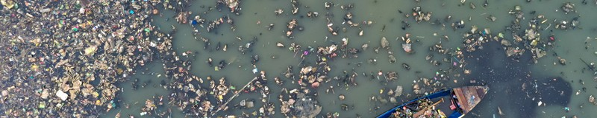

Plastic pollution is a significant global problem due to the impact of plastic on the environment, and only a tiny portion of plastics are recycled. In 2018, global polymer production resulted in **359 million tons**, but only **47.1%** of plastic waste was properly disposed of through recycling, landfills, and energy recovery. Research has shown that rivers are like highways transporting **0.4–4 million metric tonnes** of plastic from human- inhabited land into the oceans. Every year, **8 to 12 million tonnes** of plastic debris enter the ocean due to the mishandling of plastic waste in aquatic areas. Many water bodies in India are now **severely polluted**. Plastic pollution in rivers and lakes necessitates immediate and concerted action. Deploying innovative solutions like **semi-autonomous water cleaning technology** is imperative to reduce the adverse impacts of plastic waste on aquatic ecosystems and human health. By leveraging data-driven approaches and advanced techniques, one can effectively combat plastic pollution, ensuring the preservation and sustainability of our invaluable water resources for generations to come.

**Chilika Lake - Orissa**, **Dal Lake - Jammu and Kashmir**, and **Powai Lake- Bombay** are on the list of the country's most severely polluted water bodies. **Doddakallasandra Lake(Banglore)** has raised the alarm over rampant waste dumping and subsequent burning, leading to a severe environmental hazard. The lake, renowned for its rich biodiversity, is now threatened as plastic waste infiltrates its waters, prompting concerned citizens. **Santragachi Lake(near Kolkata)** is surrounded by heavy garbage dumped into it, threatening migratory birds. A survey identified ten of the largest rivers in the world as the top plastic waste carriers — including the **Indus**, **Brahmaputra**, and **Ganges** from India.

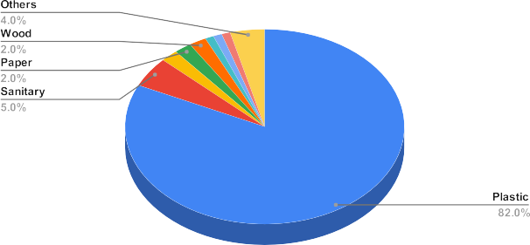

**PROBLEM OVERVIEW**

**PROBLEM OVERVIEW**

Water bodies in various states across India, including lakes and wetlands, exhibit **concerning pollution levels.** Macro plastics hurt aquatic wildlife; for instance, organisms can be entangled or suffocated, and their ingestion can cause the occlusion of the gastrointestinal tract. The plastic layer above the water also affects the dissolved oxygen in the water. Plastic waste can be classified into different categories according to their usage. The top categories encountered in different lakes are **bags**, **bottles**, **beverage bottles**, **bottle caps**, **cellophane bags**, **ﬁshing lines**, **food wrappers**, **packaging material**, **plastic canisters**, **plastic plates**, and **synthetic clothes**.





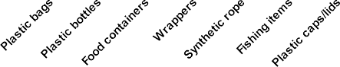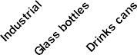

**MANUAL LAKE CLEANING**

Currently, there is **no adequate method** for lake cleaning other than manual work, which is dangerous and infeasible in most cases due to scale and inefficiency. The plastic waste thus collected for various reasons **stagnates** on the water surface, resulting in immense pollution. Sometimes, contractors hire **manual labourers** to clean drains, lakes and rivers. Manual scavenging is prohibited and violates the state government’s notification of December 2022. However, due to a lack of adequate alternative solutions, Labourers enter the water bodies without any safety measures. This practice poses a **high health risk** and even chances of death in extreme cases. According to government data, **339** people have died while cleaning sewers in India in the last five years.

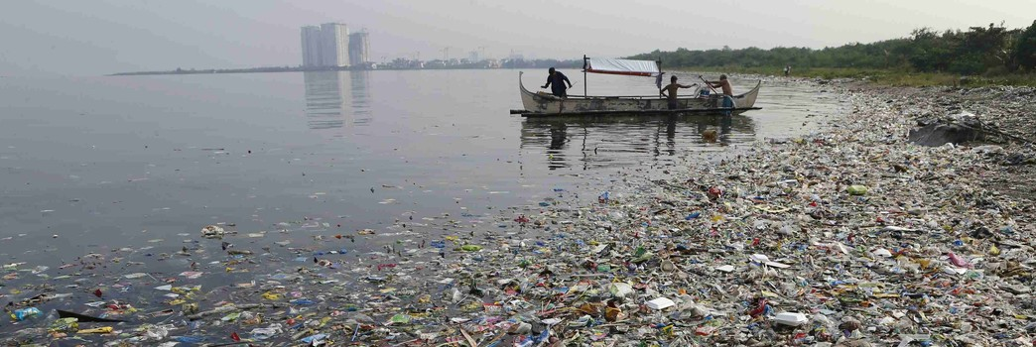

**OUR SOLUTION**

### Product Summary : Our Self-Navigating Water Cleaning Bot is engineered to address the critical issue of plastic pollution in water bodies efficiently and precisely. Here's a concise overview of our solution:

**Semi Autonomous and Navigation:** Our Bot operates semi-autonomously, navigating through water bodies independently using **camera** and a sophisticated **navigation algorithm**.

**Target Identification and Localization:** With the **visual image feed** from a high-resolution camera system, the Bot accurately **identifies and localizes target garbage**, ensuring effective collection of debris.

**Data Processing and Control:** Data captured by the camera is processed onboard by a **Raspberry Pi**, which generates instructions for the Bot's actions. These instructions are then executed by a Raspberry Pi microcontroller, controlling the Bot's motorized components.

**Motorized Mechanism:** The Bot features a high-torque DC motor connected to geared Paddles, enabling **precise movement and maneuverability** in the water.

**Debris Collection System:** Utilizing a conveyor system comprising a high-torque motor, rollers, and a belt conveyor, our Bot efficiently collects debris from target locations.

**Storage Unit:** Debris collected is transferred to a strategically designed storage unit, minimizing unnecessary weight on the Bot and ensuring optimal performance.

**Confirmation and Progression:** Upon successful debris collection, the Bot uses its camera system to **confirm proper collection** before proceeding to the following target location.

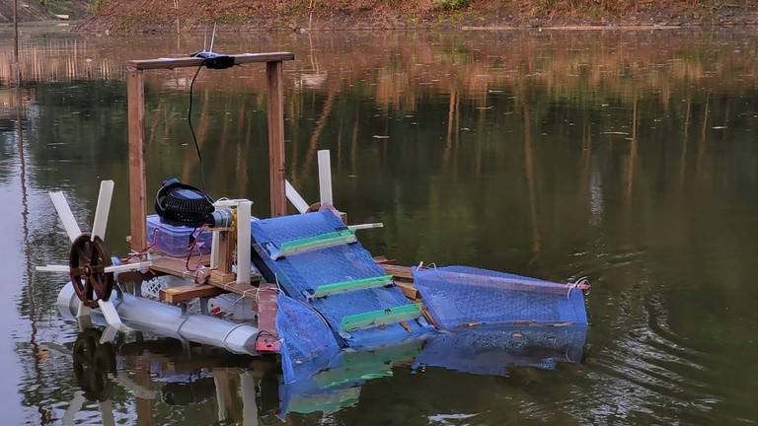

**FEATURES OF THE BOT**

## GARBAGE COLLECTION

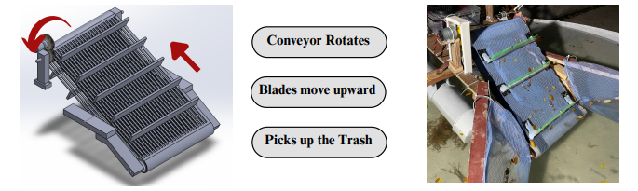**Conveyor Belt:** The Conveyor Belt is used to pick up the garbage. The belt is attached to the garbage picking flaps, and a DC motor powers it. The flaps attached to the belt pick up the trash and accumulate it in the Garbage Bin via belt rotation.

1. **shaped Extension:** The v-shaped extension guides the garbage onto the belt. The net attached to these two v-shaped bars guides the debris to properly align with the centre of the conveyor belt, causing the waste to travel towards the flaps. This helps the conveyor belt pick up the garbage.

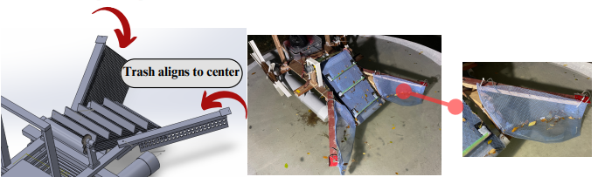

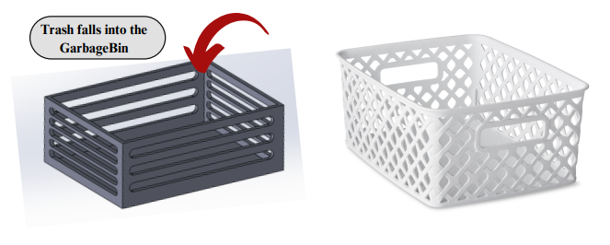**Garbage Collection in Bins:** The garbage proceeds upwards along the conveyor belt and is collected in the garbage bin. The Garbage bin can lift up to **8 Kgs** of waste.

**FEATURES OF THE BOT**

## MANEUVERABILITY

**Main rotation Paddles:** The Paddles move the Bot in the lake. Clockwise rotation of both the Paddles will lead to forward motion, and anticlockwise rotation of both the Paddles will lead to backward motion. In contrast, the clockwise rotation of one and anticlockwise rotation of the other will lead to the rotation of the Bot about itself.

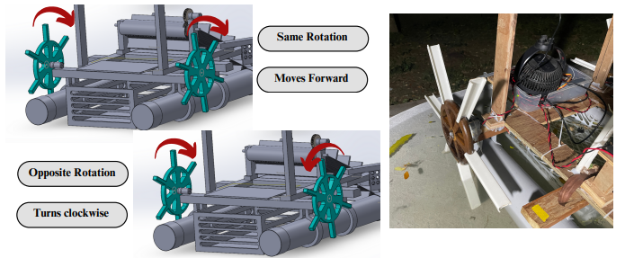

## SEMI-AUTONOMOUS CONTROL

**Remote Control (Manual):** The RC controller can manually operate the Bot, in which six channels are available, of which four are used.

CH 1 and CH2 are used to control the **forward - backwards** and **right-left rotation** of the bot, respectively. CH 3 is used to **control the conveyer belt**, and CH 4 is used to **toggle from manual to self navigating mode**. The Bot automatically switches to self-navigation mode when the controller is turned off.

CH 1 corresponds to the THROTTLE of the RC transmitter, and CH2 corresponds to the ROLL of the transmitter.

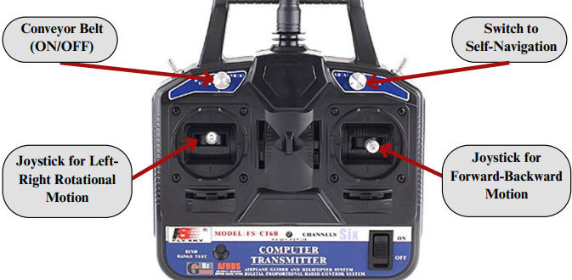

#### Self-Navigating Control:

The webcam attached to the bot acquires an image feed and applies various **image processing and object detection** techniques. The **yolov8** model is used to determine the garbage location. The bot is aligned and maneuvered toward the trash with the help of the PID controller.

**Error**: The X-coordinate at the centre of the image is referred to as the target value, with the X-coordinate at the centre of the bounding box serving as the measured value, while the speed of the Paddles acts as the manipulated variable

**Control Law**: The control law for the PID controller is defined as follows: speed = k*error + ki * cumulative error + kd1 * (error - prev_error) - kd2 * change in speed

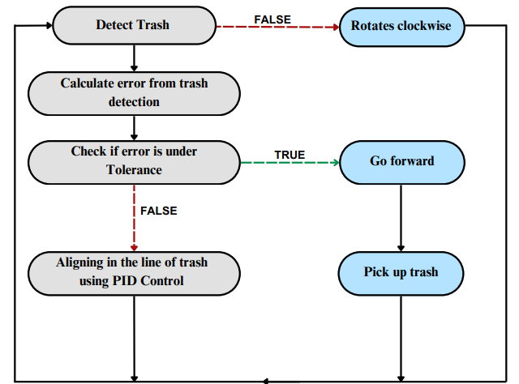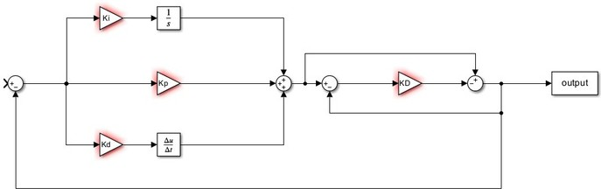**kd2**: This term ensures that there are no sudden changes in the speed of the robot

8

**LIST OF COMPONENTS**

**Mechanical Components**

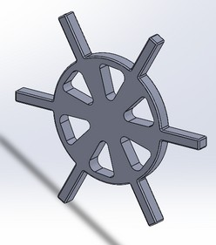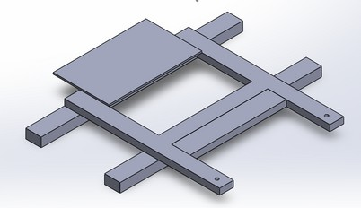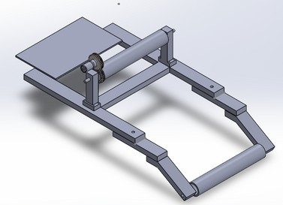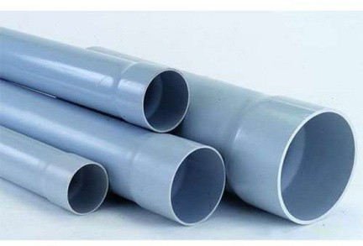

#### Wooden Base Platform and Extended Support :

It is the **main frame** of the bot, which connects to floaters, conveyor belts, and sealed electronic boxes. It is made up of **0.5-inch plywood**. It has dimensions of  **40cm by 50cm.**

#### PVC Sealed Pipes (Floatation) :

The PVC pipes are responsible for the **bot's floatation**. The wooden base frame is mounted on this part. It is made up of PVC material with a dimension of **100mm**.

#### Wheels with Paddles:

The Wheels with Paddles helps with the bot's traversal. It is connected to the geared DC motor. The flap's inner section is made of wood, and the extended part is made of plastic. The wheel is of **diameter 165mm**, and the plastic flap is of **length 150 mm**.

**Conveyor System:** The conveyor system, mounted on the wooden base, collects the debris from the water surface and transfers it to the storage unit. Its three main subcomponents are **the geared DCmotor, belt**, and **rollers**. The belt is mounted on a 50mm PVC pipe roller, consisting of flaps to lift the trash as the belt makes a steep angle with the water's surface.

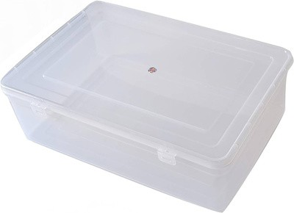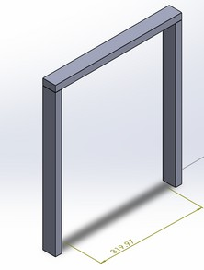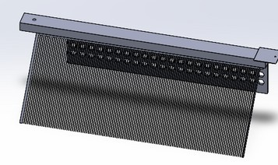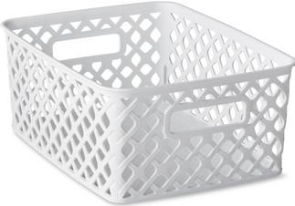

#### Garbage Bin :

The garbage bin made of Plastic is placed in between the floaters and the base platform. It has capacity of **20.6 liters**. All the debris passed from the conveyor system get collected in it.

#### V-shaped Extension Structure :

The V-shaped bar and net structure is a **forward extension** of the bot. This is made primarily of plywood and is **500 mm in length**. The extension helps correctly align the garbage so it works smoothly on the conveyor belt.

#### Camera Mount :

The camera mount is at an elevated height in the central right portion for a clear view. It provides a platform for the camera to detect garbage. It has a **height of 49 cm** and is made of Plywood

#### Sealed Box of Electronic Parts :

The sealed box of electronics is located at the back part. All the electronic components are placed in one place, which is this sealed box. It contains a Raspberry Pi 5, an L298N motor driver, and a battery. As our bot is dealing with water, it plays a crucial role in the insulation of the components. It’s dimensions are **260mm X 160mm X 60mm**.

|  |  |
| --- | --- |
| **Raspberry Pi 5 :**  The Raspberry Pi 5 is a high-performance processor with dual-display support up to 4K via micro-HDMI, hardware video decoding up to 4Kp60, 8 GB of RAM, Bluetooth 5.0, USB 3.0, and PoE capability. It's used to **automate the bot**, receiving visual data from the camera and giving instructions for its traversal. |  |
|  | **L298N Motor Driver :** The L298N motor driver **controls the rotation direction and speed of DC motors**. It can drive two motors simultaneously, allowing the bot to have **differential steering**. This motor driver is a dual H- bridge module capable of controlling two DC motors or one bipolar stepper motor with a peak output current of up to 2A. |
| **Geared DC MOTOR (conveyor and powered Paddles) :**  The **12V** geared **30 rpm** High-Torque DC motor is used in conveyor belts and powered Paddles. It is a high-torque motor equipped with gears. |  |
|  | **Flash Lights:**  This Flashlight is **waterproof** , lithium ion battery powered white LED , with adjustable range . |
|  | |

**LIST OF COMPONENTS**

**Electronic Components**

**HP Camera (W200):**

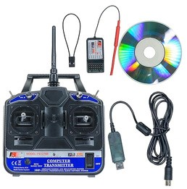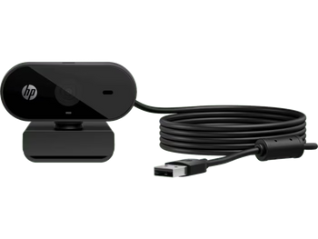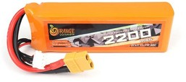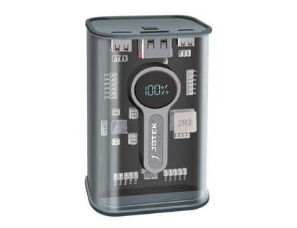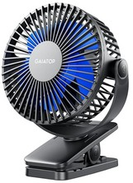

The camera provides **visual input** to our automation system. The debris on the water surface is detected by processing the visual inputs provided by the camera. The camera’s resolution is **1280*720p** and Max frame rate is **30fps.**

#### RC Transmitter and Receiver :

The transmitter and receiver are critical components for the bot's maneuver and the conveyor belt's functioning. It is a **six channel** transmitter-receiver system with a **204 GHz** communication frequency. The range of the communication system is **500m - 1km**.

#### Battery :

The **2200 mAh** battery is the power source for the wheels' motor with Paddles, the conveyor system.

#### Power Bank :

The **10000 mAh**, **23 Watt** power bank is used to provide power to the system responsible for the autonomous control of the bot. The autonomous systems consist of a Raspberry Pi microcontroller and a camera.

#### Cooling Fan:

The cooling fan above the electronic components lets the bot work in sunny weather by keeping Raspberry Pi cool. This increases the performance of the processor and positively impacts garbage detection.

# 

**PRODUCT SPECIFICAITONS**

### 

**Approximate time required to clean a 1m x 1m area of a water body:** Considering bot dimensions: **length = 95cm** and **width =73cm** The turning time (90 degrees) of the bot **is 4 seconds**.

The estimated time required to move in a 1-meter square area is

**19.516 seconds**.

Experimentation in various scenarios revealed that due to drag and garbage obstruction, the actual time required to cover a 1-meter square area is approximately 6-7 seconds more than the estimated time.

Therefore, nearly **25 seconds** of time can be considered to clean 1 meter square of area.



**Approximate mass of trash collected in one hour:**

Sight distance of camera (S) = **350 cm**

Time to align with trash **= 35 sec**

Time to reach trash = S / speed of bot = 350 / 8.5m = **41 sec**

Total time to collect trash = 35 sec (align) + 41 sec (reach) = **76 sec** Number of trash collected in one hour = 3600 sec / 76 sec = 47.25 ≈ **47** (rounded down to the nearest whole number)

Average mass of trash = **100 gm**

Mass of trash in one hour = Number of trash in one hour x Average mass of trash = 47 x 100 = **4700 gm**

Therefore, the approximate mass of trash collected by the bot in one hour is **4700 grams**.

**INNOVATIVENESS**

**Automated Garbage Detection:** The camera **detects the garbage** before and then

**meneuvers towards** it. This feature makes the bot power efficient as it travels in a targeted direction rather than blindly.

**Cost Efficient:** Our bot has intelligent design ideas and optimizations at every step, costing **26570 Rs.** During mass production, the price of the bot can be **reduced to 70 to 80 per cent** of its original cost.

**Continuous Garbage Collection:** With the help of a constantly moving conveyor belt, the bot will continuously collect the debris and transfer it to the storage unit. The bot can traverse up to **one and a half hours in one go**.

**V-Shaped Extension:** The V-shaped extensions used in our bot direct the garbage on the water's surface towards the centre. This results in efficient garbage picking and improves the ability to **capture broad types of debris**.

**Floating Garbage:** The garbage bin used with our bot is perforated, so the collected **garbage keeps floating** on water. This reduces the weight of the trash to be added to the payload of the bot, making it battery-efficient.

**Continuous Operation:** The robot can operate around the clock with periodic charging. This feature is particularly beneficial in areas where manual cleanup efforts may be limited due to resource constraints or safety concerns.

**Switching to Remote Control:** Considering the diverse conditions like lakes, rivers and other bodies, the bot can be controlled manually with just one click of the remote control, which controls the motion of the bot and the function of the conveyor belt according to the required condition to avoid any mishaps.

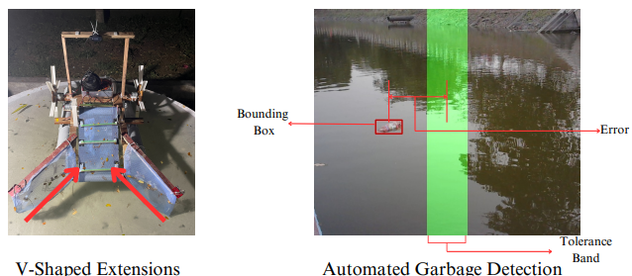

**UTILITY**

**Tackling Plastic Pollution Crisis:** According to an Indian Express report, around **350 million tonnes** of plastic waste are generated annually, while 25 percent of it is recycled or incinerated, the remaining **75 percent go unrecycled** and is dumped in landfills or littered on land or rivers, lakes and oceans. Our portable and affordable cleaning bot tackles this head-on, removing plastic debris from urban lakes and rivers.

**Ideal for Resource-Limited Areas:** Many areas, especially those with poorly planned development around lakes, lack proper waste management infrastructure. Here, the bot's **affordability and portability** shine. It can be easily deployed in these locations to address pollution problems.

**Sanitation of Stagnant Water & Low Flow Water Bodies:** Slow-moving rivers and stagnant lakes are **pollution hotspots**. The bot's maneuverability allows it to navigate these areas effectively, removing floating waste and improving water quality.

**Targeted Waste Collection:** Our bot specializes in collecting **the most common water pollutants** – single-use plastics, food packaging, tetra packs, aquatic weeds, tin, and aluminum cans.and even dead aquatic life. This targeted approach ensures efficient waste removal from water bodies**.**

**Restoring City Lakes:** Many urban lakes are in a critical state due to pollution. Karnataka State Pollution Control Board (KSPCB) has sounded the alarm over the worsening condition of Bengaluru's lakes. The bot's cost-effectiveness and efficiency make it a valuable tool for cleaning these lakes and restoring them to their former health.

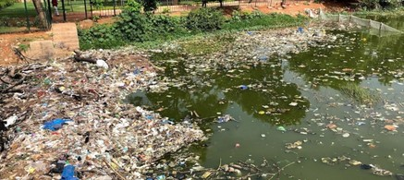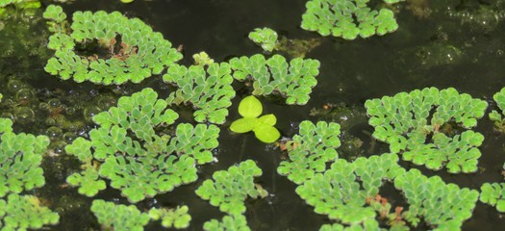**Beyond Plastic: Advanced Weed Harvesting:** Our bot goes beyond plastic by acting as a **floating-weed harvester** for invasive aquatic plants like water hyacinth, duckweed, mosquito fern and watermeal. This helps control their growth and improves overall water health.

Bangalore Water Crisis Mosquito Fern

**COST ANALYSIS**

|  |  |  |  |
| --- | --- | --- | --- |
| S no. | Components | Quantity | Price |
| 1 | Wood | 1 | 1500 |
| 2 | PVC sealed pipes | 2 | 300 |
| 3 | Wooden Wheels | 2 | 500 |
| 4 | Plastic strips | 2 | 200 |
| 5 | gear | 1 | 180 |
| 6 | mesh | 1 | 50 |
| 7 | bearings | 4 | 180 |
| 8 | rubber strip | 1 | 100 |
| 9 | Lithium Ion battery(2200mah,11,1v) | 1 | 2500 |
| 10 | Garbage Bin | 1 | 100 |
| 11 | Sealed Box | 1 | 50 |
| 12 | Raspberry pi 5 | 1 | 8000 |
| 13 | L298N motor driver | 4 | 1000 |
| 14 | Geared DC MOTOR | 3 | 1350 |
| 15 | Flash Lights | 2 | 360 |
| 16 | HP Camera | 1 | 2000 |
| 17 | RC transmitter and recieve | 1 | 5700 |
| 18 | Power Bank | 1 | 2000 |
| 19 | Miscellaneous (frame/screws/bolts,adhesive) |  | 500 |
|  | Total |  | 26570 |

**FUTURE PROSPECTS**

**Fully Autonomous :** A bot which is capable of **coming back to charge itself** after each cycle will reduce the need of human intervention in the cleaning process.

**Solar Power :** Adopting a solar battery-powered electric motor ensures **sustainable**, autonomous operation, reducing environmental impact and operational costs.

**Detachable Automatic Garbage Bin** : The automatic garbage bin streamlines the waste collection process, allowing **auto-removal and auto-replacement** when complete, enhancing operational efficiency.

**Waste Segregation System** : Implementation of a waste segregation system distinguishes between degradable and non-degradable materials, facilitating **targeted disposal** or recycling efforts and minimizing environmental contamination.

**Water Mapping and Navigation**: Equip the bot with LiDAR or sonar technology to create **real-time maps** of the water body. This allows for efficient path planning, avoiding obstacles and ensuring complete coverage during cleaning cycles.

**Adaptive Cleaning Mechanisms**: Integrate **various cleaning methods** based on the type of pollution encountered. For example, use skimmers for surface debris, brushes for biofilm removal, and underwater vacuums for bottom sediment.

**Microplastics Capture**: Integrate filters or micro-mesh technology to capture microplastics while cleaning, preventing further pollution.

**Communication and Collaboration**: A fleet of bots could communicate with each other, **coordinating cleaning efforts** and covering large areas efficiently. This could involve swarm intelligence algorithms where bots adapt their behavior based on real-time data and the overall cleaning strategy.

**pH and COD(Chemical Oxygen Demand) Sensor**: Integration of water pH and COD(Chemical Oxygen Demand) sensors for real-time monitoring is crucial in assessing **water quality** and guiding cleaning efforts effectively.

# 

**ENVIRONMENTAL IMPACTS**

**UN’s Sustainable Development Goals :** The Bot satisfies 5 out of 17 **SDGs** (Sustainable Development Goals) which are **Good Health and Wellbeing**, **Clean Water and Sanitation**, **Sustainable cities and communities**, **Climate action**, **Life Below Water**, **Life on Land**.

**Untreated Wastewater Pollution:** With **70% of surface water** polluted by untreated wastewater, our Bot intervenes by efficiently removing plastic debris and other pollutants from water bodies, contributing to a cleaner environment.

**Polluted Rivers:** The Ganges, ranked **2nd most polluted** globally, impacts **2.9 million** people. Polyethene from discarded plastic bags, food-packaging films and milk packets is increasingly gagging the Ganges river, turning it into a toxic water body downstream. Our Bot's targeted cleaning efforts directly address pollution in critical waterways, enhancing water quality and public health outcomes.

**Future Water Demand and Pollution:** With freshwater demand set to **double** by 2030, our Bot's proactive approach to cleaning water bodies helps mitigate the potential exacerbation of water pollution, ensuring sustainability for future generations.

**Industrial and Agricultural Pollution:** Significant pollution stems from industrial waste and agricultural runoff, impacting water quality. Our Bot's role in removing debris reduces overall pollution levels and preserves water quality.

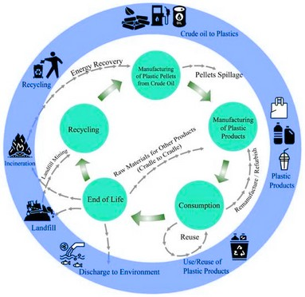**Improved Aquatic Life:** Cleaner water fosters **healthier aquatic ecosystems**, leading to a resurgence of fish populations, plankton growth, and increased biodiversity

**ANNEXURE**

**Different Views of CAD Model**

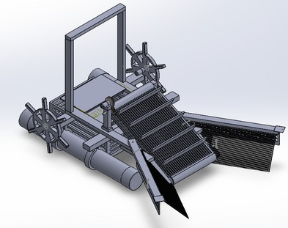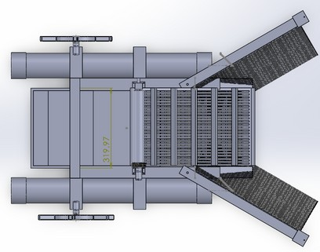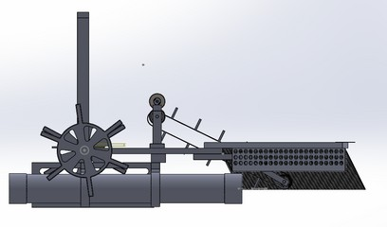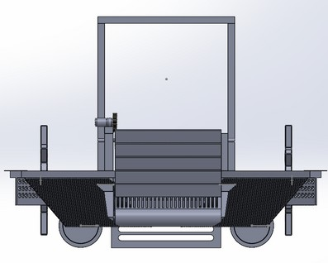

#### Orthogonal View Top View

**Side View Front view**

19

# 

**CODE SNIPPETS**

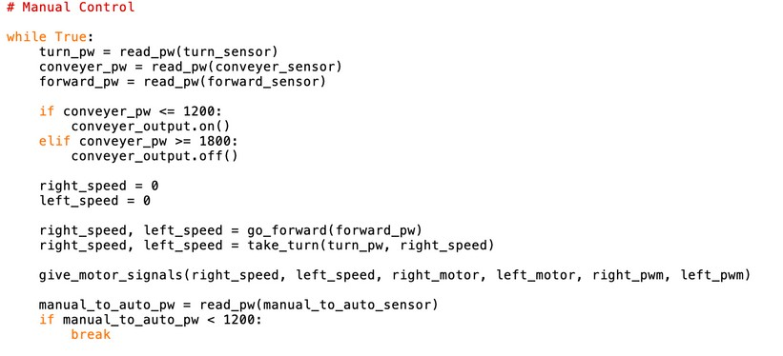

**Calculations :**

**Motor specification**:

Voltage........................................................................................ 12 V

Rated speed................................................................................. 30 RPM

* Speed of belt=Perimeter of wheel x RPM=( Pi x Diameter x RPM)/60) =(3.14 x 0.05 x 30x 0.5)/60 = 0.04 m/s
* Speed of bot = 8.5 cm/s
* Drag froce = 0.5*ρ*v^2* Cd * A
* Cd = 0.82 for long cylinder
* Drag force = 0.04803 N
* Power Consumed = F*V = 0.00408 J/s
* Required Run time = (Nearly) 2 Hours
* Energy = 0.00408*60*60 = 29.39 J
* Battery capacity Required = 14.6977/11.1=**2.64Ah**

**Operation Time**

Average Run time:- 1.5 hr (Experimental)

Average current to the bot:- 2A (Experimental)

Voltage rating:- 11.1 V

**Approximate mass of trash collected in one hour:**

* Sight distance of camera (S) = **350 cm.**
* Time to align with trash = **35 sec**.
* Time to reach trash = S / speed of bot = 350 / 8.5m = **41 sec**.
* Total time to collect trash = 35 sec (align) + 41 sec (reach) = **76 sec**.
* Number of trash collected in one hour = 3600 sec / 76 sec = 47.25 ≈ **47**. (rounded down to the nearest whole number)
* Average mass of trash = **100 gm**.
* Mass of trash in one hour = Number of trash in one hour x Average mass of trash = 47 x 100 = **4700 gm**.
* Therefore, the approximate mass of trash collected by the bot in one hour is **4700 grams.**

21

**REFERENCES**

* Timesofindia : [Three Rajasthan lakes among the most polluted in the country](https://timesofindia.indiatimes.com/city/jaipur/three-raj-lakes-among-the-most-polluted-in-the-country/articleshow/56674802.cms) :
* Bangalore Mirror :[Trash troubles taint Doddakallasandra Lak](https://bangaloremirror.indiatimes.com/bangalore/civic/trash-troubles-taint-doddakallasandra-lake/articleshow/106966656.cms#:~:text=Secondly%2C%20the%20plastic%20waste%20that,the%20ecosystem%20in%20Doddakallasandra%20Lake)e : Iffath Fathima
* Conservationindia : [Plastic in Lake, Santragachi, Kolkata](https://www.conservationindia.org/gallery/plastic-in-lake-santragachi-kolkata#:~:text=Santragachi%20lake%20is%20surrounded%20by,music%20playing%20adjacent%20to%20it) :
* ACS Omega :[Microplastics in Freshwater Ecosystems of India: Current Trends and Future Perspectives](https://www.ncbi.nlm.nih.gov/pmc/articles/PMC10536847/) : Kannaiyan Neelavannancorresponding , Indra Sekhar Sen
* UTS: [Addressing plastic pollution in India](https://www.uts.edu.au/isf/explore-research/projects/addressing-plastic-pollution-india)
* OPUS : [Addressing plastic pollution in India: Background paper prepared for Mumbai July 2018 Business forum on Addressing Plastic Pollution in India](https://opus.lib.uts.edu.au/handle/10453/136201) : Lewis H , Retamal M , Atherton, A .
* Mongabay : [Indus, Brahmaputra and Ganga among the top 10 plastic waste carrying rivers](https://india.mongabay.com/2018/01/indus-brahmaputra-and-ganga-among-the-top-10-plastic-waste-carrying-rivers/) : Vrushal Pendharkar
* scientificamerican : [Stemming the Plastic Tide: 10 Rivers Contribute Most of the Plastic in the Oceans](https://www.scientificamerican.com/article/stemming-the-plastic-tide-10-rivers-contribute-most-of-the-plastic-in-the-oceans/) : PRACHI PATEL
* [Lakes of India](https://lakesofindia.com/)
* [Around 90% of all river-borne plastic that ends up in the ocean comes from just 10 rivers](https://www.weforum.org/agenda/2018/06/90-of-plastic-polluting-our-oceans-comes-from-just-10-rivers/)
* [YAMUNA](https://www.oceansplasticleanup.com/Oceans_Seas_Rivers/Yamuna_Rivers_Plastic_Waste_A_To_Z_Index_Top_Ocean_Polluters.htm)
* [Vembanad Lake among most polluted in the world, microplastic found in it can contaminate food web](https://www.thenewsminute.com/kerala/vembanad-lake-among-most-polluted-world-microplastic-found-it-can-contaminate-food-web-59779)
* Hindustantimes : [Manual scavenger used for BMC’s pre-monsoon clean-up](https://www.hindustantimes.com/cities/mumbai-news/manual-scavenging-still-practised-in-mumbai-despite-prohibition-hindustan-times-investigation-exposes-unsafe-and-inhumane-working-conditions-for-labourers-hired-by-contractors-and-ngos-to-clean-choked-nullahs-and-drains-101681414049890.html) : Linah Baliga
* [Microplastics in Freshwater Ecosystems of India: Current Trends and Futu](https://pubs.acs.org/doi/pdf/10.1021/acsomega.3c01214)
* [Causes for the pollution of lakes in Bengaluru](https://www.purecult.in/blogs/environmental-conservation/causes-for-the-pollution-of-lakes-in-bengaluru)
* [Massive fish die-off witnessed in Sabarmati](https://timesofindia.indiatimes.com/city/ahmedabad/massive-fish-die-off-witnessed-in-sabarmati/articleshow/68712483.cms)
* [Ahmedabad’s Existing 17 Artificial Lakes Either Polluted Or Empty](https://www.ahmedabadmirror.com/citys-lakes-thirst-for-water/62715378.html)
* [Scroll - How Bengaluru’s water crisis is rooted in the neglect of its lakes](https://scroll.in/article/1065813/how-bengalurus-water-crisis-is-rooted-in-the-neglect-of-itslakes#:~:text=Today%2C%20lakes%20like%20Varthur%20are,the%20rest%20of%20the%20city.)
* [DownToEarth - Plastic waste woes: A primer on India’s marine litter problem](https://www.downtoearth.org.in/blog/pollution/plastic-waste-woes-a-primer-on-india-s-marine-litter-problem-87059#:~:text=Currently%2C%20India%20is%20reeling%20under,Indian%20cities%2C%20according%20to%20UNEP.)
* [Gitnux - Plastic Waste In India Statistics [Fresh Research]](https://gitnux.org/plastic-waste-in-india-statistics/#:~:text=around%20the%20world.-,India's%20coastal%20and%20marine%20regions%20accumulate%20around%2038.2%20million%20metric,India's%20coastal%20and%20marine%20regions.)
* [CSIRO - India generates 26,000 tonnes of plastic waste every day. This is how we reduce that number.](https://www.csiro.au/en/news/all/articles/2023/december/circular-economy-roadmap-india#:~:text=Climate%20change-,India%20generates%2026%2C000%20tonnes%20of%20plastic%20waste%20every%20day.,roadmap%20aims%20to%20fix%20that.)
* [ResearchGate - Mitigation measures to avert the impacts of plastics and microplastics in the marine environment (a review)](https://www.researchgate.net/publication/323353175_Mitigation_measures_to_avert_the_impacts_of_plastics_and_microplastics_in_the_marine_environment_a_review/figures?lo=1)
* [ResearchGate - Characterization of anthropogenic marine macro-debris affecting coral habitat in the highly urbanized seascape of Mumbai megacity](https://www.researchgate.net/publication/357575771_Characterization_of_anthropogenic_marine_macro-debris_affecting_coral_habitat_in_the_highly_urbanized_seascape_of_Mumbai_megacity/figures?lo=1)
* [Statista - Plastic Items Dominate Ocean Garbage](https://www.statista.com/chart/25056/waste-items-polluting-oceans/)
* [Our Chart Data - Google Sheets](https://docs.google.com/spreadsheets/d/1_CcHucbA4zCScHJ0DIn5BYZm6LRVspeL7dZrUgot2RY/edit?usp=sharing)
* [SnapShot: The Anthropocene by the Numbers](https://www.anthroponumbers.org/catalog/snapshot)
* [MDPI-Impacts of Plastic Pollution on Ecosystem Services, Sustainable Development Goals, and Need to Focus on Circular Economy and Policy Interventions](https://www.mdpi.com/2071-1050/13/17/9963)