ARTIFICIAL INTELLIGENCE

ASSIGNMENT 1 | REPORT

# Assumptions

1. It is an electives advisory system and not a prediction system.
2. The system is made by taking into account a BTech 4th year student.
3. No GPA based classification is done as in my opinion it is not the right thing to do to classify courses to be done on the amount of GPA one has.
4. Difficulty level of the courses had also been not taken into consideration as again it is a very subjective concept, a course which might be very simple for person x might be the most difficult thing person y ever did.
5. Multiple features of prolog have been used to create the electives system.
6. The course data is obtained from <http://techtree.iiitd.edu.in/> and is used as it is.
7. The mandatory courses data is obtained from <https://www.iiitd.ac.in/academics/btech> and is used as it is. Only the courses which do not have an alternative are added as mandatory courses.
8. The courses required for minors are obtained from <https://www.iiitd.ac.in/academics/resources> and is used as it is. Only the courses which do not have an alternative are added as mandatory courses. Minors in quantum mechanics is not considered while making the reccomendations.
9. Suggestions for career related courses are totally on the discretion of the programmer.

# Working

1. To start the program, the user has to call the *start* function.
2. The program starts by asking the user to enter the semester type (monsoon/winter).
3. This is followed by asking the user to enter the user’s branch.
4. The user is prompted to enter any new courses which needs to be added to the database (if any new courses have been offered).
5. To add new courses, one has to enter it’s code, abbreviation, name, pre-reqs, anti-reqs, the course department name and the semester type it would be offered in.
6. The user can enter more than 1 new courses too.

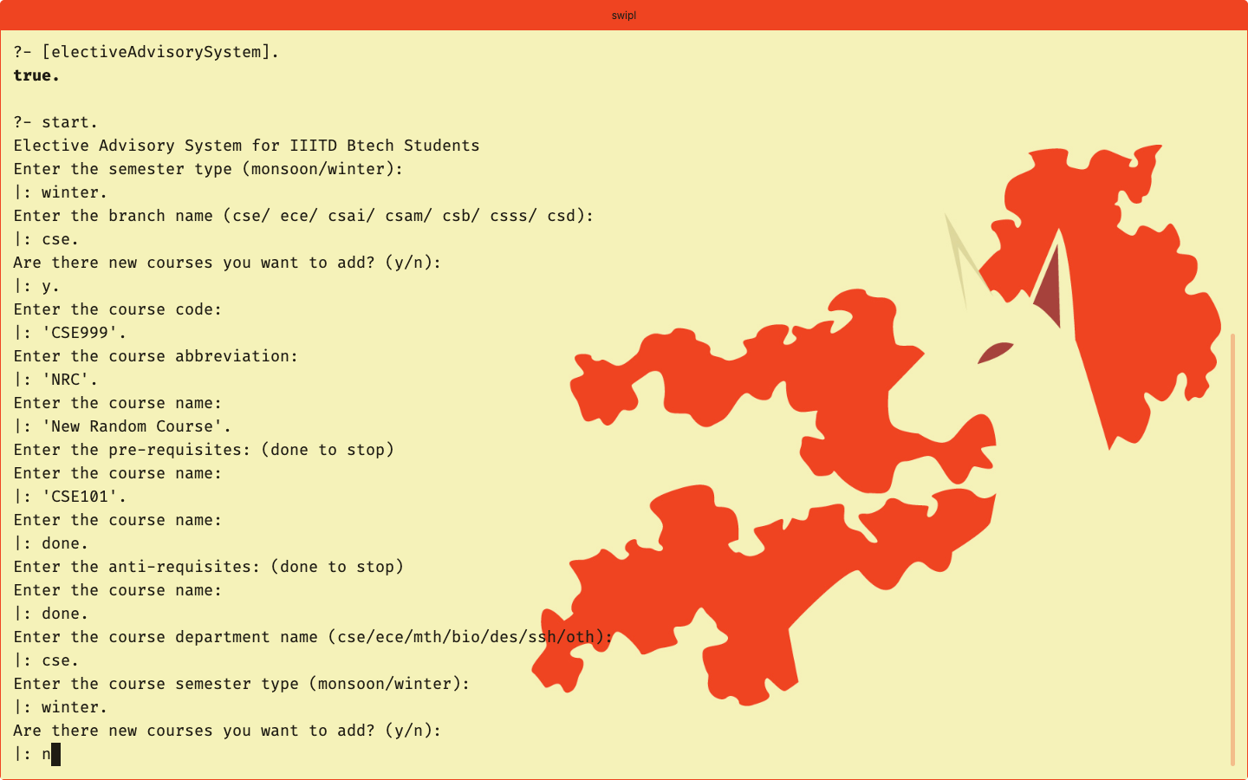

1. Then the system asks the user whether the user wants to delete any of the previously offered courses.
2. To delete the course, one just needs to enter the course abbreviation.
3. One can delete more than one courses too.
4. After that the user is prompted to enter the courses done by the user in the previous semesters.
5. Once the user enters the courses, the system tells the user the core courses which are available to the user to do in the current semester given the prereqs and antireqs done.

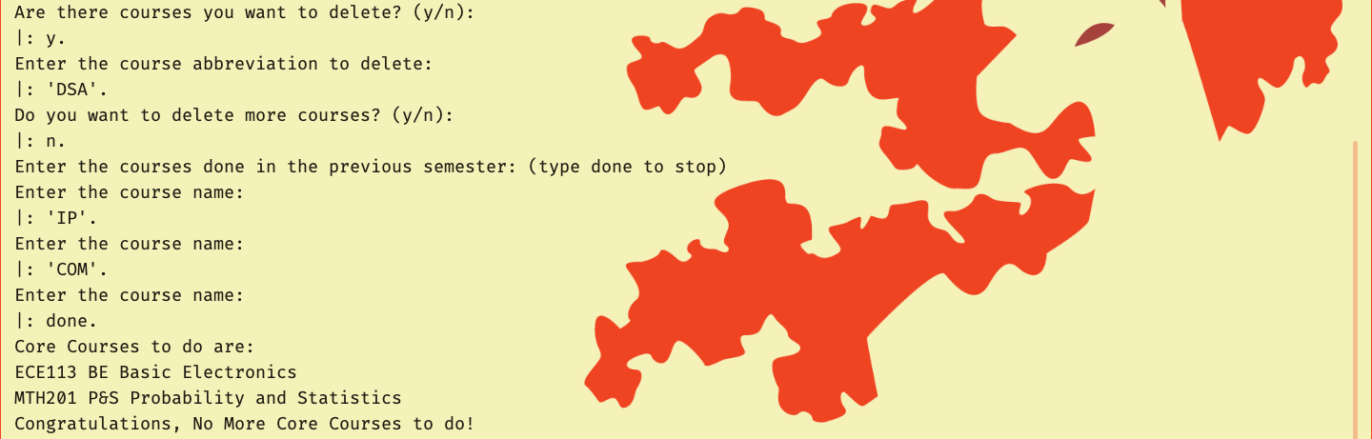

1. After this the system asks the user whether the user wants to do a minor or not.
2. If yes, the system tells the user the mandatory courses to be done for the selected minor program, which are available to the user to do in the current semester given the prereqs and antireqs done.
3. After this, the user is asked whether the user wants any career related course advice or not.
4. If yes, the system asks for the career related path the user wants and suggests the courses which can be done for the provided career path, given the set of antireqs and prereqs done.

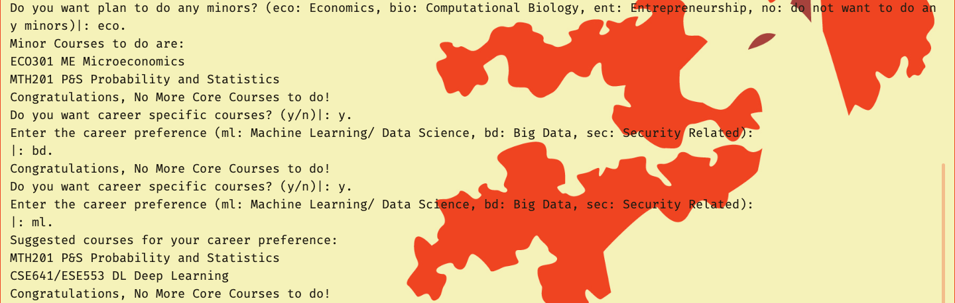

1. After this the system asks the user what all courses the user plans to do in the current semester. This might include any of the suggestions generated above or some other course the user might have in mind.
2. After this the user is asked about the department name whose courses the user wants as suggestions.

