Artificial Intelligence | Assignment 2

Report

# Data Preprocessing

* From the roaddistance.csv file, the first empty column and the last empty column was removed.
* To generate heuristics.csv file, python was used.
* Using BING API, latitudes and longitudes for each city were generated.
* Using the geopy library, Euclidean distance, rounded off to the nearest integer in kms was calculated and used as the final heuristic.

# Working

* The program first reads the heuristic.csv file.
* To make sure that the heuristics are consistent, the heuristics are taken as the straight line distance between the two cities, whose integer division is done by 4.
* After this, the program reads roaddistance.csv file.
* It is made sure that the first line is not read while parsing the csv and a bidirectional graph is generated using that.
* After that the Start place and the Goal place are taken from the user input.
* The program ensures that both the places are actually present in the database, and if not then the program prompts the user to enter them again.
* The program then asks the user to enter the algorithm to be used for calculating the path.
* In this program, the available algorithms are:
  + Depth First Search
  + Best First Search
* The program makes sure that the algorithm entered by the user is among the above ones else, it prompts the user to enter it again.
* Best First Search is implemented using sorting method.
* Once the path is calculated, the path along with the path length is printed.
* The program works for both the cases when there is a direct connection between the two cities as well as when there is no direct connection between the two cities.

Agartala -> Pune (Direct edge exists)

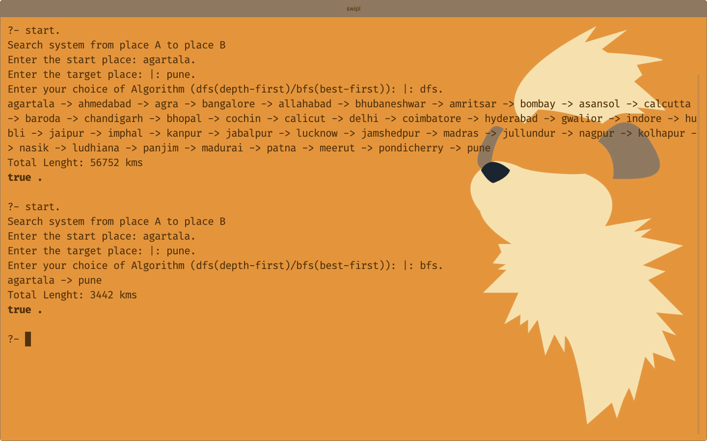

Agra -> Asansol (Direct edge does not exist)

