CSE232 | Assignment 2
Report

Question 3
- IP address using ifconfig
  - Ifconfig is used to configure the kernel-resident network interfaces.
  - It is used at boot time to setup interfaces as necessary.
  - After that, it is usually only needed when debugging or when system tuning is needed.
  - To look at all the interfaces, both up and down, I can use -a flag:
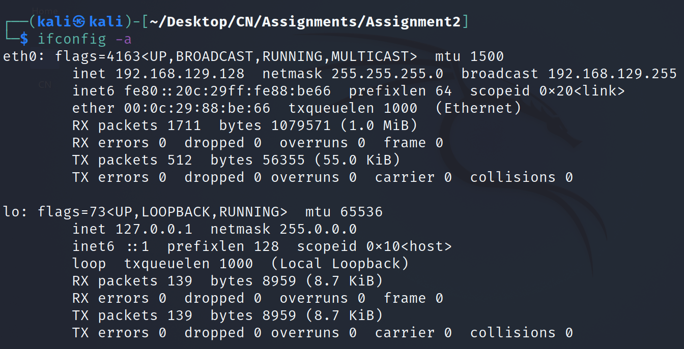
  - The above shows that I have 2 interfaces:
    - eth0
    - lo
  - The lo or the loopback interface is for the local host, so we can ignore that.
  - The other, that is eth0 is the one through which my machine connects with the internet.
  - So we can have a closer look at it by giving its name as parameter to the ifconfig command:
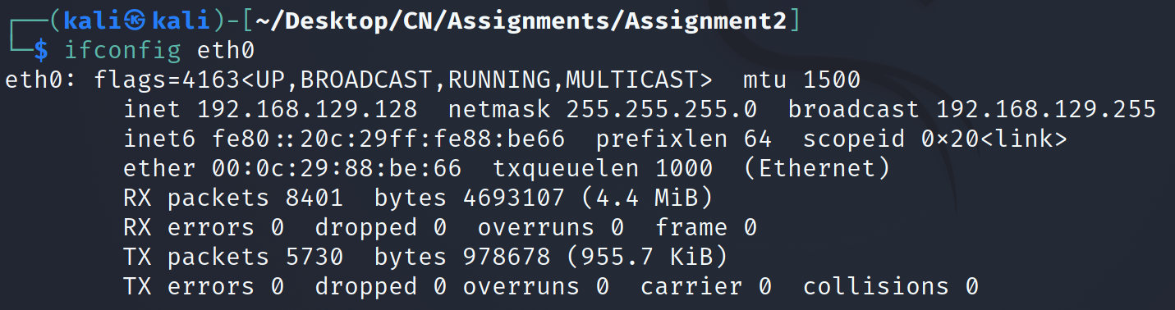
  - Through the above, we can see that the ip addresses are as follows:
    - IPv4 address: 192.168.129.128
    - IPv6 address: fe80::20c:29ff:fe88:be66
- IP address using whatismyip.com
  - The following screenshot was taken after visiting the above website:
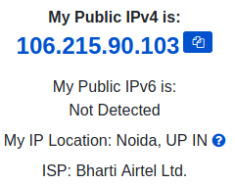
  - We can clearly see that the IP addresses obtained by ifconfig and the one obtained by visiting the above website are different.
  - This is because the IP address shown on the above website is my public/external IP address, whereas the IP address obtained from ifcongfig is my private/internal IP address.
  - External IP addresses are usually assigned to router or modem instead of being assigned to each and every machine in that network, where as internal IP address is assigned to each machine which connects to the internet.

Question 4

Question 7
- In this question, I have sent 10 packets for each command to eliminate any kind of redundancy throughout.
- 127.0.0.1 refers to the loopback ip address.
- In other words it is the localhost.
- So when we are sending the ping, we are actually sending it to the localhost itself.
- The following image shows that the ping command is working
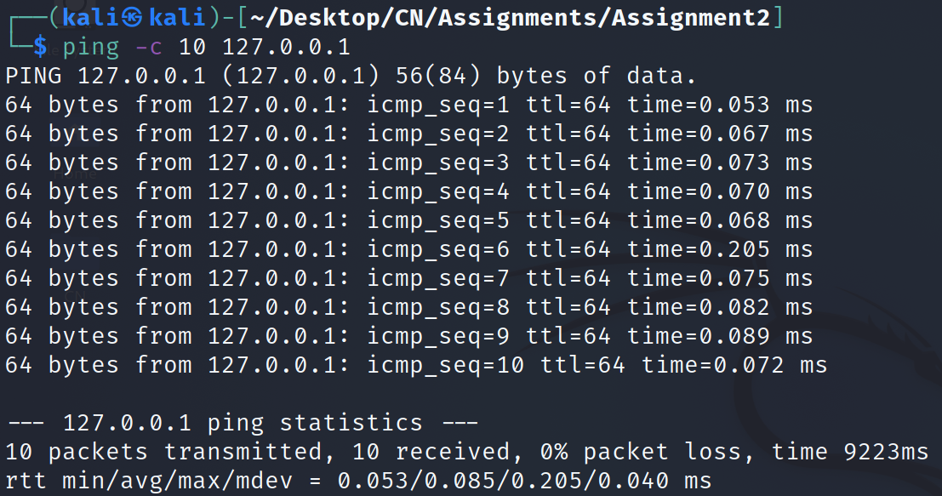
- To make the ping command fail, I can do that in 2 ways:
  - Increasing the size of packet to be sent via ping by a lot.
    - This results in 100% packet loss as since the size is too large, the response to be received exceeds the waiting time, and the server marks it as lost packet.
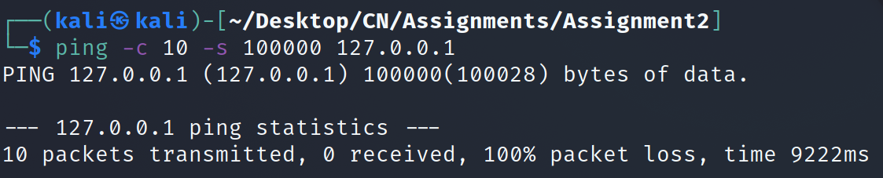
    - This solution would work for any ip address and is not specific to the one in question.
  - Another, and more reliable solution is to deactivate the loopback interface.
    - Since 127.0.0.1 is the loopback address, if we deactivate the loopback interface, the ping would not be sent, thus resulting in it’s failure.
    - Please note that this solution, unlike the first one, works only for the IP in question and not any other one.
    - Initial ifconfig state:
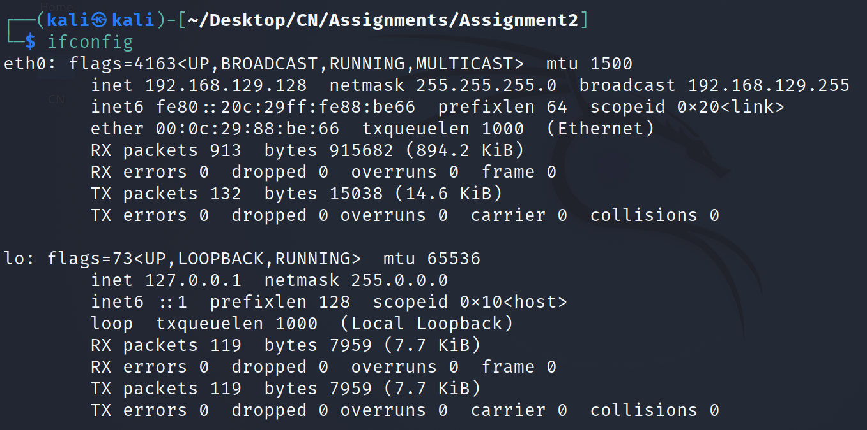
    - Disabling the loopback interface:
    - ifconfig after disabling the loopback interface:
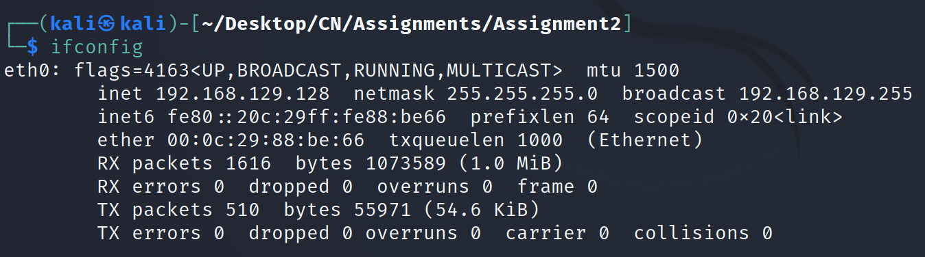
    - Now sending the ping
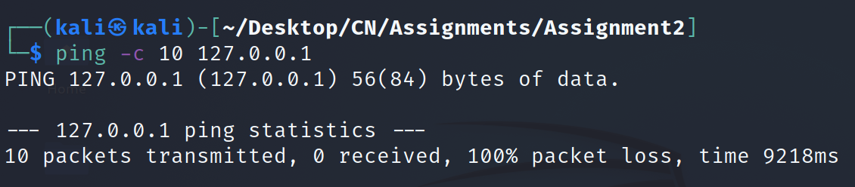

Q7: ping -c 10 -s 100000 -d 127.0.0.1
Q6 a: sudo traceroute -I www.iiith.ac.in
b: ping -c 100 www.iiith.ac.in : 55.393
c: ping -c 10 192.168.129.2 : .531
ping -c 10 192.168.1.1: 4.939
ping -c 10 122.160.220.236: 8.028
ping -c 10 125.18.20.101: 8.732
ping -c 10 182.79.198.222: 46.266
d: ?
Q5 a: nslookup google.com
nslookup -type=ns google.com
nslookup ns1.google.com
nslookup google.com ns1.google.com
b: nslookup -debug google.com

Q4 a: ping -M do -c 1 -s 3000 www.google.com
b: netstat -atp

Q3 a: ifconfig par eth0 vala
b: diff bcoz whatis par public ip and ifconfig se private

