CSE232 | Assignment 3
Report

Question 1
- Maximum expected value of throughput is 5 Mbps. Since there are 2 links, the minimum of the two would be the expected throughput.

- Average Computed throughput of the transfer: 3.97Mbps
- Diff
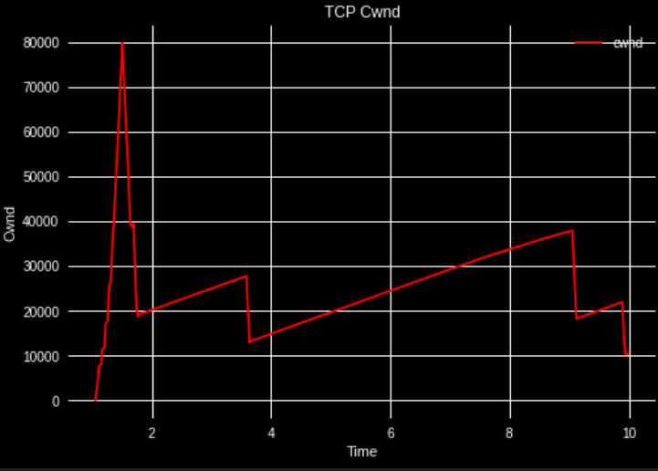

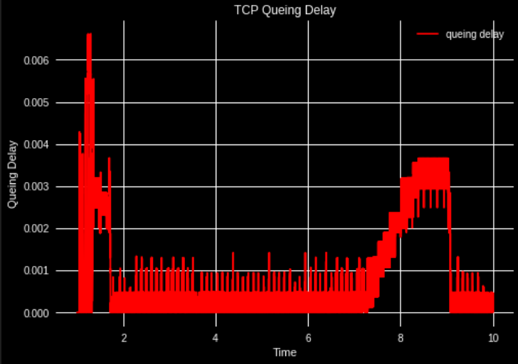
- sdf

Question 2
- Average computed throughput: 3.93Mbps
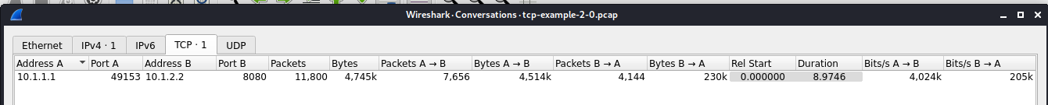

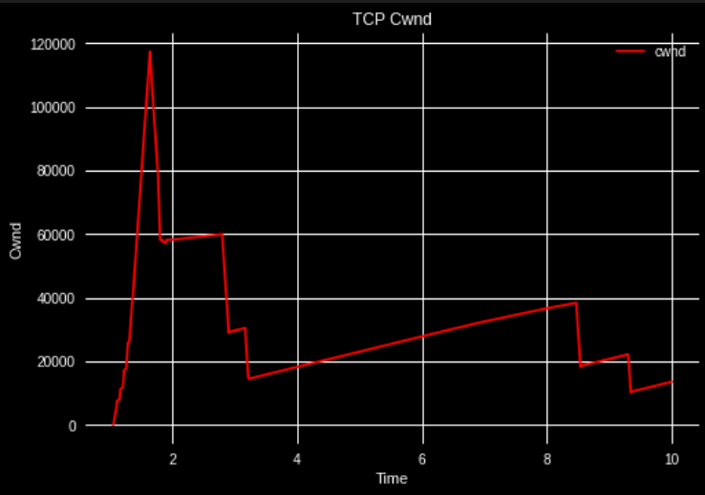
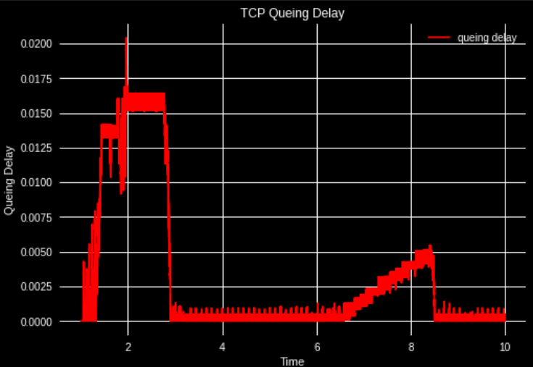

- ds

Question 3
- Average Throughput: 4.719Mbps
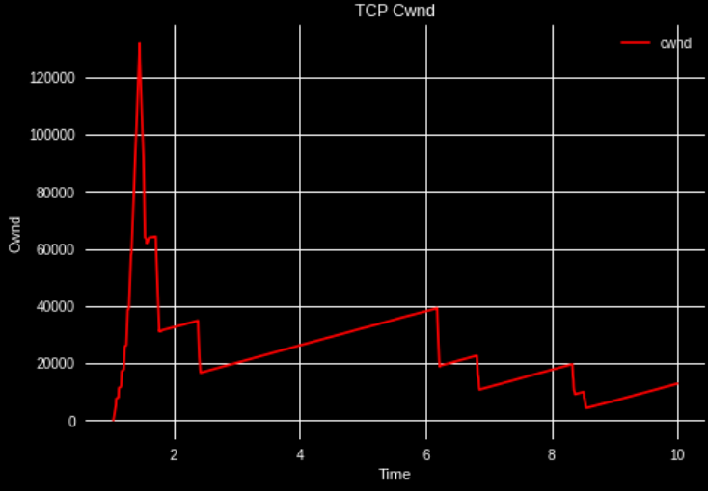

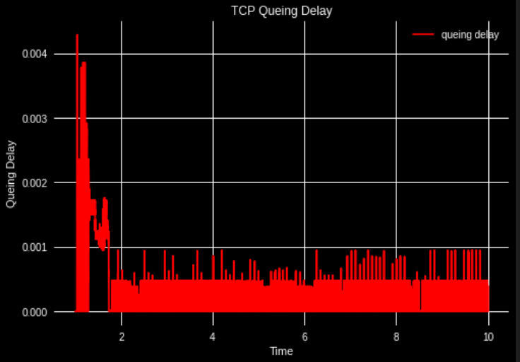

Question 4
- Average Throughput: 4.195Mbps

