CSE 343: Machine Learning
Assignment 2 | Report

Question 1. Decision Trees and Random Forest
- Loading the dataset
  - The dataset was loaded and converted to dataframe using the pandas library.
- Preprocessing the data
  - ‘No’ column was dropped from the dataframe
  - A total of 2067 entries corresponding to ‘na’ in the pm2.5 column were found.
  - There were no other column with any nan values.
  - The model was trained by:
    - Removing the rows corresponding to the nan values.
    - Replacing the nan values with their mean values.
    - Replacing the nan values with their median values.
  - Since the number of nan values were relatively small, all three of the above gave approximately similar results.
  - In the end, I decided to follow the first approach, i.e. to remove the rows corresponding to the nan values as the data was spread over different months, hours of the day, and years.
  - Replacing the values with mean or median did not feel suitable to me as the pm2.5 vales depend a lot on the above 3 mentioned factors.
  - Thus the decision to remove them completely was taken.
  - Final dataset shape was found to be (41757, 12)
  - The entries in the ‘cbwd’ column had textual entries rather than numerical ones.
  - These were changed to numeric data.
  - Basic Info about the dataset was obtained:
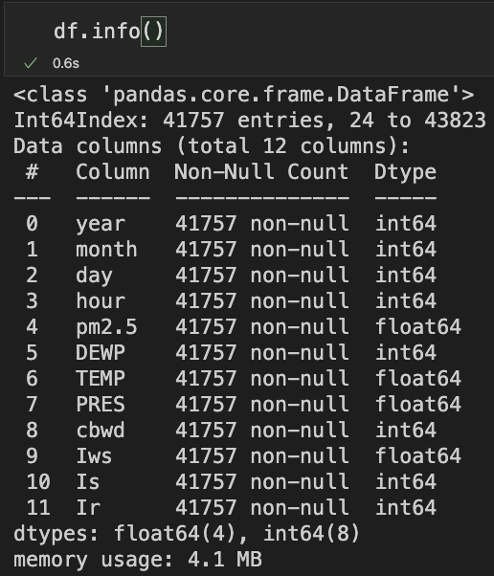
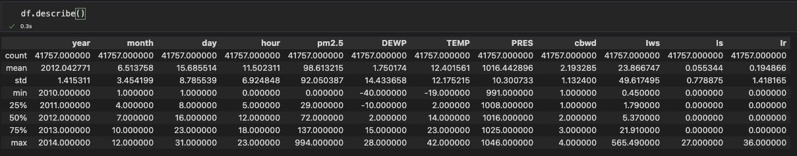
  - The data was divided into train:validation:test set in the ration 70:15:15
  - After this, the above sets were divided into x and y sets for each.
  - Since the decision tree and random forest are immune to the variance in the data and they perform in similar fashion for both normalized and non normalized data, the given dataset was not normalized.
- Decision trees with gini index and entropy
  - Decision Trees having criterion as entropy and gini index were trained.
  - The accuracies on train, valid and test sets were calculated and were as follows:
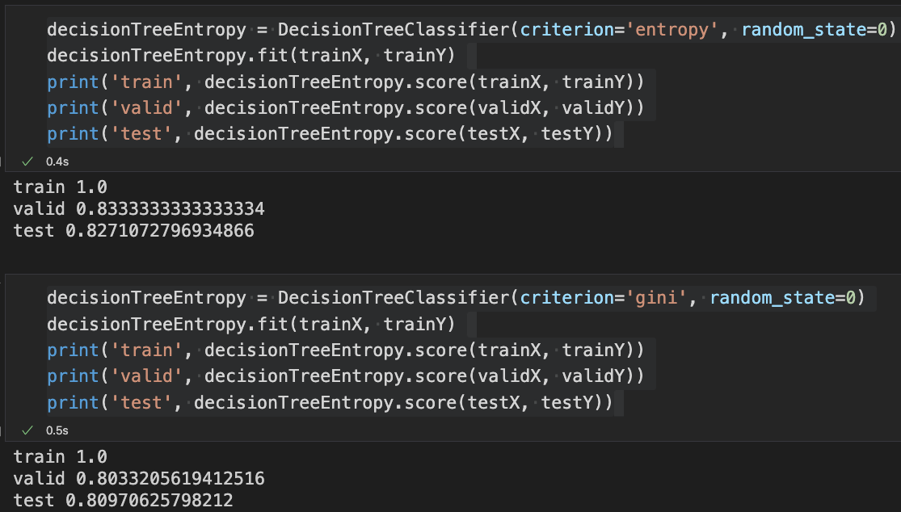
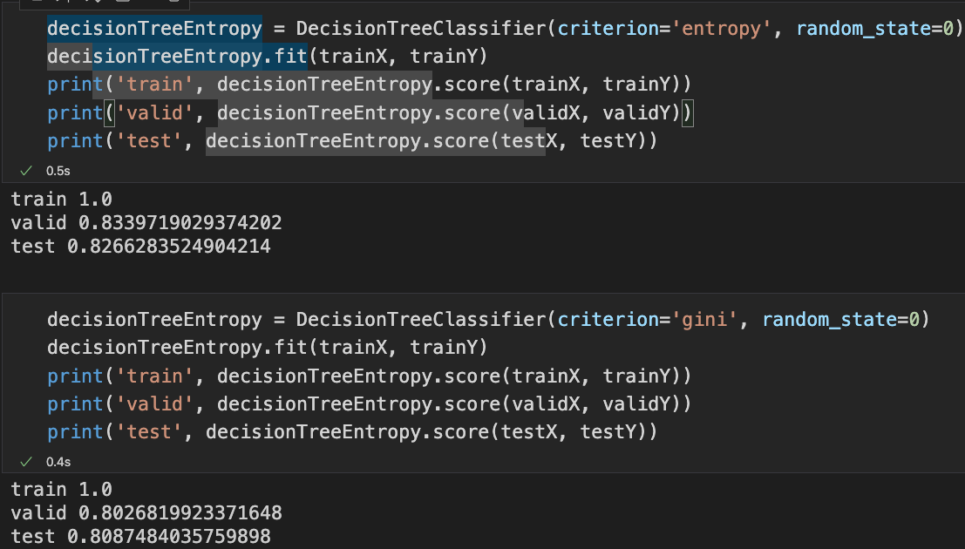
  - Courtesy to the above values obtained, ‘entropy’ was used for all the further evaluations.
- Decision Tree on different max depths
  - The trees were trained with different max depths and corresponding accuracies were calculated.
  - The curve for test and train set were plotted and were as follows.
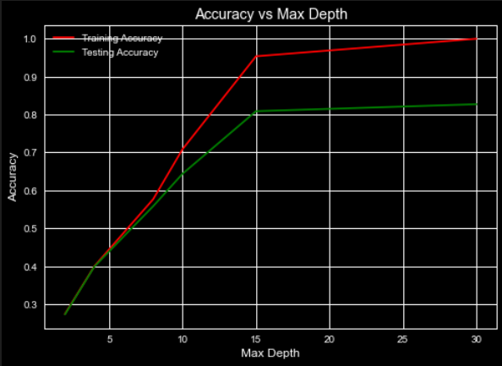
- Ensembling
  - 100 different decision trees were created with max depth 3.
  - 50% of the data was randomly selected and that was used to train the models.
  - Predictions were made after taking the majority vote of the decision stumps.
  - Using the above predictions, the accuracies were calculated on the test data which came out to be:
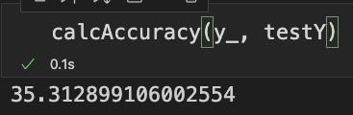
  - In the first part, the model was free to chose the depth for itself. This even though could have lead to overfitting, still gave a pretty good accuracy for the given test set.
  - In the second part, the max depth of the trees were fixed. For lower depths, the accuracies obtained were pretty low, but as the max depth increased, the training and the testing accuracies increased as well.
  - In the current part, even though ensembling was done with 100 stumps, but the accuracy obtained was not good enough as the max depth was restricted to just three. This restricted the model from applying various combinations on the input parameters, thus decreasing the accuracy. Still if we extrapolate the graph from the 2nd part, we can see that the accuracy obtained by the ensemble is significantly higher than the one obtained using just a single tree.
- Random Forest with Different Depths
  - In the b part, best accuracies were obtained on the max depth of 30, so that was included in the max depths of the current part.
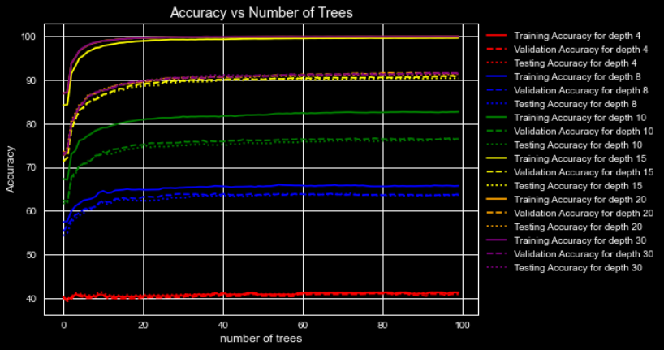
  - The ensemble model was trained on the different value of max depths and number of trees. For the output majority vote was obtained and the accuracies obtained were plotted as following:
  - As it is evident from the graph above, the best accuracies obtained were for the data with more number of depths.
  - Results were similar for the model having about 20 or more trees and each tree having depth of about 15 or more.
- Adaboost
  - Sklearn’s implementation of adaboost was used.
  - Different number of estimators were used to get the best values from the adaboost classifier.
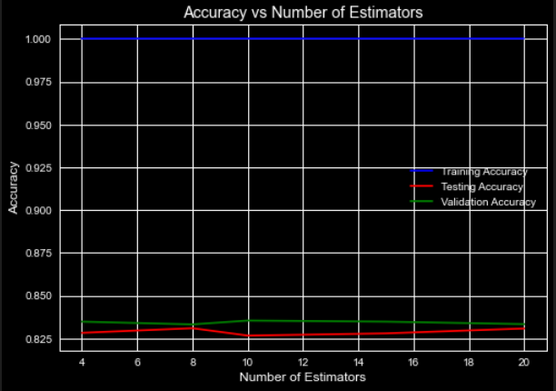
  - The different models were trained and the corresponding accuracies were generated in the form of a graph:
  - The above graph shows the effect of estimators on the accuracies when using the adaboost model.
  - The model here shows that there was likely overfitting as the underlying model of decision trees did not have any check on the number of depth of the trees being generated.
  - Irrespective of that, the results were pretty good.
  - There was a difference between the best results obtained on random forest and here because of the underlying decision tree. In the previous part, there was a check on the max depth which was not present here. This lead to excessive overfitting here which resulted in the evident loss of accuracy on the validation and testing set.

Question 2. MLP
- Neural Network Class
  - The neural network class was implemented from scratch containing all the desired parameters, activation functions, weight initializations and class methods.
- Dataset and Preprocessing
  - The dataset was read using numpy library.
  - The training set consisted of 60,000 samples and the testing set consisted of 10,000 samples.
  - The two sets were merged together and the resultant set was divided into the train:test:validation sets in the ration 70:20:10
  - Each image was a matrix of 28*28 and represented one number.
  - Draw image function can be used to visualize any of the data samples.
  - The images look like:
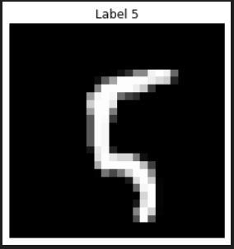
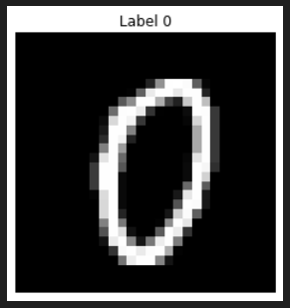
  - The data was then normalized for using in the models.

- Training Model with different Activation Functions
  - The model was trained with various activation functions.
  - The parameters of the model were:
      - N_inputs = 784
      - N_outputs = 10
      - N_layers = 4 (Number of hidden layers)
      - Layer_sizes = [256, 128, 64, 32]
      - activation = activation function being used
      - learning_rate = 0.08
      - weight_init = normal
      - num_epochs = 150
      - batch_size = len(X)//2 (X is the vector)
  - Each model’s final weights were also stored.
  - Their evaluations are as follows:
    - ReLU:
      - Test Accuracy obtained was:
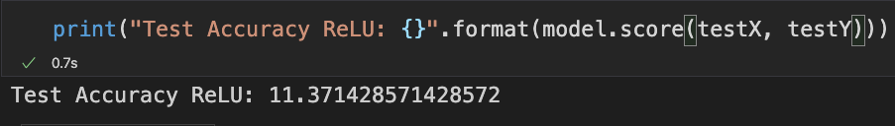
    - Leaky ReLU:
      - Test Accuracy obtained was:
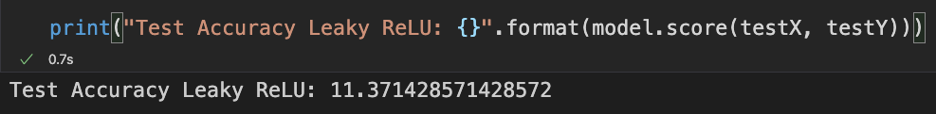
    - Sigmoid:
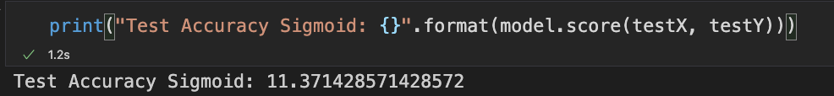
      - Test Accuracy obtained was:
    - Linear:
      - Test Accuracy obtained was:
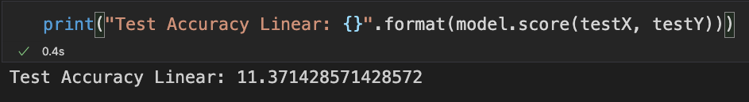
    - tanh:
      - Before running tanh and softmax, the data was shuffled once again.
      - Test Accuracy obtained was:
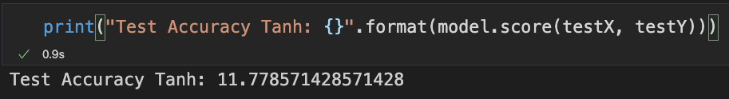
    - softmax:
      - For softmax, due to my computational limitations, I was not able to use the actual softmax gradient to output the values. Instead I used the gradient format of sigmoid on softmax.
      - Both the codes however are present in the code file submitted.
      - Test Accuracy obtained was:
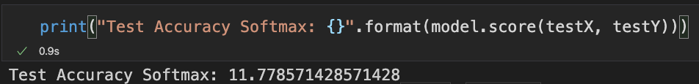
- Training vs Epochs Plot
  - The train vs epochs and accuracy vs epochs plots are as follows:
    - ReLU
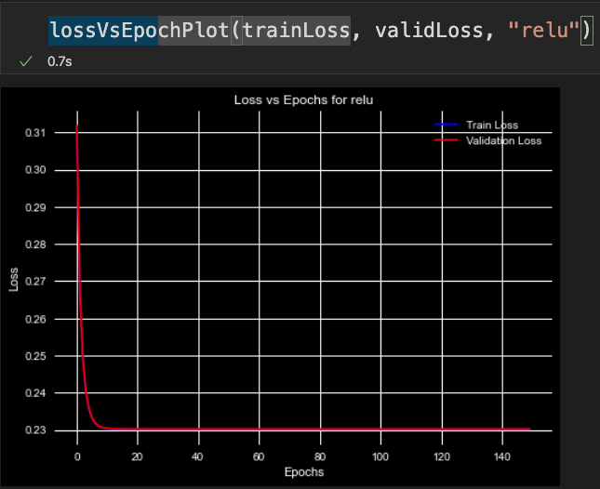
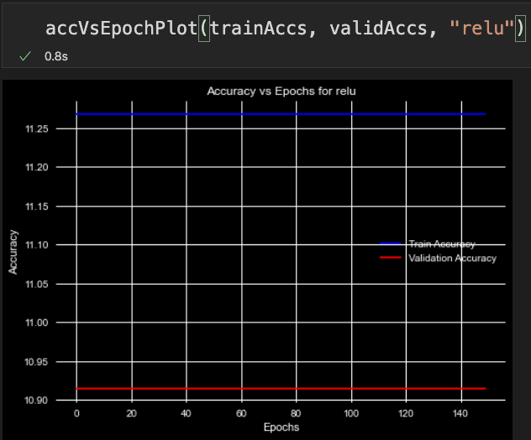
    - Leaky ReLU

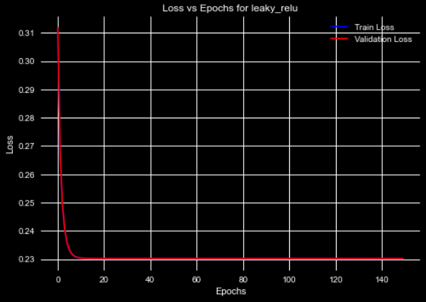
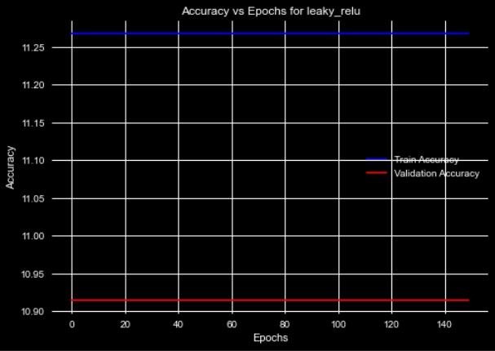
    - Sigmoid
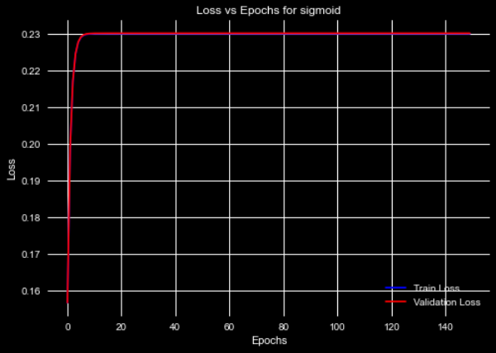
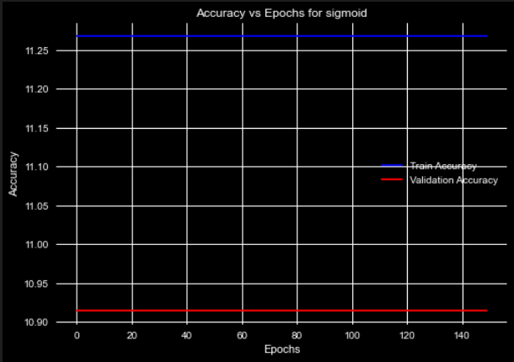
    - Linear
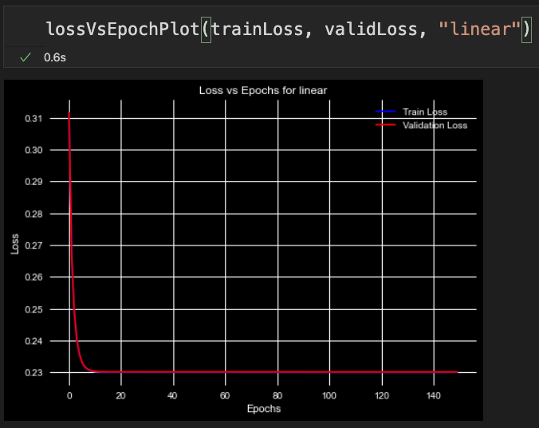
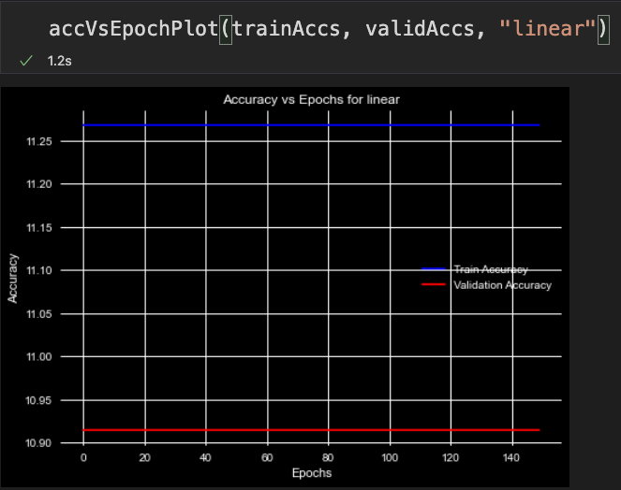
    - tanh:
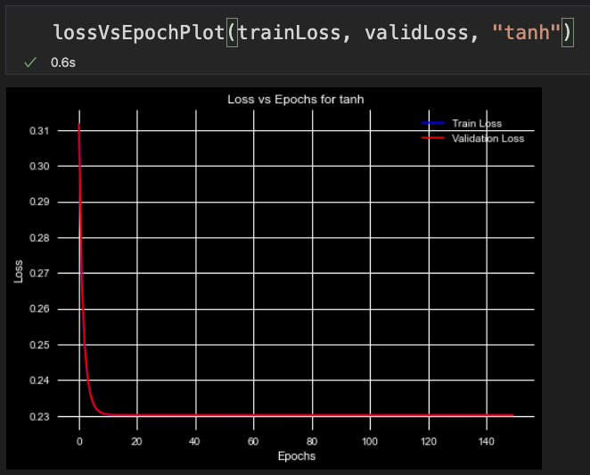
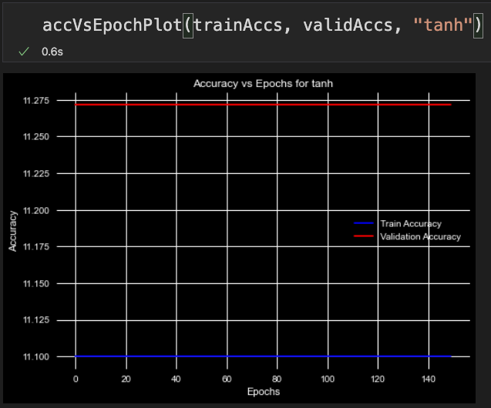
    - softmax:
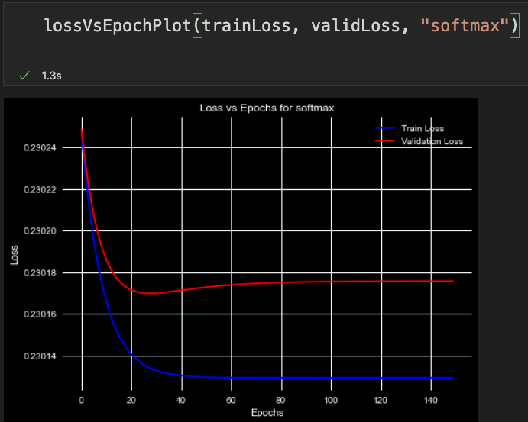
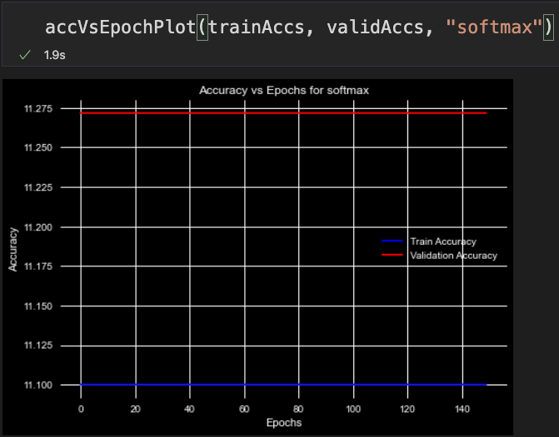

- Best Function for the Output Layer

