**Report**

**IDEA**

Our solution consists of two bots to automate the loading and unloading process. One bot picks up the parcel from the truck and the other takes the parcel and sorts it based on the barcode printed on it.

**Components Used:**

|  |  |
| --- | --- |
| **Components** | **Estimated Price(in Rs.)** |
| **Raspberry Pi** | **3000 X 1** |
| **Raspberry Pi 5MP Camera Module** | **450 X 2** |
| **Motor Driver** | **125 X 4** |
| **Arduino Mega Board** | **1000 X 1** |
| **Jumper Wires** | **150 X 1** |
| **Motors** | **200 X 14** |
| **IR Sensors** | **45 X 1** |
| **Multi Camera Adapter Board** | **500 X 1** |
| **batteries** | **30 X 2** |

|  |  |
| --- | --- |
| **Total** | **8955** |

**Circuit:**

* **Picker Bot**

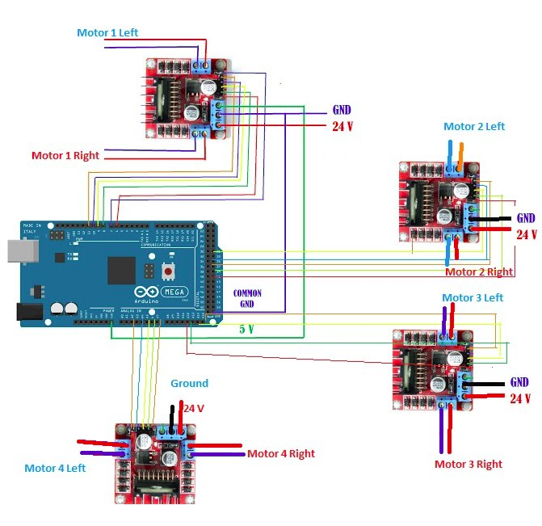

* **Receiver Bot**

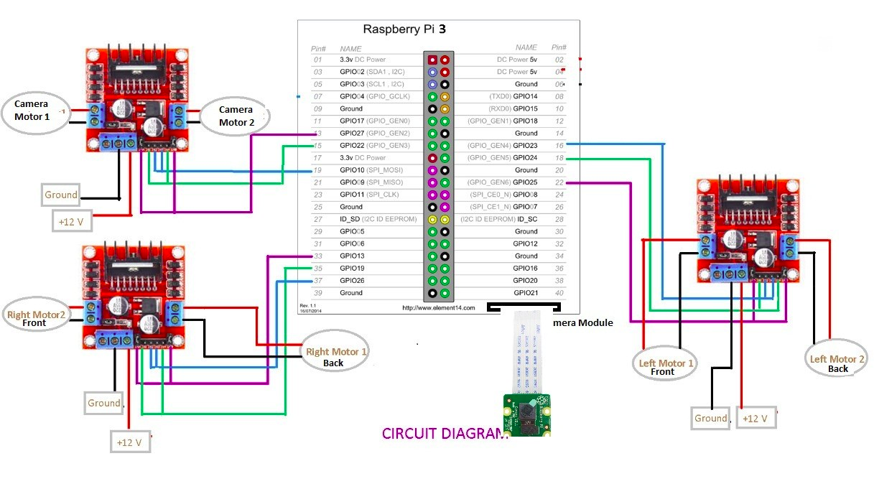

**Workflow**

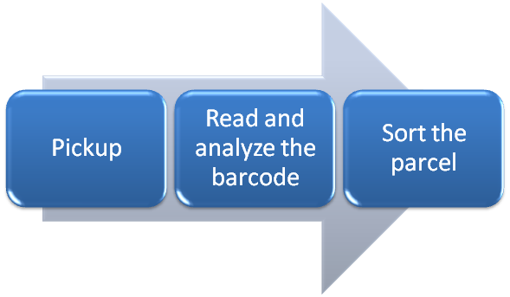

**Process:**

* The first bot detects the height of the parcel stack and picks up the highest parcel.
* It then places the parcel on a transparent table in bot 2 and then the lid of bot 2 is closed.
* Bot 2 has two moving cameras placed horizontally and vertical to detect the barcode from right to left and top to bottom respectively.
* After detecting the barcode, the second bot moves through an angle to place the parcel in the respective cart.
* After that , it will retrace its path and continue the process.

**Modal Design:**

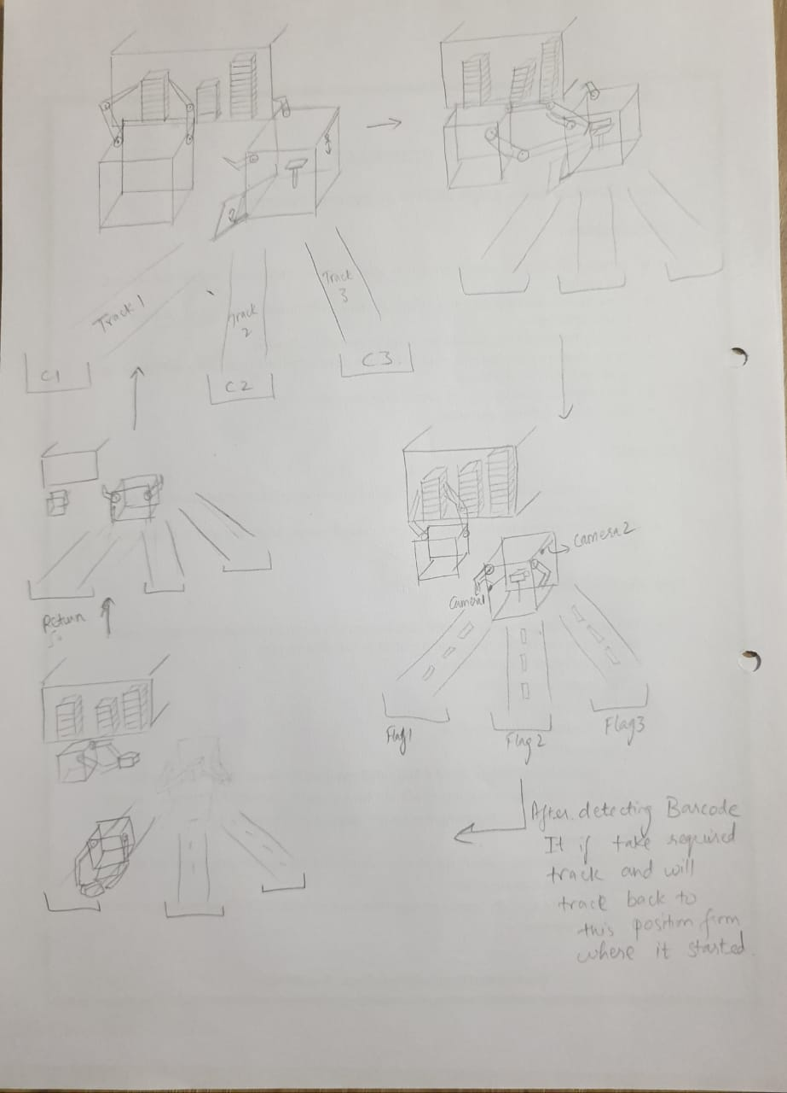

Fig1: Schematic explaining flow of the process

**Bot1**

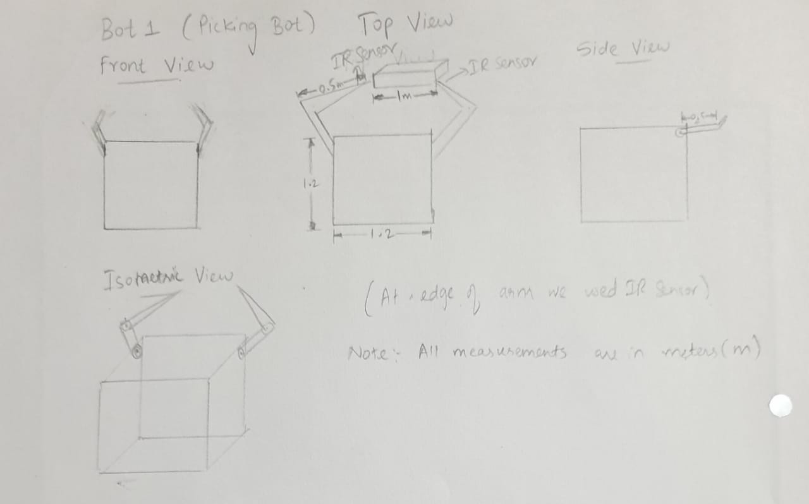

Fig2: Bot1 Front, top, side and isometric views

**Bot2**

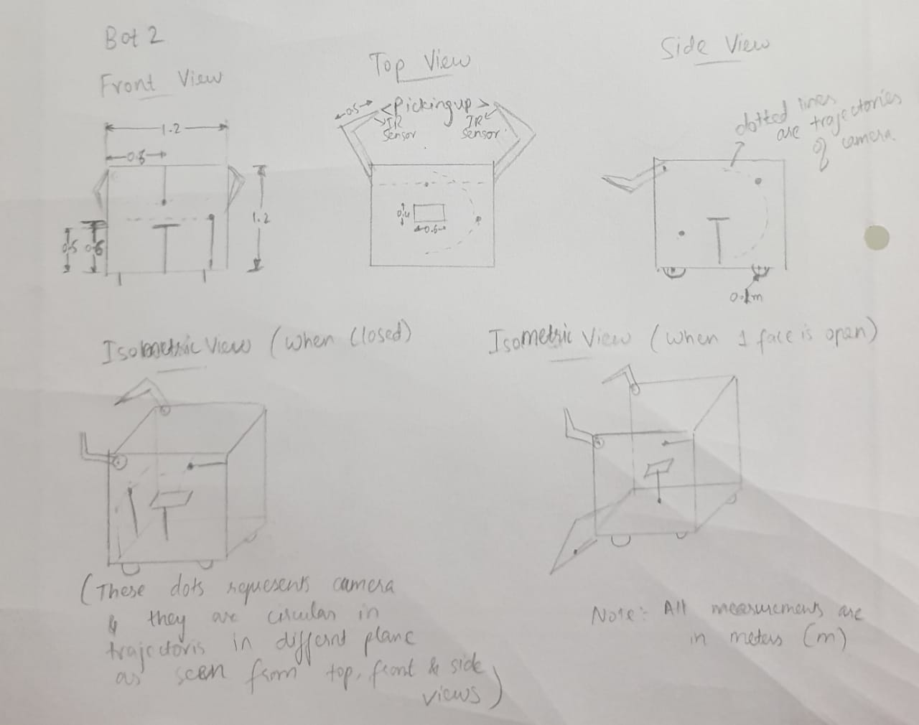

Fig3: Bot2 Front, top, side and isometric views

**Cost :**

**Durability and strength:**

/*

To automate the loading and unloading process, our solution consists of two robots to perform the given task. The first robot picks up the highest parcel from those piled up in the truck in multiple rows. It then rotates orthogonally and handovers the parcel to another bot standing beside it. The second bot has a cart like structure open at one end. It has cameras installed on all of its faces so as to detect and analyze the barcode which can be present on any of its faces. Using neural networks and machine learning algorithms, it analyses the barcode and then sorts it accordingly and puts them in cart A,B or C after travelling 50 metres from its initial point.

*/