**Setup**:

1.Before installing protractor first we need to install node.js and npm.

**Open the Terminal app** and type brew install node

Wait for some time it downloads some files and installs them. And that’s it.

2. Check below :

* To see if Node is installed, type node -v in Terminal. This should print the version number so you’ll see something like this v8.11.4.
* To see if NPM is installed, type npm -v in Terminal. This should print the version number so you’ll see something like this 5.6.0

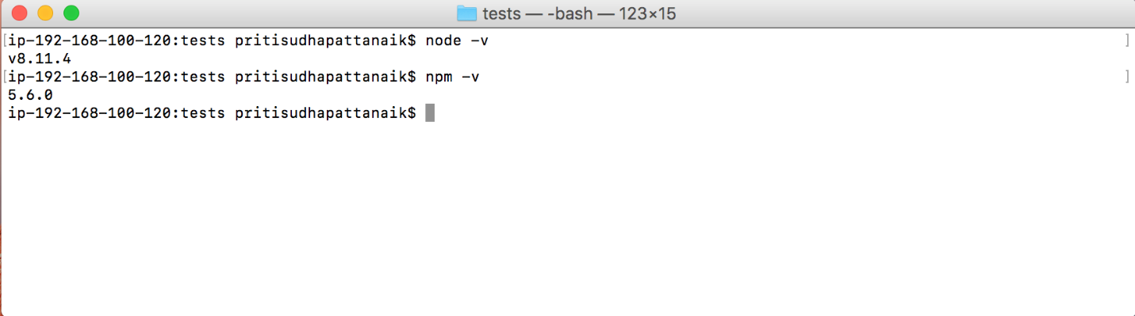

3. Use npm to install Protractor :

npm install -g protractor

This will install two command line tools, protractor and webdriver-manager. Try running protractor --version to make sure it's working.

The webdriver-manager is a helper tool to easily get an instance of a Selenium Server running. Use it to download the necessary binaries with:

webdriver-manager update

Now start up a server with:

**webdriver-manager start**

This will start up a Selenium Server and will output a bunch of info logs. Your Protractor test will send requests to this server to control a local browser. You can see information about the status of the server at <http://localhost:4444/wd/hub>.

**Run Protractor script of OMS:**

1. Clone protractor script to your local machine.

git clone -b develop-oms <https://github.com/envistaInteractive/enspire-oms.git>

1. Navigate to the path :

OMS/enspire-oms/src/tests

1. Before Running below command add all dependencies as below.

Command: sudo npm run e2e conf.js.qa_SCL

Dependencies:

npm install npm-run-all --save-dev

npm install replace -g

npm install --save replace

Install other packages also

npm install appium

npm install bower

npm install grunt-cli

npm install gulp

npm install now

npm install protractor-api-resource

npm install protractor-hotkeys

npm install protractor-html-reporter-2

npm install protractor-jasmine2-screenshot-reporter

npm install protractor-video-reporter

npm install restler

npm install typescript

node install .bin

node install @types

node install ansi-regex

node install ansi-styles

node install async

node install balanced-match

node install bluebird

node install brace-expansion

node install camelcase

node install chalk

node install cliui

node install color-convert

node install color-name

node install concat-map

node install cross-spawn

node install decamelize

node install define-properties

node install emoji-regex

node install error-ex

node install es-abstract

node install es-to-primitive

node install escape-string-regexp

node install find-up

node install fs

node install fs-extra

node install fs.realpath

node install function-bind

node install get-caller-file

node install glob

node install graceful-fs

node install has

node install has-flag

node install has-symbols

node install hosted-git-info

node install inflight

node install inherits

node install is-arrayish

node install is-callable

node install is-date-object

node install is-fullwidth-code-point

node install is-regex

node install is-symbol

node install isexe

node install jasmine-reporters

node install jasmine2-protractor-utils

node install json-parse-better-errors

node install jsonfile

node install klaw

node install listfiles.py

node install load-json-file

node install locate-path

node install lodash

node install memorystream

node install minimatch

node install minimist

node install mkdirp

node install ngx-papaparse

node install nice-try

node install normalize-package-data

node install npm-run-all

node install object-inspect

node install object-keys

node install object.assign

node install once

node install optimist

node install p-limit

node install p-locate

node install p-try

node install papaparse

node install parse-json

node install path

node install path-exists

node install path-is-absolute

node install path-key

node install path-parse

node install path-type

node install pdfreader

node install pidtree

node install pify

node install process

node install protractor

node install protractor-html-reporter

node install protractor-html-screenshot-reporter

node install protractor-jasmine2-html-reporter

node install q

node install read-pkg

node install replace

node install require-directory

node install require-main-filename

node install resolve

node install rimraf

node install sax

node install semver

node install set-blocking

node install shebang-command

node install shebang-regex

node install shell-quote

node install spdx-correct

node install spdx-exceptions

node install spdx-expression-parse

node install spdx-license-ids

node install string-search

node install string-width

node install string.prototype.padend

node install string.prototype.trimend

node install string.prototype.trimleft

node install string.prototype.trimright

node install string.prototype.trimstart

node install strip-ansi

node install strip-bom

node install supports-color

node install tslib

node install underscore

node install universalify

node install util

node install validate-npm-package-license

node install which

node install which-module

node install wordwrap

node install wrap-ansi

node install wrappy

node install xmldoc

node install xmldom

node install y18n

node install yargs

node install yargs-parser