**JOINING:**

**1.CROSS JOIN/CARRTESIAN JOIN:**

* SELECT * FROM EMP, DEPT
* SELECT * FROM EMP CROSS JOIN DEPT
* SELECT ENAME , DEPT.DEPTNO,LOC FROM EMP CROSS JOIN DEPT

**2.NATURAL JOIN :**

* SELECT * FROM EMP NATURAL JOIN DEPT ORDER BY ENAME

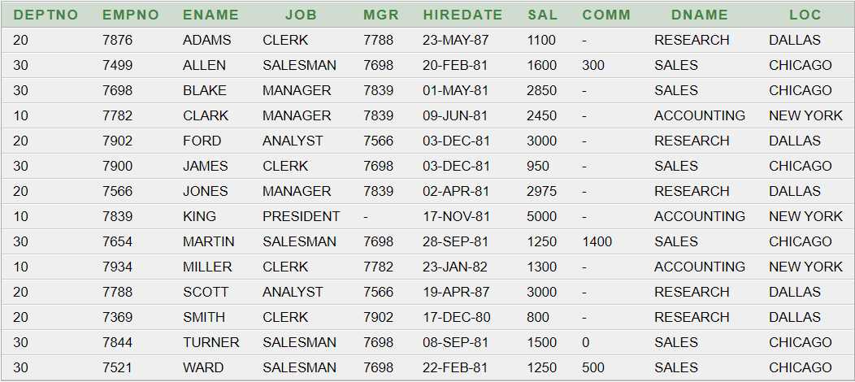

*EXPENSIVE … USES HUGE MEMORY

**3.EQUI JOIN:**

* SELECT ENAME, DEPT.DEPTNO , LOC FROM EMP, DEPT WHERE EMP.DEPTNO=DEPT.DEPTNO

*EMP.DEPTNO=DEPT.DEPTNO 🡪THIS MUST BE INCLUDED

*OTHER CONDITION MAY HAVE BEEN INCLUDED

**4.NON-EQUI JOIN:**

* NO EQUAL SINE
* SELECT E.ENAME , E.SAL ,S.GRADE FROM EMP E, SALGRADE S WHERE E.SAL BETWEEN S.LOSAL AND S.HISAL

OR

* SELECT ENAME ,SAL , GRADE FROM EMP, SALGRADE WHERE SAL BETWEEN LOSAL AND HISAL

**5.OUTER JOIN:**

* SELECT * FROM EMP,DEPT WHERE EMP.DEPTNO(+)=

DEPT.DEPTNO

USE (+) WHERE EXTRA NULL ROW WILL BE CREATED

* SELECT ENAME , DEPT.DEPTNO , LOC FROM EMP,DEPT WHERE EMP.DEPTNO(+)=DEPT.DEPTNO

**6.SELF JOIN**:

* SELECT E.ENMAE "EMPLOYEES" , NVL(M.ENAME,'CEO') "MANAGER" FROM EMP E, EMP M WHERE E.MGR=M.EMPNO
* THIS ONE SUCKS