ID: 20-42414-1

Name : Pritom Debnath

**Date :-08.12.20**

1.Select all the employees name along with their manager names, and if an employee does not have a manager, display him as “CEO”.

2.Get all the employees who work in the same departments as of SCOTT

3.Display all the employees who have joined before their managers.

4.List all the employees who are earning more than their managers.

5.Fetch all the employees who are earning same salaries.

6.Select all the employees who are earning same as SMITH. Display employee name , his date of joining, his manager name & his manager's date of joining.

7.Create a view named DEPT20 that contains the employee number, employee name, and department number for all employees in department 20. Label the view column EMPLOYEE_ID, EMPLOYEE, and DEPARTMENT_ID. Do not allow an employee to be reassigned to another department through the view.

**Answers :**

1. SELECT E.ENMAE "EMPLOYEES" , NVL(M.ENAME,'CEO') "MANAGER" FROM EMP E, EMP M WHERE E.MGR=M.EMPNO

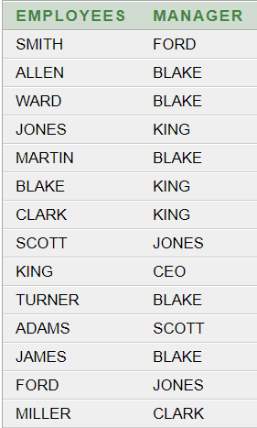

2. SELECT E.EMPNO, E.ENAME, E.JOB, E.MGR, E. HIREDATE , E.SAL, E.COMM, E.DEPTNO FROM EMP E , EMP S WHERE E.DEPTNO=S.DEPTNO AND S.ENAME='SCOTT'

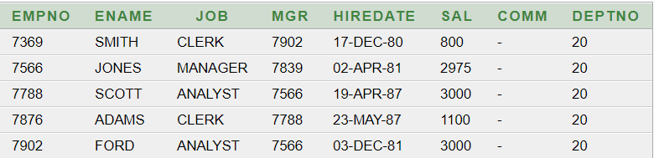

3.SELECT E.* FROM EMP E , EMP M WHERE E.HIREDATE<M.HIREDATE AND E.MGR=M.EMPNO

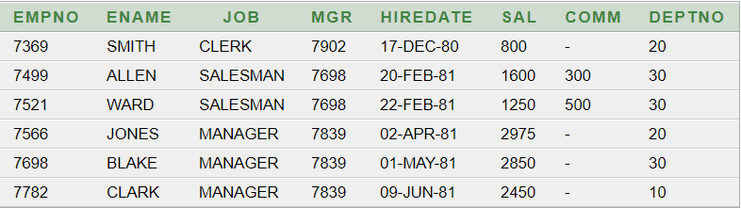

4. SELECT E.* FROM EMP E , EMP M WHERE E.SAL>M.SAL AND E.MGR=M.EMPNO

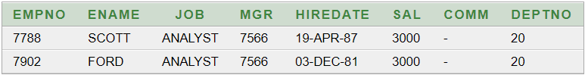

5. SELECT E.* FROM EMP E , EMP M WHERE E.SAL=M.SAL AND E.EMPNO<>M.EMPNO

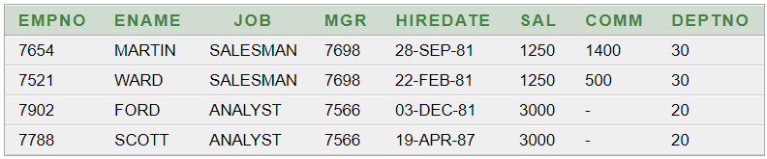

6. SELECT E.ENAME ,E.HIREDATE ,M.ENAME,M.HIREDATE FROM EMP E, EMP M ,EMP S WHERE E.SAL=S.SAL AND E.MGR=M.EMPNO AND S.ENAME='SMITH'

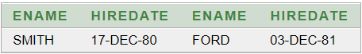

7.CREATE OR REPLACE VIEW DEPT20 (EMPLOYEE_ID,EMPLOYEE,DEPARTMENT_ID) AS SELECT EMPNO,ENAME,DEPTNO FROM EMP WHERE DEPTNO=20 WITH CHECK OPTION CONSTRAINT DEPT20_DK

**Date :-15.12.20**

1.Create a sequence to be used with the primary key column of the DEPARTMENT table. The sequence should start at 60 and have a maximum value of 200. Have your sequence increment by ten numbers. Name the sequence DEPT_ID_SEQ.

1. Write a script to display the following information about your sequences: sequence name, maximum value, increment size, and last number.
2. Create a user **Rahul** with the password ret23erz.
3. Create a new role **Accounts**.
4. Grant system privileges create table, view and sequence to role Accounts.
5. Assign role Accounts to Rahul.
6. Change password of **Rahul** with the new password **rec34tg**

**Answer :**

**1**.CREATE SEQUENCE DEPT_ID_SEQ

INCREMENT BY 10

START WITH 60

MAXVALUE 200

NOCACHE

NOCYCLE

**2**. SELECT SEQUENCE_NAME,MAX_VALUE,INCREMENT_BY, LAST_NUMBER FROM USER_SEQUENCES



**3**.CREATE USER Rahul IDENTIFIED BY ret23erz

**4**.CREATE ROLE Accounts

**5**.GRANT CREATE TABLE, CREATE VIEW, CREATE SEQUENCE TO Accounts

**6**.GRANT Accounts to Rahul

**7**.ALTER USER Rahul IDENTIFIED BY rec34tg