****************************Practice 1******************************

21.10.20

1. Display all information provided in the EMP table.
2. Display the sal, comm, (sal+1200)-(sal*34) from emp table.
3. Display the information as "Clerk has a salary 1000 taka"
4. Display the employee name, job, and start date of employees hired between February 20, 1981, and May 1, 1981.
5. Display the names of all employees where the third letter of their name is an A.
6. Display the name and job title of all employees who don’t have a manager.
7. Create a query to display the name and salary of employees earning more than $2850.
8. Write a query to list the name and salary of employees who earn more than $1500 and are in department 10 or 30.

**Answers:**

1.

select * from emp ;

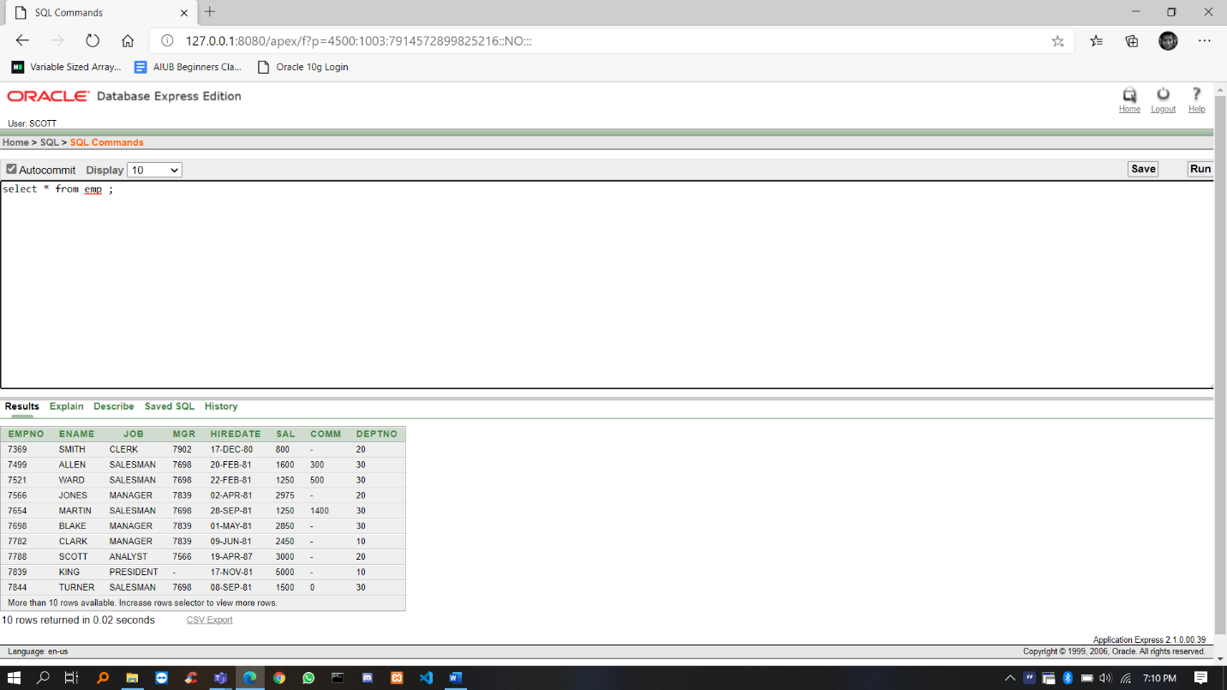

2.

select sal, comm, (sal+1200)-(sal*34) from emp ;

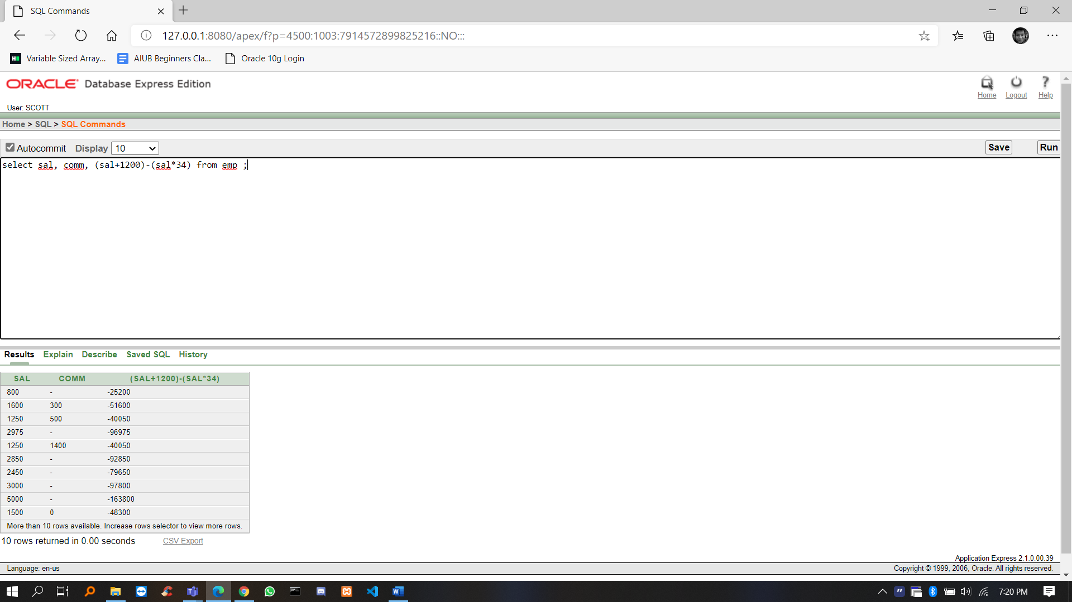

3. SELECT ENAME || ' has a salary '||SAL||' taka' FROM EMP;

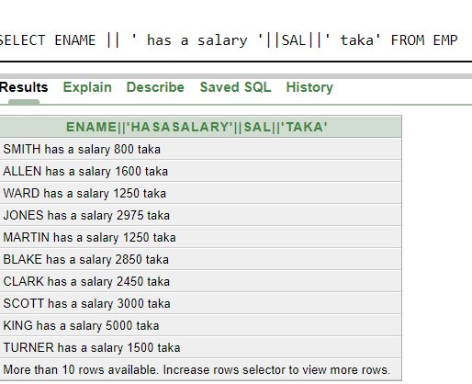

4. SELECT ENAME , JOB , HIREDATE FROM EMP WHERE HIREDATE BETWEEN '20-FEB-81' AND '1-MAY-81';

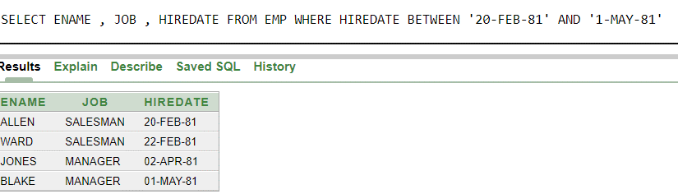

5. SELECT ENAME FROM EMP WHERE ENAME LIKE '__A%'

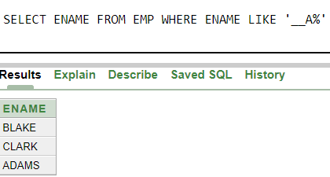

6. SELECT ENAME , JOB FROM EMP WHERE MGR IS NULL

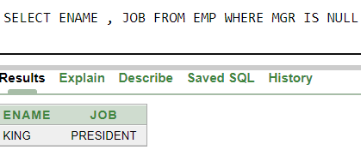

7. SELECT ENAME , SAL FROM EMP WHERE SAL>2850

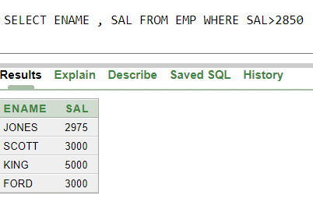

8.SELECT ENAME , SAL FROM EMP WHERE SAL>1500 AND DEPTNO IN(10,30);

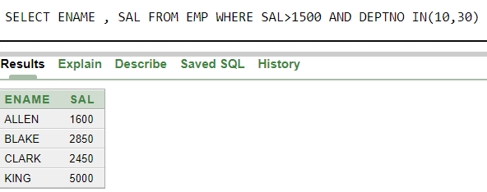

****************************Practice 2******************************

29.10.20

1.Write a query to display the current date. Label the column Date.

2.Display the employee number, name, salary, and salary increase by 15% expressed as a whole number. Label the column New Salary.

3.Modify your previous query to add a column that will subtract the old salary from the new salary. Label the column Increase. Rerun your query.

4.Display the employee’s name, hire date, and salary review date, which is the first Monday after six months of service. Label the column REVIEW. Format the dates to appear in the format

similar to “Sunday, the Seventh of September, 1981.”

5.For each employee display the employee name and calculate the number of months between today and the date the employee was hired. Label the column MONTHS_WORKED. Order your results by the number of months employed. Round the number of months up to the closest whole number. **(bonus)**

6.Create a query that will display the employee name and commission amount. If the employee does not earn commission, put “No Commission.” Label the column COMM.

**ANSWERS:**

1. SELECT SYSDATE AS "DATE" FROM DUAL

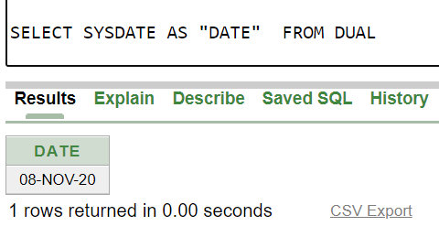

1. SELECT EMPNO, ENAME , SAL , SAL+ROUND(SAL*0.15) AS "NEW SALARY" FROM EMP

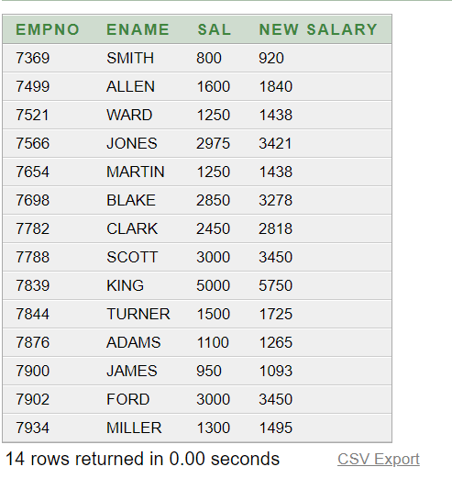

1. SELECT EMPNO, ENAME , SAL , SAL+ROUND(SAL*0.15) AS "NEW SALARY", ROUND(SAL*0.15) AS "INCREASE" FROM EMP

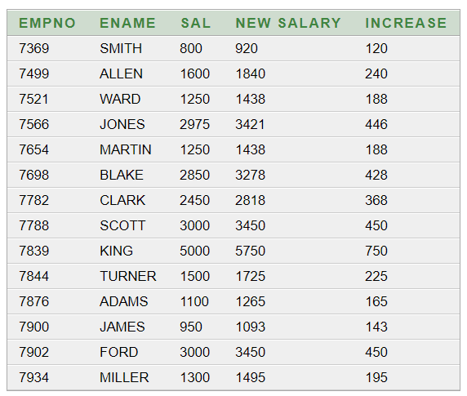

1. SELECT ENAME, HIREDATE,TO_CHAR(NEXT_DAY(ADD_MONTHS(HIREDATE, 6), 'MONDAY'),'fmDay, " the " ddspth " of " Month, YYYY') as "REVIEW" FROM EMP

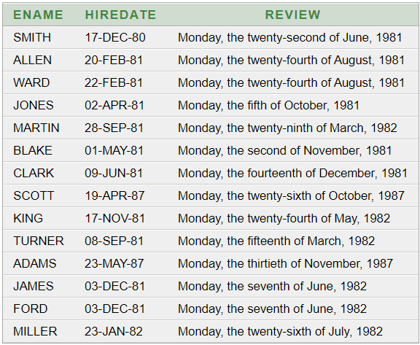

5.

SELECT ENAME,ROUND(MONTHS_BETWEEN(SYSDATE,HIREDATE)) AS "MONTHS_WORKED" FROM EMP ORDER BY (MONTHS_WORKED)

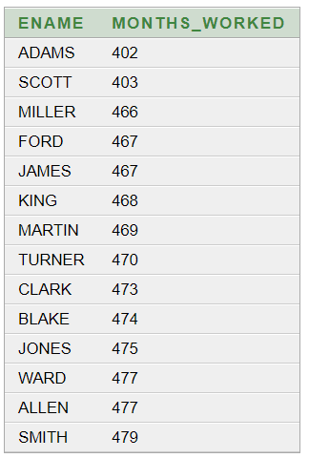

6. SELECT ENAME , COMM AS "COMMISION AMOUNT" , NVL(TO_CHAR(COMM),'NO COMMISION') COMM FROM EMP

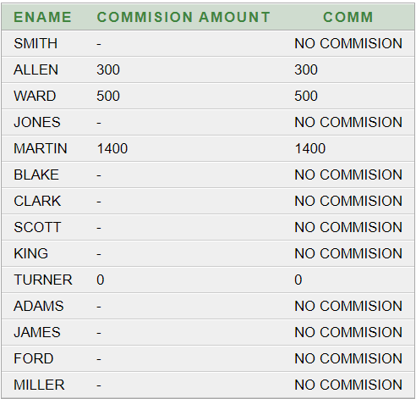

****************************Practice 3*****************************

1.11.20

1.Find average, maximum, minimum salary of the employees according to department number.

2.Find average, maximum, minimum salary of the employees according to job category.

3.Find the name of lowest paid manager. (Manager is not Job).

4.Find the location where maximum number of employee is located

5.Find out job group having highest amount of total salary. (Sal + comm)

6.Suppose you need to know the name and department no. of the employee who earns the highest salary. Write a SQL query to return this information.

**Answers:**

1.

SELECT DEPTNO , AVG(SAL) , MAX(SAL) , MIN(SAL) FROM EMP GROUP BY DEPTNO**;**

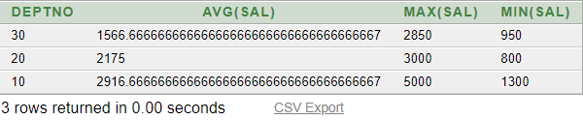

2.

SELECT JOB , AVG(SAL) , MAX(SAL) , MIN(SAL) FROM EMP GROUP BY JOB;

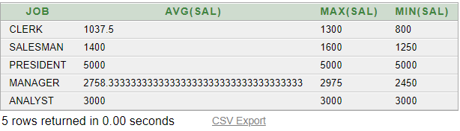

3.

SELECT ENAME FROM EMP WHERE EMPNO = (SELECT MGR FROM EMP WHERE SAL =( SELECT MIN(SAL) FROM EMP WHERE JOB NOT IN ('MANAGER') ) )

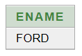

4. SELECT LOC FROM DEPT WHERE DEPTNO =(SELECT DEPTNO FROM EMP GROUP BY DEPTNO HAVING COUNT(DEPTNO)=(SELECT MAX(COUNT(DEPTNO)) FROM EMP GROUP BY DEPTNO))

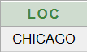

5. SELECT JOB FROM EMP GROUP BY JOB HAVING SUM(SAL+NVL(COMM,0))=(SELECT MAX(SUM(SAL+NVL(COMM,0))) FROM EMP GROUP BY JOB)

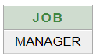

6. SELECT ENAME , DEPTNO FROM EMP WHERE SAL=(SELECT MAX(SAL) FROM EMP)

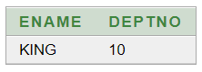

****************************Practice 4******************************

3.11.20

1.Create a table named **Student** from following structure using SQL commands:

|  |  |
| --- | --- |
| Column Name | Data Type |
| **s_id** | Number |
| **s_name** | Varchar2(20) |
| **phone** | number |
| **address** | Varchar2(50) |
| **email** | Varchar2(30) |
| **credit_completed** | Number(3) |
| **course_completed** | Number(2) |
| **cgpa** | Number |

1. Add following columns into the above **student** table:

|  |  |
| --- | --- |
| Column Name | Data Type |
| **department** | Varchar2(5) |
| **gender** | Varchar2(6) |

1. Modify the column name **department** into **dept**.

**Subqueries**

1. Display all the employees who are earning more than all the managers.
2. Select employee number, job & salaries of all the Analysts who are earning more than any of the managers.

**ANSWERS:**

1.

CREATE TABLE Student (s_id NUMBER,s_name VARCHAR2(20),phone NUMBER ,address VARCHAR2(50),

email VARCHAR2(30),credit_completed NUMBER(3),course_completed NUMBER(2),cgpa NUMBER)

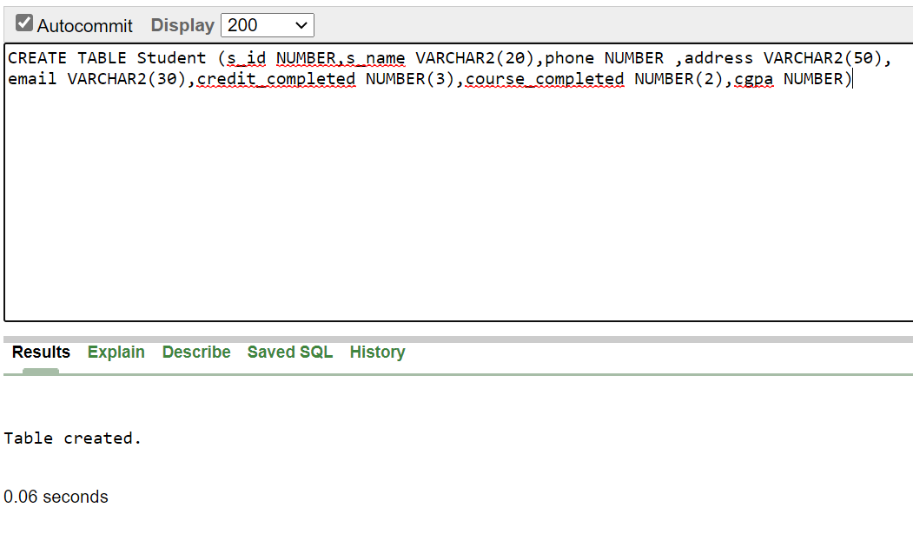

2.

ALTER TABLE Student ADD(department VARCHAR2(5),gender VARCHAR2(6))

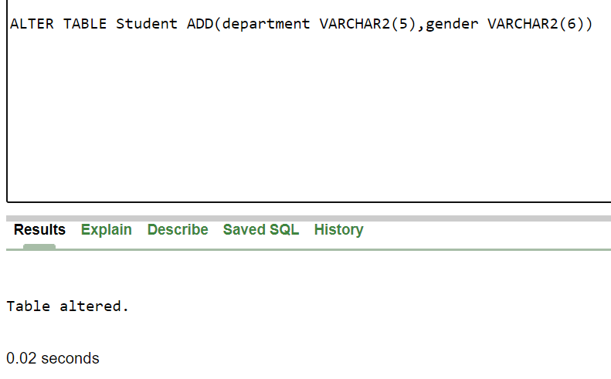

3.

ALTER TABLE Student RENAME COLUMN department TO dept

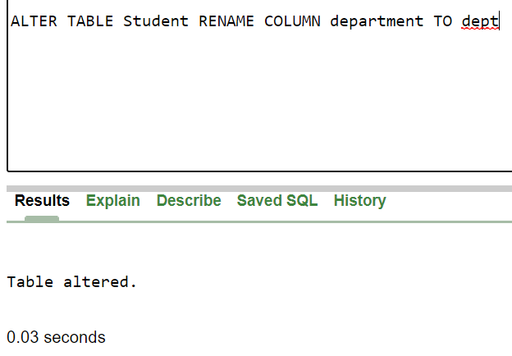

4.

SELECT * FROM EMP WHERE SAL > ( SELECT MAX(SAL) FROM EMP WHERE JOB='MANAGER')

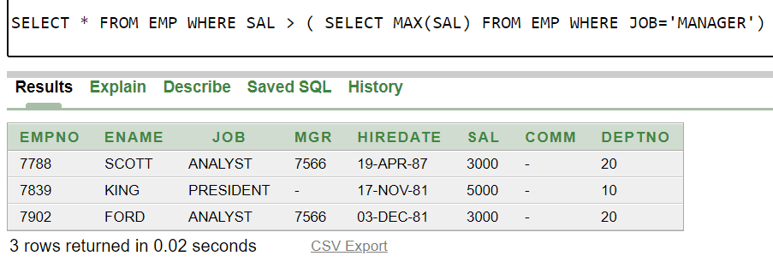

5.SELECT EMPNO,JOB,SAL FROM EMP WHERE JOB IN ('ANALYST') AND SAL>(SELECT MIN(SAL) FROM EMP WHERE JOB IN('MANAGER'))

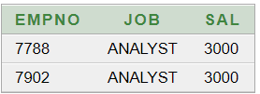

****************************Practice 5******************************

8.11.20

1.Select all the employees who are earning same as SMITH.

2.Display all the employees who are getting some commission in marketing department where the employees have joined only on weekdays.

3.Display all the employees who are getting more than the average salaries of all the employees.

**ANSWERS:**

1. SELECT * FROM EMP WHERE SAL=(SELECT SAL FROM EMP WHERE ENAME='SMITH')



2.

3.SELECT * FROM EMP WHERE SAL>(SELECT AVG(SAL) FROM

EMP )

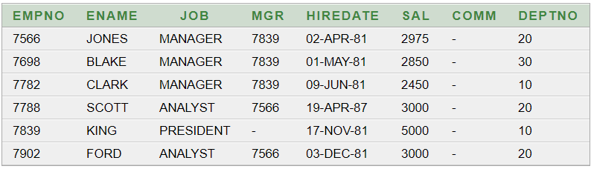

4. ABC Consulting is a small-sized consulting firm in the IT industry.ABC’s business is managing several Systems Development projects by assigning staff consultants to these projects as their skills are needed.Each employee is designated to have one primary skill, but there may be other employees with the same primary skill. A consultant may work on one or more projects, or may not yet be assigned to a project.The company charges for each project by billing each consultant's hours worked by the billing rate. The hourly billing rate is dependent on the employee’s primary job skill.

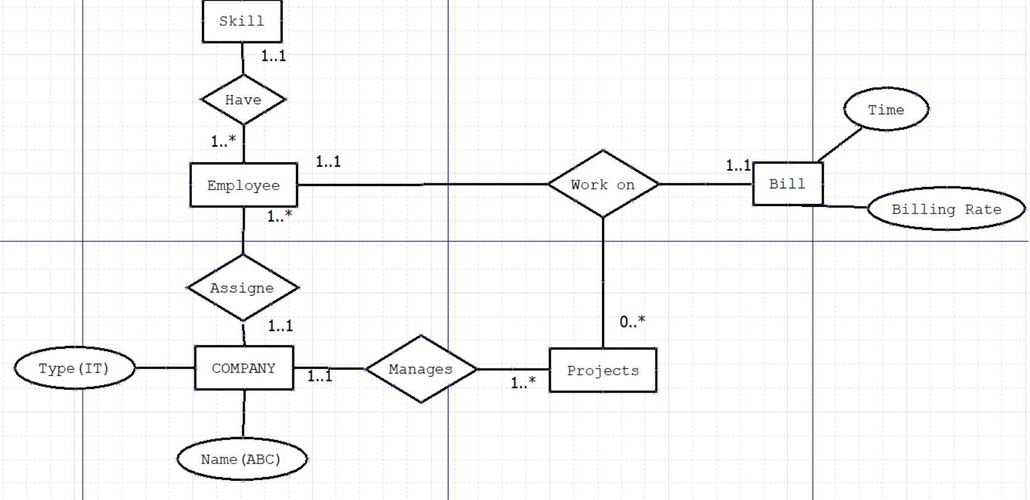

5. A company operates a warehouse parts supply business. The company has several warehouses located in Toronto which each store several hundreds of automotive parts. We need to keep a record of how many parts are "on hand" - meaning inventory levels that tell us how many we have for each part. To help us organize our parts, each part is assigned a specific classification.There are 4 classifications that we use to organize hundreds of parts.

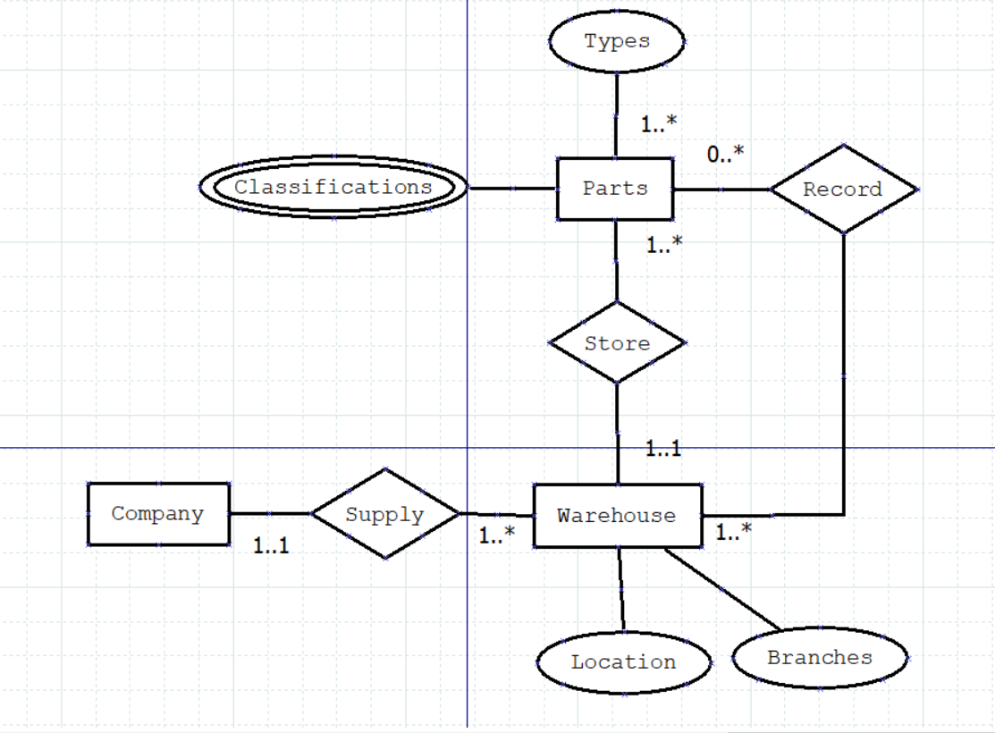

**END**