**BANK MANAGEMENT SYSTEM**

In this project we will discuss about a management system of a bank named CCPD. We have used total 7 entities such as **BANK, BRANCH, MANAGER, EMPLOYEE, LOAN, ACCOUNT, CUSTOMER**. The attributes of **BANK** are: Bank name , licence_no (Primary key) and address. The bank has many managers and branches. One manager manages one branch. **MANAGER** and **BRANCH** also has some attributes. **BRANCH** has its name, id and location **. MANAGER** has m_id, m_name, salary, phone no and salary. One branch has many employee. Employees work for one manager who manages the branch. **EMPLOYEE** has name, id, date of birth , age and salary. One branch has many Account. **ACCOUNT** carries account no, type and balance. **CUSTOMER** has name, address, phone no, customer id. One customer can have one loan or many customers can have many loans. **LOAN** has loan type, amount, loan no. The brunch provides the loan.

**Case Study**

At first, we created a new user and granted all the necessary privileges. We have normalized all the relations between the entities and eliminated all the extra tables. Then we created all the tables with proper constraints and inserted some data into tables. We also created some sequences and used them to insert data into tables. Then we created one simple and one complex view and used them to find out some information. At the very end we run some query to justify our project.

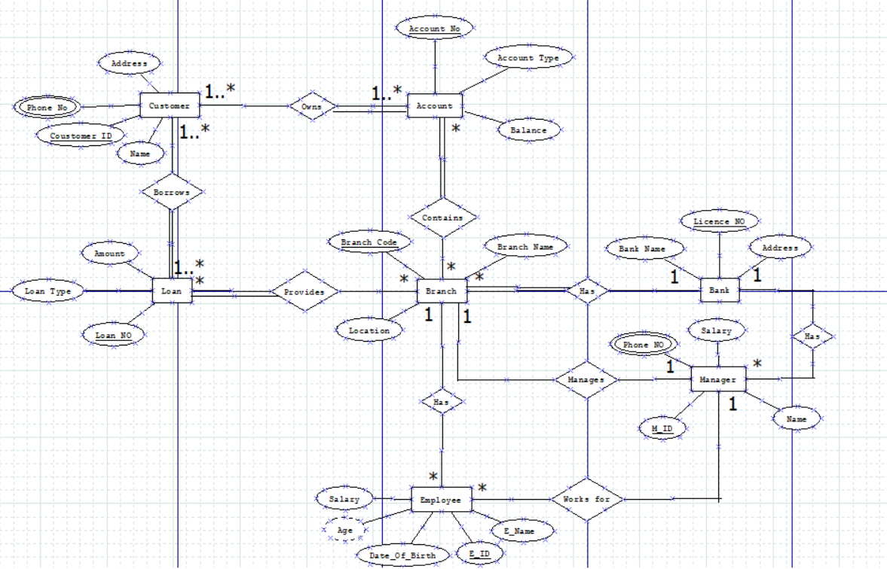

**\* Normalization \***

**1#Customer * Account**

**Owns**(Customer_ID, C_Name, Phone_NO, C_Address, Account_No,Account Type, Balance)

|  |  |  |  |  |  |  |
| --- | --- | --- | --- | --- | --- | --- |
| Customer_ID | C_Name | Phone_NO | C_Address | Account_NO | Acc type | Balance |
| 1001 | Pritom | 01523  01526 | Dhaka | 101 | Current | 1000 |
| 2002 | Sadia | 01569  01568 | Dhaka | 102 | Saving | 2000 |
| 3003 | Rima | 01542  01541 | Tangail | 103 | Saving | 3000 |
| 4004 | Kabir | 01578  01587 | Tangail | 104 | Current | 4000 |

**1NF:**

|  |  |  |  |  |  |  |
| --- | --- | --- | --- | --- | --- | --- |
| Customer_ID | C_Name | Phone_NO | C_Address | Account_NO | Acc type | Balance |
| 1001 | Pritom | 01523 | Dhaka | 101 | Current | 1000 |
| 1001 | Pritom | 01526 | Dhaka | 101 | Current | 1000 |
| 2002 | Sadia | 01569 | Dhaka | 102 | Saving | 2000 |
| 2002 | Sadia | 01568 | Dhaka | 102 | Saving | 2000 |
| 3003 | Rima | 01542 | Tangail | 103 | Saving | 3000 |
| 3003 | Rima | 01541 | Tangail | 103 | Saving | 3000 |
| 4004 | Kabir | 01578 | Tangail | 104 | Current | 4000 |
| 4004 | Kabir | 01587 | Tangail | 104 | Current | 4000 |

**2NF:**

|  |  |  |  |
| --- | --- | --- | --- |
| Customer_ID | C_Name | Phone_NO | C_Address |
| 1001 | Pritom | 01523 | Dhaka |
| 1001 | Pritom | 01526 | Dhaka |
| 2002 | Sadia | 01569 | Dhaka |
| 2002 | Sadia | 01568 | Dhaka |
| 3003 | Rima | 01542 | Tangail |
| 3003 | Rima | 01541 | Tangail |
| 4004 | Kabir | 01578 | Tangail |
| 4004 | Kabir | 01587 | Tangail |

|  |  |  |
| --- | --- | --- |
| Account_NO | Acc type | Balance |
| 101 | Current | 1000 |
| 102 | Saving | 2000 |
| 103 | Saving | 3000 |
| 104 | Current | 4000 |

|  |  |
| --- | --- |
| Customer_ID | Account_NO |
| 1001 | 101 |
| 2002 | 102 |
| 3003 | 103 |
| 4004 | 104 |

**3NF :** No transitive dependency

**2#Customer * Loan**

**Borrows**(Customer_ID, Name, Phone_NO, C_Address, Loan_NO, Loan Type, Amount)

|  |  |  |  |  |  |  |
| --- | --- | --- | --- | --- | --- | --- |
| Customer_ID | C_Name | Phone_NO | C_Address | Loan_NO | Loan type | Amount |
| 1001 | Pritom | 01523  01526 | Dhaka | 111 | Credit | 100 |
| 2002 | Sadia | 01569  01568 | Dhaka | 112 | Home | 200 |
| 3003 | Rima | 01542  01541 | Tangail | 113 | Business | 300 |
| 4004 | Kabir | 01578  01587 | Tangail | 114 | Personal | 400 |

**1NF:**

|  |  |  |  |  |  |  |
| --- | --- | --- | --- | --- | --- | --- |
| Customer_ID | Name | Phone_NO | C_Address | Loan_NO | Loan type | Amount |
| 1001 | Pritom | 01523 | Dhaka | 111 | Credit | 100 |
| 1001 | Pritom | 01526 | Dhaka | 111 | Credit | 100 |
| 2002 | Sadia | 01569 | Dhaka | 112 | Home | 200 |
| 2002 | Sadia | 01568 | Dhaka | 112 | Home | 200 |
| 3003 | Rima | 01542 | Tangail | 113 | Business | 300 |
| 3003 | Rima | 01541 | Tangail | 113 | Business | 300 |
| 4004 | Kabir | 01578 | Tangail | 114 | Personal | 400 |
| 4004 | Kabir | 01587 | Tangail | 114 | Personal | 400 |

**2NF:**

|  |  |  |  |
| --- | --- | --- | --- |
| Customer_ID | C_Name | Phone_NO | C_Address |
| 1001 | Pritom | 01523 | Dhaka |
| 1001 | Pritom | 01526 | Dhaka |
| 2002 | Sadia | 01569 | Dhaka |
| 2002 | Sadia | 01568 | Dhaka |
| 3003 | Rima | 01542 | Tangail |
| 3003 | Rima | 01541 | Tangail |
| 4004 | Kabir | 01578 | Tangail |
| 4004 | Kabir | 01587 | Tangail |

|  |  |  |
| --- | --- | --- |
| Loan_NO | Loan type | Amount |
| 111 | Credit | 1000 |
| 112 | Home | 2000 |
| 113 | Business | 3000 |
| 114 | Personal | 4000 |

|  |  |
| --- | --- |
| Customer_ID | Loan_NO |
| 1001 | 111 |
| 2002 | 112 |
| 3003 | 113 |
| 4004 | 114 |

**3NF :** No transitive dependency

**3#Loan * Branch**

**Provides**(Loan_NO, Loan type, Amount, Branch_ID, Branch_Name, Location)

|  |  |  |  |  |  |
| --- | --- | --- | --- | --- | --- |
| Loan_NO | Loan type | Amount | Branch_ID | Branch_Name | Location |
| 111 | Credit | 100 | 1111 | Dhaka Branch | Dhaka |
| 112 | Home | 200 | 1111 | Dhaka Branch | Dhaka |
| 113 | Business | 300 | 2222 | Tangail Branch | Tangail |
| 114 | Personal | 400 | 2222 | Tangail Branch | Tangail |

**1NF :** No multivalued attributes.

**2NF:**

|  |  |  |
| --- | --- | --- |
| Loan_NO | Loan type | Amount |
| 111 | Credit | 100 |
| 112 | Home | 200 |
| 113 | Business | 300 |
| 114 | Personal | 400 |

|  |  |  |
| --- | --- | --- |
| Branch_ID | Branch_Name | Location |
| 1111 | Dhaka Branch | Dhaka |
| 2222 | Tangail Branch | Tangail |

|  |  |
| --- | --- |
| Loan_NO | Branch_ID |
| 111 | 1111 |
| 112 | 1111 |
| 113 | 2222 |
| 114 | 2222 |

**3NF :** No transitive dependency

**4#Branch * Account**

**Contains**(Branch_ID, Branch_Name, Location , Account_No, Account Type, Balance)

|  |  |  |  |  |  |
| --- | --- | --- | --- | --- | --- |
| Branch_ID | Branch_Name | Location | Account_NO | Acc type | Balance |
| 1111 | Dhaka Branch | Dhaka | 101 | Current | 1000 |
| 1111 | Dhaka Branch | Dhaka | 102 | Saving | 2000 |
| 2222 | Tangail Branch | Tangail | 103 | Saving | 3000 |
| 2222 | Tangail Branch | Tangail | 104 | Current | 4000 |

**1NF :** No multivalued attributes.

**2NF:**

|  |  |  |
| --- | --- | --- |
| Account_NO | Acc type | Balance |
| 101 | Current | 1000 |
| 102 | Saving | 2000 |
| 103 | Saving | 3000 |
| 104 | Current | 4000 |

|  |  |  |
| --- | --- | --- |
| Branch_ID | Branch_Name | Location |
| 1111 | Dhaka Branch | Dhaka |
| 2222 | Tangail Branch | Tangail |

|  |  |
| --- | --- |
| Account_NO | Branch_ID |
| 101 | 1111 |
| 102 | 1111 |
| 103 | 2222 |
| 104 | 2222 |

**3NF :** No transitive dependency

**5#Branch * Employees**

**Has** (Branch_ID, Branch_Name, Location, E_ID, E_Name, Salary, DOB, Age)

|  |  |  |  |  |  |  |  |
| --- | --- | --- | --- | --- | --- | --- | --- |
| Branch_ID | Branch_Name | Location | E_ID | E_Name | Salary | DOB | Age |
| 1111 | Dhaka Branch | Dhaka | 2001 | Anng | 100 | 1-sep- 1980 | 40 |
| 1111 | Dhaka Branch | Dhaka | 2002 | Katara | 200 | 25-oct-1981 | 39 |
| 2222 | Tangail Branch | Tangail | 2003 | Suki | 300 | 12-may-1979 | 41 |
| 2222 | Tangail Branch | Tangail | 2004 | Zuko | 400 | 12-jan-1982 | 38 |

**1NF :** No multivalued attributes.

**2NF:**

|  |  |  |  |  |  |
| --- | --- | --- | --- | --- | --- |
| E_ID | Branch_ID | E_Name | Salary | DOB | Age |
| 2001 | 1111 | Anng | 100 | 1-sep- 1980 | 40 |
| 2002 | 1111 | Katara | 200 | 25-oct-1981 | 39 |
| 2003 | 2222 | Suki | 300 | 12-may-1979 | 41 |
| 2004 | 2222 | Zuko | 400 | 12-jan-1982 | 38 |

|  |  |  |
| --- | --- | --- |
| Branch_ID | Branch_Name | Location |
| 1111 | Dhaka Branch | Dhaka |
| 2222 | Tangail Branch | Tangail |

**3NF:**

|  |  |  |  |  |  |  |  |
| --- | --- | --- | --- | --- | --- | --- | --- |
| E_ID | | Branch_ID | E_Name | | Salary | | Birth_ID |
| 2001 | | 1111 | Anng | | 100 | | 1 |
| 2002 | | 1111 | Katara | | 200 | | 2 |
| 2003 | | 2222 | Suki | | 300 | | 3 |
| 2004 | | 2222 | Zuko | | 400 | | 4 |
| Birth_ID | DOB | | | Age | |
| 1 | 1-sep- 1980 | | | 40 | |
| 2 | 25-oct-1981 | | | 39 | |
| 3 | 12-may-1979 | | | 41 | |
| 4 | 12-jan-1982 | | | 38 | |

|  |  |  |
| --- | --- | --- |
| Branch_ID | Branch_Name | Location |
| 1111 | Dhaka Branch | Dhaka |
| 2222 | Tangail Branch | Tangail |

**6#Branch * Bank**

**Has** (Branch_ID, Branch_Name, Location, Licence_NO, Bank_Name, Address)

|  |  |  |  |  |  |
| --- | --- | --- | --- | --- | --- |
| Branch_ID | Branch_Name | Location | Licence_NO | Bank_Name | Address |
| 1111 | Dhaka Branch | Dhaka | 9090 | CCPD | Ladakh |
| 2222 | Tangail Branch | Tangail | 9090 | CCPD | Ladakh |
| 3333 | Gazipur Branch | Gazipur | 9090 | CCPD | Ladakh |
| 4444 | Kumilla Branch | Kumilla | 9090 | CCPD | Ladakh |

**1NF :** No multivalued attributes.

**2NF:**

|  |  |  |  |
| --- | --- | --- | --- |
| Branch_ID | Branch_Name | Location | Licence_NO |
| 1111 | Dhaka Branch | Dhaka | 9090 |
| 2222 | Tangail Branch | Tangail | 9090 |
| 3333 | Gazipur Branch | Gazipur | 9090 |
| 4444 | Kumilla Branch | Kumilla | 9090 |

|  |  |  |
| --- | --- | --- |
| Licence_NO | Bank_Name | Address |
| 9090 | CCPD | Ladakh |

**3NF:** No transitive dependency

**7#Branch * Manager**

**Manages** (Branch_ID, Branch_Name, Location, M_ID, Name, Salary, Phone_NO)

|  |  |  |  |  |  |  |
| --- | --- | --- | --- | --- | --- | --- |
| Branch_ID | Branch_Name | Location | M_ID | Name | Salary | Phone_NO |
| 1111 | Dhaka Branch | Dhaka | 601 | Ash | 9000 | 01789 |
| 01798 |
| 2222 | Tangail Branch | Tangail | 602 | Sam | 8000 | 01756 |
| 01765 |
| 3333 | Gazipur Branch | Gazipur | 603 | Ram | 7000 | 01723 |
| 01732 |
| 4444 | Kumilla Branch | Kumilla | 604 | Tom | 8000 | 01712 |
| 01721 |

**1NF:**

|  |  |  |  |  |  |  |
| --- | --- | --- | --- | --- | --- | --- |
| Branch_ID | Branch_Name | Location | M_ID | Name | Salary | Phone_NO |
| 1111 | Dhaka Branch | Dhaka | 601 | Ash | 9000 | 01789 |
| 1111 | Dhaka Branch | Dhaka | 601 | Ash | 9000 | 01798 |
| 2222 | Tangail Branch | Tangail | 602 | Sam | 8000 | 01756 |
| 2222 | Tangail Branch | Tangail | 602 | Sam | 8000 | 01765 |
| 3333 | Gazipur Branch | Gazipur | 603 | Ram | 7000 | 01732 |
| 3333 | Gazipur Branch | Gazipur | 603 | Ram | 7000 | 01723 |
| 4444 | Kumilla Branch | Kumilla | 604 | Tom | 8000 | 01712 |
| 4444 | Kumilla Branch | Kumilla | 604 | Tom | 8000 | 01721 |

**2NF:**

|  |  |  |  |
| --- | --- | --- | --- |
| Branch_ID | Branch_Name | Location | M_ID |
| 1111 | Dhaka Branch | Dhaka | 601 |
| 2222 | Tangail Branch | Tangail | 602 |
| 3333 | Gazipur Branch | Gazipur | 603 |
| 4444 | Kumilla Branch | Kumilla | 604 |

|  |  |  |  |
| --- | --- | --- | --- |
| M_ID | Name | Salary | Phone_NO |
| 601 | Ash | 9000 | 01789 |
| 601 | Ash | 9000 | 01798 |
| 602 | Sam | 8000 | 01756 |
| 602 | Sam | 8000 | 01765 |
| 603 | Ram | 7000 | 01732 |
| 603 | Ram | 7000 | 01723 |
| 604 | Tom | 8000 | 01712 |
| 604 | Tom | 8000 | 01721 |

**3NF:** No transitive dependency

**8#Manager * Employee**

**Works For** (M_ID, Name, Salary, Phone_NO, E_ID, E_Name, Salary, DOB, Age)

|  |  |  |  |  |  |  |  |  |
| --- | --- | --- | --- | --- | --- | --- | --- | --- |
| M_ID | Name | M_Salary | Phone_NO | E_ID | E_Name | E_Salary | DOB | Age |
| 601 | Ash | 9000 | 01789 | 2001 | Anng | 100 | 1-sep- 1980 | 40 |
| 01798 |
| 601 | Ash | 9000 | 01789 | 2002 | Katara | 200 | 25-oct-1981 | 39 |
| 01798 |
| 602 | Sam | 8000 | 01756 | 2003 | Suki | 300 | 12-may-1979 | 41 |
| 01765 |
| 602 | Sam | 8000 | 01756 | 2004 | Zuko | 400 | 12-jan-1982 | 38 |
| 01765 |

**1NF:**

|  |  |  |  |  |  |  |  |  |
| --- | --- | --- | --- | --- | --- | --- | --- | --- |
| M_ID | Name | M_Salary | Phone_NO | E_ID | E_Name | E_Salary | DOB | Age |
| 601 | Ash | 9000 | 01789 | 2001 | Anng | 100 | 1-sep- 1980 | 40 |
| 601 | Ash | 9000 | 01789 | 2001 | Anng | 100 | 1-sep- 1980 | 40 |
| 601 | Ash | 9000 | 01798 | 2002 | Katara | 200 | 25-oct-1981 | 39 |
| 601 | Ash | 9000 | 01798 | 2002 | Katara | 200 | 25-oct-1981 | 39 |
| 602 | Sam | 8000 | 01756 | 2003 | Suki | 300 | 12-may-1979 | 41 |
| 602 | Sam | 8000 | 01756 | 2003 | Suki | 300 | 12-may-1979 | 41 |
| 602 | Sam | 8000 | 01765 | 2004 | Zuko | 400 | 12-jan-1982 | 38 |
| 602 | Sam | 8000 | 01765 | 2004 | Zuko | 400 | 12-jan-1982 | 38 |

**2NF:**

|  |  |  |  |  |  |
| --- | --- | --- | --- | --- | --- |
| E_ID | E_Name | E_Salary | DOB | Age | M_ID |
| 2001 | Anng | 100 | 1-sep- 1980 | 40 | 601 |
| 2001 | Anng | 100 | 1-sep- 1980 | 40 | 601 |
| 2002 | Katara | 200 | 25-oct-1981 | 39 | 601 |
| 2002 | Katara | 200 | 25-oct-1981 | 39 | 601 |
| 2003 | Suki | 300 | 12-may-1979 | 41 | 602 |
| 2003 | Suki | 300 | 12-may-1979 | 41 | 602 |
| 2004 | Zuko | 400 | 12-jan-1982 | 38 | 602 |
| 2004 | Zuko | 400 | 12-jan-1982 | 38 | 602 |

|  |  |  |  |
| --- | --- | --- | --- |
| M_ID | Name | M_Salary | Phone_NO |
| 601 | Ash | 9000 | 01789 |
| 601 | Ash | 9000 | 01798 |
| 602 | Sam | 8000 | 01756 |
| 602 | Sam | 8000 | 01765 |

**3NF :**

|  |  |  |  |
| --- | --- | --- | --- |
| M_ID | Name | M_Salary | Phone_NO |
| 601 | Ash | 9000 | 01789 |
| 601 | Ash | 9000 | 01798 |
| 602 | Sam | 8000 | 01756 |
| 602 | Sam | 8000 | 01765 |

|  |  |  |  |  |
| --- | --- | --- | --- | --- |
| E_ID | E_Name | E_Salary | Birth_ID | M_ID |
| 2001 | Anng | 1000 | 1 | 601 |
| 2002 | Katara | 2000 | 2 | 601 |
| 2003 | Suki | 3000 | 3 | 602 |
| 2004 | Zuko | 4000 | 4 | 602 |

|  |  |  |
| --- | --- | --- |
| Birth_ID | DOB | Age |
| 1 | 1-sep-1980 | 40 |
| 2 | 25-oct-1981 | 39 |
| 3 | 12-may-1979 | 41 |
| 4 | 12-jan-1982 | 38 |

**9#Bank * Manager**

**Has** (Licence_NO, Bank_Name, Address, M_ID, Name, Salary, Phone_NO)

|  |  |  |  |  |  |  |
| --- | --- | --- | --- | --- | --- | --- |
| Licence_NO | Bank_Name | Address | M_ID | Name | Salary | Phone_NO |
| 9090 | CCPD | Ladakh | 601 | Ash | 9000 | 01789 |
| 01798 |
| 9090 | CCPD | Ladakh | 602 | Sam | 8000 | 01756 |
| 01765 |
| 9090 | CCPD | Ladakh | 603 | Ram | 7000 | 01756 |
| 01765 |
| 9090 | CCPD | Ladakh | 604 | Tom | 8000 | 01712 |
| 01721 |

**1NF:**

|  |  |  |  |  |  |  |
| --- | --- | --- | --- | --- | --- | --- |
| Licence_NO | Bank_Name | Address | M_ID | Name | Salary | Phone_NO |
| 9090 | CCPD | Ladakh | 601 | Ash | 9000 | 01789 |
| 9090 | CCPD | Ladakh | 601 | Ash | 9000 | 01798 |
| 9090 | CCPD | Ladakh | 602 | Sam | 8000 | 01756 |
| 9090 | CCPD | Ladakh | 602 | Sam | 8000 | 01765 |
| 9090 | CCPD | Ladakh | 603 | Ram | 7000 | 01756 |
| 9090 | CCPD | Ladakh | 603 | Ram | 7000 | 01765 |
| 9090 | CCPD | Ladakh | 604 | Tom | 8000 | 01712 |
| 9090 | CCPD | Ladakh | 604 | Tom | 8000 | 01721 |

**2NF:**

|  |  |  |  |  |
| --- | --- | --- | --- | --- |
| Licence_NO | M_ID | Name | Salary | Phone_NO |
| 9090 | 601 | Ash | 9000 | 01789 |
| 9090 | 601 | Ash | 9000 | 01798 |
| 9090 | 602 | Sam | 8000 | 01756 |
| 9090 | 602 | Sam | 8000 | 01765 |
| 9090 | 603 | Ram | 7000 | 01756 |
| 9090 | 603 | Ram | 7000 | 01765 |
| 9090 | 604 | Tom | 8000 | 01712 |
| 9090 | 604 | Tom | 8000 | 01721 |

|  |  |  |
| --- | --- | --- |
| Licence_NO | Bank_Name | Address |
| 9090 | CCPD | Ladakh |

**3NF:** No transitive dependency

**\* Final Tables \***

1.Customer:

|  |  |  |  |
| --- | --- | --- | --- |
| Customer_ID | C_Name | Phone_NO | C_Address |

2.Account:

|  |  |  |
| --- | --- | --- |
| Account_NO | Acc type | Balance |

3.Customer_Account:

|  |  |
| --- | --- |
| Customer_ID | Account_NO |

|  |  |  |  |
| --- | --- | --- | --- |
| ~~Customer_ID~~ | ~~Name~~ | ~~Phone_NO~~ | ~~Address~~ |

4.Loan:

|  |  |  |
| --- | --- | --- |
| Loan_NO | Loan type | Amount |

5.Customer_Loan

|  |  |
| --- | --- |
| Customer_ID | Loan_NO |

|  |  |  |
| --- | --- | --- |
| ~~Loan_NO~~ | ~~Loan type~~ | ~~Amount~~ |

6.Loan_Branch

|  |  |
| --- | --- |
| Loan_NO | Branch_ID |

|  |  |  |
| --- | --- | --- |
| ~~Account_NO~~ | ~~Acc type~~ | ~~Balance~~ |

7.Branch:

|  |  |  |
| --- | --- | --- |
| Branch_ID | Branch_Name | Location |

8.Account_Branch:

|  |  |
| --- | --- |
| Account_NO | Branch_ID |

Branch_Employee

|  |  |  |  |  |
| --- | --- | --- | --- | --- |
| E_ID | Branch_ID | E_Name | Salary | Birth_ID |

9.Birth

|  |  |  |
| --- | --- | --- |
| Birth_ID | DOB | Age |

|  |  |  |
| --- | --- | --- |
| ~~Branch_ID~~ | ~~Branch_Name~~ | ~~Location~~ |

10.Bank:

|  |  |  |
| --- | --- | --- |
| Licence_NO | Bank_Name | Address |

Branch_Bank:

|  |  |  |  |
| --- | --- | --- | --- |
| Branch_ID | Branch_Name | Location | Licence_NO |

11.Manager:

|  |  |  |  |
| --- | --- | --- | --- |
| M_ID | M_Name | M_Salary | Phone_NO |

Branch_Manager:

|  |  |  |  |
| --- | --- | --- | --- |
| Branch_ID | Branch_Name | Location | M_ID |

|  |  |  |  |
| --- | --- | --- | --- |
| ~~M_ID~~ | ~~Name~~ | ~~M_Salary~~ | ~~Phone_NO~~ |

Employee_Manager:

|  |  |  |  |  |
| --- | --- | --- | --- | --- |
| E_ID | E_Name | E_Salary | Birth_ID | M_ID |

|  |  |  |
| --- | --- | --- |
| ~~Birth_ID~~ | ~~DOB~~ | ~~Age~~ |

Bank_Manager:

|  |  |  |  |  |
| --- | --- | --- | --- | --- |
| Licence_NO | M_ID | Name | M_Salary | Phone_NO |

|  |  |  |
| --- | --- | --- |
| ~~Licence_NO~~ | ~~Bank_Name~~ | ~~Address~~ |

|  |  |  |
| --- | --- | --- |
| ~~Branch_ID~~ | ~~Branch_Name~~ | ~~Location~~ |

**From table Branch_Bank, Branch_Manager, Bank_Manager:**

**We can notice there is a transitive dependency between these three table so we have to normalize them again.**

12.B_M_Bank:

|  |  |  |
| --- | --- | --- |
| Branch_ID | M_ID | Licence_NO |

**And from table Branch_Employee and Employee_Manager we get,**

13.B_M_Emp:

|  |  |  |
| --- | --- | --- |
| Branch_ID | M_ID | E_ID |

14.Employee:

|  |  |  |  |
| --- | --- | --- | --- |
| E_ID | E_Name | E_Salary | Birth_ID |

**\* QUERIES \***

**User Creation:**

1. CREATE USER PROJECT IDENTIFIED BY PROJECT

**Granting privileges:**

1. GRANT CREATE TABLE, CREATE SEQUENCE, CREATE VIEW TO PROJECT
2. GRANT CONNECT, RESOURCE, UNLIMITED TABLESPACE TO PROJECT

**Table creation:**

1.Customer

CREATE TABLE CUSTOMER (CUSTOMER_ID NUMBER(20) CONSTRAINT PK_CUSTOMER_ID PRIMARY KEY, C_NAME VARCHAR2(50) ,PHONE_NO VARCHAR2(12), C_ADDRESS VARCHAR2(15) )

2.Account:

CREATE TABLE ACCOUNT (ACCOUNT_NO NUMBER(20) CONSTRAINT PK_ACCOUNT_NO PRIMARY KEY, ACC_TYPE VARCHAR2(50), BALANCE NUMBER(12) CONSTRAINT CK_BAL CHECK(BALANCE >0))

3.Customer_Account:

CREATE TABLE CUSTOMER_ACCOUNT (CUSTOMER_ID NUMBER(20), ACCOUNT_NO NUMBER(20))

4.Loan:

CREATE TABLE LOAN (LOAN_NO NUMBER(10) CONSTRAINT PK_LOAN PRIMARY KEY, LOAN_TYPE VARCHAR2(14) ,BALANCE NUMBER)

5.Customer_Loan:

CREATE TABLE CUSTOMER_LOAN (CUSTOMER_ID NUMBER(20), LOAN_NO NUMBER(20))

6.Loan_Branch:

CREATE TABLE LOAN_BRANCH (LOAN_NO NUMBER(20) NOT NULL, BRANCH_ID NUMBER(20) CONSTRAINT FK_BRANCH REFERENCES BRANCH)

7.Branch:

CREATE TABLE BRANCH ( BRANCH_ID NUMBER(4) CONSTRAINT PK_BRANCH PRIMARY KEY,BRANCH_NAME VARCHAR2(14) ,LOCATION VARCHAR2(13) )

8.Account_Branch:

CREATE TABLE ACCOUNT_BRANCH (ACCOUNT_NO NUMBER, BRANCH_ID NUMBER)

9.Birth:

CREATE TABLE BIRTH (BIRTH_ID NUMBER(10) CONSTRAINT PK_BID PRIMARY KEY,DOB DATE,AGE VARCHAR2(2))

10.Bank:

CREATE TABLE BANK (LICENCE_NO NUMBER(4) CONSTRAINT PK_BANK PRIMARY KEY,BANK_NAME VARCHAR2(14) ,ADDRESS VARCHAR2(13))

11.Manager:

CREATE TABLE MANAGER (M_ID NUMBER(20) CONSTRAINT PK_MID PRIMARY KEY, M_NAME VARCHAR2(50) ,PHONE_NO VARCHAR2(12),SALARY NUMBER CONSTRAINT CK_SAL CHECK(SALARY >0))

12.B_M_Bank:

CREATE TABLE B_M_BANK (BRANCH_ID NUMBER, M_ID NUMBER, LICENCE_NO NUMBER)

13. B_M_EMP:

CREATE TABLE B_M_EMP (BRANCH_ID NUMBER, M_ID NUMBER, E_ID NUMBER)

14.Employee:

CREATE TABLE EMPLOYEE ( E_ID NUMBER(4),E_NAME VARCHAR2(14) ,E_SALARY NUMBER , BIRTH_ID NUMBER)

* INSERTING VALUES *

**1.CUSTOMER:**

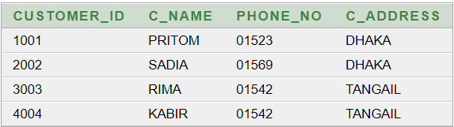

**2.ACCOUNT:**

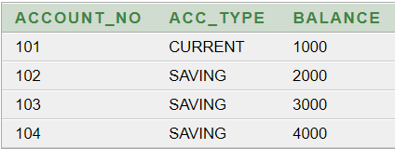

**3.CUSTOMER_ACCOUNT :**

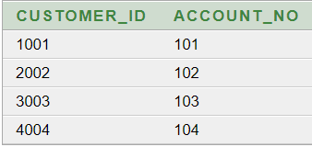

**4.LOAN :**

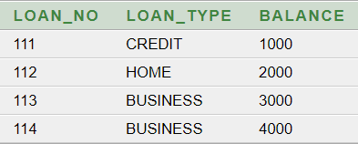

**5. CUSTOMER_LOAN :**

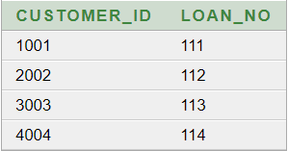

**6.LOAN_BRANCH:**

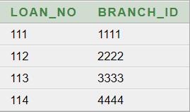

**7.BRANCH:**

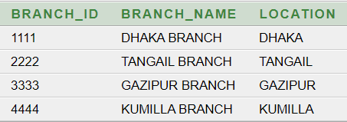

**8.ACCOUNT_BRANCH:**

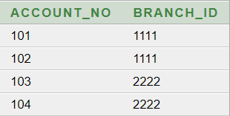

**9.BIRTH**

**INSERTED USING SEQUENCE

INSERT INTO BIRTH VALUES (BIRTH_BIRTH_ID.NEXTVAL,TO_DATE('12-01-1982','DD-MM-YYYY'),'38')

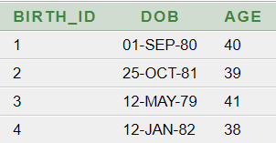

**10.BANK:**

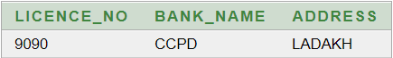

**11.MANAGER:**

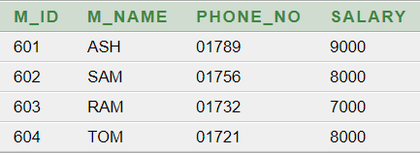

**12. B_M_BANK:**

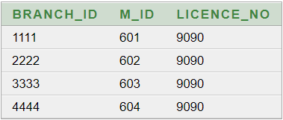

**13.B_M_Emp:**

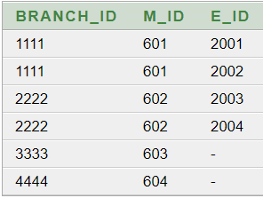

**14.EMPLOYEE**

**INSERTED USING SEQUENCE

**INSERT INTO EMPLOYEE VALUES (EMPLOYEE_E_ID.NEXTVAL,'ANNG',1000,1)

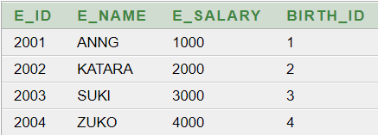

* SEQUENCE *

**FOR BIRTH ID:**

CREATE SEQUENCE BIRTH_BIRTH_ID INCREMENT BY 1 START WITH 1 NOCACHE NOCYCLE

**FOR EMPLOYEE ID:**

CREATE SEQUENCE EMPLOYEE_E_ID INCREMENT BY 1 START WITH 2001 NOCACHE NOCYCLE

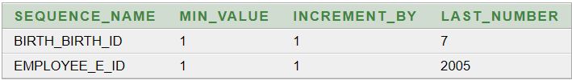

**\*\* CURRENT VALUES:**

1.SELECT BIRTH_BIRTH_ID. CURRVAL AS CURRENT_VALUE FROM DUAL

2. SELECT EMPLOYEE_E_ID. CURRVAL AS CURRENT_VALUE FROM DUAL

**\* VIEW \***

**1.SIMPLE VIEW:**

CREATE VIEW CINFO (ID, NAME, ADDRESS) AS SELECT CUSTOMER_ID, C_NAME, C_ADDRESS FROM CUSTOMER WHERE C_ADDRESS='DHAKA

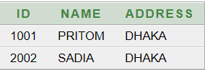

**2.COMPLEX VIEW:**

CREATE VIEW EMPINFO AS SELECT E.E_ID, E.E_NAME, B.M_ID, M.M_NAME FROM EMPLOYEE E, B_M_EMP B, MANAGER M WHERE E.E_ID=B.E_ID AND B.M_ID=M.M_ID

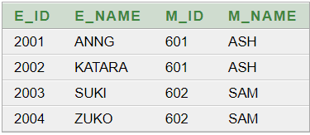

**Simple Queries:**

**1.Using view:**

a. Print customer name whose id is 1001 and lives in DHAKA.

Answer: SELECT NAME FROM CINFO WHERE ID IN (1001) AND ADDRESS IN ('DHAKA')

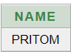

b. Show the employees working for ASH.

Answer: SELECT * FROM EMPINFO WHERE M_NAME='ASH'

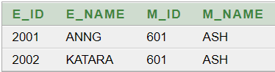

**2.Using tables:**

a. Print customer name whose id is 1001 and lives in DHAKA.

Answers: SELECT C_NAME FROM CUSTOMER WHERE CUSTOMER_ID=1001 AND C_ADDRESS='DHAKA'

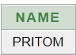

b. Show the employees working for ASH.

Answers: SELECT E.E_ID, E.E_NAME, E.E_SALARY,B.DOB, B.AGE, M.M_ID, M.M_NAME FROM MANAGER M , EMPLOYEE E, BIRTH B, B_M_EMP BM WHERE E.BIRTH_ID=B.BIRTH_ID AND E.E_ID=BM.E_ID AND BM.M_ID=M.M_ID AND M.M_NAME='ASH'

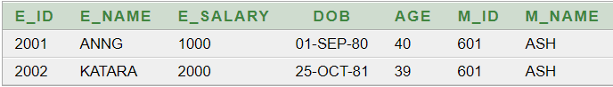

Group Members:

1.Pritom Debnath (20-42414-1)

2.Sadia Ali Sultana (20-42386-1)