***Pregnancy data:***

**For mom :**

**Gestation days:**

1. **Risk (**Before 37 weeks, After 328 days / after 42 weeks**)**
2. **No risk (** 280 days or 40 weeks**)**

**Age :**

1. **Perfect age** (19-34 years old)
2. **Early age** (17 years old)
3. **Late age** (after 35 years old)

**Perfect weight (according to height):**

1. **Low (**A BMI below 18.5 kg/m(2))
2. **Perfect (**A BMI between 18.5 and 24.9 kg/m(2))/(height = 168.3cm; weight = 66.4kg)
3. **High (**A BMI between 25, 29.9 or more than 30 kg/m(2)**)**

**Smoking habit :**

1. **Risk** (Stop smoking. That's because women who smoke during pregnancy up their risk for pregnancy complications such as preterm delivery and having a low-birth-weight baby.)
2. **No risk** (If you are finding it tough to stop smoking, don’t despair. One cigarette a day.There is evidence to suggest that stopping smoking by the fourth month of pregnancy can reduce some of the risks, such as low birth weight and premature birth.)

**N.B :** Quitting smoking at any stage of your pregnancy has health benefits for you and your baby. Even after just one day of not smoking, your baby will get more oxygen. This will help your baby’s lungs develop well. Quitting now also lowers your chances of having a baby with low birth weight.

**For dad:**

**Age :**

1. **Perfect age (**34 to 39 years old**)**
2. **Early age (**16-19 years old**)**
3. **Late age** (over 45 years old)

**Perfect weight (according to height):**

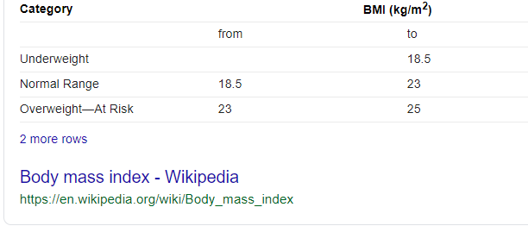

1. **Low (**A BMI below 18.5 kg/m(2**)**
2. **Perfect** (BMI17.6 - 24.77 kg/m(2)**)** (height = 181.2 cm and weight = 81.4 kg )
3. **High (**A BMI between 25, 29.9 or more than 30 kg/m(2)**)**