MyNextHire-Zoom Integration FAQs

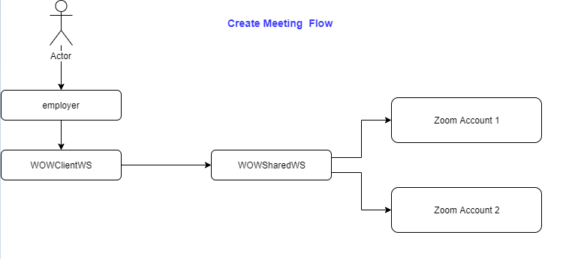

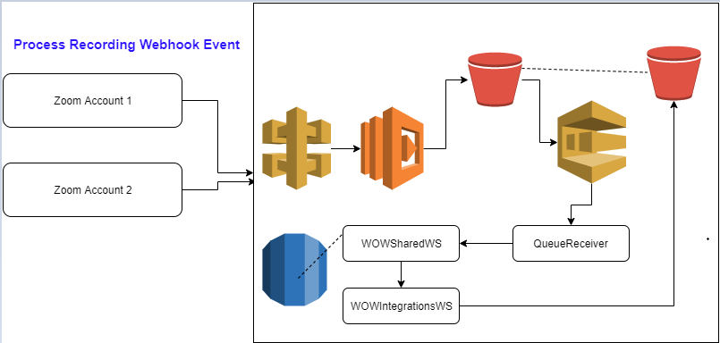

How to procure Zoom hosts?
Login to https://zoom.us/

Go to ADMIN – Billing
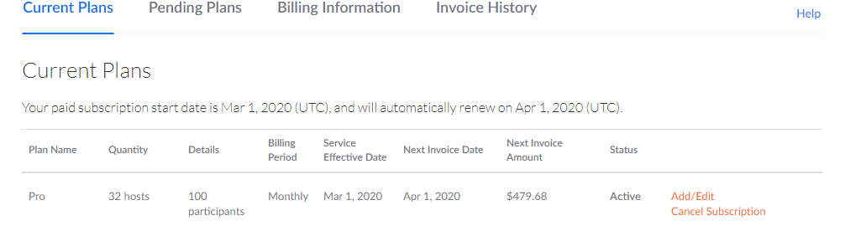

Click on Add/Edit. Add required number of hosts and click on continue.
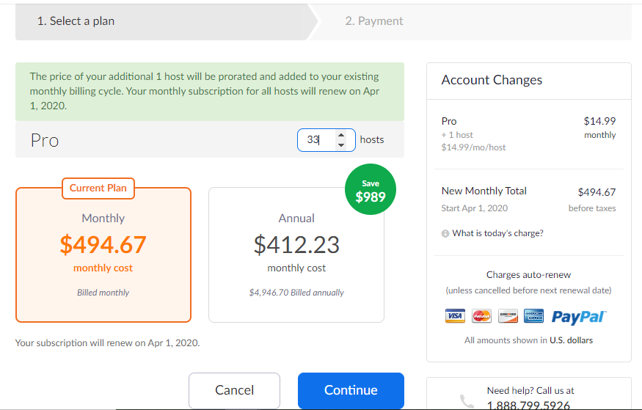

Verify payment method & new account charges and click on Update.

How to add new Groups & Zoom users?
Groups are logical separation of users. It makes easy to track users per client, control default settings etc.

To add new group, navigate to ADMIN --- User Management --- Group Management
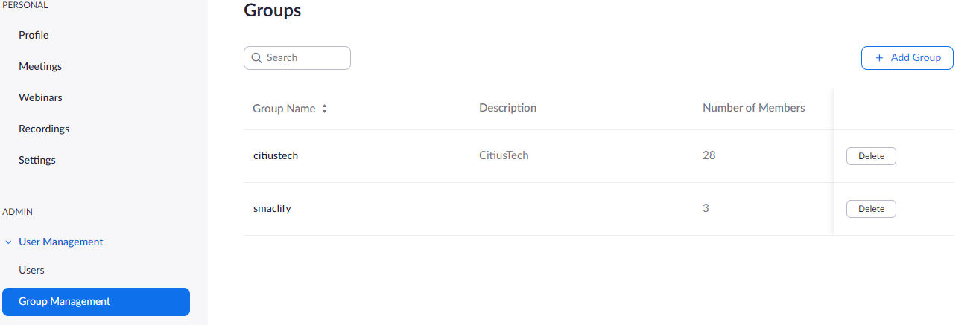

Click on Add Group. Enter group name and description(optional) and click on Add

Group Setting:
We need to set default values for various parameters for newly created Group. In future if we add any new user to the group, all group defaults also get applied to the user.

Click on Group Name -- Group Settings
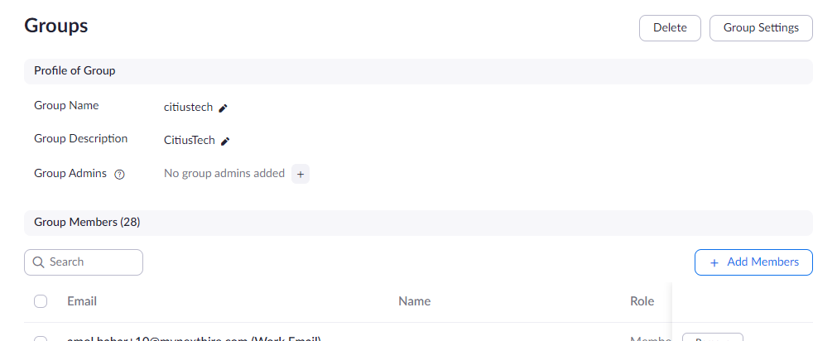

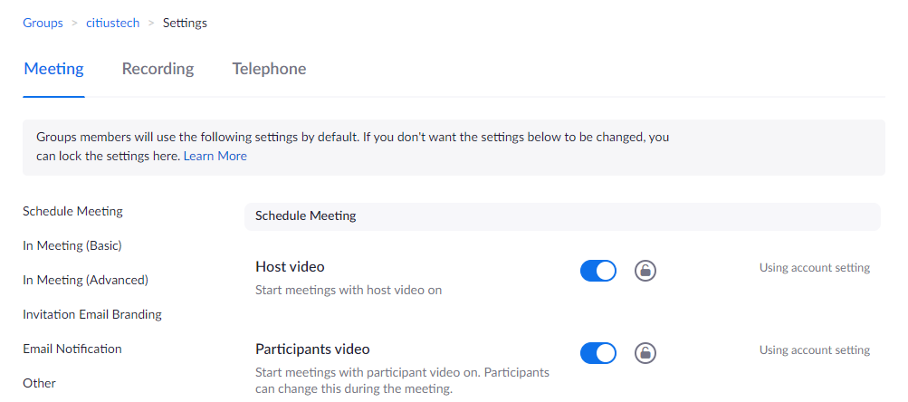

Key Attributes & default values [Meeting]:
- Host Video – Enabled
- Participants Video – Enabled
- Audio Type – Telephone and Computer Audio
- Join Before Host – Enabled
- Use Personal Meeting ID (PMI) when scheduling a meeting – Disabled
- Use Personal Meeting ID (PMI) when starting an instant meeting – Disabled
- Only authenticated users can join meetings – Disabled
- Require a password when scheduling new meetings – Disabled
- Require a password for instant meetings – Disabled
- Embed password in meeting link for one-click join – Disabled
- Require password for participants joining by phone – Disabled
- Mute participants upon entry – Disabled
- Upcoming meeting reminder – Disabled
- Chat – Enabled
- Private Chat – Enabled
- Play sound when participants join or leave – Enabled
- Screen Sharing – Enabled
- Who Can Share? – All participants
- Who can start sharing when someone else is sharing? – Only Host
- Annotation – Enabled
- Whiteboard – Enabled
- Remote Control – Enabled
- Allow removed participants to rejoin – Disabled
- Group HD Video – Disabled/Locked
- Virtual Background – Enabled
- Email Notification – Disable All Notifications

Key Attributes & default values [Recording]:
- Local Recording – Disabled
- Cloud Recording:
- Record active speaker with shared screen - Enabled
- Record gallery view with shared screen - Disabled
- Record active speaker, gallery view and shared screen separately - Disabled
- Record an audio only file - Enabled
- Save chat messages from the meeting / webinar - Enabled
- Add a timestamp to the recording - Disabled
- Display participants' names in the recording - Enabled
- Record thumbnails when sharing - Enabled
- Optimize the recording for 3rd party video editor - Disabled
- Save panellist chat to the recording – Disabled

- Automatic Recording – Enabled
- Record in the cloud - Enabled
- Host can pause/stop the auto recording in the cloud – Enabled

- Only authenticated users can view cloud recordings – Disabled
- Require password to access shared cloud recordings – Disabled
- The host can delete cloud recordings – Enabled
- Auto delete cloud recordings after days – 7 Days
- Recording consent - Disabled
- Multiple audio notifications of recorded meeting - Disabled

Adding New Users:
Click on Users -- Click on Add Users

NOTE: New users must be added to the existing Group.
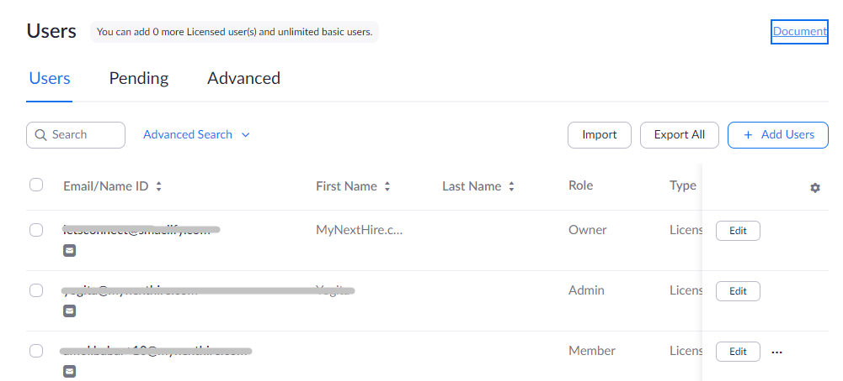

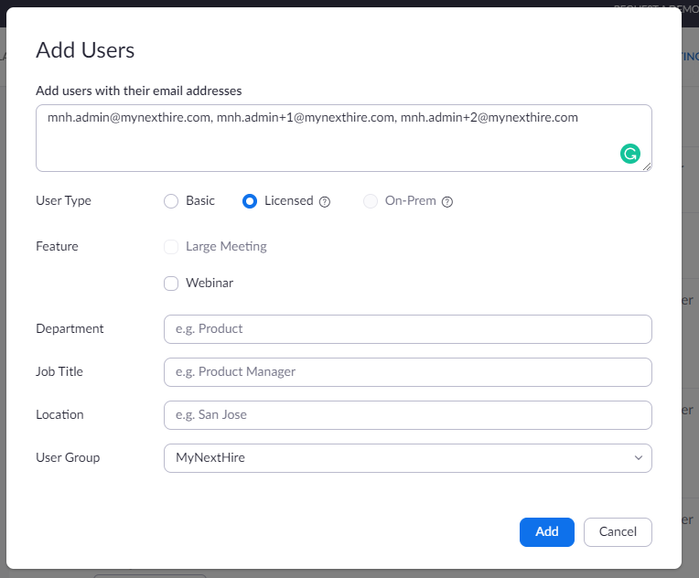

As shown in above screenshot we can enter comma separated emails.

Please select appropriate User Group and click on Add.

NOTE:
It is mandatory that entered email should be working as Zoom sends email with verification link. While clicking on verification link make sure that you are already not logged-in to any other Zoom account. If logged-in, please logout and click on Activate Account.

Virtual Email Ids:
For Gmail based email ids we can create virtual email address on the fly without having to create alias.
E.g.:
mnh.admin+1@mynexthire.com, mnh.admin+2@mynexthire.com
All the emails sent on above email ids will be received by mnh.admin@mynexthire.com
We use this workaround to create multiple Zoom hosts.

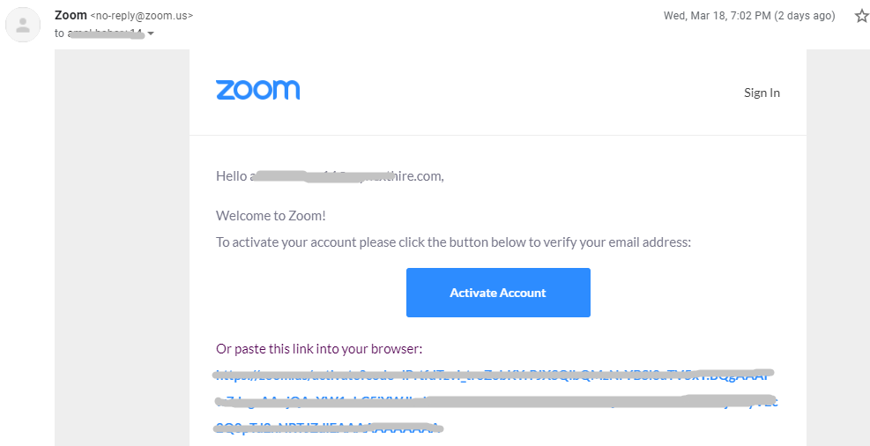

Clicking on Activate Account will open new tab
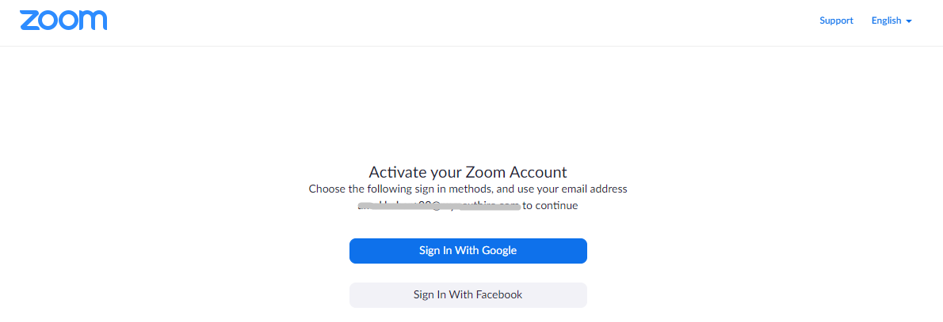

Click on Sign In With Google
After successful authentication & verification, user will be redirected to Zoom website.

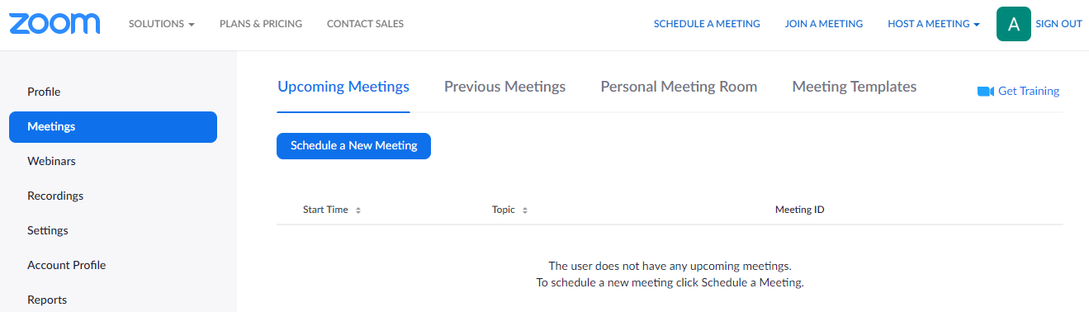

Click on Sign Out.

Repeat the same procedure, to verify other Zoom users.

How to configure Webhook URLs for various Zoom Events?
Head to https://marketplace.zoom.us/
Login with Zoom account credentials

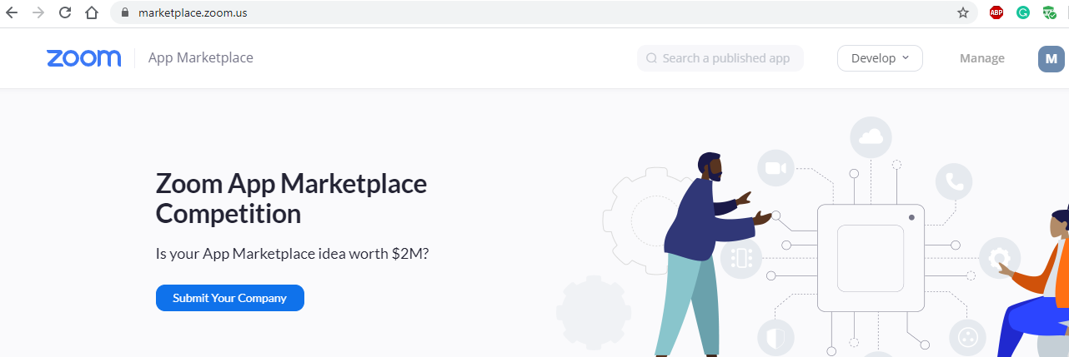

Click on Manage

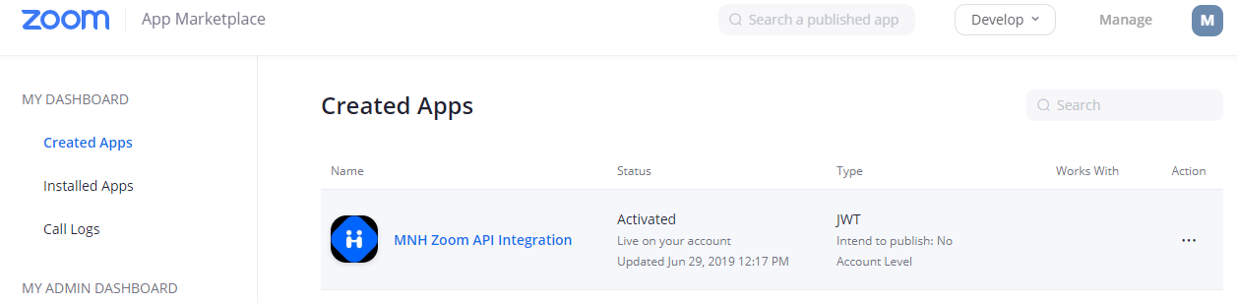

Click on MNH Zoom API Integration App
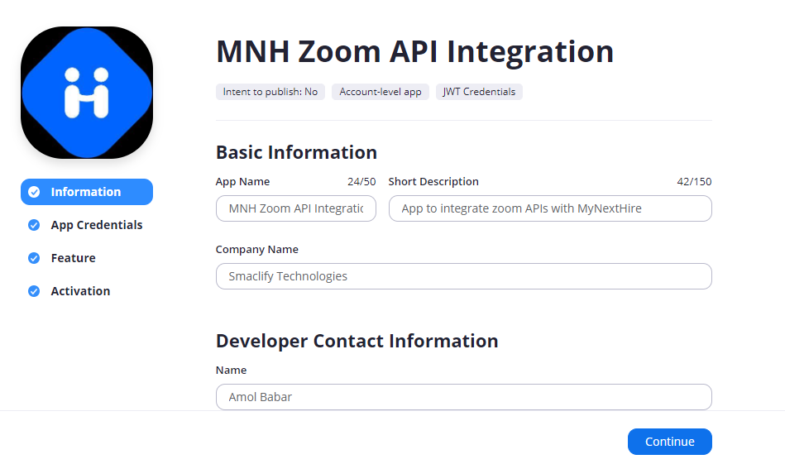
Click on Feature -- Add new event subscription -- Enter Subscription Name, Event notification endpoint URL and select all the events, which we are interested in

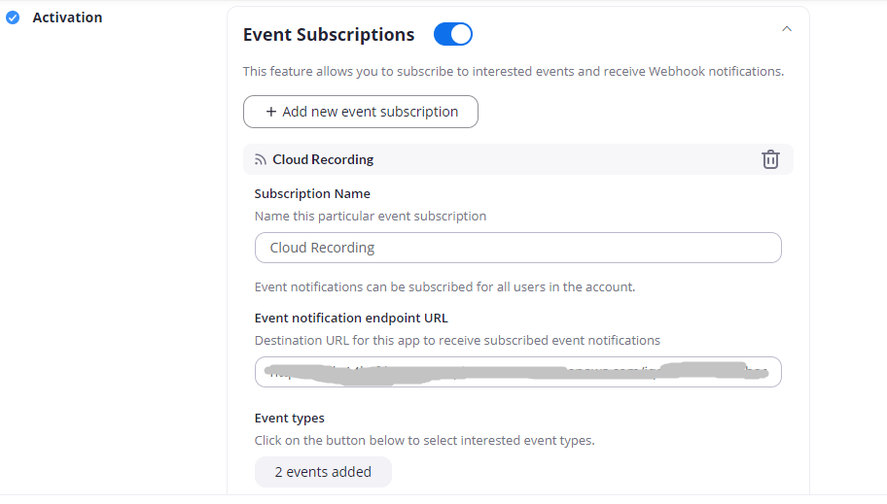
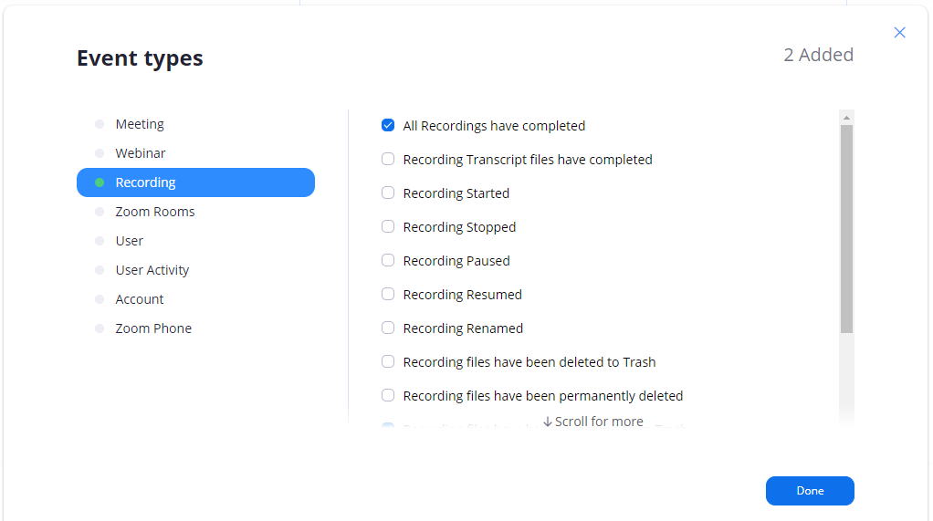

Click Done and then Save!

How to get Zoom host ids/user’s metadata?
Call internal API with MNH OAuth token.

https://staging.mynexthire.com/employer/api/settings/zoom_users_metadata/get?access_token=***********

Below users are authorized to call this API:
- system@smaclify.com
- amol.babar@smaclify.com
- vivek.jade@mynexthire.com

Sample Response JSON:
[
{
"id": "Y541ssatkad6a2s-Opasa4",
"firstName": "MNH",
"lastName": "IQA",
"email": "mnh.admin@mynexthire.com",
"verified": true,
"createdAt": "2020-03-09T04:46:21.000+0000",
"status": "active",
"pmi": 9112299776
},
{
"id": "asdasdasdojmasNNJKa2s-Opasa4",
"firstName": "",
"lastName": "",
"email": "mnh.admin+1@mynexthire.com",
"verified": false,
"createdAt": "2020-03-19T04:34:23.000+0000",
"status": "active",
"pmi": 9112299773
}
]

Here id represents Zoom host id which needs to be configured in MNH.

How to whitelist Zoom host ids in MNH so that webhook events are processed?
In order to process webhook events for new Zoom host ids, it needs to be whitelisted in the Lambda.
Lambda function name for IQA & PROD:
- [IQA/PROD]_Zoom_Webhook_Events_Receiver

Go to AWS Lambda console and click on intended Lambda function. In Configuration tab look for the Environment variables
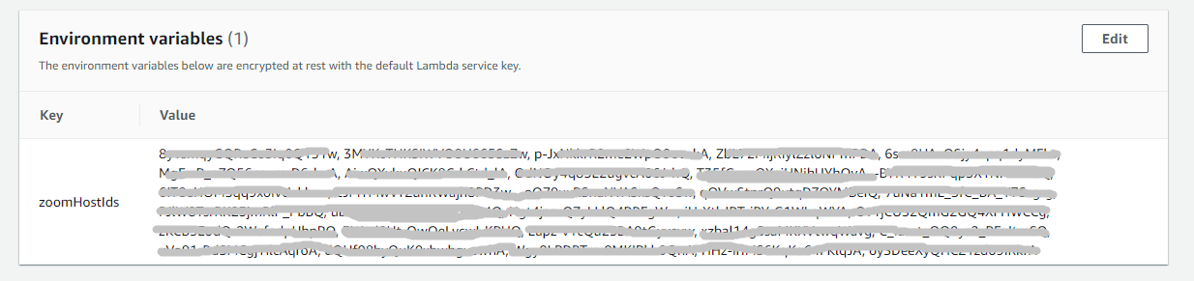
We can edit environment variable by clicking on Edit. We can configure comma separated host ids as environment variable against zoomHostIds New host ids can be appended to the existing ones.

How recordings are processed & mapped to relevant conference id?
MNH relies on recording webhook events received from Zoom. Webhook endpoints are hosted on AWS Lambda + AWS APIGateway.

Lambda function names: [IQA/PROD]_Zoom_Webhook_Events_Receiver Lambda code is in GitHub at : https://github.com/mynexthire/AWSLambda.git
Lambda function do certain validations like if host is whitelisted or not, file extension etc

All webhook events are logged at:
smaclifywow.[iqa/prod].partners/zoom/zoom_webhook_events_log/DATE/ZOOM_HOST/

Lambda then downloads recording from Zoom and uploads it at temporary location in S3: smaclifywow.[iqa/prod].external.
File naming format for recording: ZOOM_EVALUATION.150000008_15639200970001563920141000.MP4
E.g.: ZOOM_EVALUATION.ZOOM_CONFERENCE_ID_RECORDING_START_END_TIMESTAMPS.MP4

S3 bucket triggers file upload event details to SQS: smaclifywow_[iqa/prod]_ExternalMediUpload, these SQS messages are then processed by SQSQueueReceiver based on the conference id which is present in the file name. QR then do lookup on conference_details table to find out client id, evaluation id. Once required details are retrieved recordings will be copied to smaclifywow.[iqa/prod].mediastore/CLIENT_ID and relevant entry will be added in the document table with application id, client id, document source type, document source id

Also, S3 buckets, smaclifywow.[iqa/prod].external/ has lifecycle rule which deletes files after 30 days

How to enable Zoom video interviews for client?
Override setting id 3 & 10 in client_preferences table. Copy default_value column values from master_preferences table and edit it with any JSON editor to avoid errors.

NOTE:
Recommended JSON editor: https://jsoneditoronline.org/
They don’t send data across their servers. All formatting and data processing happen on the UI only.

Setting Id 3:
Set enabled attribute as true
E.g.:
{
"enabled": true,
"provider_key": "zoom"
}

Setting Id 10:
Set host_user_id It’s a list of Strings i.e. Zoom Host Ids
Don’t update api_key & api_secret_key attributes, unless client bringing their own Zoom account credentials
E.g.:
{
"api_key": "**************",
"api_secret_key": "**************",
"host_user_id": [“ZoomHost1”, “ZoomHost2”]
}

