MyNextHire SendGrid Integration FAQs
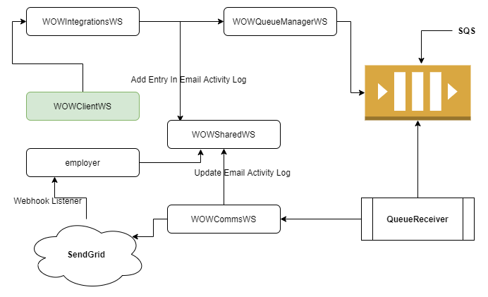

In which setting SendGrid configuration is defined?
Setting Id: 111. By default, this setting contains MNH owned SendGrid account configuration. No need to override this setting for new client unless client is opting for customized email domain or wanted to use their own SendGrid account.

How does default setting looks like?
{
"api_key": "************************",
"from_email": "no_reply@email.mynexthire.com",
"display_name": "MyNextHire",
"template_id": "02a9d773-70f8-4f34-af99-bd8166e22976"
}

api_key: SendGrid API key
from_email: Desired from email with whitelisted domain in SendGrid console. It is used as from email while sending emails from MNH
display_name: Desired display name. It is used as a default sender display name while sending emails from MNH.
template_id: SendGrid template id

How to override default SendGrid configuration?
Override setting in client preferences table.

How to whitelist domain, create default template, enable/configure webhook & events in SendGrid console?
This is out of scope for this document.
Please refer latest SendGrid documentation.
https://sendgrid.com/docs/for-developers/tracking-events/getting-started-event-webhook/
https://sendgrid.com/docs/ui/account-and-settings/how-to-set-up-domain-authentication/
https://sendgrid.com/docs/ui/sending-email/create-and-edit-legacy-transactional-templates/

