What are the differences observed in canopy forming kelp (Macrocystis pyrifera, Nereocystis luetkeana) forests along the coast of British Columbia that contributed in the change of their distribution from 2015 to 2024, and what role did different oceanographic variables play?
Introduction
Climate change and other human driven factors are currently transforming our ocean’s ecosystem worldwide (Smale et al. 2019). The impacts from these factors have triggered regime shifts in coastal ecosystems, including coral reefs, seagrass meadows and seaweed communities (Starko, Timmer et al., 2024). Kelp forests, which are most widespread in areas with temperate ecosystems where seasonal and year to year variation in temperature (5–20°C) is common (Jayathilake & Costello 2021, Starko et al. 2021) are among the coastal ecosystems most at risk (Pörtner et al. 2019, Wernberg et al. 2019). These forests are food to a wide variety of marine species, act as protection to shorelines and play a significant role as biochemical contributors to carbon and nitrogen cycling (Smale et al., 2019). Given their significance ecologically and economically, it is very important to understand how they have changed over time (Costa et al., 2020).
Kelp forests are large under water habitats that grow and reach the surface of ocean, forming canopies (Kelp Forest | NOAA Office of National Marine Sanctuaries, n.d.). These forests occupy one-third of the world’s coastlines, an area five times the size of coral reefs (Jayathilake & Costello 2021). Research from the last 20 years show that there has been a decline in kelp forests because of external stressors such as fishing, sewage pollution, invasive species and changes in fresh water flow (Wernberg et al. 2019). Among the most significant threats are marine heat waves (MHW) and ocean warming (Pörtner et al. 2019). Periods of unusually warm ocean temperatures are known as MHW (Starko et al. 2022). These are becoming more common and intense because of climate change (Smith et al. 2023). Prolonged warm water conditions contributed to the outbreak of sea star wasting disease (SSWD) causing a functional extinction of sunflower sea star (Pycnopodia helianthoides) (Hamilton et al. 2021). The loss of this major predator created a favorable habitat for sea urchins (Echinoidea), who are a dominant herbivore for kelp forests (Starko et al. 2022).
British Columbia (BC) is one region where kelp forests have historically been understudied (Starko et al. 2022). Studies taken place near BC’s coastal region suggest that there has been a decline in kelp forests (Starko et al. 2019). One major driver of these declines is the population decrease of sunflower sea star, following the impacts of SSWD, and rapid growth of sea urchins (Starko, Timmer et al., 2024). However, in areas where sea otter population is abundant, who prey heavily on sea urchins, kelp declines have been less. Methods such as snapshot analyses of kelp distribution, time-series analyses of environmental variables (e.g., temperature), and studies of sea otter occupancy provide valuable insight into kelp forests (Starko, Timmer et al., 2024). With this study I aim to assess how canopy forming kelp forest’s distribution has changed between 2015 to 2025.
Study Area and Data Summary
My study area has been selected based on data availability, each location having different sea surface temperatures (SST) and varying otter populations. The coastline of BC stretches for approximately 26,000 km (B.C. Coastal Marine Strategy, n.d.), which I divided into feasible regions. The study will focus on Cowichan Bay (north), Quatsino Sound (central) and Dundas Island (south) covering the diversity of the coastline.
Methods
I will begin with a snapshot analysis using three time periods to understand how kelp distribution changed before MHW (2004–2006), during MHW (2014–2016), and after MHW (2020–2024). Aerial imagery (QuickBird) with a resolution of (80-30 m) will be acquired from Environment and Climate Change Canada (ECCC), covering 2004 (Timepoint 1, T1) to 2024 (Timepoint 2, T2). I will map kelp extent by comparing the presence of kelp in T1 and T2. Areas with more kelp will be classified as ‘Gain,’ areas with less kelp as ‘Loss,’ and areas with little or no change as ‘Stable’.
I will use temperature data from Fisheries and Oceans Canada Lighthouse Stations to show the relative density of summer temperature measurements from 2014 to 2016. This data will be combined with the time-series information in the LiveOcean model, a regional ocean model designed for the coastal waters of southern BC. It uses data and research related to kelp forest to stimulate various ocean water properties (“LiveOcean,” 2016).
The same regions will be assessed during the snapshot analysis to confirm areas with sea otter occupancy and evaluate whether their presence has reduced sea urchin populations and increased kelp canopy cover (Starko, Timmer et al. 2024). With this, I aim to build a predictive model to examine how time-series trends, SST, and sea otter presence influence changes in kelp forests.
Expected Results and Significance:
I expect the results to show a decline in kelp canopy in both Cowichan Bay and Dundas Island, while Quatsino Sound remained relatively stable or even increased (Starko, Timmer et al. 2024) (Figure 1). Most of the major decline likely occurred during the marine heatwave period (2014–2017) (Figure 2). Rise in SSTs and high sea urchin densities were the major reason to these losses. On the contrary, the reason some areas remained stable or recovered is due the strong sea otter presence, which in return helped to control sea urchin population.
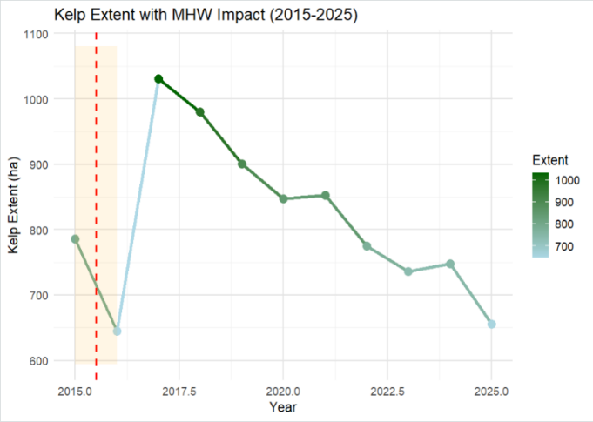
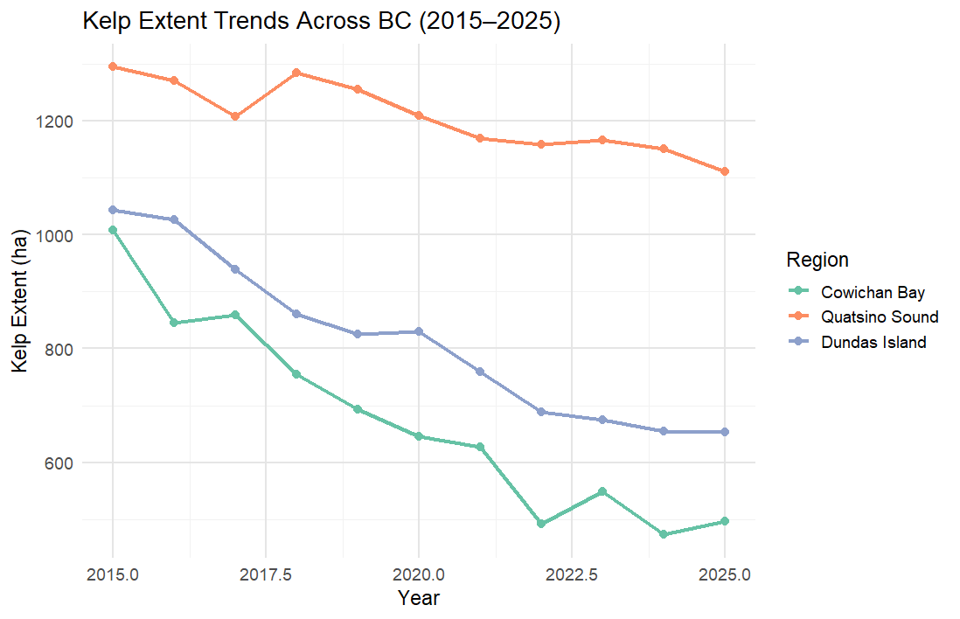
These results will confirm that kelp forests are a conservation concern for the province, making it important to map them regularly, on a year-to-year basis, and closely monitor them for better management in the future. Spatial trends and maps can be useful for making informed decision about what actions are needed and what measures are important.
Figure 2 Timeseries of offshore kelp forest prior to the heatwave saw a constant increase, but after the heatwave there was a major decline the in the extent of kelp forest. During the summer of 2014-2017 kelp forest experienced a decline because of rise of SST and sea urchin population. Data collected from lighthouse station was used making this graph.
Figure 1. Patterns of kelp forest are consistent and growing in the Quatsino Sound and some areas of Dundas Island and decline in Cowichan Bay through the years from 2015-2025. Data collected from LiveOcean Model was used in this graph to show the trend of timeshot analysis and snapshot analysis that was carried out.

Reference
B.C. Coastal Marine Strategy. (n.d.).
Costa, M., Le Baron, N., Tenhunen, K., Nephin, J., Willis, P., Mortimor, J. P., Dudas, S., & Rubidge, E. (2020). Historical distribution of kelp forests on the coast of British Columbia: 1858–1956. Applied Geography, 120, 102230. https://doi.org/10.1016/j.apgeog.2020.102230
Hamilton SL, Saccomanno VR, Heady WN, Gehman AL and others (2021) Disease-driven mass mortality event leads to widespread extirpation and variable recovery potential of a marine predator across the eastern Pacific. Proc R Soc B 288:20211195
Institute, T. H. (n.d.). The Kelp It Is a Changin’. Hakai Institute. Retrieved October 23, 2025, from https://hakai.org/kelp-it-changin/
Jayathilake, D. R. M., & Costello, M. J. (2021). Version 2 of the world map of laminarian kelp benefits from more Arctic data and makes it the largest marine biome. Biological Conservation, 257, 109099. https://doi.org/10.1016/j.biocon.2021.109099
Kelp Forest | NOAA Office of National Marine Sanctuaries. (n.d.). Retrieved December 6, 2025, from https://sanctuaries.noaa.gov/visit/ecosystems/kelpdesc.html
LiveOcean. (2016). In Cloud Computing in Ocean and Atmospheric Sciences (pp. 277–296). Academic Press. https://doi.org/10.1016/B978-0-12-803192-6.00014-1
Pörtner HO, Roberts DC, Masson-Delmotte V, Zhai P and others (2019) IPCC special report on the ocean and cryosphere in a changing climate. Intergovernmental Panel on Climate Change, Geneva
Starko, S., Timmer, B., Reshitnyk, L., Csordas, M., McHenry, J., Schroeder, S., ... & Neufeld, C. J. (2024). Local and regional variation in kelp loss and stability across coastal British Columbia. Marine Ecology Progress Series, 733, 1–26. https://doi.org/10.3354/meps14548
Starko, S., van der Mheen, M., Pessarrodona, A., Wood, G. V., Filbee-Dexter, K., Neufeld, C. J., Montie, S., Coleman, M. A., & Wernberg, T. (2024). Impacts of marine heatwaves in coastal ecosystems depend on local environmental conditions. Global Change Biology, 30(8), e17469. https://doi.org/10.1111/gcb.17469
Starko, S., Wilkinson, D. P., & Bringloe, T. T. (2021). Recent global model underestimates the true extent of Arctic kelp habitat. Biological Conservation, 257, 109082. https://doi.org/10.1016/j.biocon.2021.109082
Starko S, Neufeld CJ, Gendall L, Timmer B and others (2022) Microclimate predicts kelp forest extinction in the face of direct and indirect marine heatwave effects. Ecol Appl 32: e2673
Smale, D. A., Wernberg, T., Oliver, E. C. J., Thomsen, M., Harvey, B. P., Straub, S. C., Burrows, M. T., Alexander, L. V., Benthuysen, J. A., Donat, M. G., Feng, M., Hobday, A. J., Holbrook, N. J., Perkins-Kirkpatrick, S. E., Scannell, H. A., Sen Gupta, A., Payne, B. L., & Moore, P. J. (2019). Marine heatwaves threaten global biodiversity and the provision of ecosystem services. Nature Climate Change, 9(4), 306–312. https://doi.org/10.1038/s41558-019-0412-1
Smith KE, Burrows MT, Hobday AJ, King NG and others (2023) Biological impacts of marine heatwaves. Annu Rev Mar Sci 15:119–145
Wernberg, T., Krumhansl, K., Filbee-Dexter, K., & Pedersen, M. F. (2019). Chapter 3—Status and Trends for the World’s Kelp Forests. In C. Sheppard (Ed.), World Seas: An Environmental Evaluation (Second Edition) (pp. 57–78). Academic Press. https://doi.org/10.1016/B978-0-12- 805052-1.00003
AI declaration – it was used in R studio to help mimic the data. I was struggling with a few sentences and I used to just make them grammatically sound.

