ASSIGNMENT 10.4

Task 1: AI-Assisted Syntax and Code Quality Review
Scenario
You join a development team and are asked to review a junior
developer’s Python script that fails to run correctly due to basic coding
mistakes. Before deployment, the code must be corrected and
Standardized

CODE/OUTPUT:
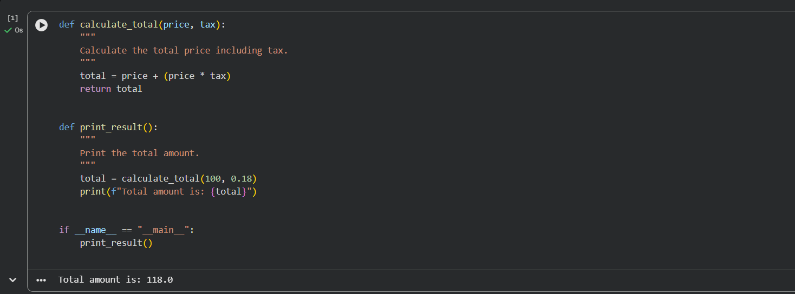
Explanation:
- The function calculate_total calculates the total price by adding tax to the original price.
- The function print_result calls calculate_total with a price of 100 and a tax rate of 18%.
- It then prints the final total amount.
- The program runs print_result to display the result.

Task 2: Performance-Oriented Code Review
Scenario
A data processing function works correctly but is inefficient and slows
down the system when large datasets are used.
CODE/OUTPUT:
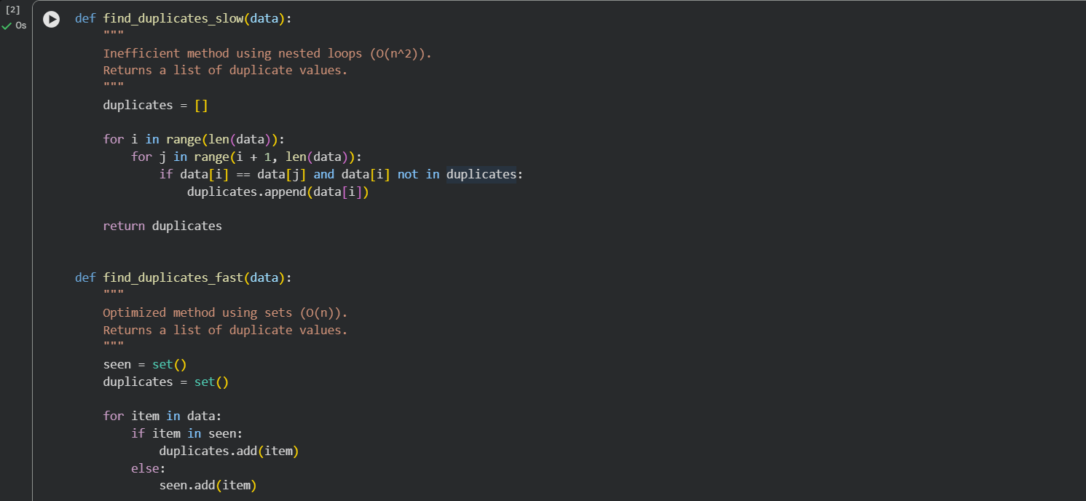
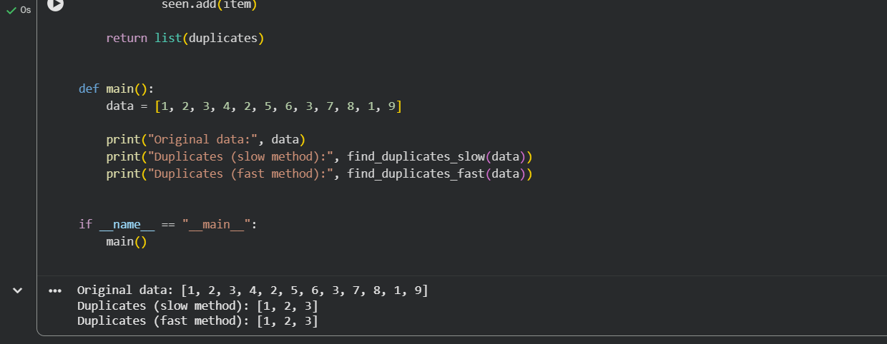Explanation:
- The program finds duplicate elements in a list using two different methods.
- find_duplicates_slow uses nested loops to compare each element with others, which is slower for large datasets.
- find_duplicates_fast uses sets to track seen values, making it much faster and more efficient.
The main function demonstrates both methods and prints the duplicate values found in the list.
Task 3: Readability and Maintainability Refactoring
Scenario
A working script exists in a project, but it is difficult to understand due to
poor naming, formatting, and structure. The team wants it rewritten for
long-term maintainability

CODE/OUTPUT:

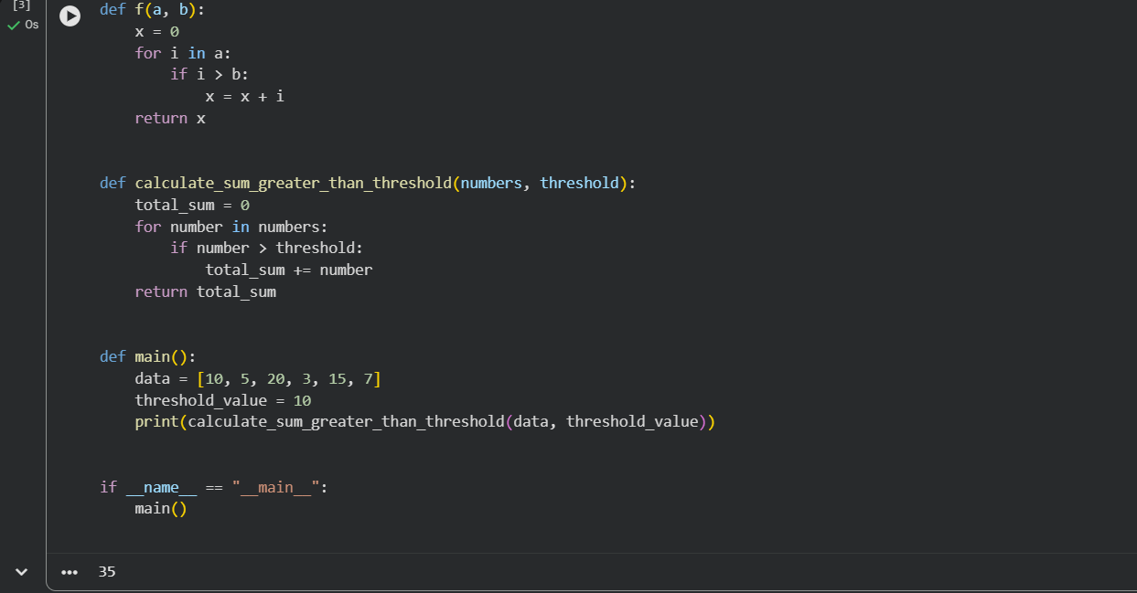
EXPLANATION:
- The program calculates the sum of numbers in a list that are greater than a given threshold value.
- The function calculate_sum_greater_than_threshold iterates through the list and adds only the values that exceed the threshold.
- The main function defines the input list and threshold, then calls the function and prints the result.
- This refactored version uses clear naming and structured logic, making the code easy to read and maintain.

Task 4: Secure Coding and Reliability Review
Scenario
A backend function retrieves user data from a database but has security
vulnerabilities and poor error handling, making it unsafe for production
deployment
CODE /OUTPUT:
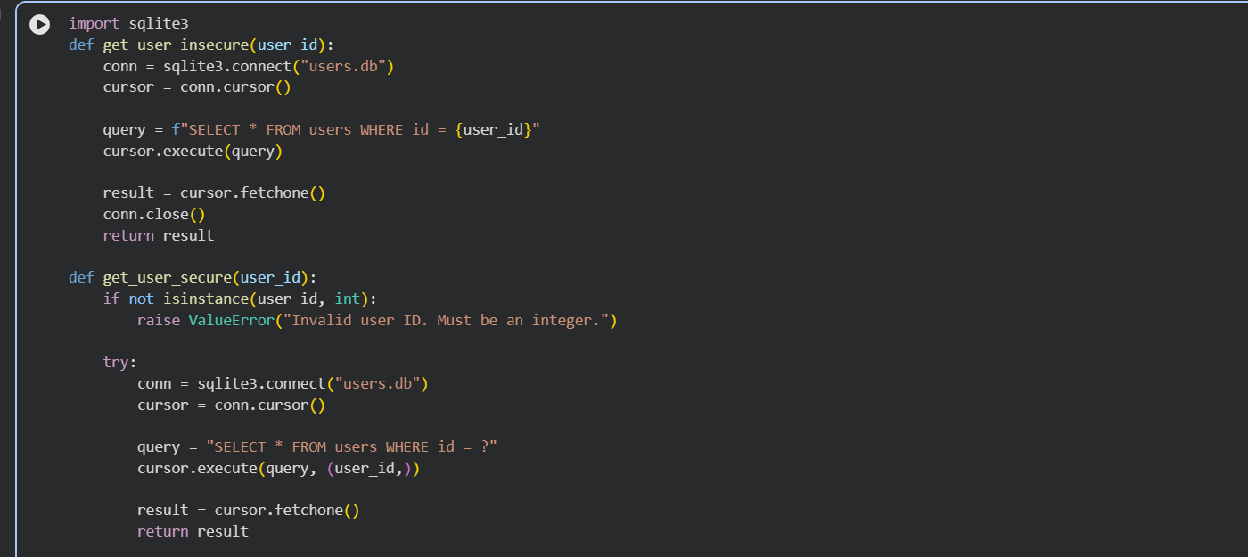
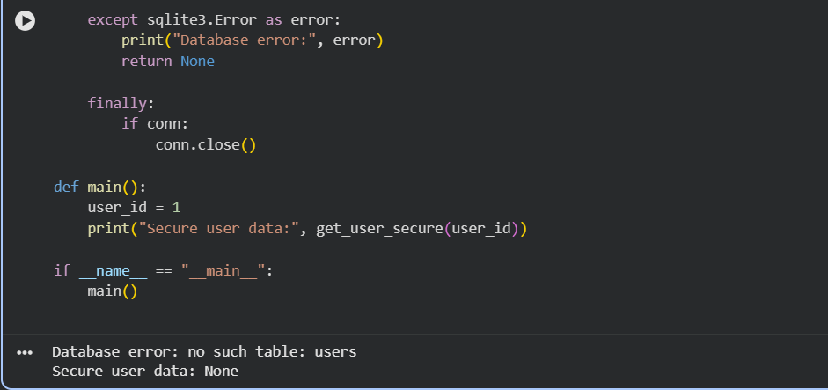
Explanation:
- The insecure function builds SQL queries using string formatting, which can lead to SQL injection attacks.
- The secure function uses parameterized queries to safely pass user input to the database.
- Input validation ensures that the user ID is of the correct type before executing the query.
- Try-except blocks handle database errors safely, making the code more reliable and suitable for production.

Task 5: AI-Based Automated Code Review Report
Scenario
Your team uses AI tools to perform automated preliminary code reviews
before human review, to improve code quality and consistency across
Projects.
CODE/OUTPUT:
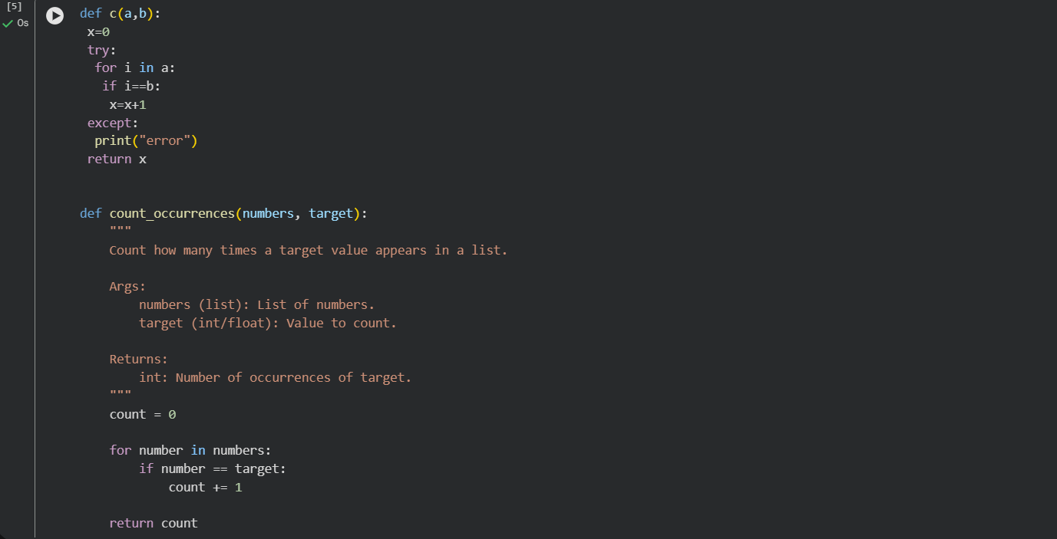
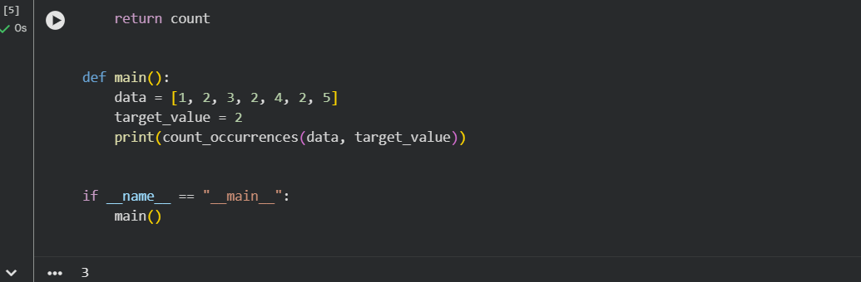
Explanation:
- The original code had poor naming, bad formatting, and unclear logic, making it hard to understand and maintain.
- The improved version uses meaningful function and variable names, proper indentation, and clear structure.
- A docstring was added to explain the purpose and usage of the function.
- Overall, the refactored code is more readable, maintainable, and consistent with Python coding standards.

