ASSIGNMENT 9.3

Task 1: Basic Docstring Generation
Scenario
You are developing a utility function that processes numerical lists and must be properly
documented for future maintenance.

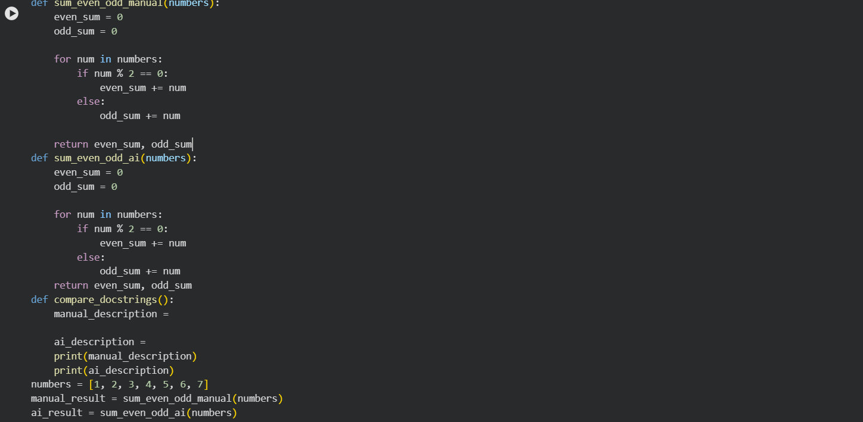
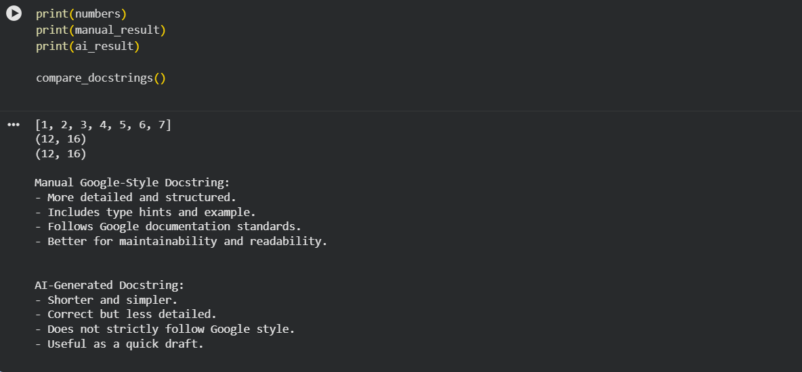

Task 2: Automatic Inline Comments
Scenario
You are developing a student management module that must be easy to understand for new
developers.
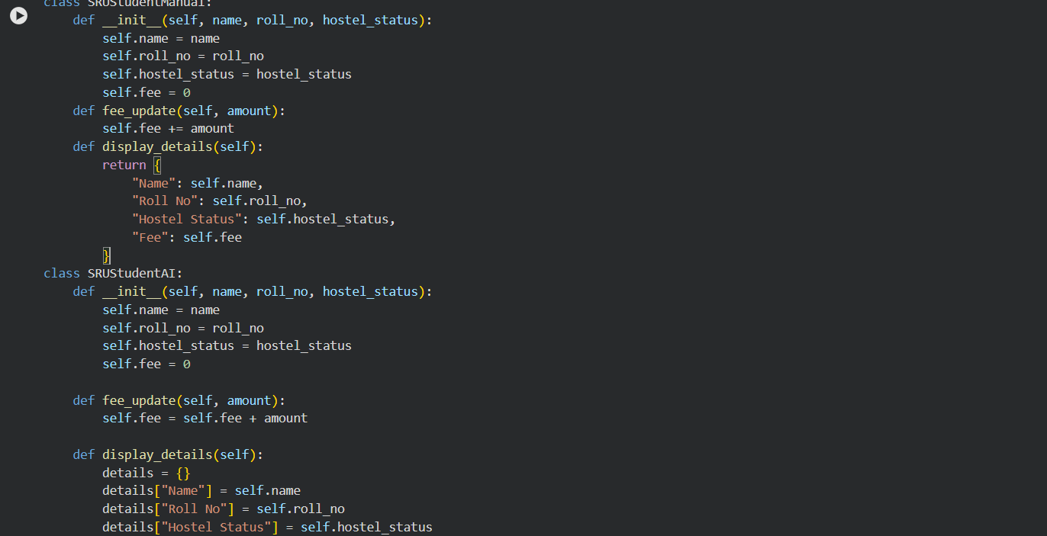
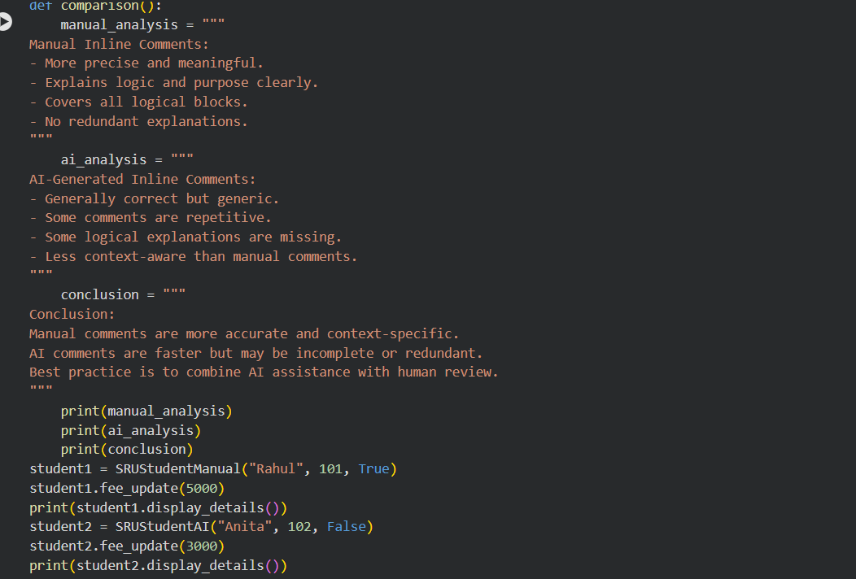
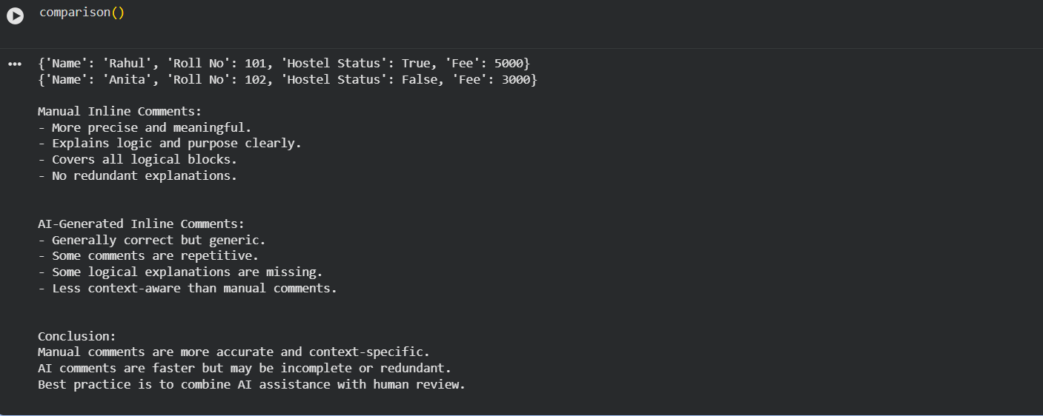

Task 3: Module-Level and Function-Level Documentation
Scenario
You are building a small calculator module that will be shared across multiple projects and
requires structured documentation.
