ASSIGNMENT 17-3

Task 1 Employee Dataset Cleaning Task:
Use AI assistance to clean an employee information dataset.
Instructions:
- Handle missing values in salary, designation, and experience
- Remove duplicate employee IDs
- Standardize text values (job titles in lowercase)
- Encode categorical features (designation, employment_type) Expected Output:
A clean dataset suitable for HR analytics and prediction tasks.
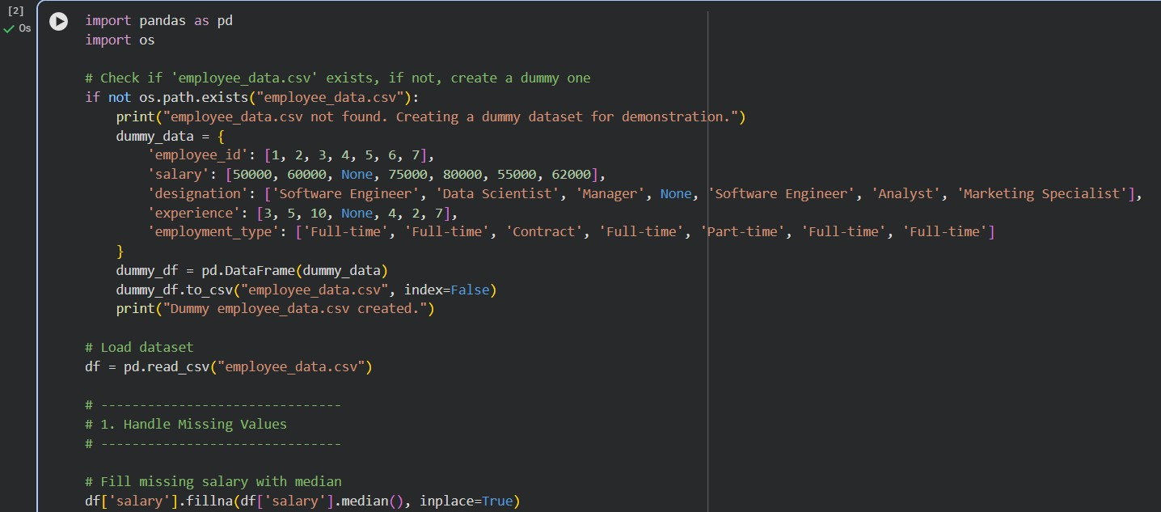
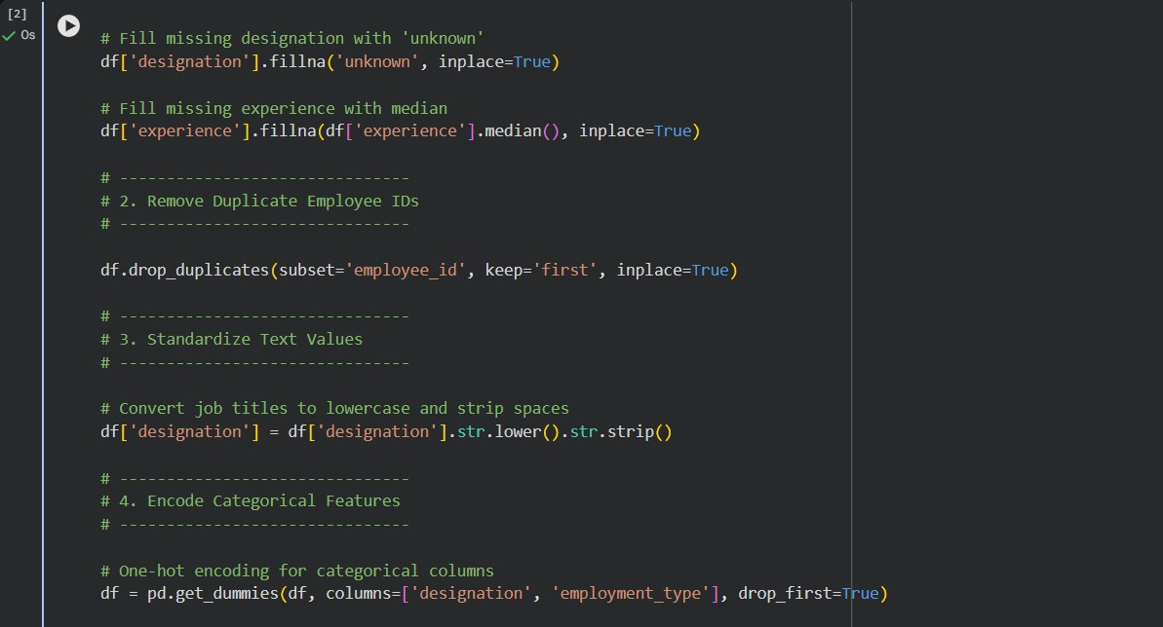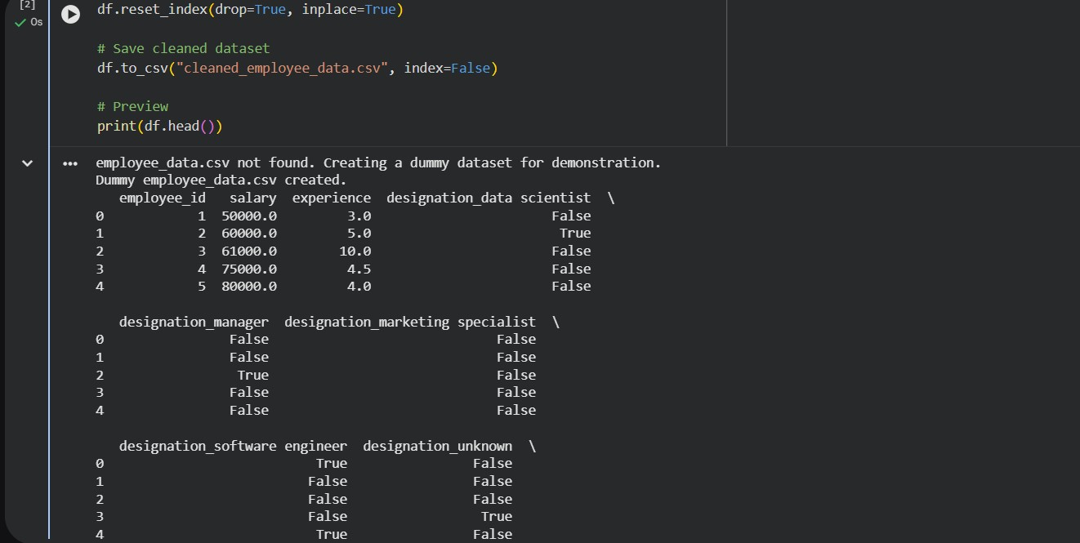
EXPLANATION:
Missing values: Salary and experience are filled with median to avoid skew; designation uses "unknown".
Duplicates: Ensures each employee_id is unique.
Standardization: Converts job titles to lowercase for consistency.
Encoding: Converts categorical variables into numeric format using one-hot encoding for ML models.

Task 2 – Student Performance Data Preprocessing Task:
Preprocess student performance data using AI assistance.
Instructions:
- Convert exam_date column into datetime format
- Extract new features (month, semester, day)
- Normalize total_marks
- Detect and handle outliers in marks using IQR or Z-score Expected Output:
A transformed dataset with time-based academic features and normalized marks. CODE:
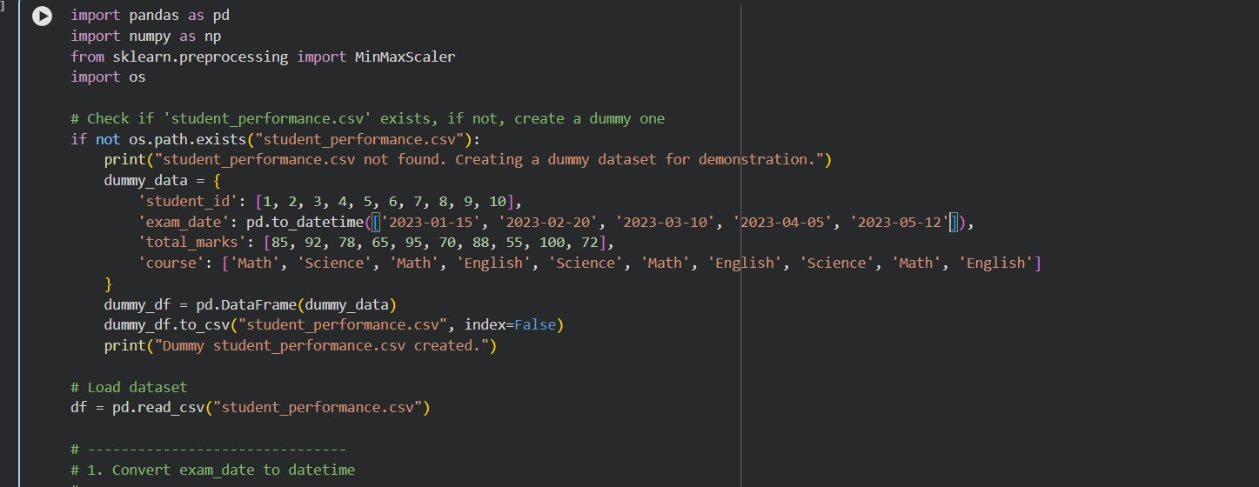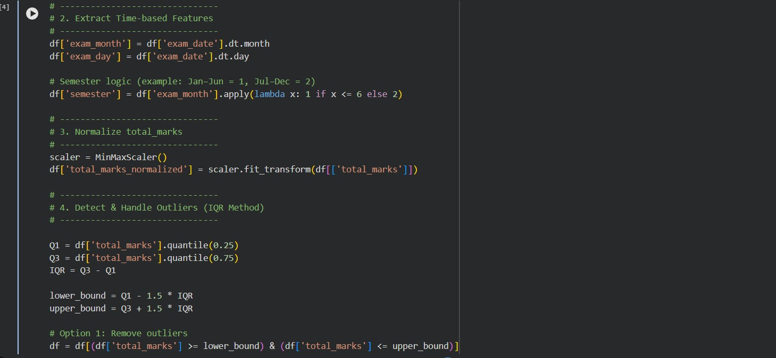
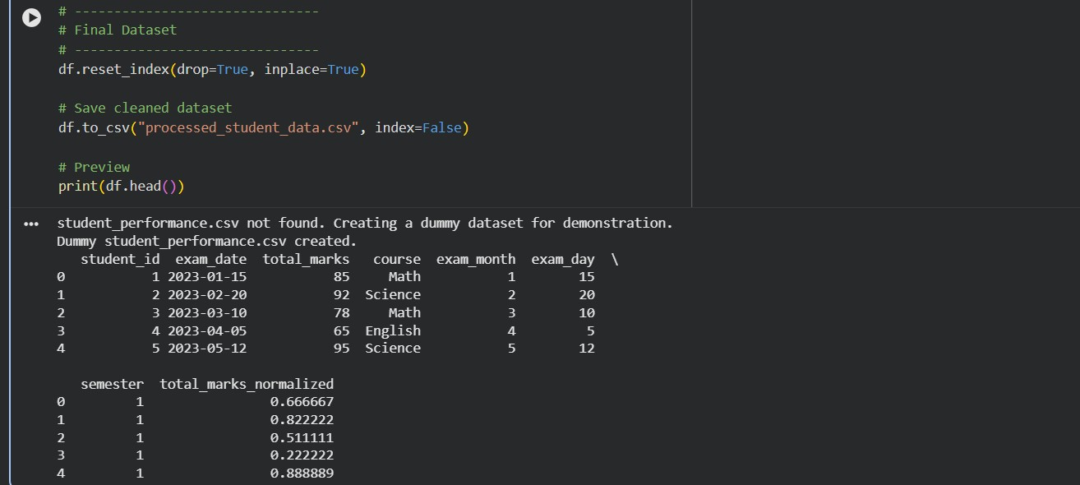
EXPLANATION:

Datetime conversion ensures proper time-based analysis.
Feature extraction (month, day, semester) helps identify academic patterns.
Normalization scales marks between 0–1 for ML models.
Outlier handling (IQR) removes or caps extreme values to improve model accuracy.

Task 3 – Student Health Data Preparation Task:
Clean and preprocess student health records using AI scripts.
Instructions:
- Handle missing values in height, weight, BMI
- Encode categorical features (medical_condition, fitness_status)
- Scale numerical features using standard scaling
- Split dataset into training and testing sets Expected Output:
A preprocessed dataset ready for predictive health analysis.

EXPLANATION:
- Missing values are filled with median to reduce bias.
- Categorical encoding converts health conditions and fitness status into numeric form.
- Standard scaling ensures features like height, weight, and BMI have mean = 0 and variance = 1.
- Train-test split prepares data for building and evaluating predictive models.

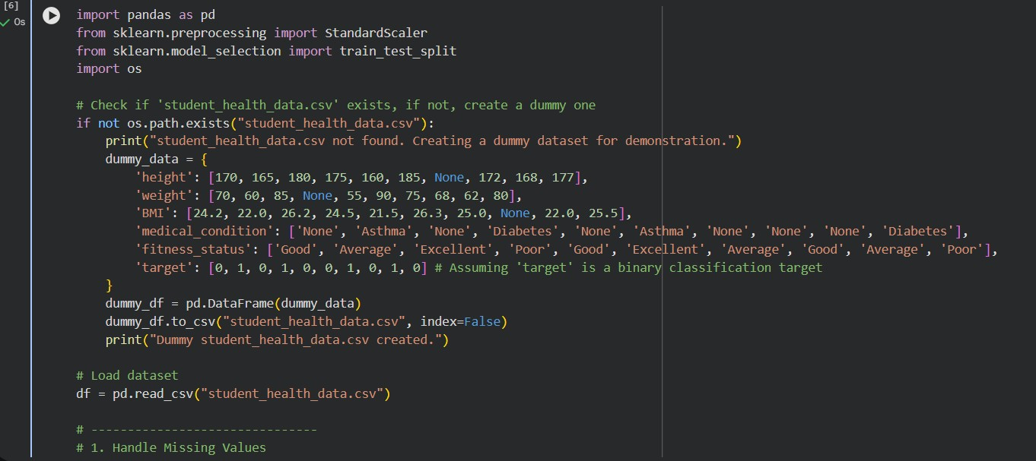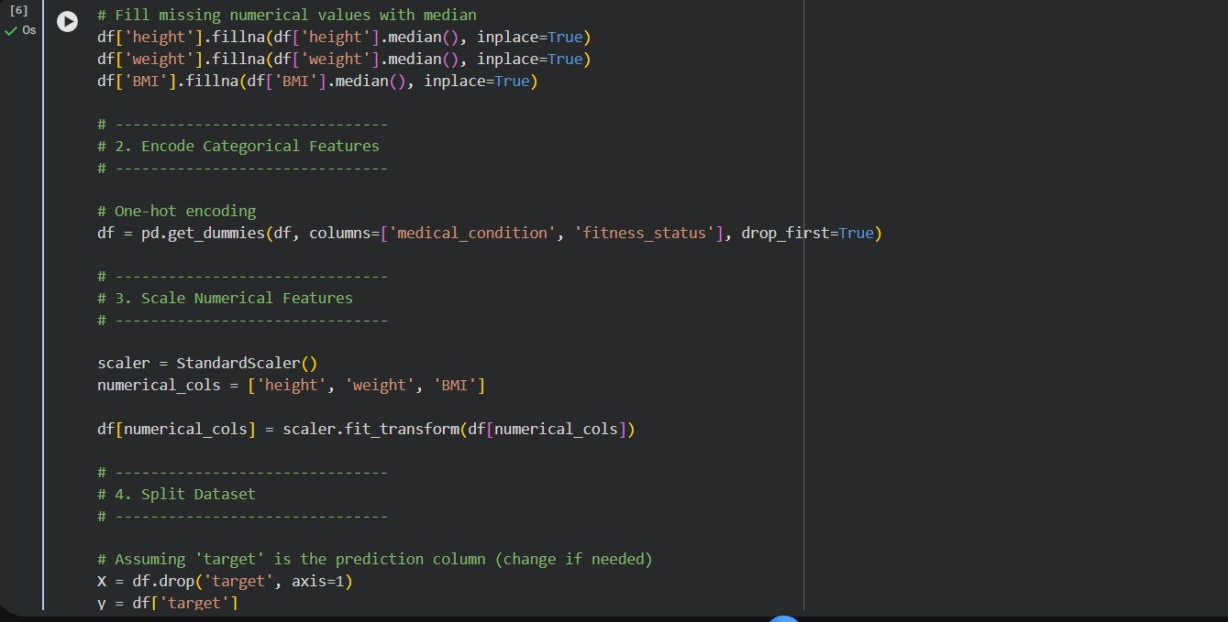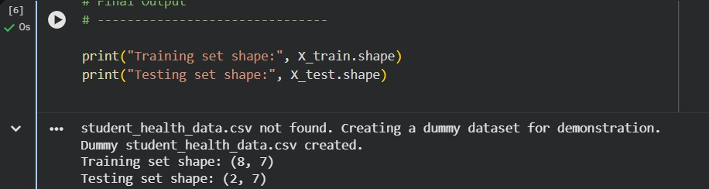

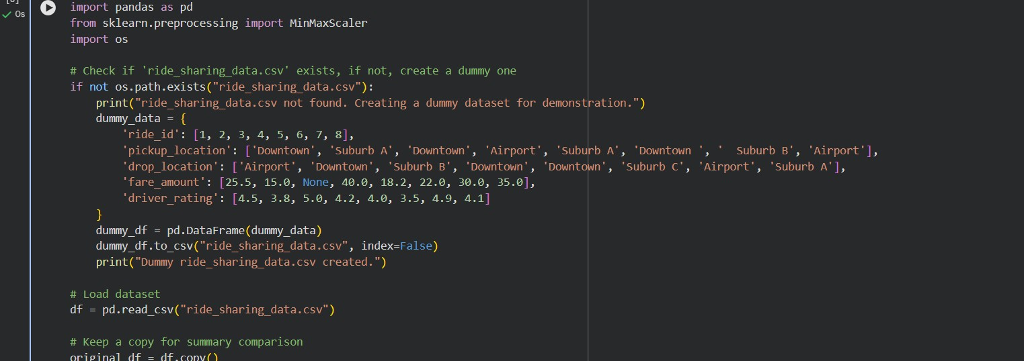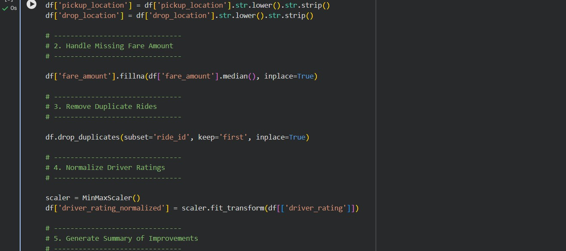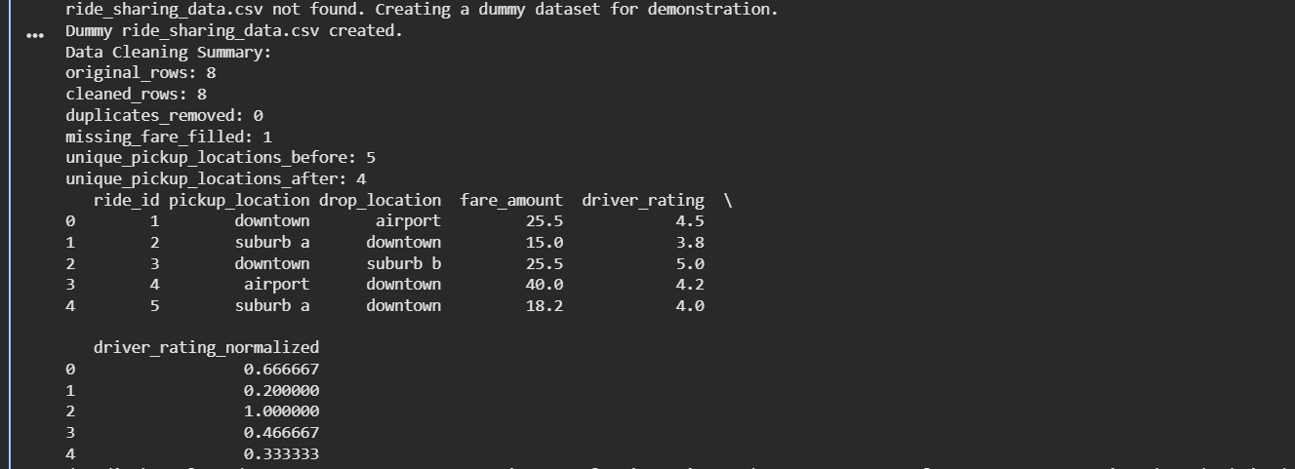
EXPLANATION:
Location standardization removes inconsistencies (case, spacing).
Missing fares are replaced with median to maintain realistic values. Duplicate rides are removed using unique ride_id.
Driver ratings are normalized (0–1 scale) for fair comparison.
Summary report highlights improvements made during cleaning.

