ASSIGNMENT 17-4

Task 1 – Smart City Traffic Sensor Data
Cleaning Scenario
A Smart City project collects real-time traffic sensor data from multiple intersections. However, the dataset contains inconsistent formats, missing values, and corrupted readings.
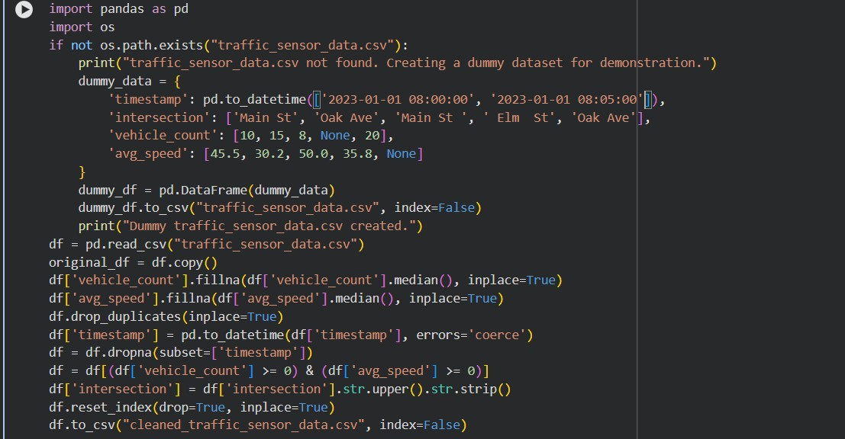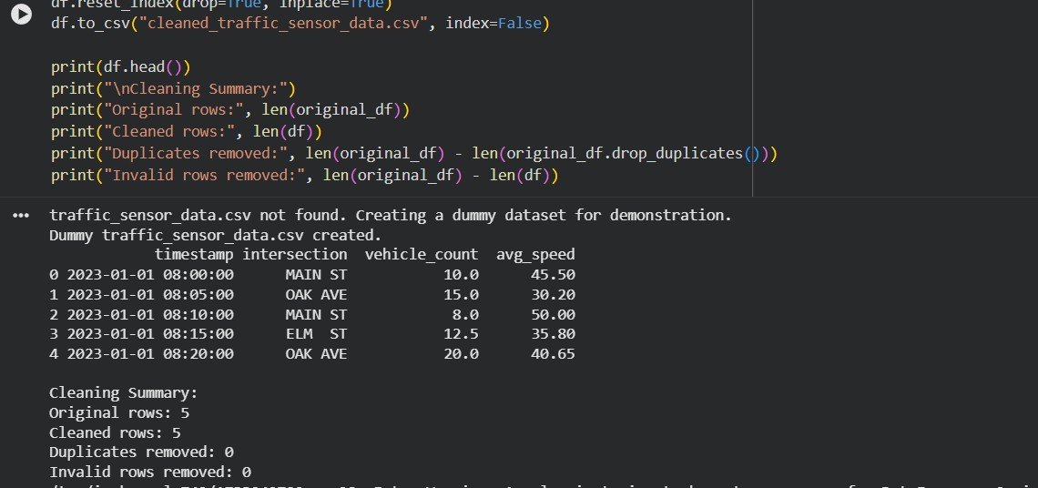

EXPLANATION:
Missing values in traffic metrics are filled using median to maintain realistic patterns.
Duplicates are removed to avoid repeated sensor readings.
Timestamp conversion ensures proper time-based analysis.
Invalid readings (negative speed or vehicle count) are filtered out.
Intersection names are standardized to uppercase for consistency.

Task 2 – Movie Streaming Platform User
Behavior Data
Scenario
A streaming platform wants to analyze user watch patterns, but the raw data is messy.
Dataset contains:
- watch_time (in minutes)
- subscription_type
- login_date
- device_type

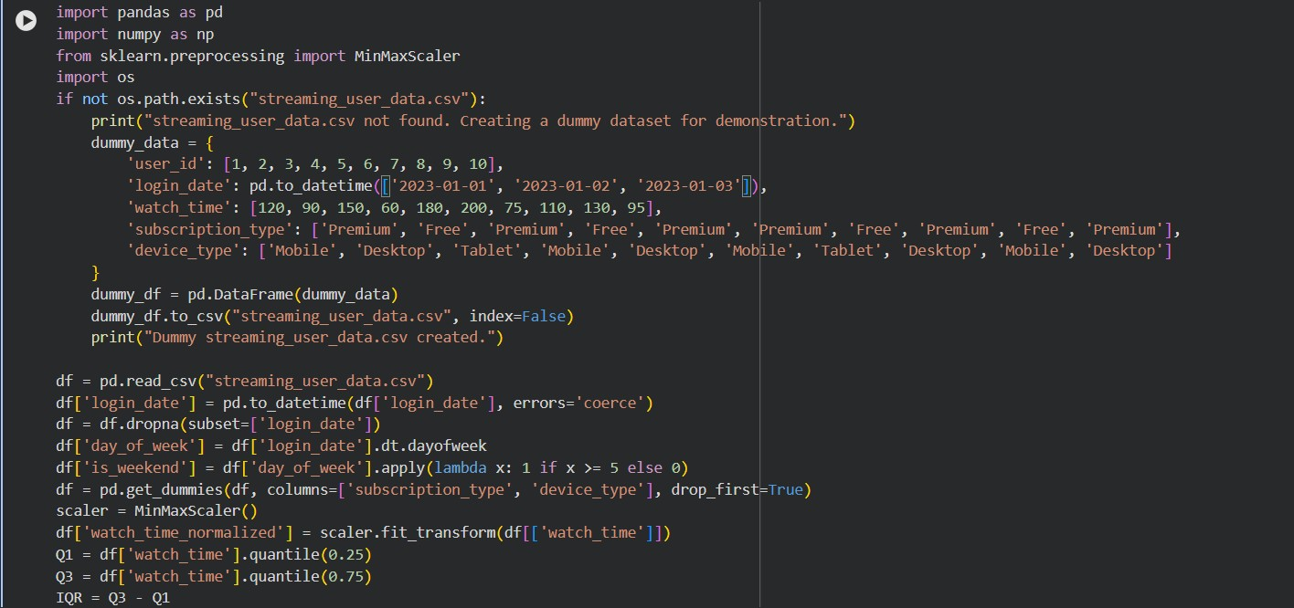
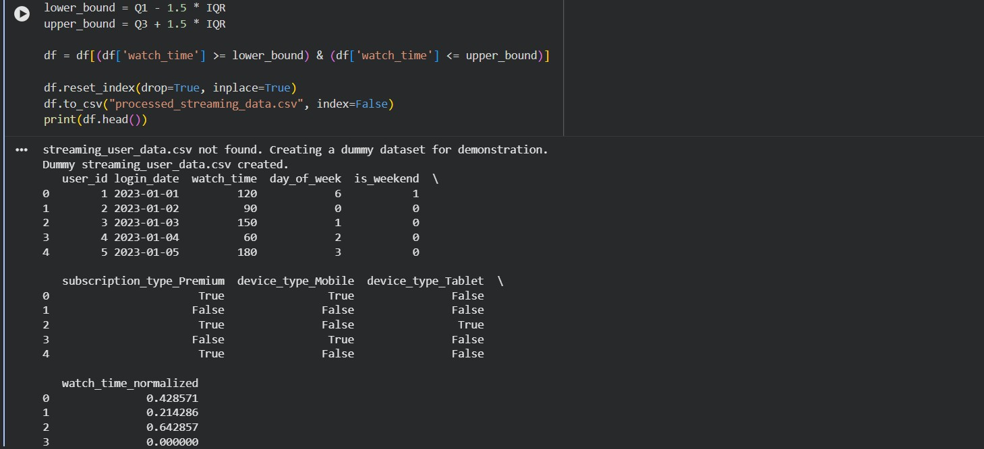

EXPLANATION:
  - Datetime conversion ensures proper handling of user activity timelines.
  - Feature engineering (day_of_week, is_weekend) helps analyze viewing behavior patterns.
  - Encoding transforms categorical variables into numeric format for ML models.
  - Outlier removal (IQR) eliminates unrealistic watch times.
  - Normalization scales watch_time to a 0–1 range for consistent analysis.
Task 5 – Climate Change Research Dataset
Preparation
Scenario
Researchers are analyzing global climate data containing:
- CO2_emissions
- avg_temperature
- country
- year
- extreme_event (Yes/No)

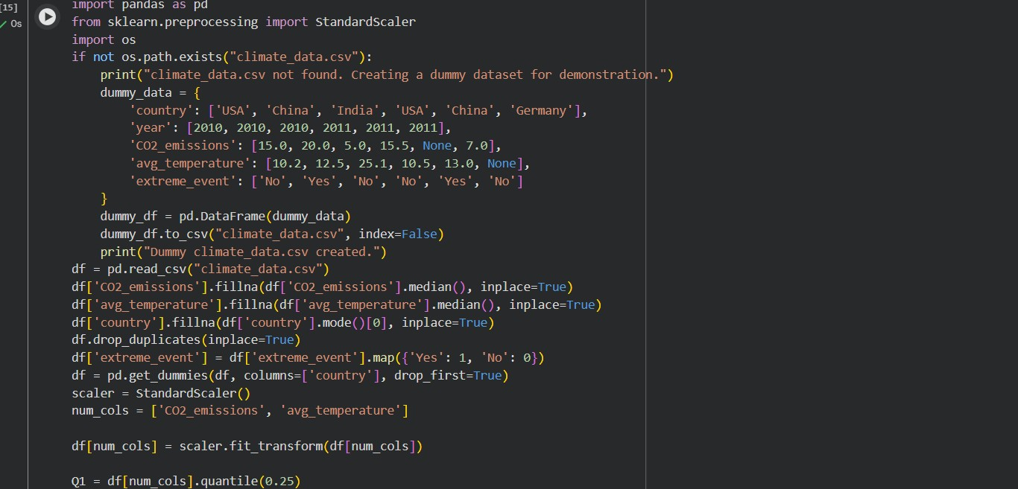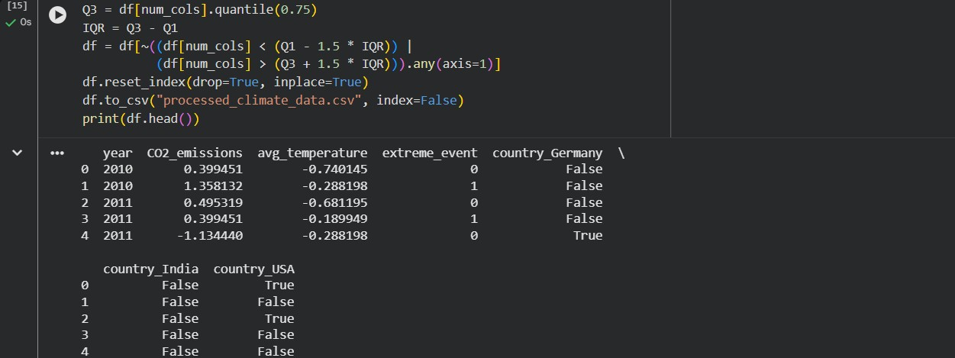

EXPLANATION:

Missing values handled using median (numerical) and mode (categorical).
Duplicates removed to ensure data integrity. Encoding converts:
  - extreme_event → binary (0/1)
  - country → one-hot encoded
Standard scaling normalizes CO₂ emissions and temperature. Outlier removal (IQR) filters extreme climate readings.

