ASSIGNMENT 18-4

Task 1 – Movie Database API Integration
Scenario
You are building a movie recommendation tool that fetches movie details from a public Movie Database API.
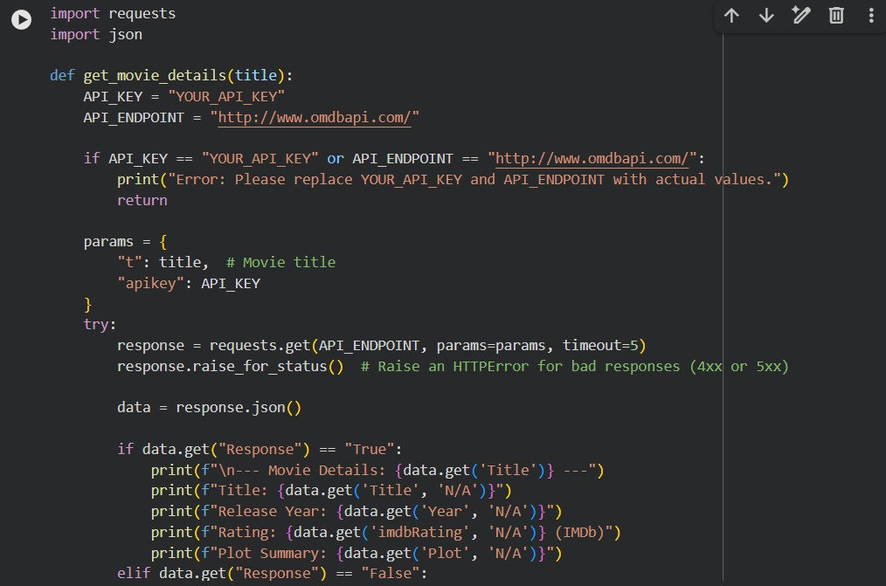
EXPLANATION:
IP validation ensures correct IPv4 format before API call.
API integration fetches country, city, and ISP details. Error handling covers:
- Invalid IP format
- API/network failures
- JSON parsing errors

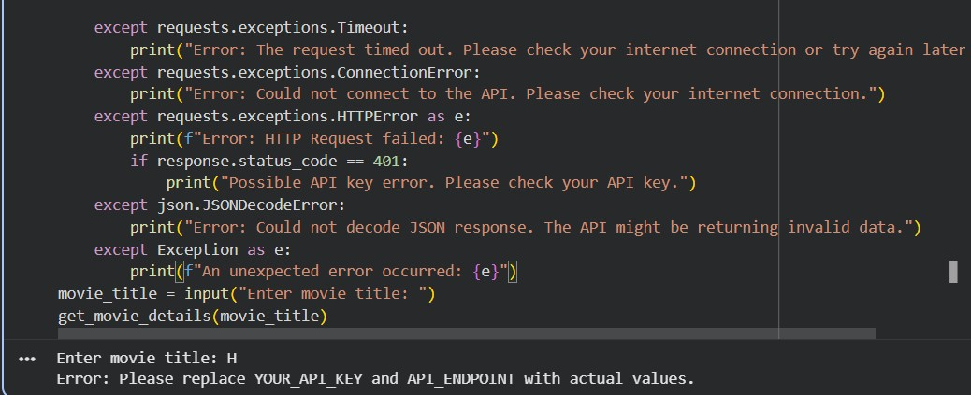

Task 4 – Geolocation API (IP Address
Lookup)
Scenario
A cybersecurity tool needs to detect the geographical location of a user based on IP address.
EXPLANATION:

IP validation ensures correct IPv4 format before API call.
API integration fetches country, city, and ISP details. Error handling covers:
- Invalid IP format
- API/network failures
- JSON parsing errors
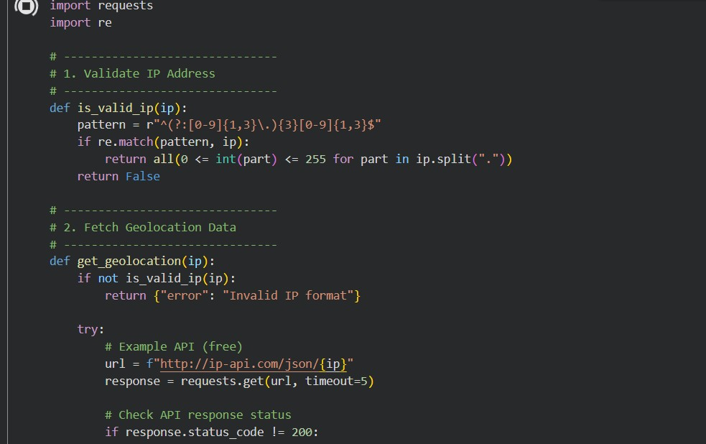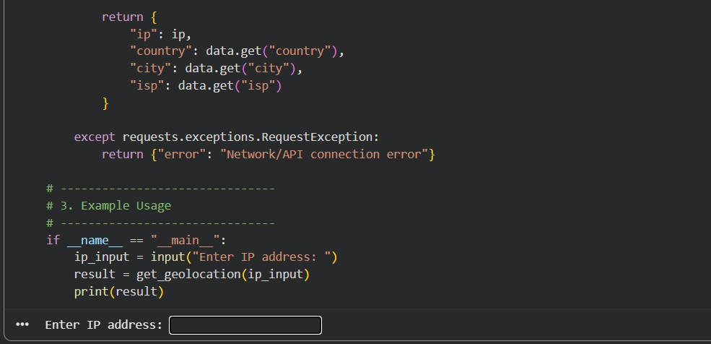

Task 5 – Real-Time Application: Payment
Gateway Simulation API
Scenario
You are building a test payment integration system that connects to a sandbox payment API.

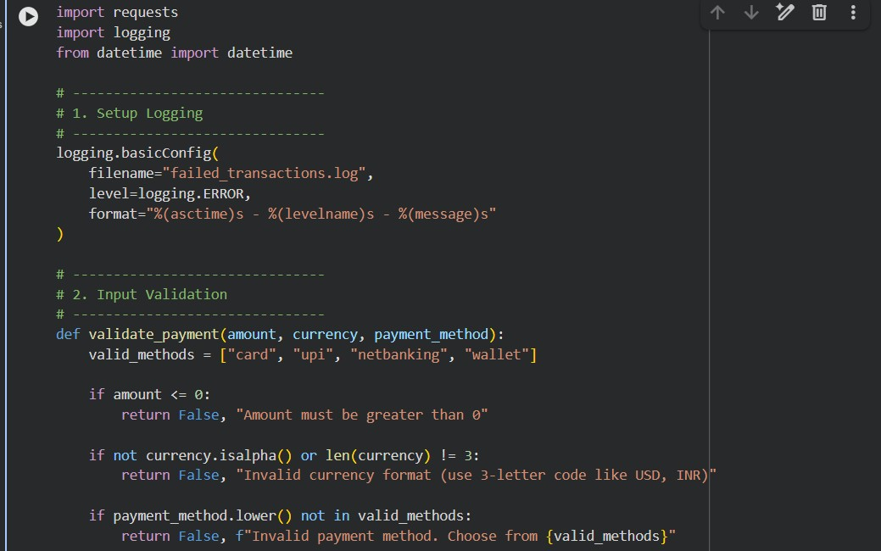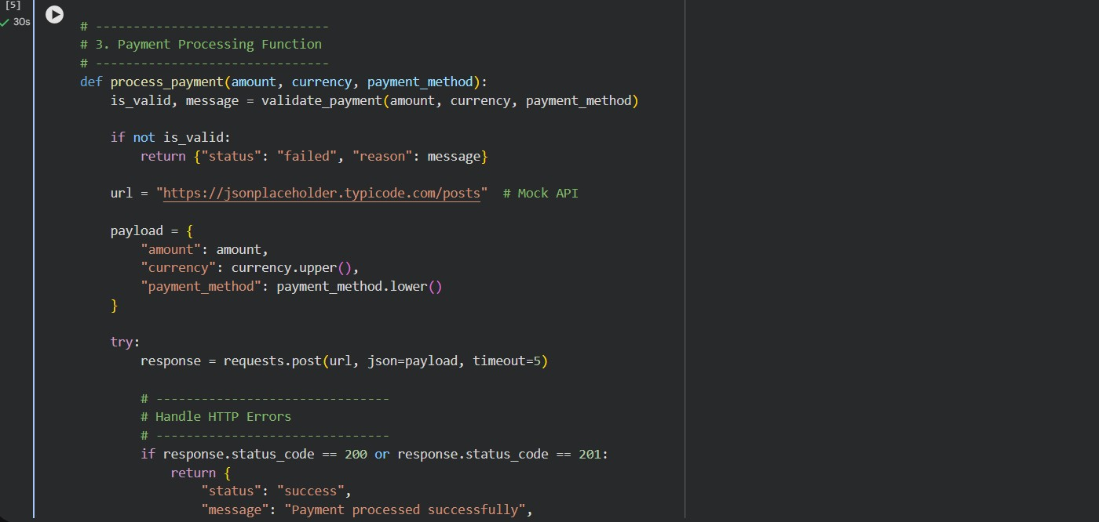
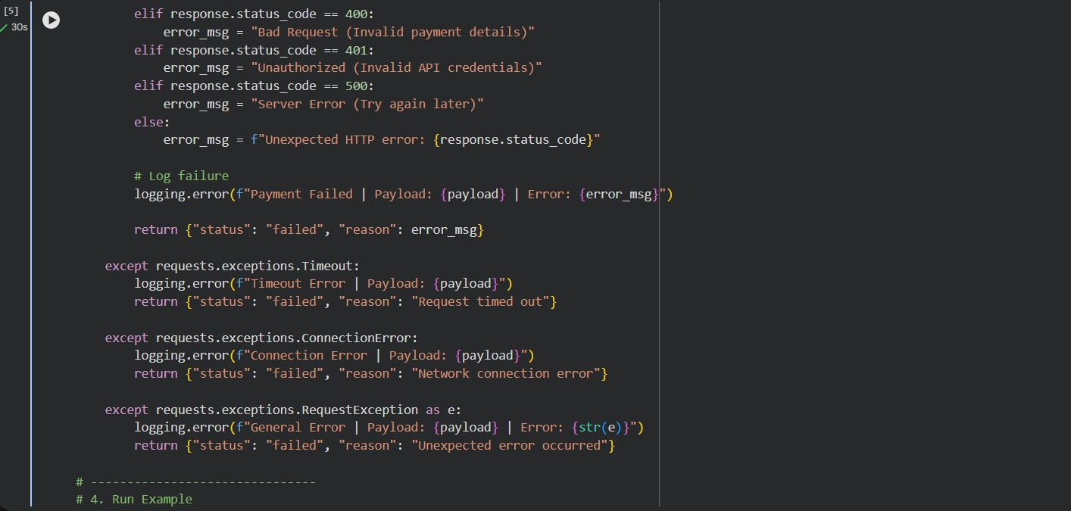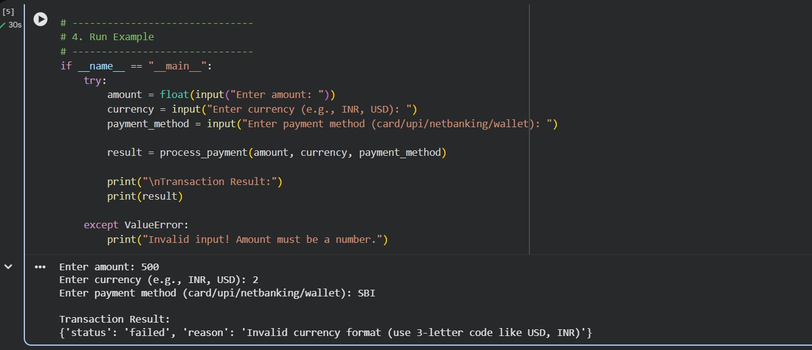

EXPLANATION:
The script validates inputs (amount, currency, payment method) before processing.
It sends a POST request to a mock payment API to simulate a transaction.
It handles errors like invalid input, HTTP errors (400, 401, 500), and network issues.
Successful payments show a confirmation message.
Failed transactions are saved in a log file for tracking and debugging.

