ASSIGNMENT - 11.3

PROMPT: Smart Contact Manager (Arrays & Linked Lists)
SR University’s student club requires a simple Contact Manager Application
to store members’ names and phone numbers. The system should support
efficient addition, searching, and deletion of contacts.

CODE:

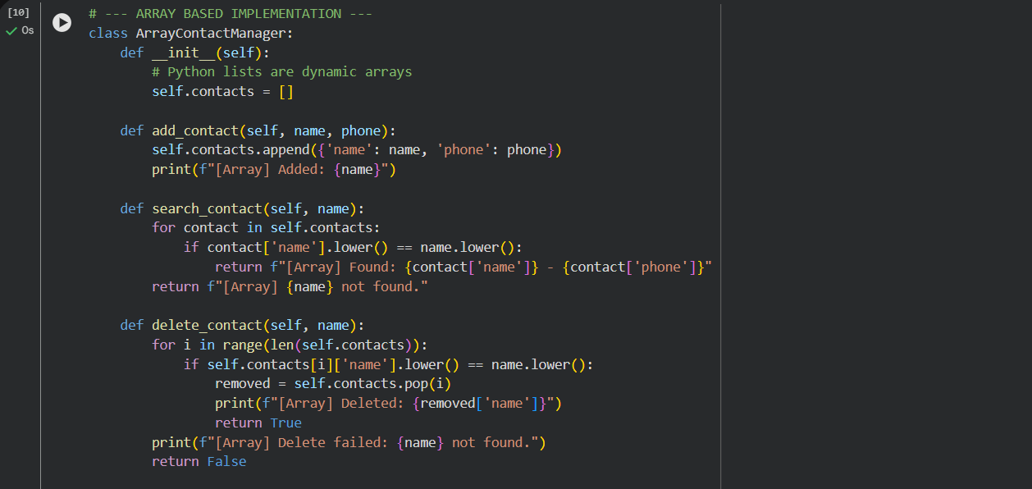
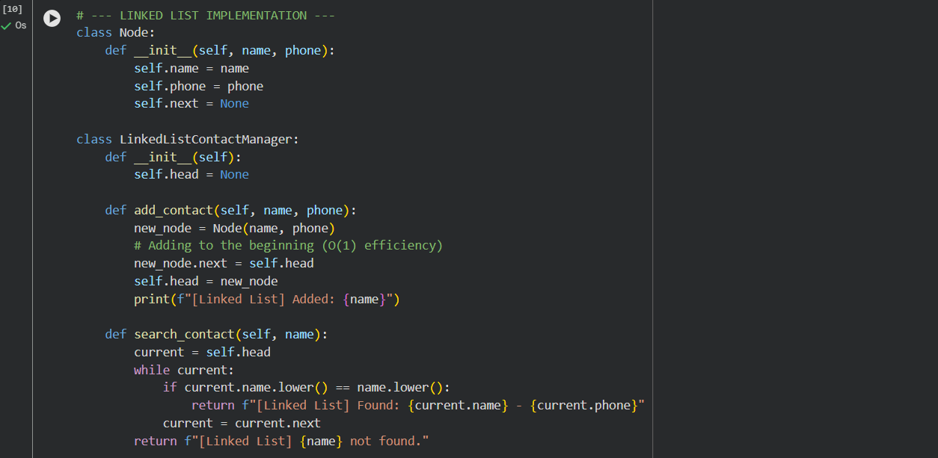
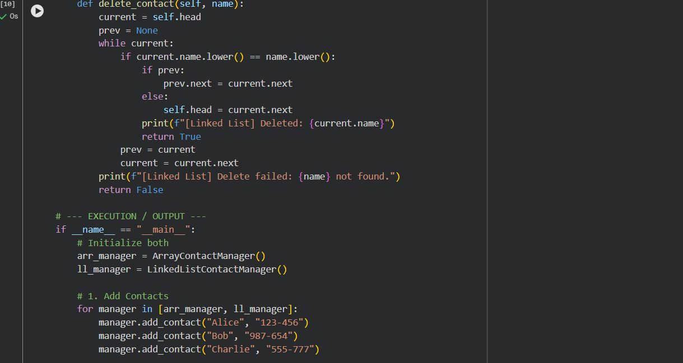
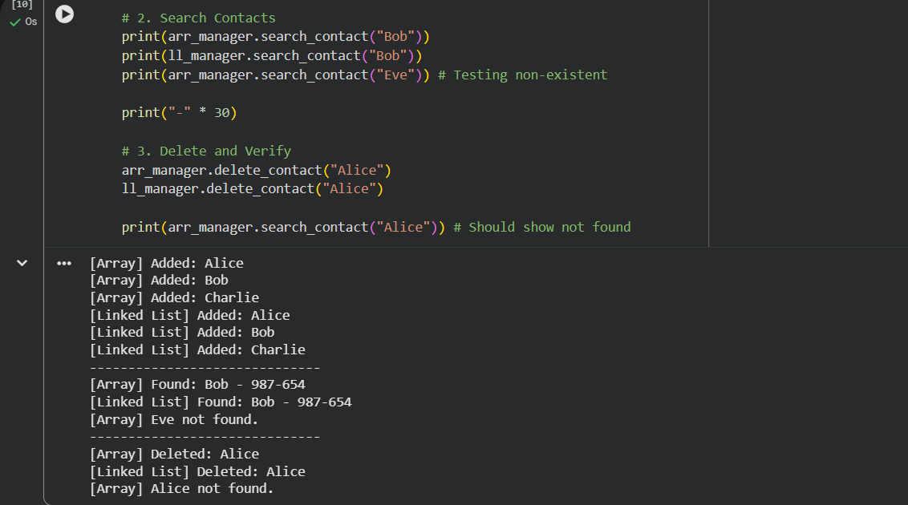

EXPLANATION:

1. Array-Based (Python Lists)
- Structure: Stores contacts in a single, solid block of memory.
- Search: Uses a "Linear Search" (checking each index one by one).
- Insertion/Deletion: Slow if done at the beginning, because every other contact must be "shifted" over to fill or create a gap.
- Efficiency: Best for small lists or adding to the very end.

2. Linked List
- Structure: Each contact is a "Node" with a pointer (link) to the next one.
- Search: Must "walk" the chain from the start until the name is found.
- Insertion/Deletion: Very fast. You don't move any data; you just change where the "links" point to skip or add a person.
- Efficiency: Best for dynamic data where you frequently add/remove members from the middle or start

2. PROMPT : Library Book Search System (Queues & Priority Queues)
The SRU Library manages book borrow requests. Students and faculty submit
requests, but faculty requests must be prioritized over student requests.
CODE:
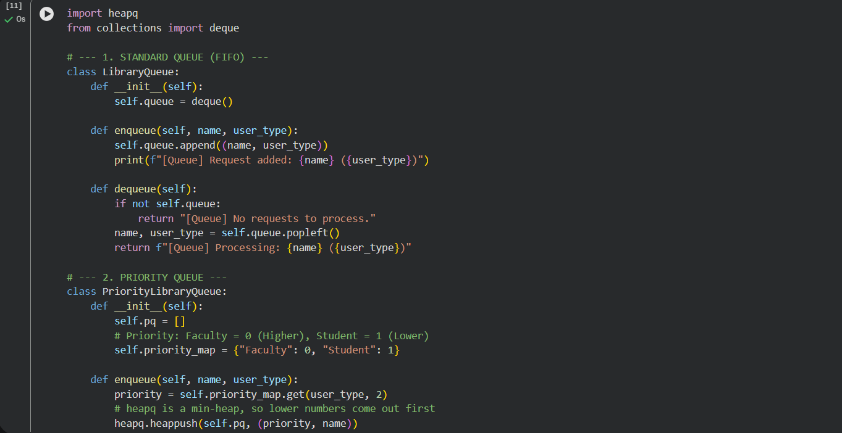
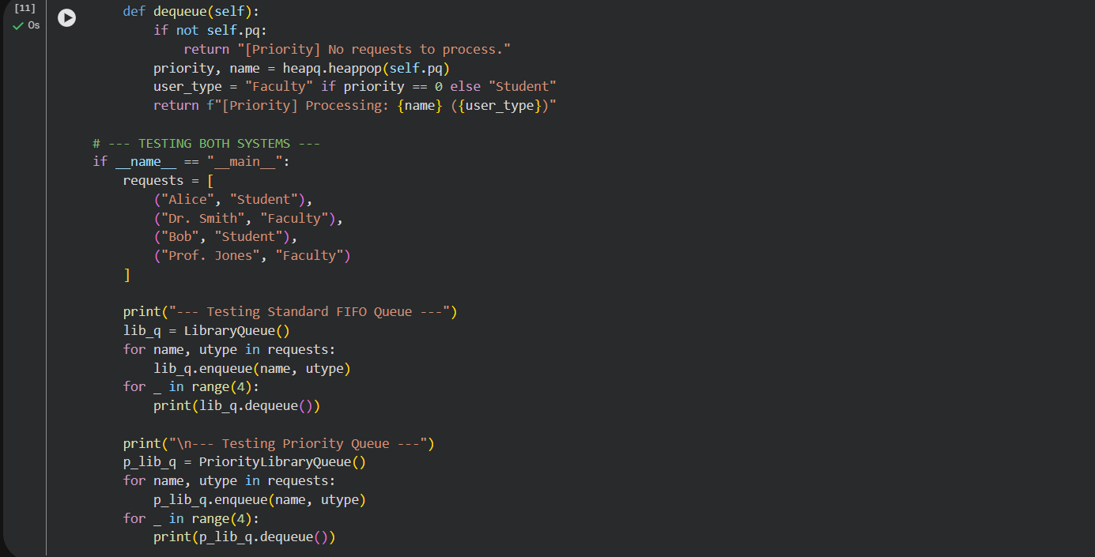

OUTPUT:
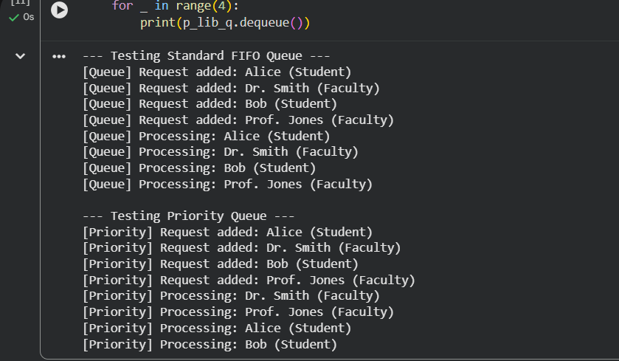
EXPLANATION:

1. Standard Queue (FIFO)
- Logic: Operates on the "First-In, First-Out" principle, exactly like a real-world standing line.
- Processing: The order of service is determined strictly by the time of arrival. If a student arrives before a professor, the student is served first.
- Use Case: Best for fair, neutral systems where everyone has equal status.

2. Priority Queue
- Logic: Assigns a "weight" or "rank" to each request. In our code, Faculty is rank 0 and Student is rank 1.
- Processing: The system always looks for the lowest rank number (highest priority) to serve next. This allows faculty members to "jump the line" regardless of when they arrived.
- Use Case: Ideal for systems with emergency levels or membership tiers (like the SRU Library).
3.PROMPT: Emergency Help Desk (Stack Implementation)
Scenario
SR University’s IT Help Desk receives technical support tickets from students
and staff. While tickets are received sequentially, issue escalation follows a
Last-In, First-Out (LIFO) approach.
OUTPUT:
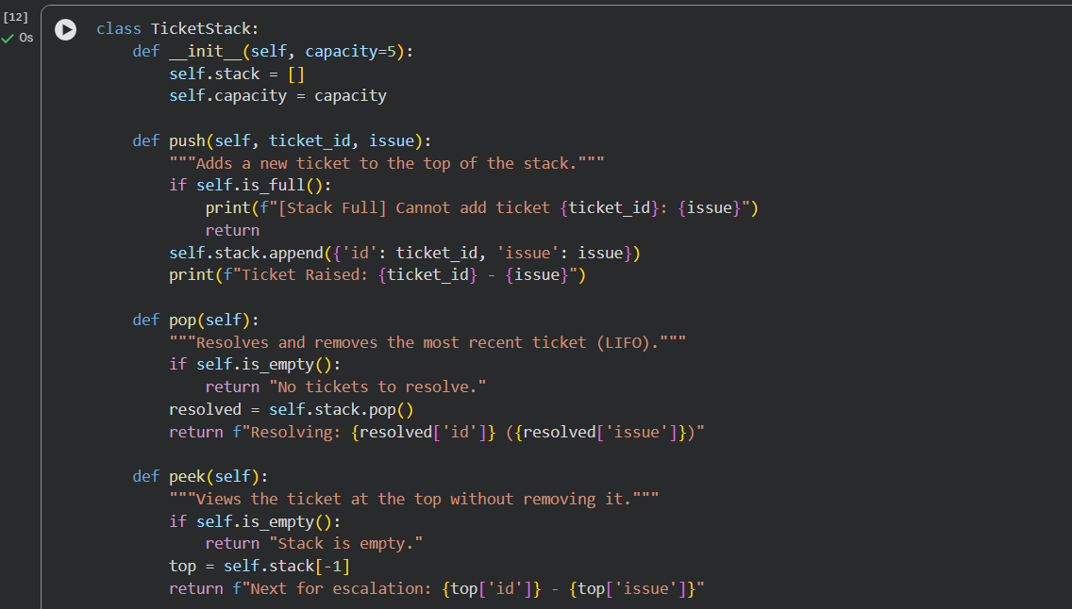
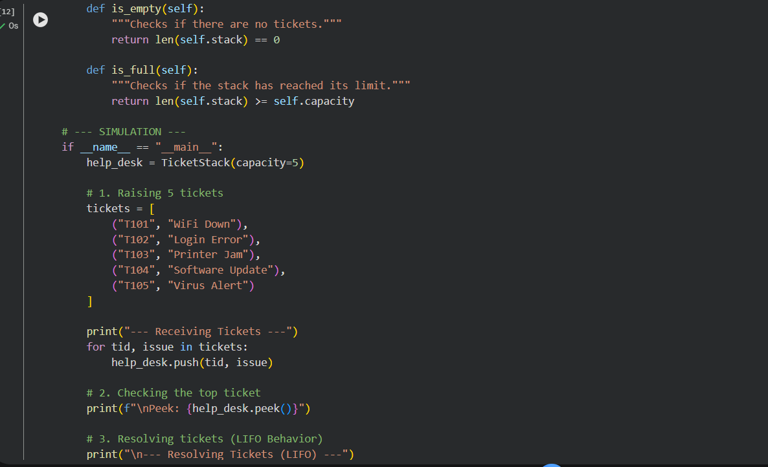
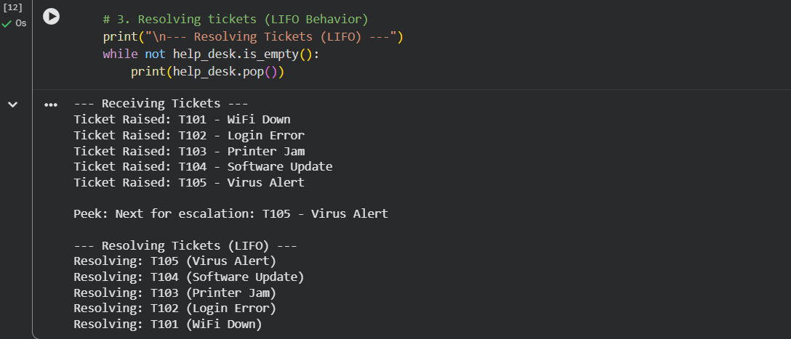
EXPLANATION:
LIFO Principle: The Help Desk operates like a stack of trays. The last ticket placed on top (T105) is the first one picked up to be fixed.
- Pop: Removes the top ticket once resolved.
- Peek: Checks the most urgent ticket without removing it from the system.
- Efficiency: Stacks are extremely fast for these operations ($O(1)$), as you never have to search through the middle; you only ever interact with the very top.
PROMPT 4: Hash Table
To implement a Hash Table and understand collision handling.

CODE:
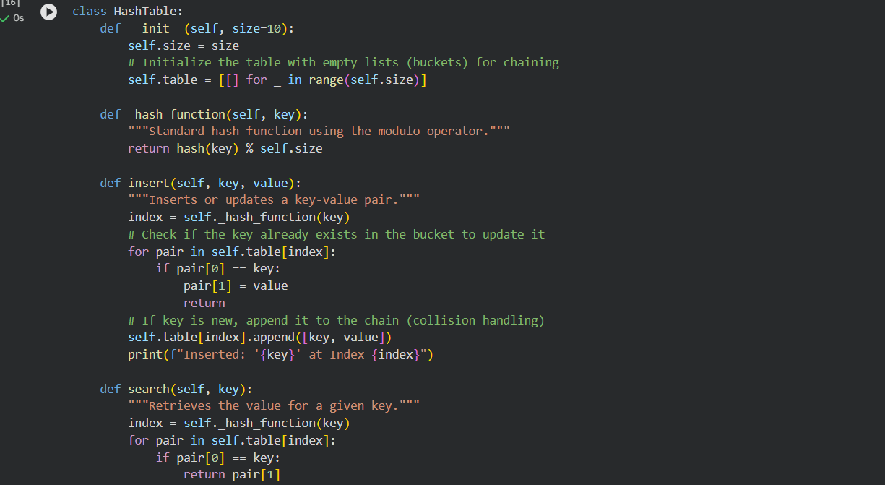
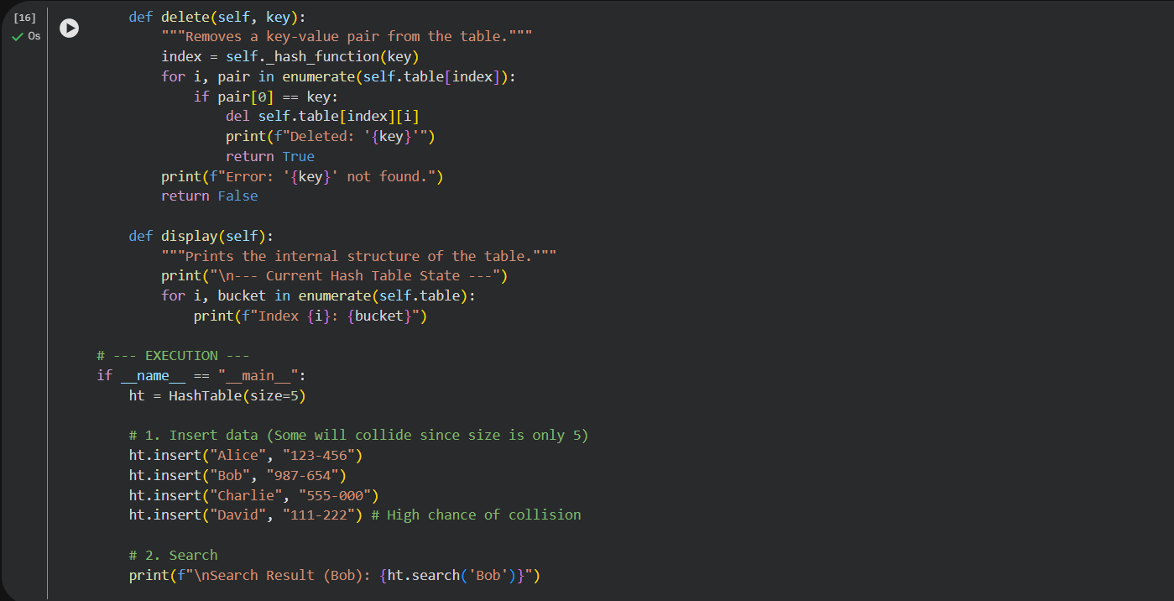
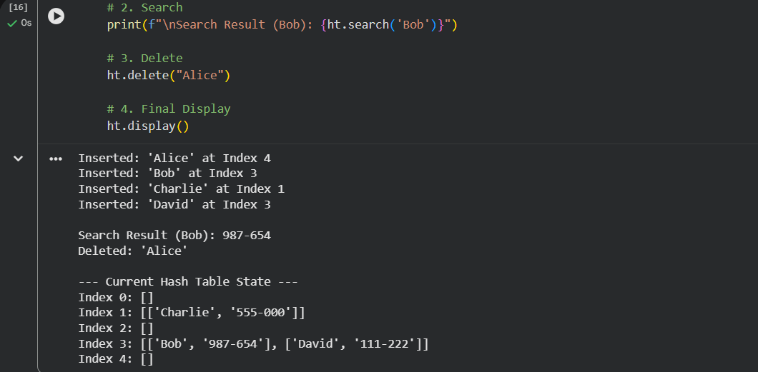

EXPLANATION:
Chaining (Collision Resolution): When two keys (like "Alice" and "David") hash to the same index, we don't overwrite the data. Instead, we store them as a nested list (a "chain") at that index.
The Hash Function: The _hash_function takes any string and converts it into a number within the range of our table size using the % (modulo) operator.
Efficiency: * Average Case: $O(1)$ for insert, search, and delete. This is why hash tables are the foundation of Python's dict and set.
- Worst Case: $O(n)$ if every single key hashes to the exact same index, turning the hash table into one giant linked list.

PROMPT 5: Real-Time Application Challenge
Design a Campus Resource Management System with the following
features:
• Student Attendance Tracking
• Event Registration System
• Library Book Borrowing
• Bus Scheduling System
• Cafeteria Order Queue
CODE:
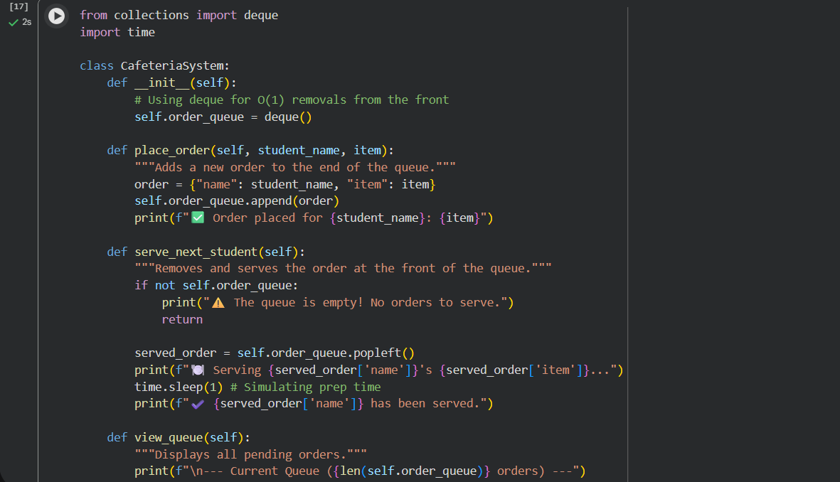
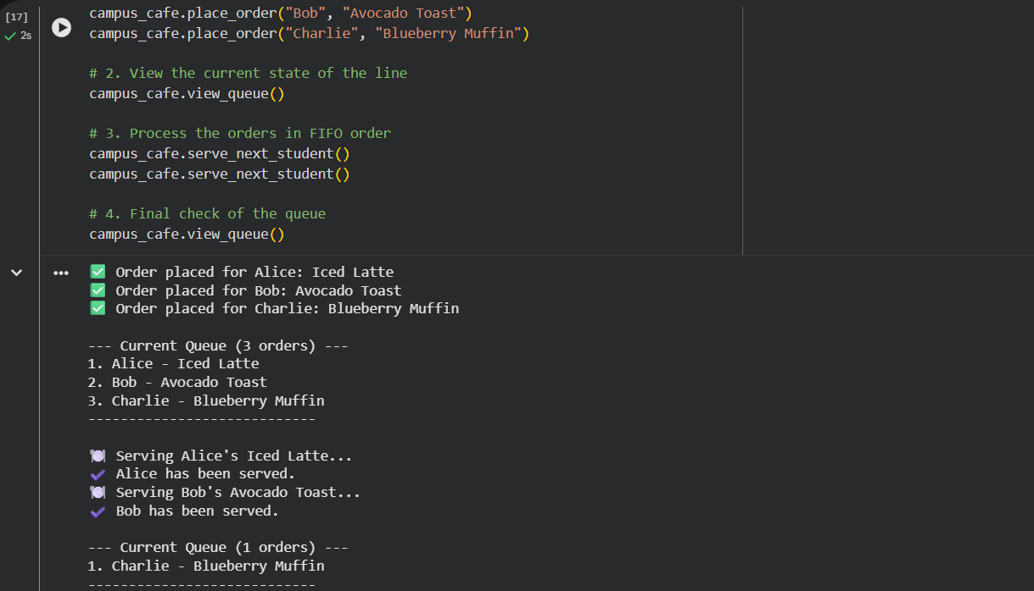
EXPLANATION:
This system is designed to handle high-traffic campus operations by prioritizing data integrity and processing speed. By matching specific real-world tasks to optimized data structures, we ensure the software remains responsive even during peak hours, like class transitions or lunch breaks.

Logic Breakdown
- Efficiency: Using structures like Hash Maps for attendance and Queues for the cafeteria ensures that as the student body grows, the system's response time remains nearly instantaneous (constant time complexity).
- Reliability: The use of Sets for event registration prevents "double-booking" errors at the data level, reducing the need for complex manual checks.
- Flow Control: The FIFO (First-In, First-Out) logic implemented in the cafeteria code ensures a fair, chronological service order, which is the standard requirement for any physical or digital waiting line.

