**WINDOWS**

**Screenshot 1:-**

IPv4 Public IP 3.17.62.165

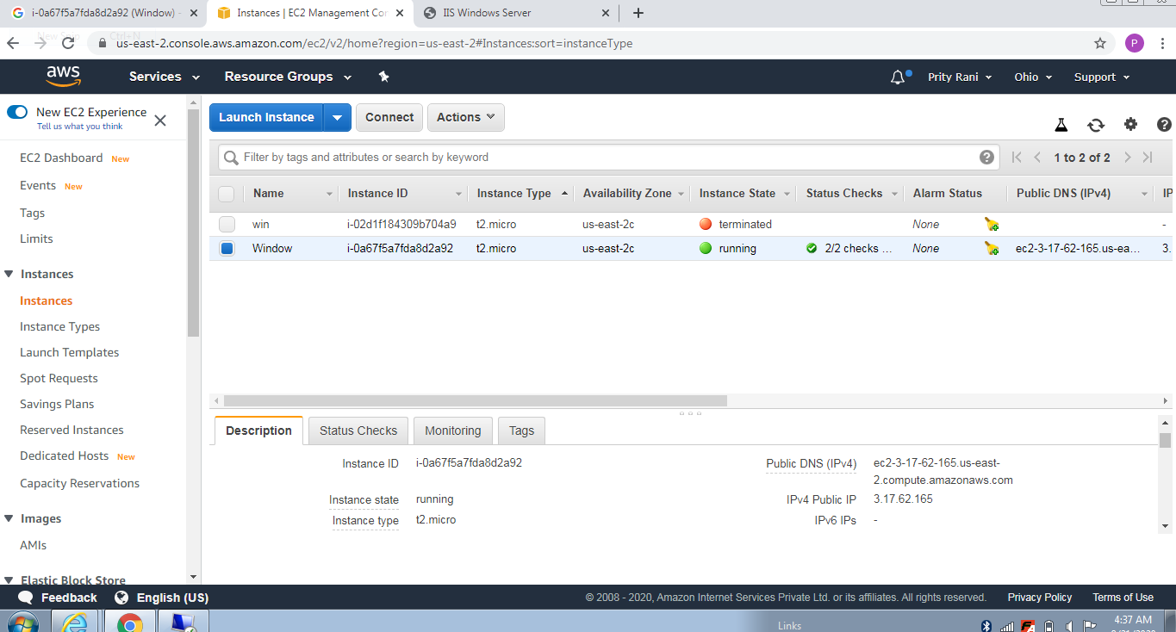

**Screenshot 2:-**

IPv4 Public IP 3.17.62.165

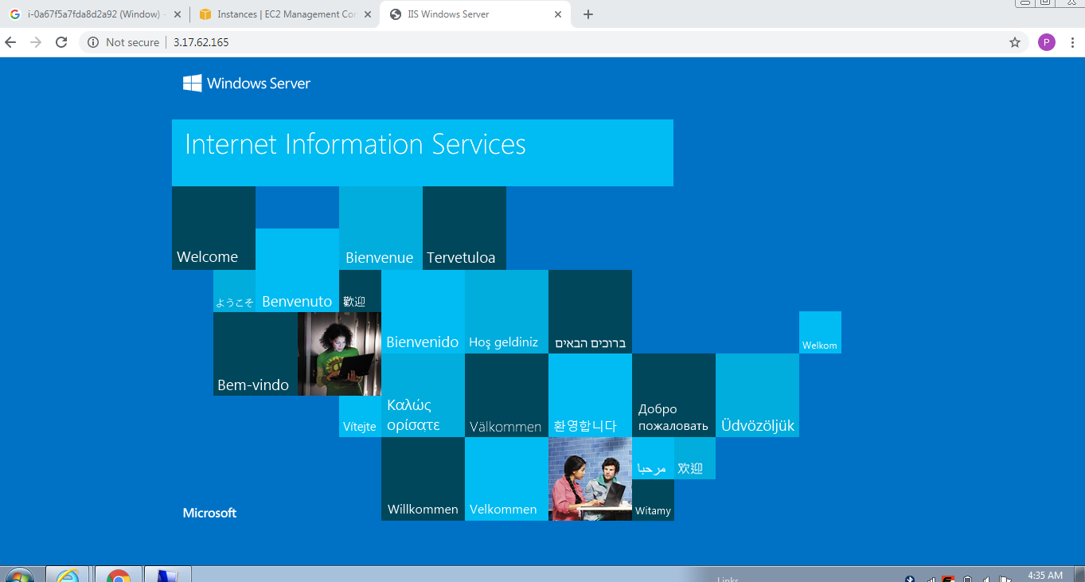

**UBUNTU**

**Screenshot:-3**

IPv4 Public IP 3.14.4.88

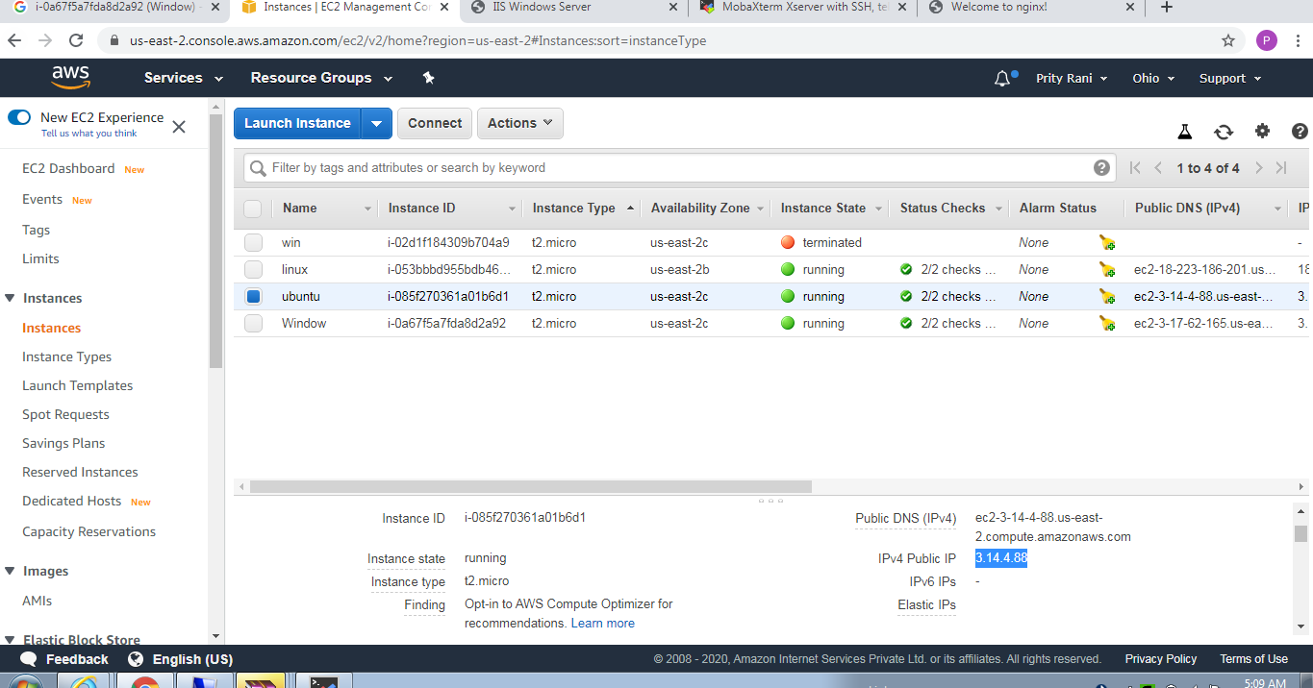

**Screenshot:-4**

IPv4 Public IP 3.14.4.88

