**HellSprint Development Hell**

Authored by Guerrero, Prince Marco R.

**Development Team:**

Artist, Lead Developer - Guerrero, Prince Marco R.

SoundFX Designer – De Zara, Ian Carlo

Database – Villanueva, Allister B.

**HellSprint – Videogame**

HellSprint is a Fast Paced first person shooter where one aims to survive through an increasing difficulty of swarms of enemies. Survive long enough and gain a ranking in the leaderboard, and prove you’re the best player out there.

**Part 1: Early Problems**

In developing HellSprint, we have a hard time finding the right identity for the game, especially that the game will be set in a Hellish Scape, and to be honest, just that subject alone, it ended up being a problem finding inspirations and coming up a designs, we also have this thought of what do we want the game to look like, wether will it be realistic or a simple 2D basic game. Artist (Prince Guerrero), modelled a character that somehow resembles the early PlayStation games, and our team ended up with a decision in this grand vision of just making a retro looking game, not only to compensate for the easy modelling time and performance aswell.

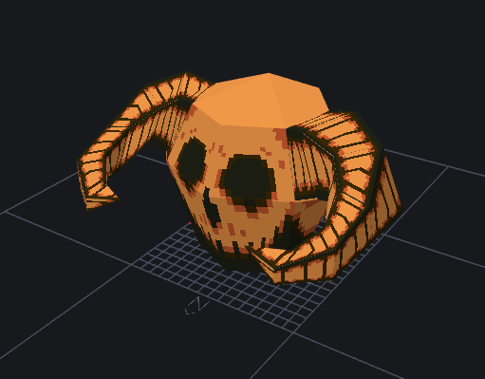

Figure 1 HellSprint Enemy : Skull

We also ended up having a problem with the availability of tools, now most of the modern tools do require a certain subscription in order to user their tools, and well, we’re students and we can’t afford those luxury utilities for our game, and we don’t even have a budget to spare, so we scourge the internet in search for Tools, and we did end up with BlockBench, a free 3D modelling tool.

**Part 2: time Time TIME!**

When it comes to developing a game, time is very consuming, but with an experience, you can easily make games in a day from scratch, but for this matter, although for me, there are no problems in time of developing the game itself, but the poundering amount of School Projects that weigh down the development, also one of our colleagues are a working student, efforts made in managing that time, scheduled meetings become rescheduled and sometimes cancelled.

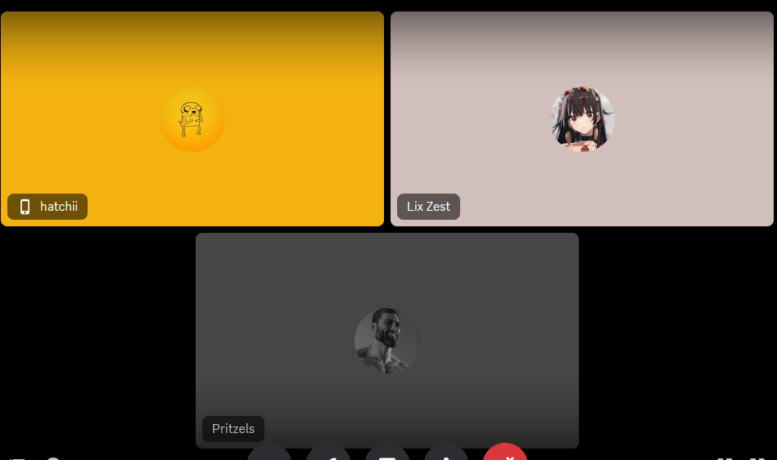

Figure 2 HellSprint DevTeam Meeting

We also did have a time error in developing the game from our side aswell, some of the members fromt the team are having a hard time to contribute to the team, and are some are not experienced well enough, although this error we’re solved from the start, by assigning designated roles to the team, the development for the game become less hassle and everyone can contribute using their own knowledege and skills.

**Part 3: Quality > Quantity**

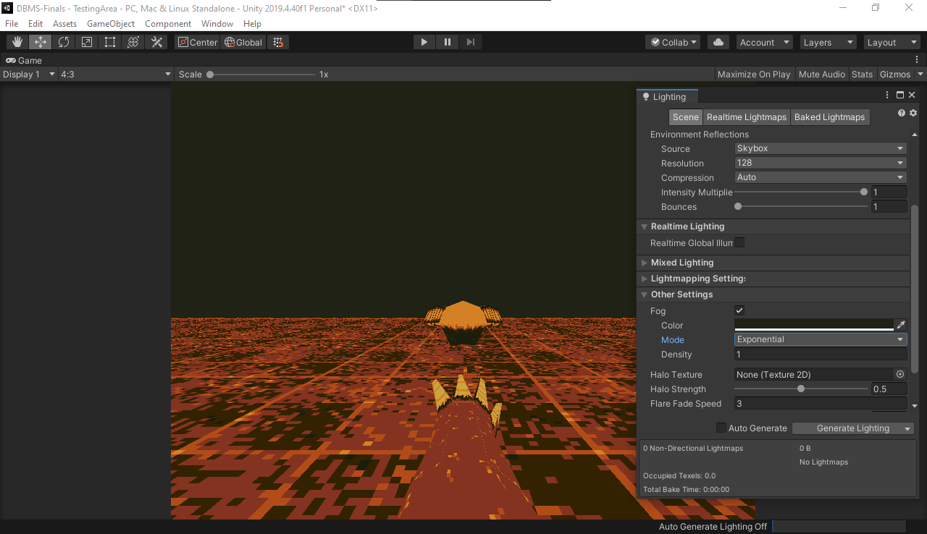

Figure 3 HellSprint Early Development using Unity Game Engine

People says, that Quantity over Quality is better, as it provides a better gameplay throughout the playthrough whilst having a more content throughout, but for our team, we never have this kind of vision, we never wanted a game that just uses the phrase, “Just call it a day”, we never wanted that kind of vision, in our team, we wanted to make a game that has a quality meaning in every way, wether it would be the characters, the world building, and overall the feel of the game. We never wanted to make a game that just “Call it a day”, although we are short in time, but our team are eager in making this game as much as someone can call it a Quality Work.

We really emphasize in making the game as much as fun, we did alpha testing in every implementation of a certain feature just to make sure that it runs well and don’t ruin the user experience by any means at all. We also made sure that the game runs very well in every machine by conducting playtests and gather their system specs, and honestly it did run well, with a good performance overall.

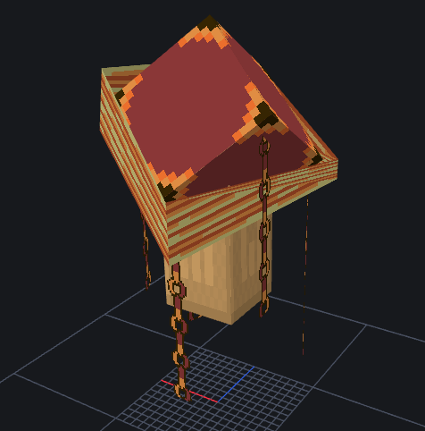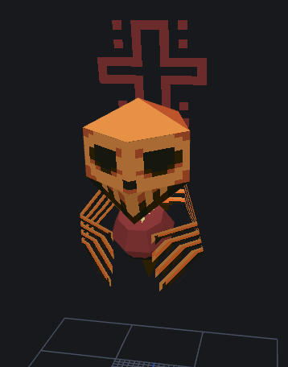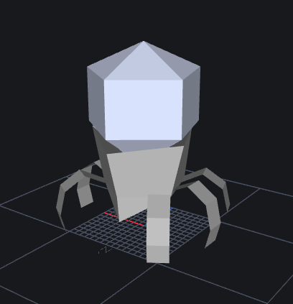

Figure 4 HellSprint Enemy : Pandora

Figure 5 HellSprint Enemy : Necro

Figure 6 HellSprint Enemy : Morph Untextured

We did dwelve into making more characters and enemies for our game, the figures above are 3D models and placeholders, but sadly they didn’t make it in the final release, these characters didn’t have enough time to be developed and provide that Quality feeling. We also didn’t have enough time in thinking of a better way to give their own use and mechanics inside the game. But hey, this is just the beginning, maybe someday, these characters may end up in a next version. Who knows.