ACAP FRIED CHICKEN



TOPIC : AFD MEAL SET A & B

DUE DATE : 21 JANUARY 2029

|  |  |
| --- | --- |
| NAME | WORKER ID |
| MUHAMMAD IRFAN BIN IBRAHIM | AK108977 |
| MUHAMMAD ASYRAF BIN IBRAHIM | AK1087937 |

Table of Content

1. Table of Content
2. Package A
3. Package B

Package A



**A**

|  |  |
| --- | --- |
| Package Name |  |
| Package Content |  |
| Package Price |  |
| Note |  |

Package B

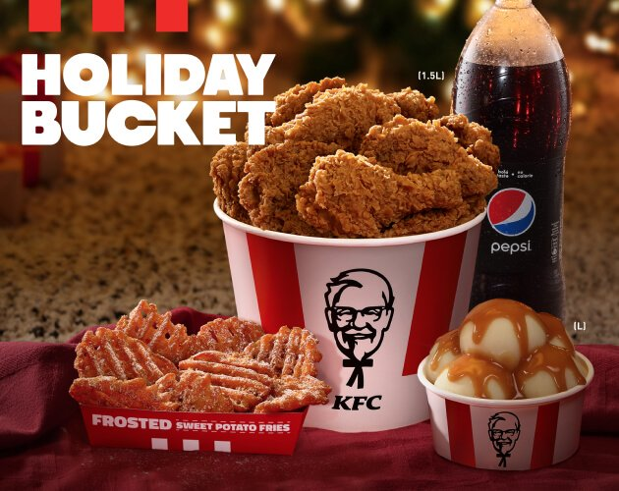

A

|  |  |
| --- | --- |
| Package Name |  |
| Package Content |  |
| Package Price |  |
| Note |  |