Smart Home System Emulator

Product Overview

**REVISION HISTORY**

|  |  |  |  |  |
| --- | --- | --- | --- | --- |
| **DATE** | **REVISION TYPE** | **REVISION #** | **COMMENTS** | **INITIALS** |
| *10/13/2021* | *Major* | *1* | *Initial version* | *DM* |
| *10/21/2021* | *Minor* | *1.1* | *Fixed commands examples: 2.7, 2.8.* | *DM* |
| *10/21/2021* | *Minor* | *1.2* | *Update of instruction how to stop the emulator: 4.3* | *DM* |
| *11/3/2021* | *Minor* | *1.3* | *Update of description for set_point command: 2.6* | *DM* |

**CONTENTS**

Revision History 2

Contents 3

1. PRODUCT OVERVIEW 4
2. LAPIC COMMANDS 5
   1. identify 5
   2. set_on 5
   3. set_off 6
   4. set_level 6
   5. move_to_color_temp 6
   6. set_point 6
   7. set_system_mode 7
   8. set_fan_mode 7
   9. measurement_show_runtime 8
3. DEVICES 9
   1. Smart Bulb 9
   2. Smart Plug 9
   3. Thermostat 9

# PRODUCT OVERVIEW

Smart Home System Emulator is software to emulate smart home systems without using hardware and physical environment.

The system includes:

* + gateway application
  + smart device applications
  + ZigBee Network Simulator
  + command-line interface LAPIC

The gateway and smart device applications interact with each other with ZigBee Network Simulator. Opportunities:

* + command sending from the gateway to a smart device
  + command sending from a device to the gateway, include response to the command and attribute reporting

Users use command-line interface LAPIC (local application programming interface controller) to interact with the gateway application. Opportunities:

* + sending a command to the gateway
  + getting command results and device measurements

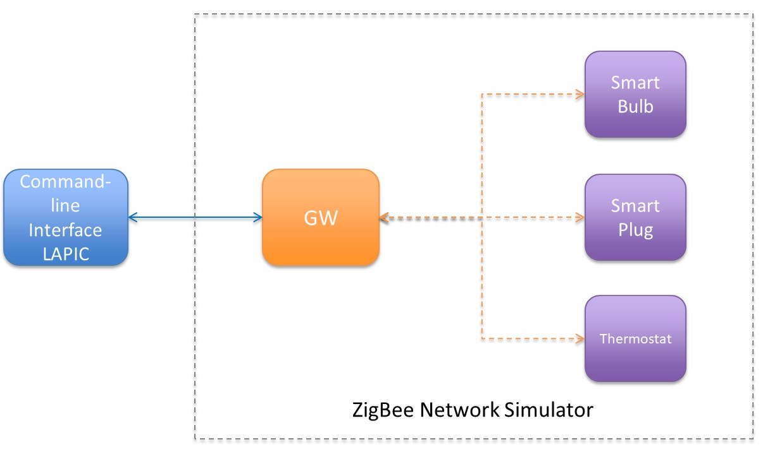

1. **LAPIC COMMANDS**

This section contains a list of commands that can be sent with LAPIC to the gateway. To execute a command print it after prompt character **>** and press enter.

LAPIC prints next the information got from gateway:

* + command sending status
    - the command was sent
      * *sent, commandId <cmdId>*
    - the command has invalid parameters and was not sent
      * *Invalid parameters please see help*
  + response for command
    - the command was executed
      * *Response for command #<cmdId> received: status COMPLETED*
    - the command was not executed or was executed with an error
      * *Response for command #<cmdId> received: status ERR*
  + device measurements (the information prints after execution *measurement_show_runtime* command, find details in 2.9)

| Device | Timestamp | Name | Value |

| -| | | |

|  |  |  |  |  |
| --- | --- | --- | --- | --- |
| | zb.aabbccddeeff0011.c | | 687291265 | | state | | true | | |
| | | | 687291265 | | lqi | | 255 | | |
| | | | 687291265 | | rssi | | 100 | | |

* 1. **IDENTIFY**

*identify <deviceId>*

Example: *identify zb.aabbccddeeff*

Description: the *identify* command starts the receiving device identifying itself. Related attributes: None

* 1. **SET_ON**

*set_on <deviceId>*

Example: *set_on zb.aabbccddeeff*

Description: the *set_on* command sets the receiving device state to true.

Related attributes: *state*

* 1. **SET_OFF**

*set_off <deviceId>*

Example: *set_off zb.aabbccddeeff*

Description: the *set_off* command sets the receiving device state to false. Related attributes: *state*

* 1. **SET_LEVEL**

*set_level <deviceId> <level>*

* + - <level>

o [0,255]

Example: *set_level zb.aabbccddeeff 128*

Description: the *set_level* command sets the receiving device currentLevel to *<level>*. Related attributes: *currentLevel*

* 1. **MOVE_TO_COLOR_TEMP**

*move_to_color_temp <deviceId> <color_temp> <transition>*

* + - <color_temp>

o [0, 65279]

* + - <transition>
      * 0

Example: *move_to_color_temp zb.aabbccddeeff 2500 0*

Description: the *move_to_color_temp* command sets the receiving device colorTemperature to *<color_temp>*

during <transition> 1/10 of second. Related attributes: *colorTemperature*

* 1. **SET_POINT**

*set_point <deviceId> <mode> <local_temp>*

* + - <mode>
      * heat
      * cool
    - <local_temp>
      * [700, 3000] for heat mode
      * [1600, 3200] for cool mode

Example: *set_point zb.aabbccddeeff heat 2500*

Description: the *set_point* command sets the receiving device *<mode>* point to *<local_temp>*. Notes: point for cool mode should be greater than for heat mode.

Related attributes: None

* 1. **SET_SYSTEM_MODE**

*set_system_mode <deviceId> <mode>*

* + - <mode>
      * off
      * auto
      * cool
      * heat
      * er_heating
      * precooling
      * fan_only
      * dry
      * sleep

Example: *set_ system _mode zb.aabbccddeeff off*

Description: the *set_system_mode* command sets the receiving device system mode to *<mode>*. Related attributes: None

* 1. **SET_FAN_MODE**

*set_fan_mode <deviceId> <mode>*

* + - <mode>
      * off
      * low
      * medium
      * high
      * on
      * auto
      * smart

Example: *set_fan_mode zb.aabbccddeeff off*

Description: the *set_fan_mode* command sets the receiving device fan mode to *<mode>*. Related attributes: None

* 1. **MEASUREMENT_SHOW_RUNTIME**

*measurement_show_runtime <boolean_value>*

* + - <boolean_value>
      * true
      * false

Example: *measurement_show_runtime true*

Description: when enabled, LAPIC will print the device's measurements immediately when it is received. Notes: the command hasn’t either response neither status.

# DEVICES

This section describes smart devices included in the system with lists of supported commands and attributes.

Notes: execute command *measurement_show_runtime* (find details in 2.9) to obtain measurements with device attributes immediately after they are received.

* 1. **SMART BULB**

DeviceId:

* + - zb. Smart Bulb

Commands:

* + - identify
    - set_on
    - set_off
    - set_level
    - move_to_color_temp

Attributes:

* + - state
    - currentLevel
    - colorTemperature
  1. **SMART PLUG**

DeviceId:

* + - zb. Smart Plug

Commands:

* + - identify
    - set_on
    - set_off

Attributes:

* + - state
  1. **THERMOSTAT**

DeviceId:

* + - zb. Thermostat

Commands:

* + - set_point
    - set_system_mode
    - set_fan_mode

Attributes:

* + - None