# SE -OVERVIEW OF THE IT INDUSTRY

# ASSIGNMENT – 1

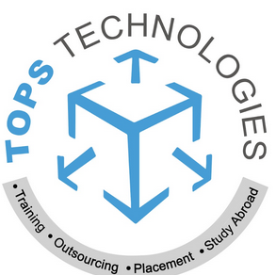

## SUBMITTED BY:

PRIYA PAREKH

## SUBMITTED TO:

CHINMAYEE MAM

BACKEND DEVELOPMENT TOPS TECHNOLOGIES

## QUESTION 1: What is software? What is software engineering?

### ANSWER:

Software:

A Set of Code/instructions that tells the computer what to do. It’s used to operate computers and execute programs or particular tasks. There are two main types of software.

1. System Software
2. Application Software

Software Engineering:

It means developing software using the design principle of engineering. IEEE defines software engineering as **Applying a systematic, disciplined, quantifiable approach to developing, operating, and maintaining software**.

## QUESTION 2: Explain the types of software

## ANSWER:

There are two main types of software and three other software.

● Application software

● System software

● Driver software

● Middleware

● Programming software

## Application software:

It’s developed or provided by a Developer/programmer.

An application can be self-contained, or it can be a group of programs that run the application for the user.

It’s designed to carry out specific tasks other than computer-related tasks it makes life easier for us. In today’s time, we use different kinds of apps that are on the Play Store or Apple Store like Exercise apps, to-do list apps other productivity apps.

There are also learning platforms, online forums, and texting apps that connect us to other foreign countries because of their vast database and network, we can connect worldwide.

Application software that is developed for the convenience of us humans. To make our Day-to-Day life easier.

Application may be pushed together with the computer and its system software and maybe coded as proprietary, open-source, or projects. When referring to applications for mobile devices term ‘app’ is commonly used.

Open-source software is software that we can use for free without paying fees or needing a license to access it. We can access its source code and make changes to it. While in Proprietary software we need to pay some fees to access it and only the developer has the right to see its source code and make changes in it.

## System Software:

This software is provided by the system. System software is a program that manages computer hardware. It also assists application software to run programs.

This software provides some built-in software like a calculator, calendar, Notepad, paint, etc. These are provided by a system we don’t need to install them separately.

OS (operating system) is the best example of system software, like Microsoft Windows, Mac OS, and Linux. The system function of MS Windows is Command interpreter (CMD) and graphical User interface (GUI).

Linux is an Open Source Operating system that is made of kernel. It provides Ubuntu, Linux Mint, Kail Linux, etc.

## Driver Software:

Driver software is a kind of system software. It controls peripherals devices that are connected to a computer. On any computer, mobile, or tablet. We can add driver software like SSD, Headphone, Printer, USB Storage Devices, and Keyboard.

## Middleware:

This kind of software is used between two different kinds of software or different kinds of OS to send remote work. It’s used in databases and Application servers.

## Programming Software:

This software is used by Developers / Programmers to write code. This software provides programming tools that enable developers to develop, write, test, and debug other software programs. This software provides a Compiler and interpreter. Like, Dev. C++, VS Code, etc.

## QUESTION 3: What is SDLC? Explain each phase of SDLC

## ANSWER:

The Software Development Life Cycle (SDLC) is a method with a clearly defined process to create high-quality software. The SDLC method has 6 phases of software development:

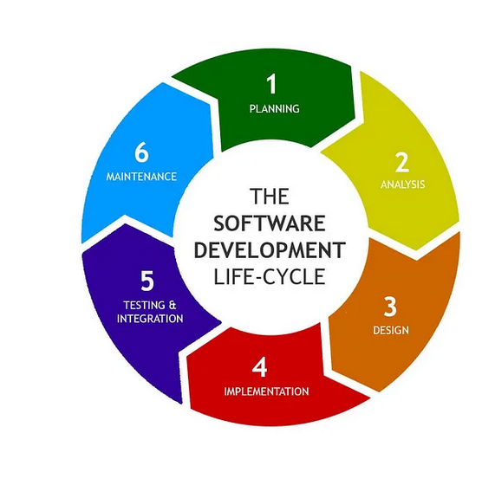

SDLC outlines lots of different tasks required to build software developers add new features and fix bugs it goes through much processing and planning. SDLC phases are below:

1. Requirement Gathering / Planning

2. Analysis

3. Designing

4. Implementation

5. Testing

6. Maintenance

### Requirement Gathering / Planning

In the planning phase, we gather resources and inquire about cost-benefit analysis, Scheduling, resource estimation, and allocation. The development team collects requirements like, who is going to use it, how is it going to be used, what information it will process, and give.

It requires team of experts, managers and schedule planner to plan everything. To create a detailed plan to achieve their goals.

### Analysis

Team will study market and collect facts, end-user requirement by documentation, client-interviews, and queries. Studying what’s already in market, its pros and cons. Finding problems, errors and recommending changes. User/ Customers’ needs and requirement. To make it consistent and complete.

### Designing

In this phase developers study requirement and needs of user to find best solution to create software. In designing multiple products design are present according to facts collected by analysis. Design is valued or judged by analysis and stakeholders. After evaluation most practical and logical design is chosen for development.

### Implementation

Now, the basic/ fundamental work of development starts. For this, developers use a particular programming code as per the design. Programmers need to follow rules set by the organization. At this stage, coders will start using compilers, interpreters, debuggers, and other programming tools for development. Languages like C, C++, Python, Java, etc. are used as per software requirements.

### Testing

After the development of the product, we need to test it, it’s a necessary step to ensure software execution is good without any problems. Even at every stage of SDLC testing is conducted, to make sure that all flows are tracked, fixed, and retested, and errors are solved. To make our software a good quality product.

### Maintenance

After all the testing is done, the final product is released as per scheduled time of organization. Then it’s tested in real real-time industry environment. It’s important to ensure that it runs smoothly. If it performs well, the organization will release it as a whole. After it will receive good feedback, the organization will continue to improve it.

### QUESTION 4: What is DFD? Create a DFD diagram on Flipkart

## ANSWER:

DFD means Data Flow Diagram. The data flow or process of the system is represented by DFD. Its graphical tool is useful for, communicating with users and managers. It is useful for analysing existing systems.

Components of DFD:

Process

Data Flow

Data Store

External Entity

DFD diagram on Flipkart:

### Level – 0 Data Flow Diagram on Flipkart

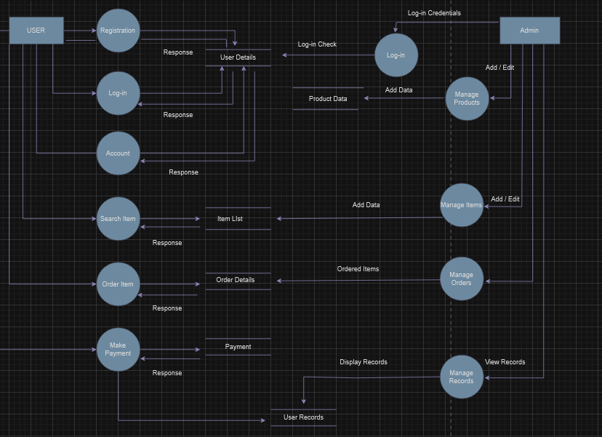

### Level – 1 Data Flow Diagram on Flipkart

### Level – 2 Data Flow Diagram on Flipkart

## 

### QUESTION 5: What is a Flow chart? Create a flowchart to make the addition of two numbers

## ANSWER:

Flow Chart: A flow chart is a Graphical representation of a step-by-step process of solving a particular problem.

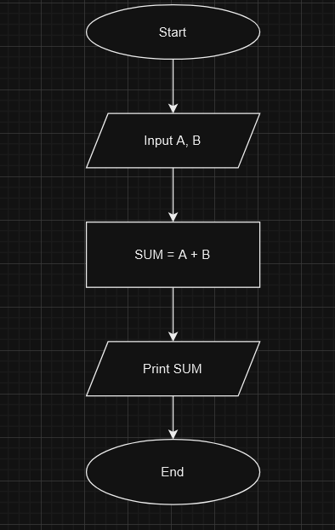

## Question 6: What is a Use case Diagram? Create a use case on bill payment on Paytm.

## Answers:

## A use case diagram is a sequence of actions performed by an actor.