**8. Design a webpage to maintain personal information using CRUD operations in MongoDB.**

**AIM:**

To design a webpage to maintain personal information using CRUD operations in MongoDB.

**CODE:**

**signup.html:**

<!DOCTYPE html>

<html lang="en">

<head>

<meta charset="utf-8">

<meta name="viewport" content="width=device-width, initial-scale=1">

<link rel="stylesheet" href="https://maxcdn.bootstrapcdn.com/bootstrap/3.4.1/css/bootstrap.min.css">

<script src="https://ajax.googleapis.com/ajax/libs/jquery/3.5.1/jquery.min.js"></script>

<script src="https://maxcdn.bootstrapcdn.com/bootstrap/3.4.1/js/bootstrap.min.js"></script>

<link rel="stylesheet"type="text/css"href="h41.css"/>

<link rel="stylesheet"type="text/css"href="h1.css"/>

<link rel="stylesheet"type="text/css"href="h3.css"/>

<link rel="stylesheet"type="text/css"href="h2.css"/>

<link rel="stylesheet"type="text/css"href="span.css"/>

<link rel="stylesheet"type="text/css"href="a1.css"/>

<link rel="stylesheet"type="text/css"href="jumbotron.css"/>

<link rel="stylesheet"type="text/css"href="body.css"/>

<title>Signup</title>

<style>

.head{

background-color:orange;

}

a:link {

color: #996515;

}

a:visited {

color: green;

}

a:hover {

color: red;

}

a:active {

color: yellow;

}

.navbar-custom{

background-color:#13CDDF;

}

.navbar-nav > li{

padding-left:30px;

padding-right:120px;

}

</style>

</head>

<body>

<div class="jumbotron text-center">Adventour in Malaysia</div><br>

<nav class="navbar navbar navbar-custom">

<div class="container-fluid">

<div class="navbar-header">

<button type="button" class="navbar-toggle" data-toggle="collapse" data-target="#myNavbar">

<span class="icon-bar"></span>

<span class="icon-bar"></span>

<span class="icon-bar"></span>

</button>

</div>

<div class="collapse navbar-collapse" id="myNavbar">

<ul class="nav navbar-nav">

<li><a href="index.html"><b>HOME</b></a></li>

<li><a href="places.html"><b>PLACES</b></a></li>

<li><a href="hotels.html"><b>HOTELS</b></a></li>

<li><a href="activities.html"><b>ACTIVITIES</b></a></li>

<li><a href="info.html"><b>MORE INFO</b></a></li>

</ul>

</div>

</div>

</nav>

<p><a href="login.html" style="color:pink">Back</a></p>

<h1><center>Please enter the following details to signup</center></h1><br>

<form method="post">

<fieldset>

<div class="head">

<h2><center>Personal Information</center></h2>

</div>

<div class="container">

<div class="row">

<div class="col-md-12">

<h3>Enter a userid:</h3>

<input type="text" id="uid" name="uid" required style="color:black"><br><br>

<h3>First Name:</h3>

<select id = "salutation" style="color:black">

<option value = "Mr.">Mr.</option>

<option value = "Ms.">Ms.</option>

<option value = "Mrs.">Mrs.</option>

<option value = "Dr.">Dr.</option>

</select>

<input type="text" id="fname" name="fname" required style="color:black"><br><br>

<h3>Last Name:</h3>

<input type="text" id="lname" name="lname" required style="color:black"><br><br>

<h3>Date of Birth:</h3>

<input type="date" id="dob" name="dob" required style="color:black"><br><br>

<h3>E-mail:</h3>

<input type="email" id="email" name="email" placeholder="abc@gmail.com" required style="color:black"><br><br>

<h3>Phone Number:</h3>

<input type="tel" id="tel" name="tel" pattern="[0-9]{10}" placeholder="Should contain 10 digits" required style="color:black"><br><br>

<h3>Country:</h3>

<input list="countries" name="country" id="country" required style="color:black">

<datalist id="countries">

<option value="Albania">

<option value="Britain">

<option value="India">

<option value="Japan">

<option value="South Korea">

<option value="United States of America">

</datalist><br><br>

<h3>City:</h3>

<input type="text" id="cname" name="cname" required style="color:black"><br><br>

<h3>Address:</h3>

<textarea rows="4" cols="50" required style="color:black"></textarea><br><br>

<h3>Do you have or had any of the following?</h3><br><br>

<input type="checkbox" name="disease" id="heart disease" style="color:black">

Heart disease<br>

<input type="checkbox" name="disease" id="eye disease" style="color:black">

Eye disease<br>

<input type="checkbox" name="disease" id="dermatologic" style="color:black">

Dermatologic<br>

<input type="checkbox" name="disease" id="gastrointestinal" style="color:black">

GastroIntestinal<br>

<input type="checkbox" name="disease" id="gyenecological" style="color:black">

Gyenecological<br><br>

<h3>Allergies if any:</h3>

<input list="allergy" name="allergies" id="allergies" style="color:black">

<datalist id="allergy">

<option value="Skin">

<option value="Drug">

<option value="Food">

<option value="Insect">

<option value="Pet">

<option value="Pollen">

</datalist>

<div class="head">

<h2><center>Login Information</center></h2>

</div>

<h3>Username:</h3>

<input type="text" id="uname" name="uname" required style="color:black"><br><br>

<h3>Password:</h3>

<input type="password" id="pwd" name="pwd" required style="color:black"><br><br>

<center>

<input type="submit" name="signup" value="Sign up" style="color:black" formaction="http://localhost:3000/signup"/>

<input type="submit" name="signup" value="Save" style="color:black" formaction="http://localhost:3000/save"/>

<input type="reset" value="Reset" style="color:black"/></center>

</h3>

</fieldset>

</form>

</div>

</div>

</div>

<br>

<div class="col-sm-12">

<h4><hr><center><b>&copy;Developed by M.V.Priyadharsini-18ITR077</b></center></h4><hr>

</div>

</body>

</html>

**server.js**

var module = require('./dbmodule');

var url = require('url');

var querystring1 = require('querystring');

var http = require('http');

http.createServer(function(request, response) {

var data1 = '';

if (request.url === '/favicon.ico') {

response.writeHead(200, { 'Content-Type': 'image/x-icon' });

response.end();

}

else

{

request.on('data', function(chunk) {

data1 += chunk;

});

request.on('end', function() {

var uid1 = querystring1.parse(data1)["uid"];

console.log(uid1);

var name = querystring1.parse(data1)["uname"];

console.log(name);

var pass = querystring1.parse(data1)["pwd"];

console.log(pass);

var fname = querystring1.parse(data1)["fname"];

var lname = querystring1.parse(data1)["lname"];

var mail = querystring1.parse(data1)['email'];

if (request.url === '/signup') {

module.authenticateUser(uid1,name, pass, fname, lname,mail,response);

} else if (request.url === '/save') {

module.saveUser(uid1,name, pass,response);

response.write("User saved");

} else {

console.log("invalid url");

}

});

}

}).listen(3000);

console.log("Server started");

**dbmodule.js**

var databaseUrl = "localhost/mydb2";

var mongojs = require("./node_modules/mongojs");

var db = mongojs(databaseUrl);

db.collection("usersignup");

console.log("Connected");

exports.authenticateUser = function(uid,uname, pwd, fname, lname, mail, response) {

console.log(uid);

console.log(uname);

console.log(pwd);

db.usersignup.find({"_id":uid, "Username": uname, "Password": pwd },

function(err, users) {

if (err || !users) {

response.write("..Not authorized user" || err);

response.end();

} else if (users.length == 0) {

response.write("Not authorized user");

response.end();

} else {

res.write('<body bgcolor="#0E035F" style="color:white">');

response.write('<center>');

response.write("Authorized user")

response.write('<h3>Welcome '+fname+ ' '+lname+'</h3>');

response.write('<h3>Your email id '+mail+' has been registered successfully.</h3>');

response.write('<h3>Your username is: '+uname+'</h3>');

response.write('<h3>Your password is: '+pwd+'</h3>');

response.write('<h3>Thank you for registering!Please login before exploring our website</h3>')

response.write('</center>');

response.write('</body');

response.end();

}

});

}

exports.saveUser = function(uid, uname, pwd, response) {

console.log('Saving user to mongo');

db.usersignup.insert({ "_id":uid,"Username": uname, "Password": pwd },

function(err, saved) {

if (err || !saved)

console.log(err);

else

console.log("User saved");

});

}

**OUTPUT:**

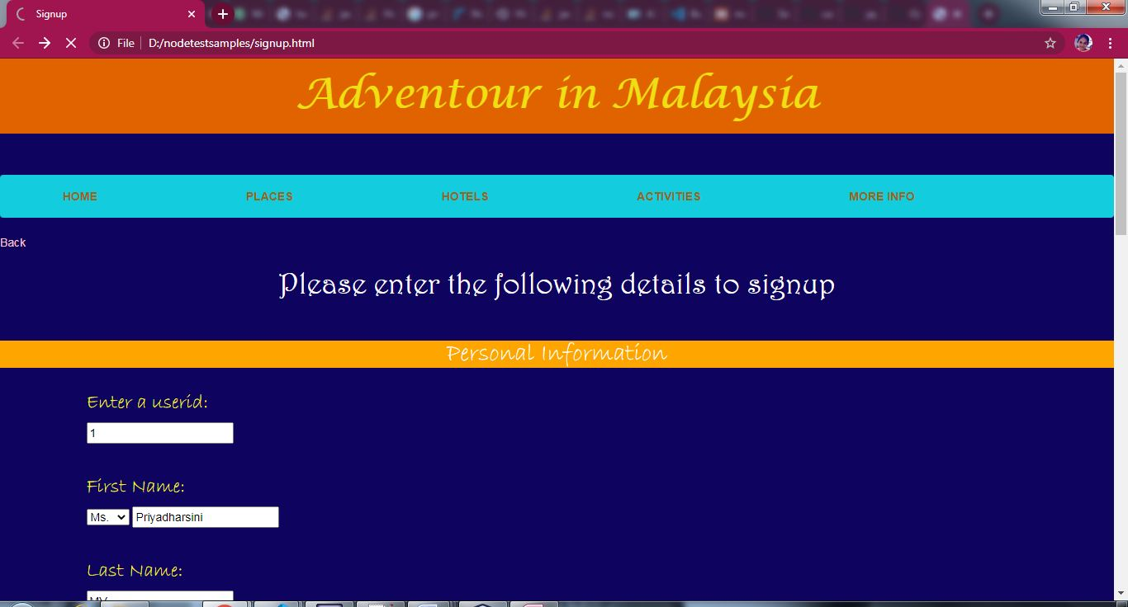

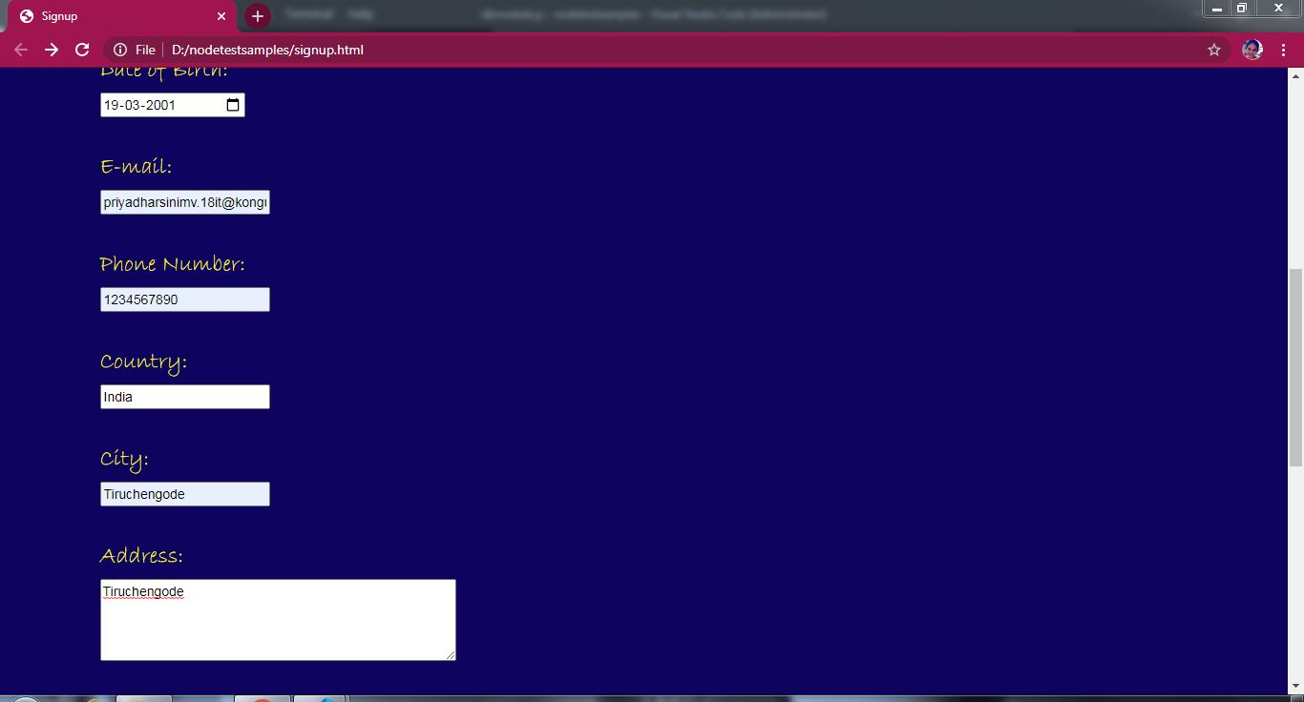

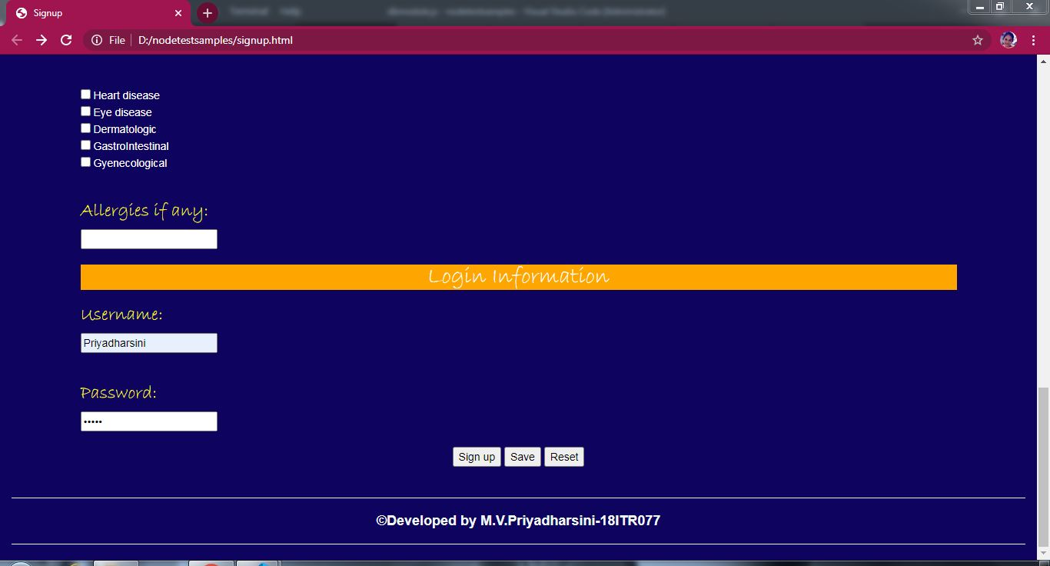

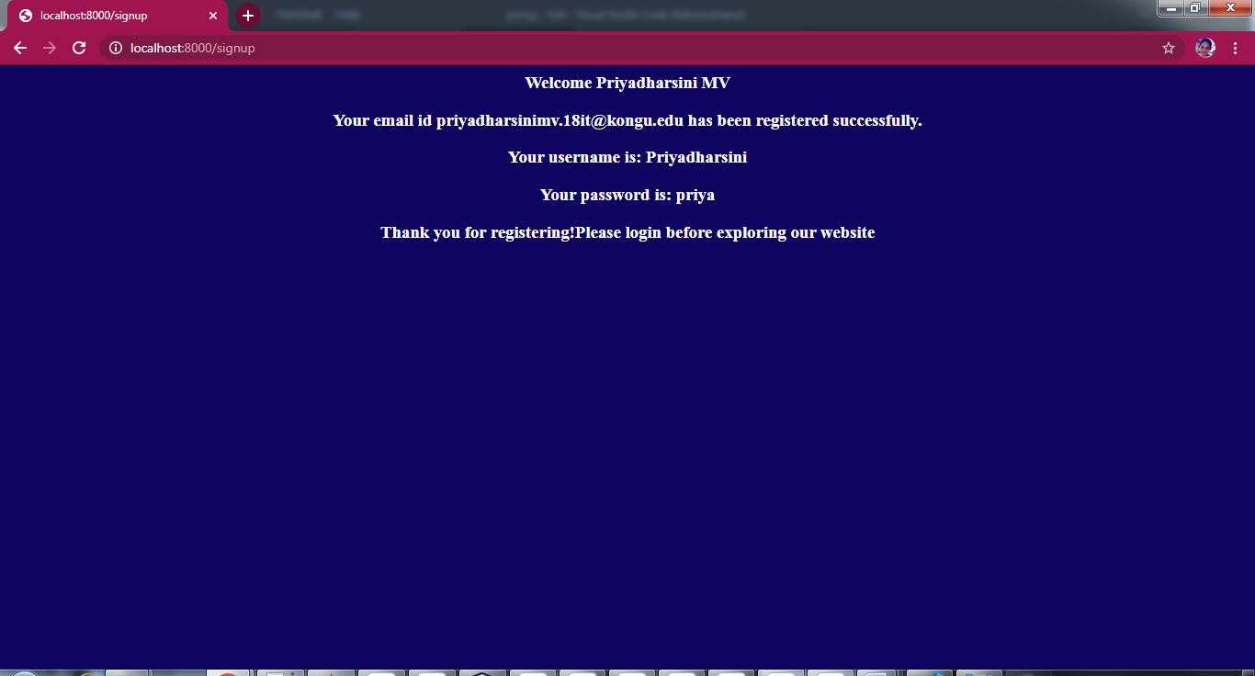

**Insert:**

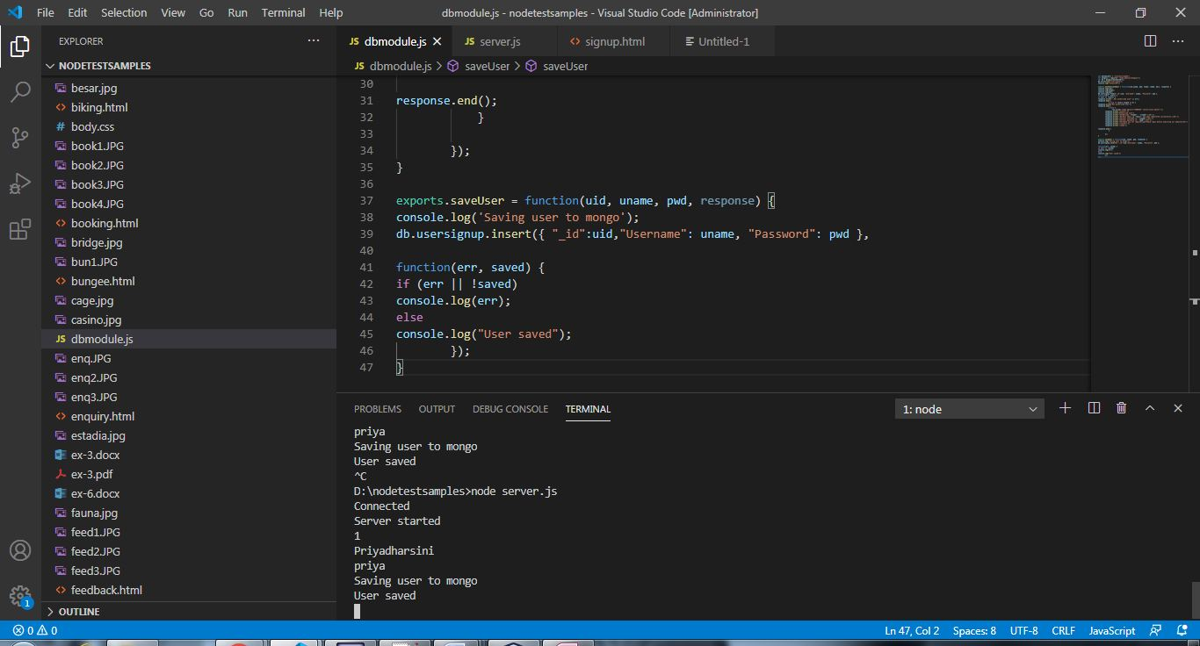

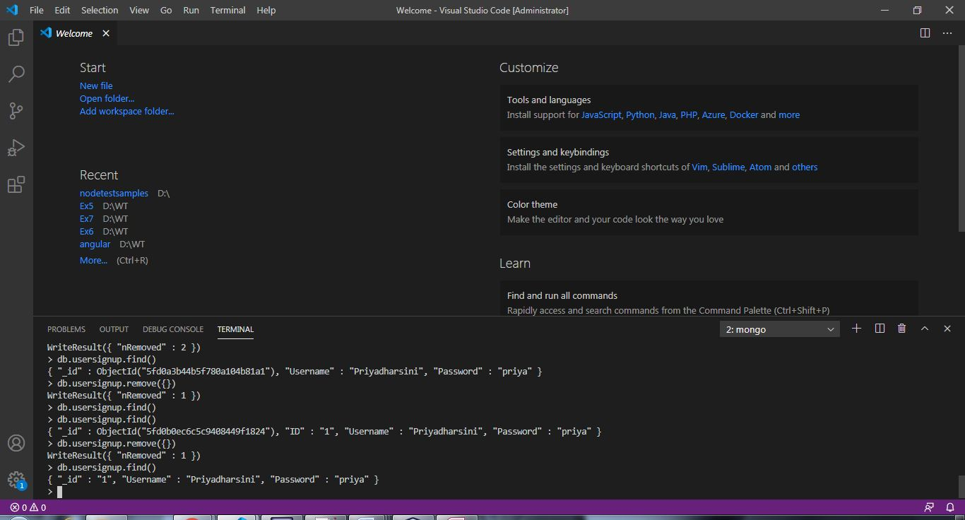

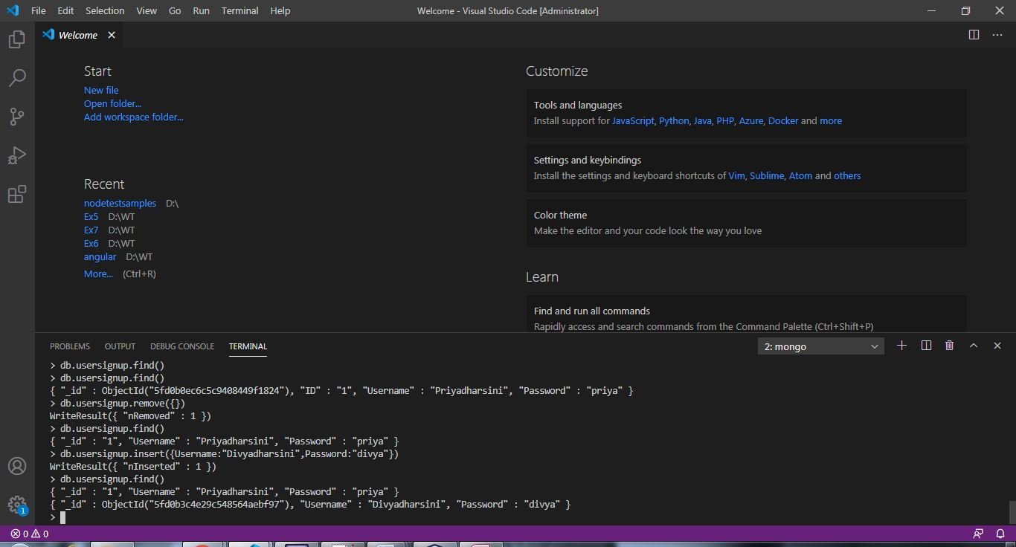

**Delete:**

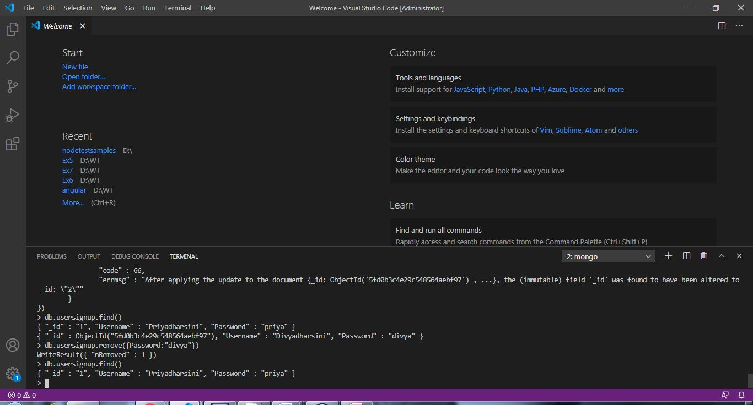

**Find:**

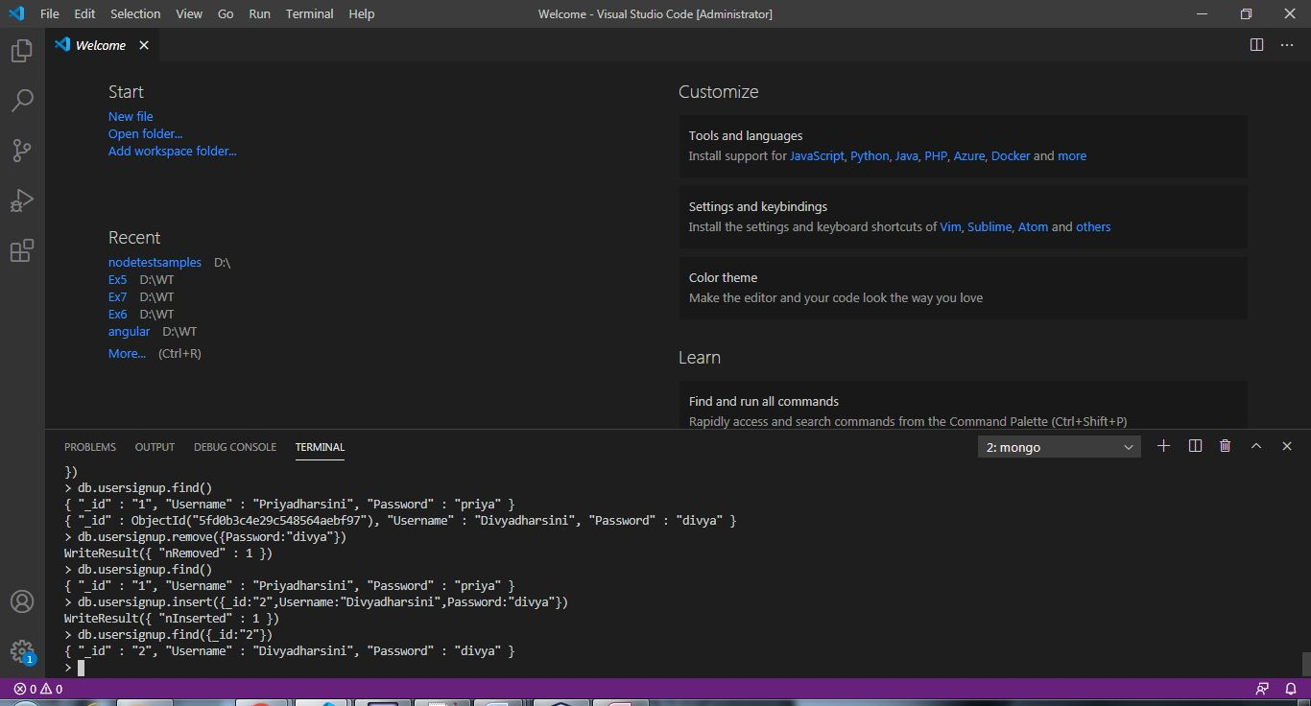

**Update:**

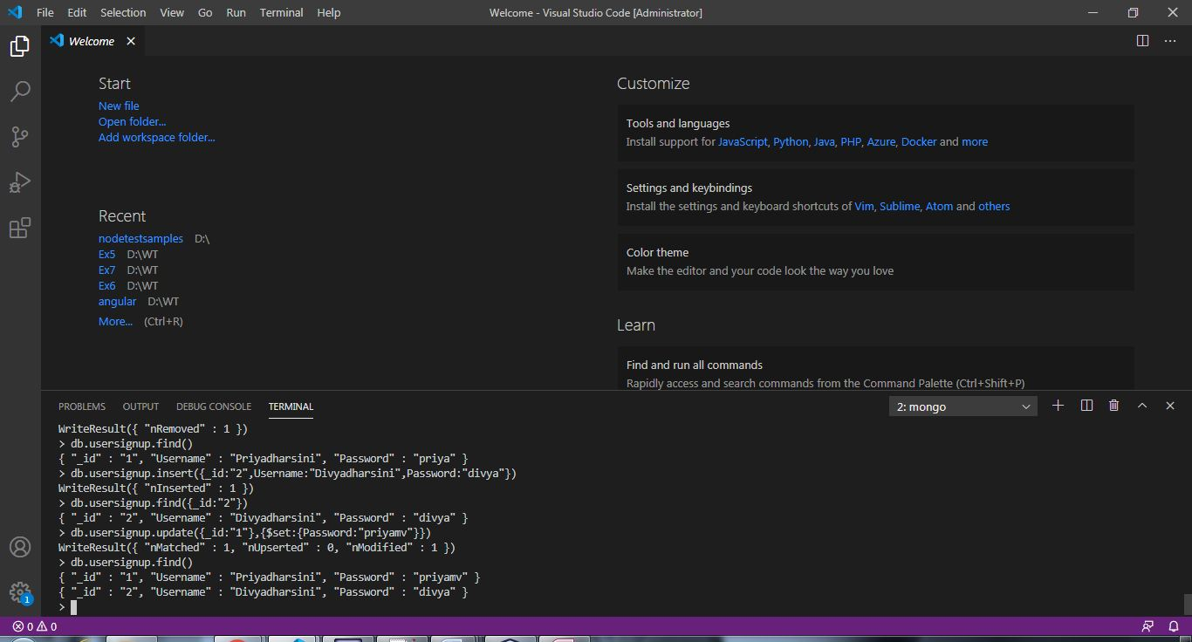

**RESULT:**

Thus the webpage to maintain personal information using CRUD operations in MongoDB has been designed successfully.