**6. Develop simple login page by performing event handling using GET and POST method**

**AIM:**

To develop a simple login page by performing event handling using GET and POST method.

**CODE:**

**GET:**

**Signup.html:**

<!DOCTYPE html>

<html lang="en">

<head>

<meta charset="utf-8">

<meta name="viewport" content="width=device-width, initial-scale=1">

<link rel="stylesheet" href="https://maxcdn.bootstrapcdn.com/bootstrap/3.4.1/css/bootstrap.min.css">

<script src="https://ajax.googleapis.com/ajax/libs/jquery/3.5.1/jquery.min.js"></script>

<script src="https://maxcdn.bootstrapcdn.com/bootstrap/3.4.1/js/bootstrap.min.js"></script>

<link rel="stylesheet"type="text/css"href="h41.css"/>

<link rel="stylesheet"type="text/css"href="h1.css"/>

<link rel="stylesheet"type="text/css"href="h3.css"/>

<link rel="stylesheet"type="text/css"href="h2.css"/>

<link rel="stylesheet"type="text/css"href="span.css"/>

<link rel="stylesheet"type="text/css"href="a1.css"/>

<link rel="stylesheet"type="text/css"href="jumbotron.css"/>

<link rel="stylesheet"type="text/css"href="body.css"/>

<title>Signup</title>

<style>

.head{

background-color:orange;

}

a:link {

color: #996515;

}

a:visited {

color: green;

}

a:hover {

color: red;

}

a:active {

color: yellow;

}

.navbar-custom{

background-color:#13CDDF;

}

.navbar-nav > li{

padding-left:30px;

padding-right:120px;

}

</style>

</head>

<body>

<div class="jumbotron text-center">Adventour in Malaysia</div><br>

<nav class="navbar navbar navbar-custom">

<div class="container-fluid">

<div class="navbar-header">

<button type="button" class="navbar-toggle" data-toggle="collapse" data-target="#myNavbar">

<span class="icon-bar"></span>

<span class="icon-bar"></span>

<span class="icon-bar"></span>

</button>

</div>

<div class="collapse navbar-collapse" id="myNavbar">

<ul class="nav navbar-nav">

<li><a href="index.html"><b>HOME</b></a></li>

<li><a href="places.html"><b>PLACES</b></a></li>

<li><a href="hotels.html"><b>HOTELS</b></a></li>

<li><a href="activities.html"><b>ACTIVITIES</b></a></li>

<li><a href="info.html"><b>MORE INFO</b></a></li>

</ul>

</div>

</div>

</nav>

<p><a href="login.html" style="color:pink">Back</a></p>

<h1><center>Please enter the following details to signup</center></h1><br>

<form method="get" action="http://localhost:8000/signup">

<fieldset>

<div class="head">

<h2><center>Personal Information</center></h2>

</div>

<div class="container">

<div class="row">

<div class="col-md-12">

<h3>First Name:</h3>

<select id = "salutation" style="color:black">

<option value = "Mr.">Mr.</option>

<option value = "Ms.">Ms.</option>

<option value = "Mrs.">Mrs.</option>

<option value = "Dr.">Dr.</option>

</select>

<input type="text" id="fname" name="fname" required style="color:black"><br><br>

<h3>Last Name:</h3>

<input type="text" id="lname" name="lname" required style="color:black"><br><br>

<h3>Date of Birth:</h3>

<input type="date" id="dob" name="dob" required style="color:black"><br><br>

<h3>E-mail:</h3>

<input type="email" id="email" name="email" placeholder="abc@gmail.com" required style="color:black"><br><br>

<h3>Phone Number:</h3>

<input type="tel" id="tel" name="tel" pattern="[0-9]{10}" placeholder="Should contain 10 digits" required style="color:black"><br><br>

<h3>Country:</h3>

<input list="countries" name="country" id="country" required style="color:black">

<datalist id="countries">

<option value="Albania">

<option value="Britain">

<option value="India">

<option value="Japan">

<option value="South Korea">

<option value="United States of America">

</datalist><br><br>

<h3>City:</h3>

<input type="text" id="cname" name="cname" required style="color:black"><br><br>

<h3>Address:</h3>

<textarea rows="4" cols="50" required style="color:black"></textarea><br><br>

<h3>Do you have or had any of the following?</h3><br><br>

<input type="checkbox" name="disease" id="heart disease" style="color:black">

Heart disease<br>

<input type="checkbox" name="disease" id="eye disease" style="color:black">

Eye disease<br>

<input type="checkbox" name="disease" id="dermatologic" style="color:black">

Dermatologic<br>

<input type="checkbox" name="disease" id="gastrointestinal" style="color:black">

GastroIntestinal<br>

<input type="checkbox" name="disease" id="gyenecological" style="color:black">

Gyenecological<br><br>

<h3>Allergies if any:</h3>

<input list="allergy" name="allergies" id="allergies" style="color:black">

<datalist id="allergy">

<option value="Skin">

<option value="Drug">

<option value="Food">

<option value="Insect">

<option value="Pet">

<option value="Pollen">

</datalist>

<div class="head">

<h2><center>Login Information</center></h2>

</div>

<h3>Username:</h3>

<input type="text" id="uname" name="uname" required style="color:black"><br><br>

<h3>Password:</h3>

<input type="password" id="pwd" name="pwd" required style="color:black"><br><br>

<center><input type="submit" value="Submit" name="signup" style="color:black"/>&ensp;&ensp;<input type="reset" value="Reset" style="color:black"/></center>

</h3>

</fieldset>

</form>

</div>

</div>

</div>

<br>

<div class="col-sm-12">

<h4><hr><center><b>&copy;Developed by M.V.Priyadharsini-18ITR077</b></center></h4><hr>

</div>

</body>

</html>

**get.js**

http = require('http');

url = require('url');

querystring = require('querystring');

function onRequest(request,response)

{

var path = url.parse(request.url).pathanme;

console.log('Request for'+path+'received.');

var query = url.parse(request.url).query;

console.log(query);

var name1 = querystring.parse(query)["fname"];

var name2 = querystring.parse(query)["lname"];

var mail = querystring.parse(query)["email"];

var name3 = querystring.parse(query)["uname"];

var pass = querystring.parse(query)["pwd"];

response.write('<body bgcolor="#0E035F" style="color:white">');

response.write('<center>');

response.write('<h3>Welcome '+name1+ ' '+name2+'</h3>');

response.write('<h3>Your email id '+mail+' has been registered successfully.</h3>');

response.write('<h3>Your username is: '+name3+'</h3>');

response.write('<h3>Your password is: '+pass+'</h3>');

response.write('<h3>Thank you for registering!Please login before exploring our website</h3>')

response.write('</center>');

response.write('</body');

response.end();

}

http.createServer(onRequest).listen(8000);

console.log('Server has started.... .');

**OUTPUT:**

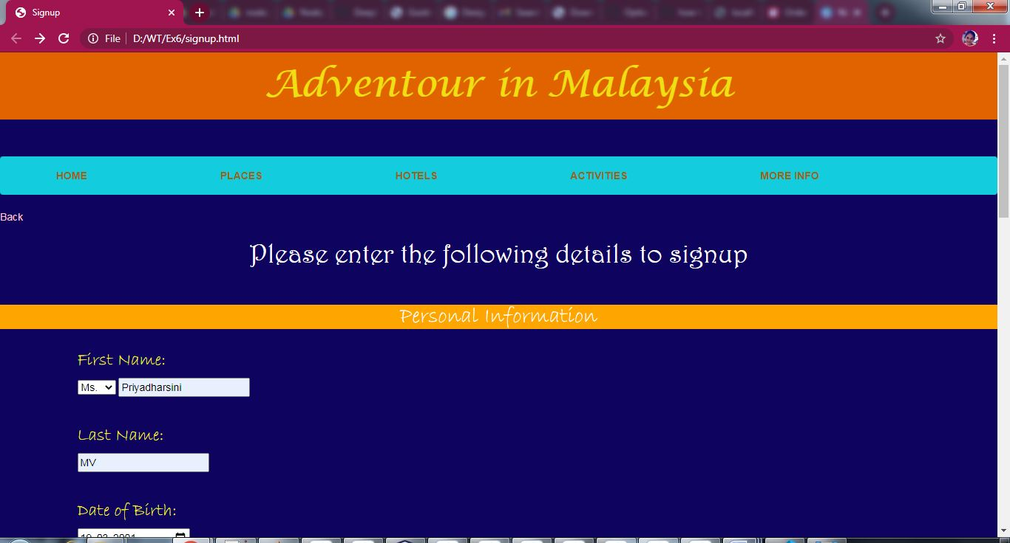

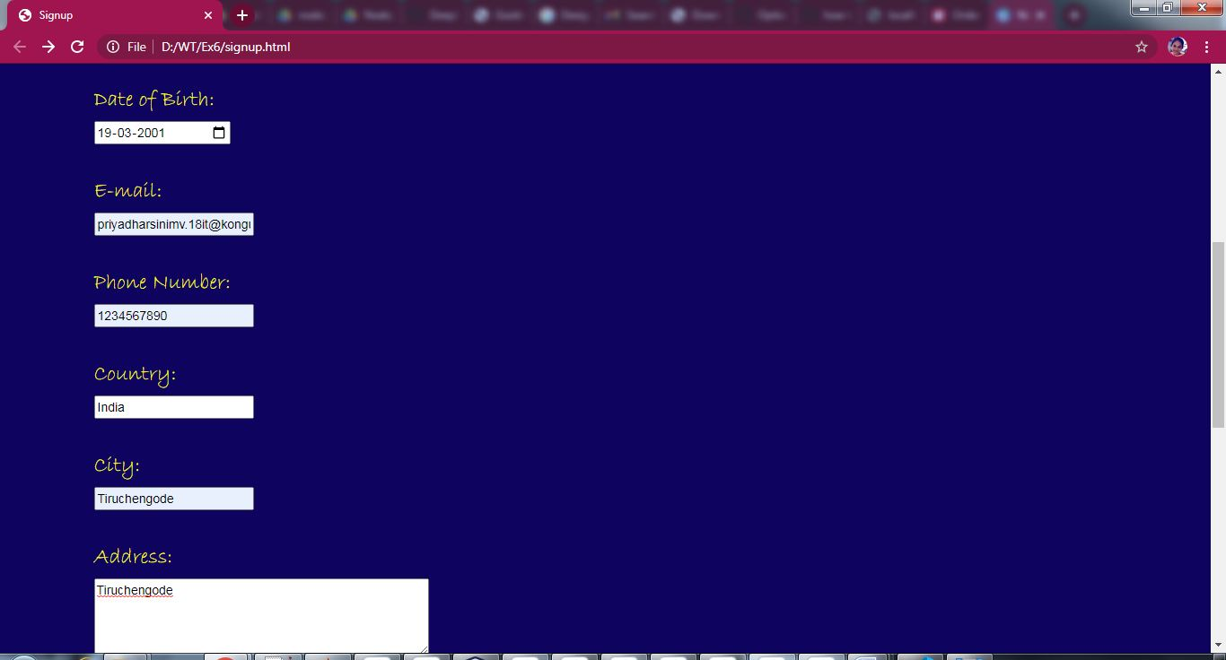

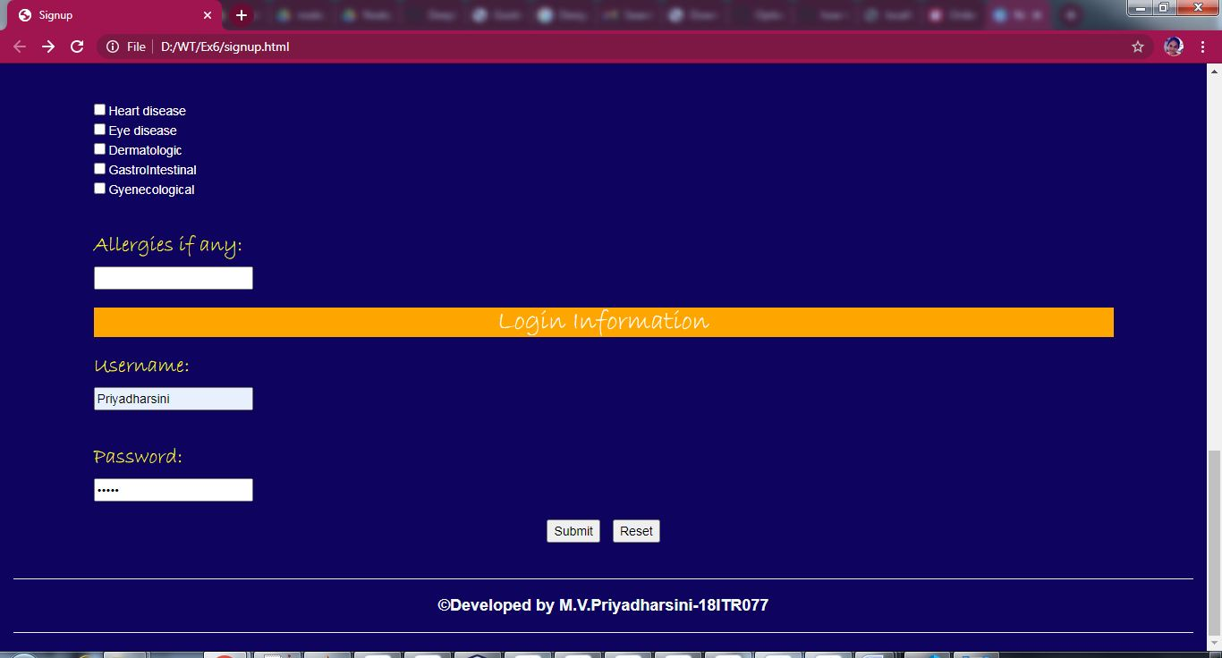

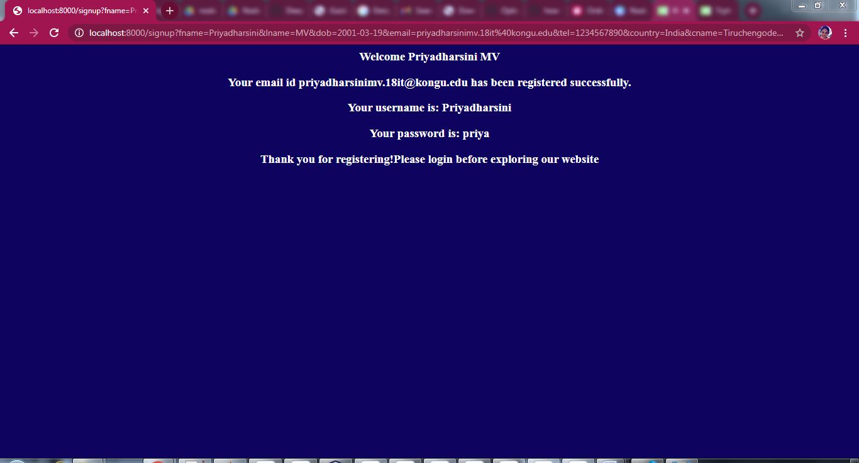

**POST:**

**signup.html:**

<!DOCTYPE html>

<html lang="en">

<head>

<meta charset="utf-8">

<meta name="viewport" content="width=device-width, initial-scale=1">

<link rel="stylesheet" href="https://maxcdn.bootstrapcdn.com/bootstrap/3.4.1/css/bootstrap.min.css">

<script src="https://ajax.googleapis.com/ajax/libs/jquery/3.5.1/jquery.min.js"></script>

<script src="https://maxcdn.bootstrapcdn.com/bootstrap/3.4.1/js/bootstrap.min.js"></script>

<link rel="stylesheet"type="text/css"href="h41.css"/>

<link rel="stylesheet"type="text/css"href="h1.css"/>

<link rel="stylesheet"type="text/css"href="h3.css"/>

<link rel="stylesheet"type="text/css"href="h2.css"/>

<link rel="stylesheet"type="text/css"href="span.css"/>

<link rel="stylesheet"type="text/css"href="a1.css"/>

<link rel="stylesheet"type="text/css"href="jumbotron.css"/>

<link rel="stylesheet"type="text/css"href="body.css"/>

<title>Signup</title>

<style>

.head{

background-color:orange;

}

a:link {

color: #996515;

}

a:visited {

color: green;

}

a:hover {

color: red;

}

a:active {

color: yellow;

}

.navbar-custom{

background-color:#13CDDF;

}

.navbar-nav > li{

padding-left:30px;

padding-right:120px;

}

</style>

</head>

<body>

<div class="jumbotron text-center">Adventour in Malaysia</div><br>

<nav class="navbar navbar navbar-custom">

<div class="container-fluid">

<div class="navbar-header">

<button type="button" class="navbar-toggle" data-toggle="collapse" data-target="#myNavbar">

<span class="icon-bar"></span>

<span class="icon-bar"></span>

<span class="icon-bar"></span>

</button>

</div>

<div class="collapse navbar-collapse" id="myNavbar">

<ul class="nav navbar-nav">

<li><a href="index.html"><b>HOME</b></a></li>

<li><a href="places.html"><b>PLACES</b></a></li>

<li><a href="hotels.html"><b>HOTELS</b></a></li>

<li><a href="activities.html"><b>ACTIVITIES</b></a></li>

<li><a href="info.html"><b>MORE INFO</b></a></li>

</ul>

</div>

</div>

</nav>

<p><a href="login.html" style="color:pink">Back</a></p>

<h1><center>Please enter the following details to signup</center></h1><br>

<form method="post" action="http://localhost:8000/signup">

<fieldset>

<div class="head">

<h2><center>Personal Information</center></h2>

</div>

<div class="container">

<div class="row">

<div class="col-md-12">

<h3>First Name:</h3>

<select id = "salutation" style="color:black">

<option value = "Mr.">Mr.</option>

<option value = "Ms.">Ms.</option>

<option value = "Mrs.">Mrs.</option>

<option value = "Dr.">Dr.</option>

</select>

<input type="text" id="fname" name="fname" required style="color:black"><br><br>

<h3>Last Name:</h3>

<input type="text" id="lname" name="lname" required style="color:black"><br><br>

<h3>Date of Birth:</h3>

<input type="date" id="dob" name="dob" required style="color:black"><br><br>

<h3>E-mail:</h3>

<input type="email" id="email" name="email" placeholder="abc@gmail.com" required style="color:black"><br><br>

<h3>Phone Number:</h3>

<input type="tel" id="tel" name="tel" pattern="[0-9]{10}" placeholder="Should contain 10 digits" required style="color:black"><br><br>

<h3>Country:</h3>

<input list="countries" name="country" id="country" required style="color:black">

<datalist id="countries">

<option value="Albania">

<option value="Britain">

<option value="India">

<option value="Japan">

<option value="South Korea">

<option value="United States of America">

</datalist><br><br>

<h3>City:</h3>

<input type="text" id="cname" name="cname" required style="color:black"><br><br>

<h3>Address:</h3>

<textarea rows="4" cols="50" required style="color:black"></textarea><br><br>

<h3>Do you have or had any of the following?</h3><br><br>

<input type="checkbox" name="disease" id="heart disease" style="color:black">

Heart disease<br>

<input type="checkbox" name="disease" id="eye disease" style="color:black">

Eye disease<br>

<input type="checkbox" name="disease" id="dermatologic" style="color:black">

Dermatologic<br>

<input type="checkbox" name="disease" id="gastrointestinal" style="color:black">

GastroIntestinal<br>

<input type="checkbox" name="disease" id="gyenecological" style="color:black">

Gyenecological<br><br>

<h3>Allergies if any:</h3>

<input list="allergy" name="allergies" id="allergies" style="color:black">

<datalist id="allergy">

<option value="Skin">

<option value="Drug">

<option value="Food">

<option value="Insect">

<option value="Pet">

<option value="Pollen">

</datalist>

<div class="head">

<h2><center>Login Information</center></h2>

</div>

<h3>Username:</h3>

<input type="text" id="uname" name="uname" required style="color:black"><br><br>

<h3>Password:</h3>

<input type="password" id="pwd" name="pwd" required style="color:black"><br><br>

<center><input type="submit" value="Submit" name="signup" style="color:black"/>&ensp;&ensp;<input type="reset" value="Reset" style="color:black"/></center>

</h3>

</fieldset>

</form>

</div>

</div>

</div>

<br>

<div class="col-sm-12">

<h4><hr><center><b>&copy;Developed by M.V.Priyadharsini-18ITR077</b></center></h4><hr>

</div>

</body>

</html>

**post.js:**

var http = require('http');

var querystring = require('querystring');

var qs,name1,name2,name3,mail,pass;

http.createServer(function(req,res)

{

var data1 = '';

req.on('data',function(chunk){

console.log(chunk);

data1 += chunk;

console.log("Data in String format: "+data1);

});

req.on('end',function(){

qs = querystring.parse(data1);

console.log(qs);

name1 = qs['fname'];

name2 = qs['lname'];

name3 = qs['uname'];

mail = qs['email'];

pass = qs['pwd'];

res.write('<body bgcolor="#0E035F" style="color:white">');

res.write('<center>');

res.write('<h3>Welcome '+name1+ ' '+name2+'</h3>');

res.write('<h3>Your email id '+mail+' has been registered successfully.</h3>');

res.write('<h3>Your username is: '+name3+'</h3>');

res.write('<h3>Your password is: '+pass+'</h3>');

res.write('<h3>Thank you for registering!Please login before exploring our website</h3>')

res.write('</center>');

res.write('</body');

res.end();

});

}).listen(8000);

console.log("Server started");

**OUTPUT:**







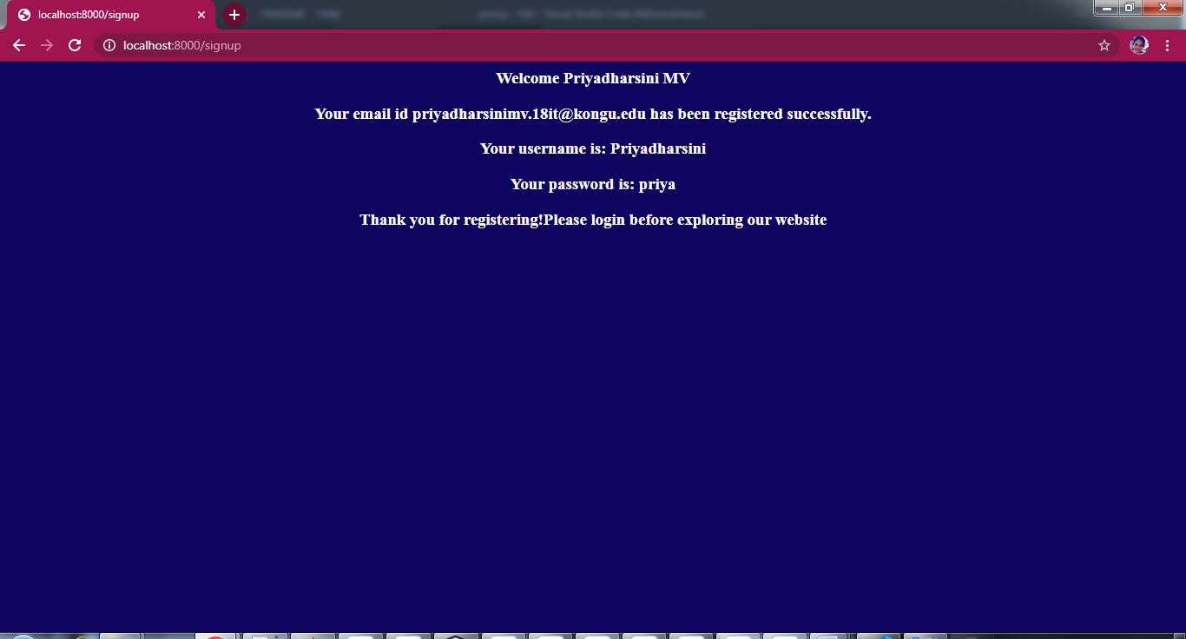

**RESULT:**

Thus the webpage to perform event handling using get and post method has been designed successfully