Log Management Dashboard
Overview
Log Management Dashboard is a web-based application designed for Security Engineers. It allows to upload, store, search, filter, sort, and paginate audit logs using a React frontend, Express.js backend, and MongoDB database.

Features
• A bulk upload API that accepts and stores 10,000 log records in a single request
• Dashboard to view stored logs
• Server-side pagination
• Server-side search
• Server-side filtering
• Server-side sorting

Technology Stack
Frontend:
- React
- Bootstrap
Backend:
- Node.js
- Express.js
Database:
- MongoDB Atlas

Frontend Design

The frontend is built using React with a modular structure:
- Components: Reusable UI elements (LogTable, Pagination)
- Pages: Main views (Dashboard)
- Hooks: Custom logic (data fetching using useLogs)
- API Layer: Handles HTTP requests

Backend Integration

Frontend fetches data using REST API:
- GET /api/logs?page=1&limit=10

Database Design (MongoDB)
Logs are stored in MongoDB with fields such as:
- actor
- action
- severity
- timestamp

Data Flow
- User opens dashboard
- Frontend sends API request
- Backend processes request
- MongoDB returns log data
- Backend sends response
- Frontend updates UI

Setup Instructions
- Clone the project from GitHub
  - git clone https://github.com/Priya-2508/Gidy-Full-Stack-Exercise
  - cd project-folder
- Install dependencies
  - npm install
- Setup MongoDB Atlas
- Create MongoDB Atlas account
- Create cluster
- Copy connection string
- Configure environment variables
  - Create .env file
  - Paste MongoDB connection string
Example:
MONGO_URI=mongodb+srv://username@cluster0.mongodb.net/myDatabase
- Run backend
Run generateLogs.js to generate 10,000 logs -> it will generate logs.json
  - node generateLogs.js
  - npm start

Upload logs.json via postman

- Run frontend
  - npm run dev
- Open browser
  - http://localhost:5173

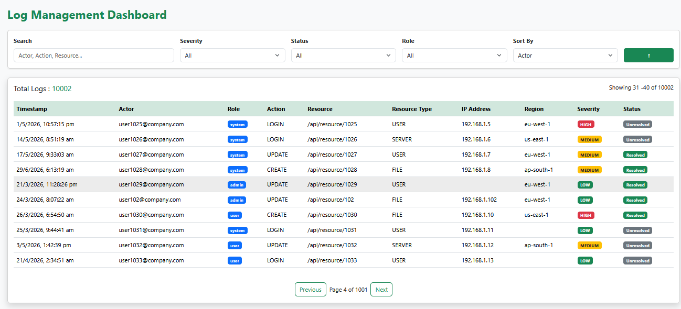
Screenshot

