/****************************************************************************/

**Assignment #1**

**Course:** *Advanced Java Programming - ITE-5215-0NB - Semester 2*

**Last Name:** *Pillarisetty*

**First Name:** *Tejeswi Devi Priya Pillarisetty*

**ID:** *N01654962*

**Section:** *0NB*

*This assignment represents my own work in accordance with Humber Academic Policy.*

***Signature:*** *Tejeswi Devi Priya Pillarisetty*

**Date:** *5th June 2024*

/****************************************************************************/

**Task 1:**

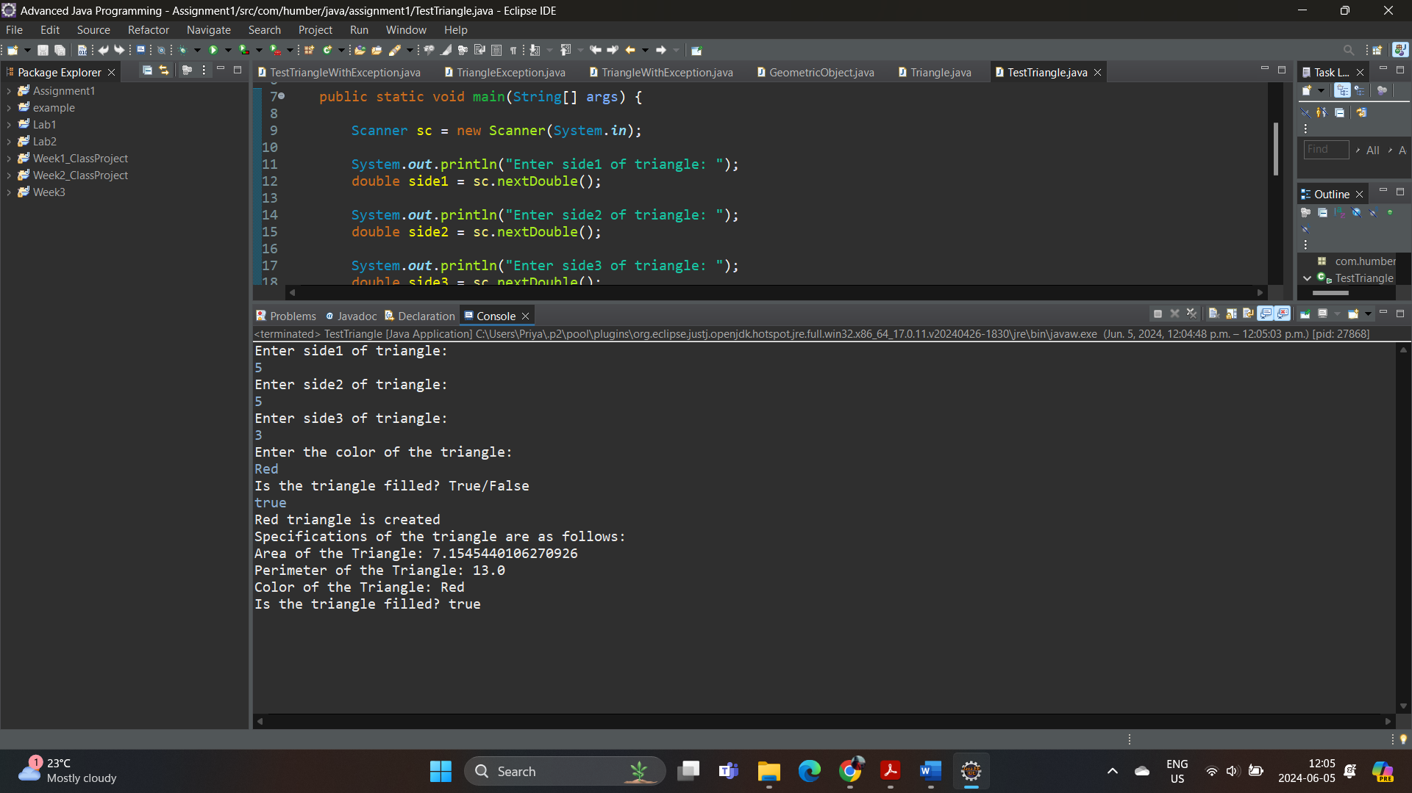

**Task 2:**

