DEEP LEARNING BASED VIRTUAL WHITEBOARD
USING HAND GESTURE RECOGNITION
PROJECT DOCUMENTATION
Department of Artificial Intelligence and Data Science
Academic Year 2026 – 2027

Submitted by
1. LATHIKA M– 24BAD062
2. PREETHI R – 24BAD091
3. PRIYA DHARSHINI R – 24BAD092
4. SREENIDHI S – 24BAD114

1. Abstract
This project is a virtual whiteboard that you control with your hand instead of a mouse, a marker or a touchscreen. A normal webcam watches the user, and the software works out what the hand is doing and turns that into drawing actions on the screen. Nothing has to be touched.
OpenCV is used to read the video frames and MediaPipe finds the hand and gives us its 21 landmark points. These points are passed to a Convolutional Neural Network (CNN) that we trained to recognise different hand gestures. Depending on the gesture, the program draws, selects, moves, resizes, erases or fills an object.
We also trained a second CNN for shape recognition. If a user draws a rough circle, square, rectangle or triangle, selects it and holds the SmartShape gesture for about a second, the program recognises the shape and replaces the shaky drawing with a clean one. The whiteboard has a 12-colour palette, undo, redo, a clear option and it can save the final drawing as a PNG image on a black background, without the webcam picture or the hand in it.
The project puts computer vision, hand tracking and deep learning together in one application that could be useful for teaching, presentations and demonstrations.

2. Introduction
A virtual whiteboard is a digital version of the board we see in classrooms. Instead of writing with a marker, the user draws on a screen and can edit, move or delete what they have drawn. This is quite common now, especially in online classes and meetings.
Most of these tools still depend on a mouse, a stylus or a touchscreen. Drawing with a mouse is not very natural, because it is hard to write or sketch properly with it, and touchscreens need special hardware. A physical whiteboard, on the other hand, needs markers, a duster and a surface, and whatever is written on it cannot be saved or edited easily.
We wanted to see if a normal laptop webcam is enough to solve this. In our system the user simply raises a hand in front of the camera and uses the index finger like a marker. Different hand poses are used for different tools, so the user can move from drawing to erasing to selecting without touching anything.
Three main technologies are used in the project:
- Computer vision: to capture and process the webcam frames.
- Hand tracking: MediaPipe detects the hand and its 21 landmarks in every frame.
- Deep learning: two CNN models, one for gestures and one for shapes.

2.1 Why this project
The reasons we chose this project are listed below.
- To reduce the need for physical whiteboards and markers.
- To let the user control a drawing board without touching any device.
- To make drawing, moving and editing objects easier and more natural.
- To clean up freehand shapes so they look like proper geometric shapes.
- To store the finished drawing digitally.
- To apply what we learned about deep learning in a practical computer vision application.

3. Problem Statement and Objectives

3.1 Problem statement
Physical whiteboards need markers and a surface, mouse-based drawing tools give only indirect control, and touchscreen tools need touch-enabled hardware. On top of that, shapes drawn by hand are rarely accurate, especially in the air without any surface to rest on.
The aim of this project is to build a real-time, webcam-based virtual whiteboard that recognises hand gestures using deep learning. The user should be able to draw, select, move, resize, erase and fill drawings, and the system should correct rough freehand shapes into circles, squares, rectangles and triangles, all without physical contact.

3.2 Objectives
- To build a real-time drawing environment that works with an ordinary webcam.
- To recognise hand gestures using a trained CNN model.
- To allow drawing and object manipulation through hand movements.
- To recognise freehand shapes and correct them automatically.
- To provide colour filling and basic canvas management.
- To provide undo, redo and clear functions.
- To save the completed drawing as a PNG image.

4. Technologies Used

4.1 Computer vision and OpenCV
Computer vision is the area of artificial intelligence that deals with making computers understand images and video. In this project OpenCV does most of the image work: it opens the webcam, flips and resizes each frame, converts colour formats, draws lines, circles and buttons, finds the contours of drawings, and writes the final image to disk.

4.2 MediaPipe hand tracking
MediaPipe is a framework from Google that can detect a hand in real time and mark 21 landmarks on it, covering the wrist, the finger joints and the fingertips. Each landmark has an X, Y and Z value. We use these numbers as the input for gesture recognition, and the index fingertip position is also used as the “pen” on the canvas.

4.3 Convolutional Neural Networks
A CNN is a type of neural network that is widely used for classification problems. Two trained CNN models are used in this project:
- Gesture CNN: takes the hand landmark coordinates and predicts which gesture the user is showing.
- Shape CNN: takes a small 28 × 28 grayscale image of a drawing and predicts whether it is a circle, square, rectangle or triangle.

4.4 TensorFlow, Keras and NumPy
TensorFlow and Keras are used to load the trained models and run the predictions while the application is running. NumPy is used for the array operations, such as storing landmark values, handling the drawing layers and doing the maths for movement and scaling.

5. System Requirements and Architecture

5.1 Hardware requirements
- A computer or laptop.
- A webcam to capture the hand movements.
- A processor that can run Python, OpenCV and the deep learning models smoothly.
- Enough RAM to hold the application and the two models.

5.2 Software requirements
Software / Library | Purpose
Python | Main programming language
OpenCV | Webcam capture and image processing
MediaPipe | Hand detection and landmark extraction
TensorFlow | Loading and running the trained models
Keras | Building the CNN models
NumPy | Numerical and array operations
collections (deque) | Keeping the recent gesture prediction history
os and time | File handling and unique names for saved images

5.3 System architecture
The system works as a loop. Every frame from the webcam goes through the same stages: the hand is detected, the landmarks are extracted and normalised, the Gesture CNN predicts the gesture, and the action controller carries out the matching whiteboard operation. The Shape CNN is only called when the user performs the SmartShape gesture. The result is displayed on the screen and can be saved at any time.
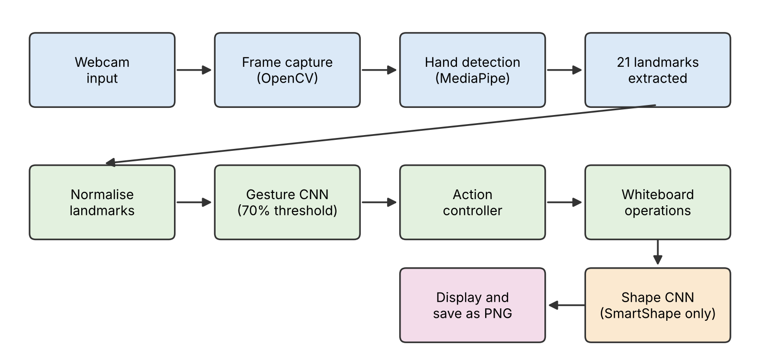
Figure 1: Overall architecture of the virtual whiteboard system

6. Working and Implementation

6.1 Webcam initialisation
When the application starts, OpenCV opens the webcam. Every frame is flipped horizontally so that it behaves like a mirror, which makes it easier for the user to move their hand in the right direction. The frame is then resized to the window size and converted from BGR to RGB, because MediaPipe expects RGB input.

6.2 Hand landmark extraction
MediaPipe processes the RGB frame and returns the 21 landmarks of the hand. Each landmark has X, Y and Z values, and these are collected into a numerical array that is later given to the gesture model. The detected hand is drawn on the screen so the user can see that the system is tracking them.
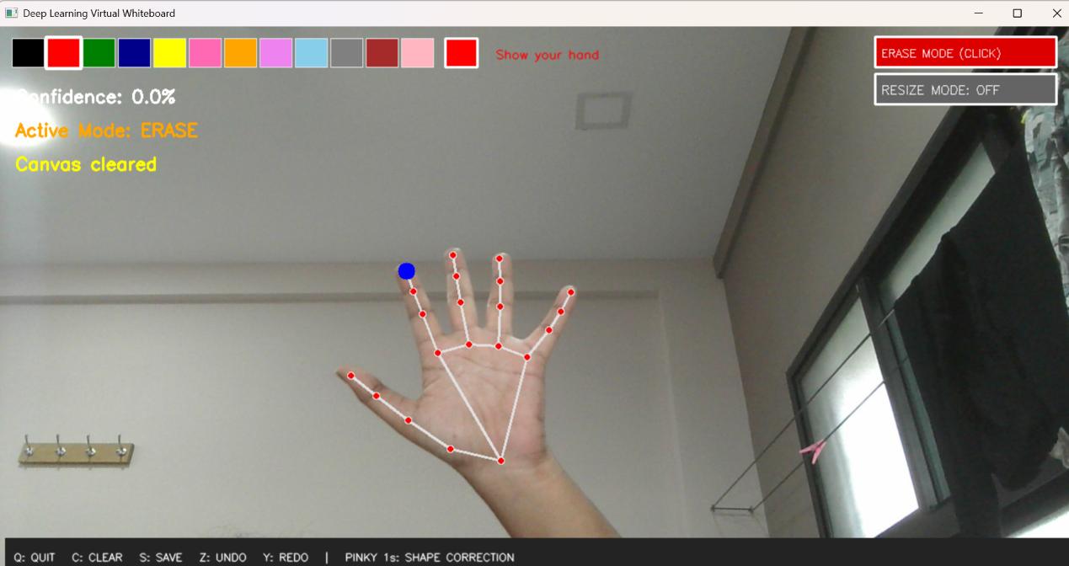
Figure 2: Hand landmarks detected by MediaPipe
The blue dot in the figure marks the index fingertip, which is the point used for drawing and pointing. When no hand is visible, the application shows “Show your hand” and the confidence drops to 0%.

6.3 Gesture recognition
The landmark values are normalised and passed to the Gesture CNN, which gives a gesture class and a confidence score. We only accept a prediction if the confidence is at least 70%. A history of the last five predictions is also kept, so the gesture label does not keep flickering between two classes when the hand is moving. The current gesture and its confidence are always shown at the top of the window, as seen in the screenshots.
The table below summarises the gestures used in the application.
Gesture | Action performed
Draw | Draws a stroke following the index fingertip
Select | Selects the drawing under the fingertip
Drag | Moves the selected drawing
Erase | Rubs out parts of the drawing (in Erase Mode)
Resize | Scales the selected drawing using thumb–index distance (in Resize Mode)
PaintFill | Fills the selected closed shape with the chosen colour
SmartShape (pinky, 1 s) | Recognises the selected drawing and corrects its shape

6.4 Drawing
For drawing, the program follows the index fingertip and joins consecutive positions with a line using OpenCV. The stroke is first stored in a separate “current” layer. When the user ends the drawing gesture, that layer is saved as an individual object. Because every finished drawing becomes its own object, it can be selected, moved or edited later without disturbing the others.

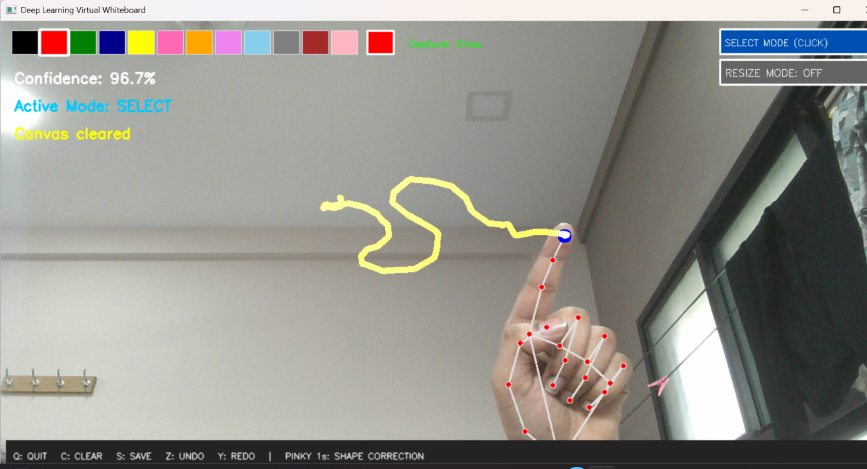
Figure 3: Drawing on the whiteboard with the index finger

6.5 Erasing
The Erase tool puts a circular eraser around the index fingertip. When the Erase gesture is detected while Erase Mode is on, the pixels under the eraser are removed from the current drawing layer and also from the layers of the saved objects. So the user can correct a new stroke as well as an older drawing.
The Select / Erase switch is a button at the top right of the window. Clicking it changes the active mode, and the current mode is also printed on the left side of the screen.
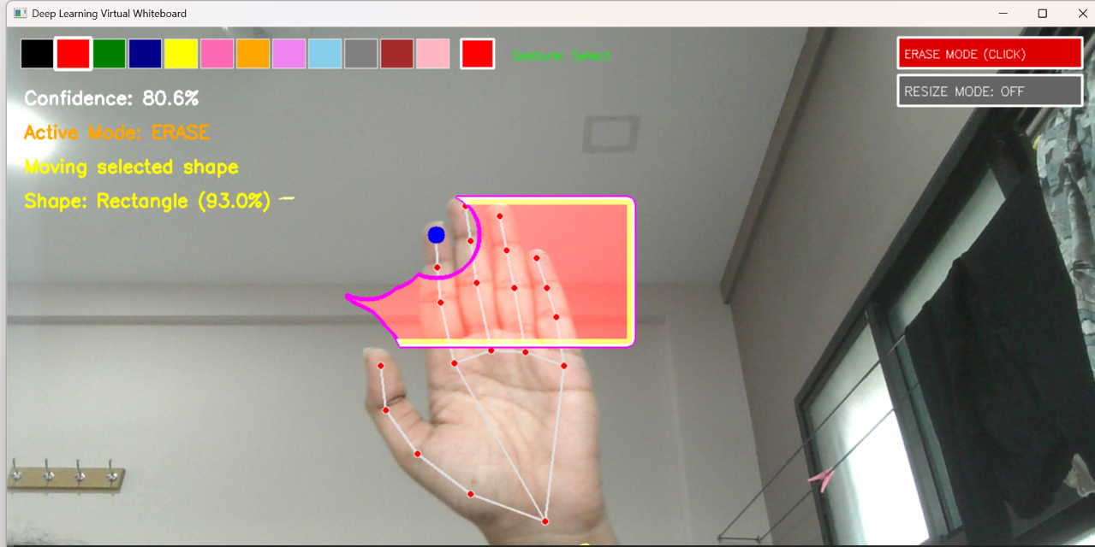
Figure 4: Erase Mode active while a corrected rectangle is being handled

6.6 Selecting and moving objects
To select a drawing, the user points at it with the selection gesture. The program finds the contours of all the objects and checks, using a point-in-polygon test, which one contains the fingertip. The selected object is highlighted with a pink outline so it is easy to see.
Once an object is selected, the Drag gesture moves it. The movement is calculated from the difference between the previous and the current hand position. We added a boundary check to the movement function so that the drawing cannot be pushed outside the canvas. The allowed movement is limited using the actual boundary of the drawing, not the whole layer, so the drawing always stays visible even if the hand goes past the edge of the screen.
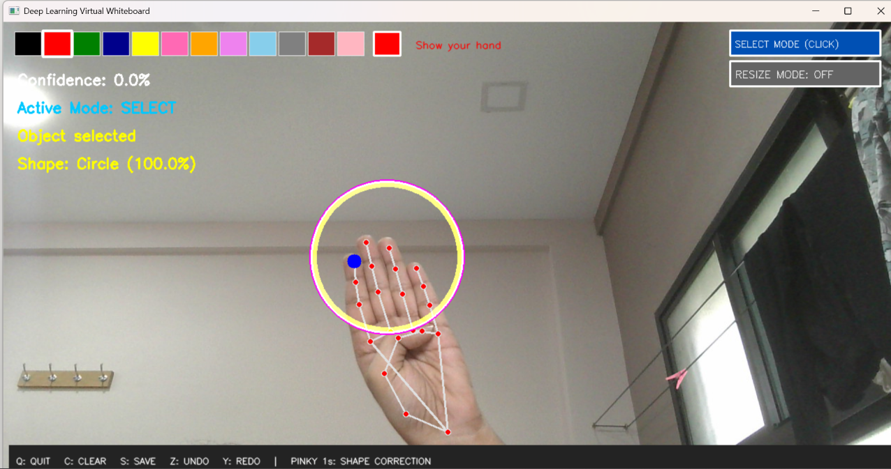
Figure 5: A selected object (circle) highlighted with an outline

6.7 Resizing
Resizing has its own button, Resize Mode. When it is switched on, the program measures the distance between the thumb tip and the index fingertip. Moving the two fingers apart makes the selected object bigger and bringing them together makes it smaller. The scale factor is kept between 0.5 and 2.0, so an object can never become too tiny or too large. The current factor is displayed on screen, for example “Resize: 1.13x” in the figure below.
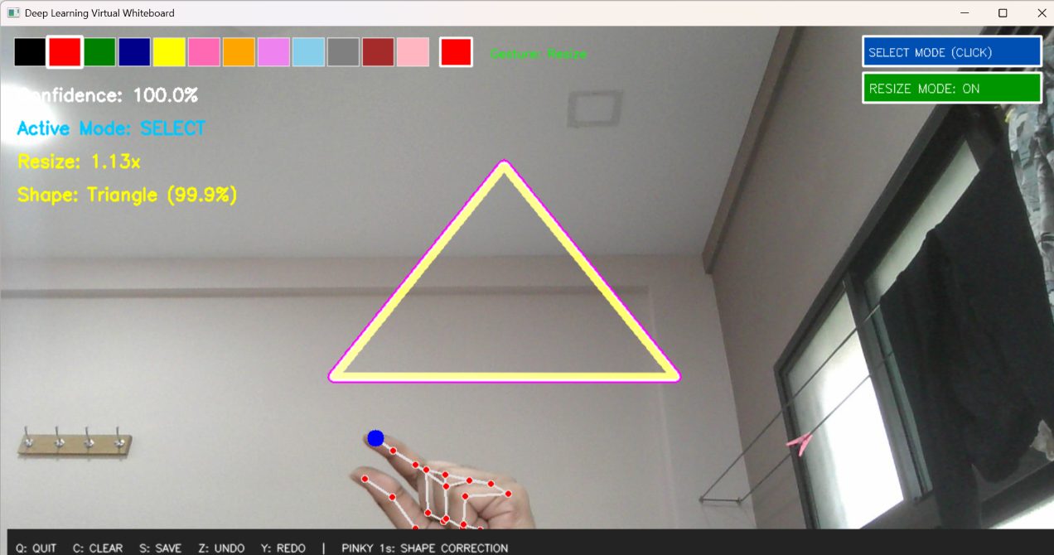
Figure 6: Resizing a selected triangle in Resize Mode

6.8 SmartShape recognition and correction
SmartShape is the feature we are most proud of in this project. Hand-drawn shapes in the air are almost never neat, so this feature cleans them up. The steps are:
- The user selects a drawing.
- The user shows the SmartShape gesture and holds it for about one second.
- The program extracts the contour of the selected drawing.
- The drawing is preprocessed and converted into a 28 × 28 grayscale image.
- The Shape CNN predicts which shape it is.
- If the confidence is at least 70%, the freehand drawing is replaced with the proper shape.
The four supported shapes are circle, square, rectangle and triangle. The name of the recognised shape and the confidence are shown on the screen, for example Circle (100.0%) in Figure 5, Rectangle (93.0%) in Figure 4 and Triangle (99.9%) in Figures 6 and 7.

6.9 Colour filling
The colour palette at the top of the window has 12 colours. The user clicks a colour and it appears in the preview box next to the palette. Then, after selecting a closed shape, the PaintFill gesture fills it with that colour. The outline of the original drawing is kept after filling.

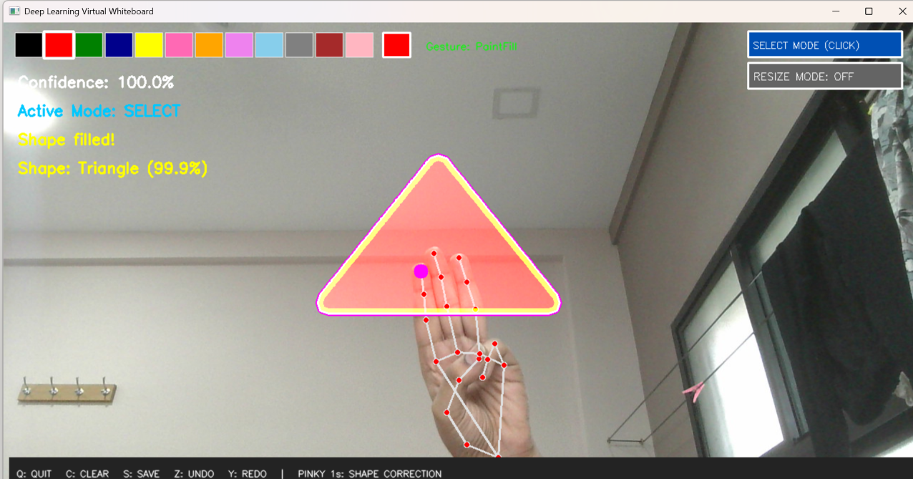
Figure 7: A triangle filled with the selected colour using PaintFill

6.10 Canvas management
Some operations are done with the keyboard, and the shortcuts are shown in the bar at the bottom of the window.
Key | Function
Z | Undo – reverses the last drawing or editing operation
Y | Redo – brings back an operation that was undone
C | Clear – removes everything from the whiteboard and resets the selection
S | Save – stores the drawing as a PNG image with a black background
Q | Quit the application

The application keeps separate drawing layers and remembers up to ten previous states for undo and redo. In the saved PNG, only the drawing is stored; the webcam picture, the hand and the buttons are left out.

7. Results, Advantages and Limitations

7.1 Results
The virtual whiteboard was built with Python, OpenCV, MediaPipe and TensorFlow/Keras, and the hand tracking, gesture recognition and shape recognition all run together in one window in real time. The screenshots in this document were taken from the running application. The main features that work are:
- Real-time hand tracking with MediaPipe.
- Gesture classification using the Gesture CNN.
- Drawing and erasing with hand gestures.
- Selecting and moving existing objects.
- Movement restricted to the canvas boundary.
- Resizing objects using the thumb–index pinch distance.
- Automatic shape correction using the Shape CNN.
- Filling shapes with any of the 12 colours.
- Undo, redo and clear canvas.
- Saving the drawing as a PNG image.

The figure below shows the empty interface as it looks when the application starts. The colour palette, colour preview, mode buttons and the keyboard shortcut bar can all be seen.
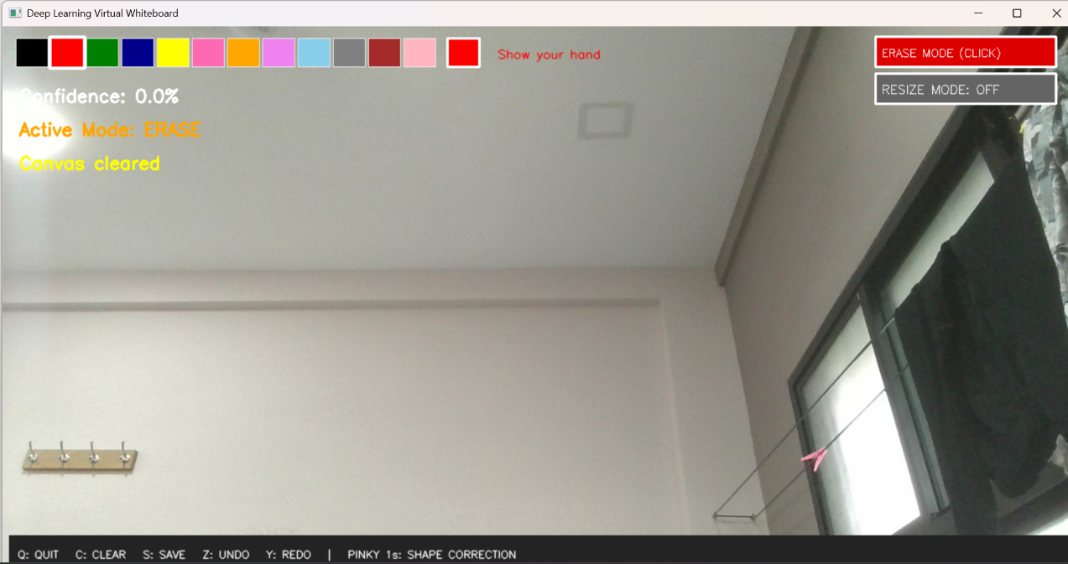
Figure 8: Interface of the virtual whiteboard when no hand is detected

7.2 Advantages
- Touchless; no markers, mouse or touchscreen are needed.
- Drawing happens in real time as the hand moves.
- Existing objects can be selected, moved and resized easily.
- Rough shapes are corrected automatically.
- 12 colours are available for filling shapes.
- Undo and redo help the user recover from mistakes.
- Objects cannot disappear outside the canvas.
- Drawings can be saved digitally as PNG files.

7.3 Limitations
- Only one hand can be used at a time.
- Only the gestures the model was trained on can be recognised.
- Shape correction works for four shapes only.
- Poor lighting or a badly placed webcam can reduce recognition accuracy.
- Drawings are saved on the local computer only; there is no cloud storage.

8. Future Enhancements and Conclusion

8.1 Future enhancements
- Support for both hands at the same time.
- Recognition of more shapes such as ellipses, pentagons and arrows.
- More gesture classes for more whiteboard operations.
- Cloud storage for saved drawings.
- Collaboration, so that more than one user can work on the same board.
- More drawing tools such as text, line thickness and different brush styles.

8.2 Conclusion
In this project we built a virtual whiteboard that is controlled completely by hand gestures. OpenCV and MediaPipe take care of the webcam and the hand landmarks, the Gesture CNN converts hand poses into commands, and the Shape CNN cleans up freehand shapes into circles, squares, rectangles and triangles.
Along with drawing, the application supports selecting, moving, resizing, erasing, colour filling, undo, redo, clearing and saving to PNG. The boundary restriction makes sure objects stay inside the canvas while they are being moved.
Working on this project helped us understand how deep learning models can be used in a real application and not just on a dataset. We believe it can be useful for teaching, presentations and interactive demonstrations, and the limitations listed above give clear directions for improving it further.

9. References
- Zhang, F. et al. (2020). MediaPipe Hands: On-device Real-time Hand Tracking. arXiv:2006.10214.
- Lugaresi, C. et al. (2019). MediaPipe: A Framework for Building Perception Pipelines. arXiv:1906.08172.
- Bradski, G. (2000). The OpenCV Library. Dr. Dobb’s Journal.
- Abadi, M. et al. (2016). TensorFlow: A System for Large-Scale Machine Learning. USENIX OSDI.
- Chollet, F. et al. (2015). Keras. https://keras.io/
- Harris, C. R. et al. (2020). Array Programming with NumPy. Nature, 585.

Project source code: https://github.com/Priya-DharshiniRamesh/Deep-Learning-Virtual-Whiteboard/tree/main

