**WEEK-1 DEEP SKILLING**

**1.Design Principles and Patterns**

**Exercise 1: Implementing the Singleton Pattern**

**Scenario:**

You need to ensure that a logging utility class in your application has only one instance throughout the application lifecycle to ensure consistent logging.

**Steps:**

1. **Create a New Java Project:**
   * Create a new Java project named **SingletonPatternExample**.
2. **Define a Singleton Class:**
   * Create a class named Logger that has a private static instance of itself.
   * Ensure the constructor of Logger is private.
   * Provide a public static method to get the instance of the Logger class.
3. **Implement the Singleton Pattern:**
   * Write code to ensure that the Logger class follows the Singleton design pattern.
4. **Test the Singleton Implementation:**
   * Create a test class to verify that only one instance of Logger is created and used across the application.

**OUTPUT:**

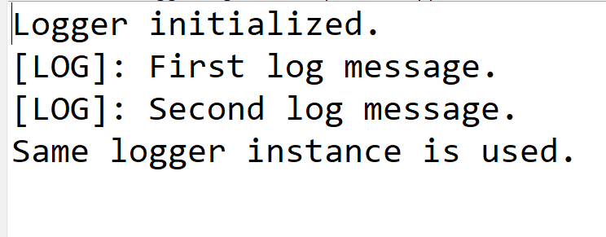

**Exercise 2: Implementing the Factory Method Pattern**

**Scenario:**

You are developing a document management system that needs to create different types of documents (e.g., Word, PDF, Excel). Use the Factory Method Pattern to achieve this.

**Steps:**

1. **Create a New Java Project:**
   * Create a new Java project named **FactoryMethodPatternExample**.
2. **Define Document Classes:**
   * Create interfaces or abstract classes for different document types such as **WordDocument**, **PdfDocument**, and **ExcelDocument**.
3. **Create Concrete Document Classes:**
   * Implement concrete classes for each document type that implements or extends the above interfaces or abstract classes.
4. **Implement the Factory Method:**
   * Create an abstract class **DocumentFactory** with a method **createDocument()**.
   * Create concrete factory classes for each document type that extends DocumentFactory and implements the **createDocument()** method.
5. **Test the Factory Method Implementation:**
   * Create a test class to demonstrate the creation of different document types using the factory method.

**OUTPUT:**

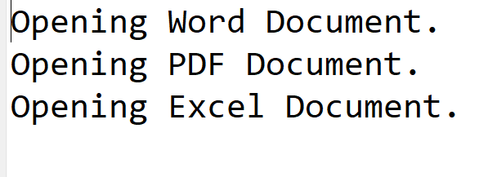

**2.DATA STRUCTURES AND ALGORITHMS**

**Exercise 2: E-commerce Platform Search Function**

**Scenario:**

You are working on the search functionality of an e-commerce platform. The search needs to be optimized for fast performance.

**Steps:**

1. **Understand Asymptotic Notation:**
   * Explain Big O notation and how it helps in analyzing algorithms.
   * Describe the best, average, and worst-case scenarios for search operations.
2. **Setup:**
   * Create a class **Product** with attributes for searching, such as **productId, productName**, and **category**.
3. **Implementation:**
   * Implement linear search and binary search algorithms.
   * Store products in an array for linear search and a sorted array for binary search.
4. **Analysis:**
   * Compare the time complexity of linear and binary search algorithms.
   * Discuss which algorithm is more suitable for your platform and why.

**OUTPUT:**

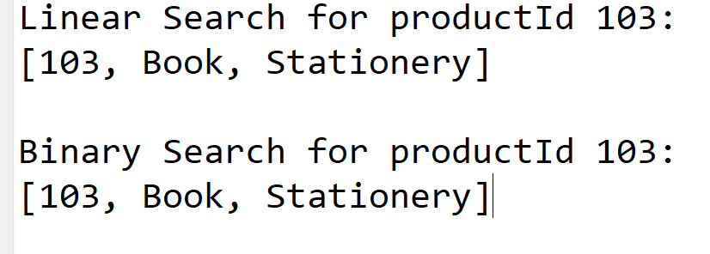

**Exercise 7: Financial Forecasting**

**Scenario:**

You are developing a financial forecasting tool that predicts future values based on past data.

**Steps:**

1. **Understand Recursive Algorithms:**
   * Explain the concept of recursion and how it can simplify certain problems.
2. **Setup:**
   * Create a method to calculate the future value using a recursive approach.
3. **Implementation:**
   * Implement a recursive algorithm to predict future values based on past growth rates.
4. **Analysis:**
   * Discuss the time complexity of your recursive algorithm.
   * Explain how to optimize the recursive solution to avoid excessive computation.

**OUTPUT:**

