**VISVESVARAYA TECHNOLOGICAL UNIVERSITY**

"Jnana Sangama", Belgavi-590 018, Karnataka, India

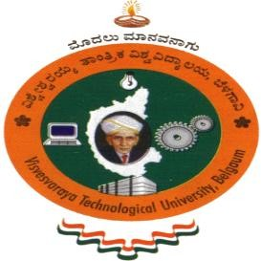

An Internship Report On

**“TECH STARTUP LANDING PAGE”**

Submitted in Partial Fulfillment of the requirement for the award of the degree of

## BACHELOR OF ENGINEERING

IN

**COMPUTER SCIENCE AND ENGINEERING**

## Submitted By

**PRIYA RAJU BHAT 1MV20CS081**

Carried out at

### Varcons Technologies Pvt. Ltd

Under the Guidance of

Internal Guide External Guide

### Ms. Thrisha V.S. Mrs. Spoorthi C

**Associate Professor Director**

**Dept. Of CSE, SIR MVIT Varcons Technologies Pvt. Ltd**

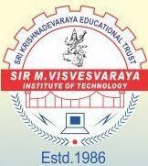

## Department of Computer Science Engineering

**Sir M. Visvesvaraya Institute of Technology**

[Affiliated to Visvesvaraya Technological University, Belgaum] Bangaluru-562157

2023-2024

**Sir M. Visvesvaraya Institute of Technology**

[Affiliated to Visvesvaraya Technological University, Belgaum] Bangaluru-562157

2023-2024



# CERTIFICATE

It is certified that the internship work entitled “**TECH STARTUP LANDING PAGE”** carried out by **Ms. Priya Raju Bhat** bearing **USN: 1MV20CS081** bonafide student of **Sir M. Visvesvaraya Institute of Technology** in partial fulfillment for the award of **Bachelor of Engineering** in **Computer Science Engineering** of the Visvesvaraya Technological University, Belagavi during the year 2023-24. It is certified that all corrections/suggestions indicated for INTERNSHIP have been executed under the directions of **Mrs. Mayuri K P.** The report has been approved as it satisfies the academic requirements in respect of INTERNSHIP prescribed for the said degree.

Signature of Guide

**Ms. Thrisha V.S.** Associate Professor Dept. of CSE

SIR MVIT

External Examination:

Name of the Examiners:

1.

2.

Signature of HOD

**Dr. T N Anitha** HOD and Professor Dept. of CSE

SIR MVIT

Signature of Principal

## Dr. Rakesh S G

Principal SIR MVIT

Signature with Date

**Company Certificate**

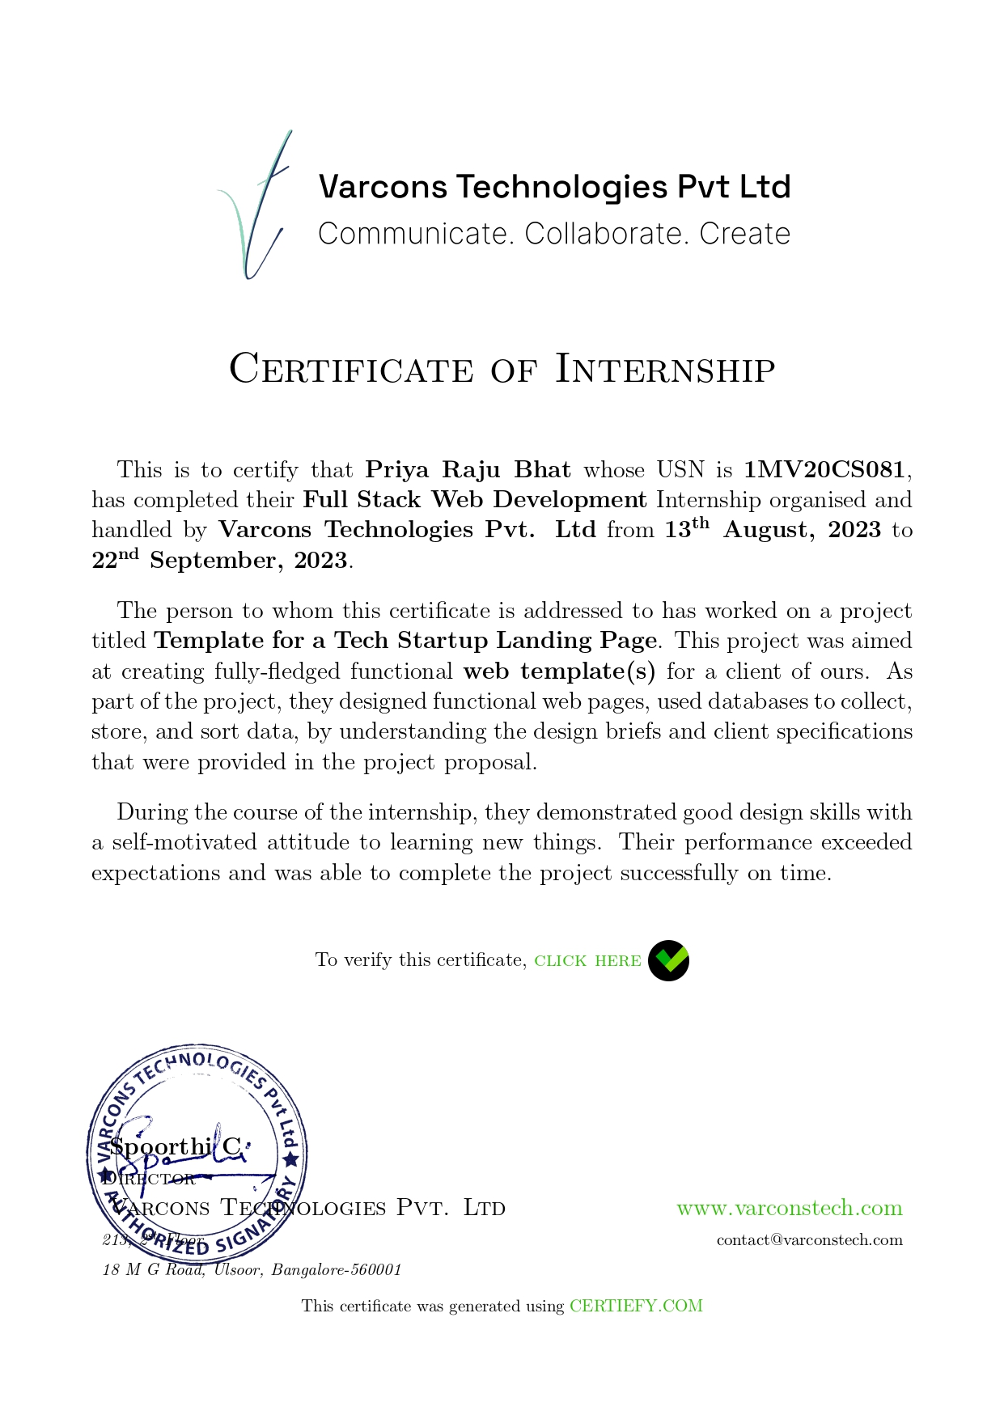

**DECLARATION**

I, **Ms. Priya Raju Bhat** bearing the USN **1MV20CS081**, student of 8th Semester B.E. Department of Computer Science Engineering, **Sir M Visvesvaraya Institute of Technology**, Bengaluru declare that the INTERNSHIP work entitled “**TECH STARTUP LANDING PAGE**”, has been duly executed by me under the guidance of **Mrs. Spoorthi C** director of Varcons Technologies Pvt. Ltd and **Ms. Thrisha V.S.**, Assoc. Professor, Department of Computer Science Engineering, Sir MVIT, Bengaluru. The INTERNSHIP report of the same is submitted in partial fulfilment of the requirement for the award of Bachelor of Engineering degree in Department of Computer Science Engineering by Visvesvaraya Technological University, Belgaum during the year 2023-2024.

Date: 05-03-2024 Ms. Priya Raju Bhat

Place: Bengaluru 1MV20CS081

**ACKNOWLEDGEMENT**

The satisfaction that accompanies the successful completion of the INTERNSHIP report which would be complete only with the mention of the almighty God and the people who made it possible, whose report rewarded the effort with success of project presentation

We are grateful to **Sir M Visvesvaraya Institute of Technology** for providing us an opportunity to enhance our knowledge through the project.

We express our sincere thanks to **Dr. Rakesh S G**, Principal, Sir MVIT, for providing us an opportunity and means to present the project.

We express our heart full thanks to **Dr. T N Anitha**, Professor and Head, Department of Computer Science & Engineering, SIR MVIT, for encouragement in our internship work, whose cooperation and guidance helped in nurturing this project report.

We would like to express profound thanks to the INTERNSHIP guide **Mrs. Mayuri K P,** Asst. Professor, Internship coordinator, Department of Computer Science Engineering for the keen interest and encouragement in our internship presentation.

We extend our thanks to the ***Varcons Technologies Pvt. Ltd*** for their effort and endurance to bring out the best in us.

Finally, we would like to thank our family members and friends for standing with us through all times.

### Priya Raju Bhat 1MV20CS081

The Tech Startup Landing Page is an essential component of our project report, playing a pivotal role in introducing and engaging stakeholders with our cutting-edge startup vision. Crafted with precision, this webpage condenses the essence of our startup's mission and potential into a concise and visually appealing format.

Within its sleek design, visitors will encounter a succinct company overview that encapsulates our core objectives.

One of the page's focal points is our value proposition, which underlines the significant advantages and transformative impact we bring to the tech industry. Highlighted are the key features of our solution, emphasizing its unique selling points. To foster active engagement, we've strategically placed attention-grabbing call-to-action buttons throughout the page, urging visitors to explore our project in greater detail or take steps toward collaboration.

In addition to this, we've made it easy for stakeholders to connect with us by providing readily accessible contact information. In essence, the Tech Startup Landing Page is a dynamic and informative portal, meticulously designed to leave a lasting impression and encourage stakeholders to delve deeper into our project report.

In conclusion, our Tech Startup Landing Page serves as a pivotal component of our project report, effectively encapsulating the essence of our tech startup and enticing stakeholders to delve deeper into our project's details. Its user-friendly design and compelling content make it an invaluable tool for presenting our innovative concept to the world.

|  |  |
| --- | --- |
| DECLARATION | i |
| ACKNOWLEDGEMENT | ii |
| ABSTRACT | iii |
| CONTENTS | iv |
| LIST OF FIGURES | v |
| LIST OF TABLES | vi |

|  |  |  |
| --- | --- | --- |
| **SL No** | **TITLE OF SCREENSHOT** | **Page No** |
| Fig 4.6.1 | LogIn Page | 15 |
| Fig 4.6.2 | Home page | 16 |
| Fig 4.6.3 | Features | 16 |
| Fig 4.6.4 | Teams Members | 17 |
| Fig 4.6.5 | Footer Section | 17 |
| Fig 4.6.6 | Pricing Plan Page | 18 |
| Fig 4.6.7 | Reviews | 18 |

|  |  |  |
| --- | --- | --- |
| Chapter No | Chapter Title | Page No |
| 1 | COMPANY PROFILE | 01-04 |
| * 1. History Of the Organization      1. Objectives      2. Operations of the Organization   2. Major Milestones   3. Structure Of the Organization   4. Services Offered |
| 2 | ABOUT THE DEPARTMENT | 05-07 |
| * 1. Specific Functionalities Of the Department   2. Process Adopted   3. Testing   4. Structure Of the Department   5. Roles and Responsibilities Of Individuals |
| 3 | TASK PERFORMED | 08-10 |
| 4 | REFLECTION NOTES | 11-19 |
| * 1. Experience   2. Technical Outcomes      1. System Requirement Specification   3. System Analysis and Design      1. Existing System      2. Proposed System   4. System Architecture   5. Implementation   6. Screenshots |
| 5 | CONCLUSION | 20 |
|  | BIBLIOGRAPHY | 21 |

# CHAPTER 1 COMPANY PROFILE

## History of the Organization:

Varcons Technologies is a leading provider of cutting-edge technologies and services, offering scalable solutions for businesses of all sizes. Founded by a group of friends who started by scribbling their ideas on a piece of paper, today offer smart, innovative services to dozens of clients. Developing SaaS products, provide Corporate Seminars, Industrial trainings and much more.

Visual Content Analysis (VCA) provides a host of services to its customers/users/clients, enabling business success driven by technology Harnessing the power of technology, we create a measurable difference for clients across various industries & multiple geographies.

They understand that the best desired output can be achieved only by understanding the clients demand better. Varcons Technologies work with their clients and help them to define their exact solution requirement. Sometimes even they wonder that they have completely redefined their solution or new application requirement during the brainstormingsession, and here they position themselves as an IT solutions consulting group comprising of high caliber consultants.

They believe that technology when used properly can help any business to scale and achieve new heights of success. It helps improve its efficiency, profitability, reliability to put it in one sentence “Technology helps you to delight your customers” and that is what we want to achieve.

### Objectives:

The primary objective of Varcons Technologies Pvt. Ltd include:

* + - 1. Accessibility: The primary objective is to make education accessible to a global audience. Anyone with an internet connection can access a wealth of educational resources, breaking down geographical barriers.
      2. Flexibility: Provide learners with the flexibility to learn at their own pace, anytime and anywhere, accommodating diverse schedules and lifestyles.
      3. Diversity of Courses: Offer a wide variety of courses and subjects to cater to the diverse interests and needs of learners, from academic subjects to vocational skills.
      4. Personalization: Utilize artificial intelligence and data analytics to create personalized learning paths for all.
      5. Engagement: Foster active and engaging learning experiences through multimedia content, interactive assignments, discussion forums, and peer collaboration.

### Operations of the Organization:

CSI's operations encompass a wide range of activities aimed at promoting full stack development and creation of attractive templates for online surfing. Key operational areas include:

* Website as Software

They develop websites that behave and interact similar to sophisticated software.

* Search Engine Optimisation

They help manage our SEO campaign more efficiently and effectively. They help us gain market share by leveraging our expertise, our holistic approach to identify anything that may be hurting our traffic or rankings and show us just how to outrank the competition.

* Comprehensive Customer Support

With a comprehensive range of services, they guarantee our technology needs are not just met, but exceeded. They shall work with customers/users closely to understand the way the users/customers use/make use of products/services

* Branding and Design

They offer professional Graphic design, Brochure design & Logo design. They are experts in crafting visual content to convey the right message to the customers. They also design custom wraps for our products(also known as package designing)

* Analytics and Research

They analyse the way the users/customers interact with them/their business by gathering, studying and understanding the consumer voice and their perception of the product/service

* Embedded Systems and IOT

They work with Consumer Electronics, Lighting, Home Automation, Metering, Sensor- Technology, Home Appliance and Medical Device companies to help them create smart and connected products. Through its integrated Embedded and IoT services, VCA helps build intelligent & connected devices that can be remotely monitored and controlled while leveraging edge and cloud computing for a host of intelligent applications and analytics.

## Major Milestones

Varcons Technologies Private Limited, incorporated on 11 July 2022, is a privately held company registered at the Registrar of Companies, Bangalore. Classified as a Non-govt company, it operates in the realm of other computer-related activities, such as the maintenance of websites for other firms and the creation of multimedia presentations. With an authorized share capital of Rs. 1,000,000 and a paid-up capital of Rs. 10,000, Varcons Technologies Pvt. Ltd. is positioned to provide innovative solutions in the digital domain. The company's Annual General Meeting (AGM) details are yet to be disclosed, and its balance sheet information is pending filing with the Ministry of Corporate Affairs (MCA). The board of directors comprises Chikaegowdanadoddi Kariyappa Somalatha and Haralahalli Chandraiah Spoorthi. Being a recently established firm, Varcons Technologies Private Limited is in its nascent stages, and while its potential is promising, it has yet to mark significant milestones. However, with its dedicated team and strategic direction, the company is poised to carve its path in the competitive landscape of digital services, offering innovative solutions to its clientele.

## Structure of the Organization:

Varcons Technologies Private Limited operates within a structured organizational framework tailored to facilitate its mission effectively. At the helm is an executive leadership team responsible for steering strategic direction, overseeing operational management, and fostering external engagements. The company is structured into specialized departments and divisions, each dedicated to different facets of digital services, including website maintenance, multimedia presentations, and other computer-related activities. While Varcons Technologies Pvt. Ltd. is still in its early stages, it aspires to establish a robust advisory board composed of industry experts and leaders to provide valuable guidance and expertise. Additionally, the company aims to expand its presence by establishing regional branches, enabling localized service delivery and addressing specific digital needs unique to each region. This structured approach ensures Varcons Technologies Pvt. Ltd.'s comprehensive coverage and effective service delivery, positioning it to thrive in the competitive digital marketplace.

## Services Offered:

Company Name plays an essential role as an institute, the level of education, development of student’s skills are based on their trainers. If you do not have a good mentor then you may lag in many things from others and that is why we at Varcons Technologies gives you the facility of skilled employees so that you do not feel unsecured about the academics. Personality development and academic status are some of those things which lie on mentor’s hands. If you are trained well then you can do well in your future and knowing its importance of Varcons Technologies always tries to give us the best.

They have a great team of skilled mentors who are always ready to direct their trainees in the best possible way they can and to ensure the skills of mentors we held many skill development programs as well so that each and every mentor can develop their own skills with the demands of the companies so that they can prepare a complete packaged trainee.

## Services provided by the Company

* Core Java and Advanced Java
* Web services and development
* Dot Net Framework
* Python
* Selenium Testing
* Conference / Event Management Service
* Academic Project Guidance
* On The Job Training

# CHAPTER 2

# ABOUT THE DEPARTMENT

## Specific Functionalities of the Department:

Within Varcons Technologies Private Limited's structured organizational framework, specialized departments fulfill distinct functionalities to deliver top-notch digital services. The Website Maintenance Department ensures clients' websites operate smoothly by conducting regular updates, implementing security measures, and optimizing performance. The Multimedia Presentations Division excels in crafting engaging multimedia content, including presentations, videos, and animations, tailored to clients' specifications.

Meanwhile, the Other Computer-Related Activities Unit handles a diverse range of tasks such as software development, IT consulting, and technical support services, showcasing expertise across various domains. As Varcons Technologies Pvt. Ltd. advances, these departments will adapt to evolving market demands, leveraging innovation to maintain their competitive edge in the digital landscape.

## Process Adopted:

The processes adopted within Varcons Technologies Pvt. Ltd is, where the theoretical design is turned into a working system. The most crucial stage in achieving a new successful system and in giving confidence on the new system for the users that it will work efficiently and effectively.

The system can be implemented only after thorough testing is done and if it is found to workaccording to the specification. It involves careful planning, investigation of the current system and its constraints on implementation, design of methods to achieve the changeover and an evaluation of change over methods a part from planning.

Two major tasks of preparing the implementation are education and training of the users andtesting of the system. The more complex the system being implemented, the more involved will be the system analysis and design effort required just for implementation.

The implementation phase comprises of several activities. The required hardware and software acquisition is carried out. The system may require some software to be developed.For this, programs are written and tested. The user then changes over to his new fully testedsystem and the old system is discontinued.

## Testing:

The testing phase is an important part of software development. It is the Information zed system will help in automate process of finding errors and missing operations and also a complete verification to determine whether the objectives are met and the user requirementsare satisfied. Software testing is carried out in three steps:

* + 1. The first includes unit testing, where in each module is tested to provide its correctness, validity and also determine any missing operations and to verify whether theobjectives have been met. Errors are noted down and corrected immediately.
    2. Unit testing is the important and major part of the project. So errors are rectified easily inparticular module and program clarity is increased. In this project entire system is divided into several modules and is developed individually. So unit testing is conducted to individual modules.
    3. The second step includes Integration testing. It need not be the case, the software whosemodules when run individually and showing perfect results, will also show perfect results when run as a whole.

## Structure of the Department:

Within Varcons Technologies Pvt. Ltd, each department operates within a structured framework designed to optimize collaboration, coordination, and efficiency. Typically, departments are organized hierarchically, with department heads or directors overseeing day- to-day operations, strategic planning, and resource allocation. Reporting to department heads are teams of cybersecurity professionals, subject matter experts, researchers, and support staff, each contributing specialized skills and expertise to departmental objectives. Furthermore, departments often collaborate closely with other departments and external stakeholders to leverage synergies, share resources, and maximize impact. This structured approach ensures clear lines of communication, accountability, and collaboration within departments, facilitating the achievement of organizational goals and objectives.

## Roles and Responsibilities of Individuals:

In Varcons Technologies Private Limited, individuals hold diverse roles and responsibilities tailored to their expertise and the company's operational needs

* + 1. Executive Leadership Team: At the helm of the organization, the executive leadership team sets strategic goals, oversees day-to-day operations, and fosters external partnerships. They guide the company towards achieving its mission and vision while ensuring alignment with stakeholders' expectations.
    2. Department Heads: Responsible for managing specific departments, heads oversee the execution of departmental goals, allocate resources efficiently, and ensure the quality and timeliness of deliverables. They provide leadership and direction to their teams, fostering a collaborative and productive work environment.
    3. Technical Specialists: Within each department, technical specialists bring expertise in areas such as website maintenance, multimedia content creation, software development, and IT consulting. They leverage their skills to execute tasks efficiently, troubleshoot technical issues, and innovate solutions to meet client requirements.
    4. Advisory Board Members: Comprising cybersecurity experts, industry leaders, government officials, and academic luminaries, the advisory board offers strategic guidance and expertise to the company. They provide valuable insights into industry trends, regulatory compliance, and emerging technologies, shaping Varcons Technologies' long-term strategy.
    5. Regional Managers: As Varcons Technologies Pvt. Ltd. expands its presence, regional managers oversee operations in different geographic areas. They establish and maintain relationships with clients, manage local teams, and ensure the company's services align with regional needs and regulations.
    6. Support Staff: Administrative and support staff play a crucial role in ensuring the smooth functioning of day-to-day operations. They handle tasks such as customer inquiries, scheduling, documentation, and other administrative duties, supporting the overall efficiency of the organization.

Each individual within Varcons Technologies Pvt. Ltd. contributes uniquely to the company's success, working collaboratively towards delivering high-quality digital services and maintaining customer satisfaction.

# CHAPTER 3 TASK PERFORMED

Varcons Technologies Private Limited specializes in providing a range of digital services, catering to the diverse needs of its clientele. Here's a detailed breakdown of the tasks performed by the firm:

## Website Maintenance:

One of the core services offered by Varcons Technologies is website maintenance. This involves ensuring that clients' websites are up-to-date, secure, and running smoothly. Tasks within this domain include:

Regular updates: Varcons Technologies ensures that clients' websites are updated with the latest software versions, security patches, and plugins to protect against vulnerabilities and ensure optimal performance.

Security measures: The firm implements robust security measures, such as firewalls, encryption, and regular security audits, to safeguard clients' websites against cyber threats and unauthorized access.

Performance optimization: Varcons Technologies optimizes website performance by optimizing code, compressing images, and implementing caching techniques to improve page load times and enhance user experience.

## Multimedia Content Creation:

Another key service offered by Varcons Technologies is the creation of multimedia content, including presentations, videos, animations, and other digital assets. This involves:

Understanding client requirements: The firm works closely with clients to understand their objectives, target audience, and desired message to create custom multimedia content that effectively communicates their brand message.

Creative design: Varcons Technologies employs talented designers and multimedia experts to create visually stunning and engaging content using the latest design tools and techniques.

Content production: The firm handles all aspects of content production, including scripting, storyboarding, animation, voiceovers, and editing, to deliver high-quality multimedia content that captivates and engages audiences.

Other Computer-Related Activities: Varcons Technologies also provides a range of other computer-related activities, such as software development, IT consulting, system integration, and technical support services. Tasks within this domain include:

## Software development:

The firm develops custom software solutions tailored to clients' specific requirements, ranging from web applications and mobile apps to enterprise software systems.

IT consulting: Varcons Technologies offers expert IT consulting services to help clients make informed decisions about their technology infrastructure, strategy, and investments.

System integration: The firm assists clients in integrating disparate systems and technologies to streamline business processes, improve efficiency, and enhance collaboration.

Technical support: Varcons Technologies provides comprehensive technical support services to troubleshoot issues, resolve problems, and ensure the smooth operation of clients' IT systems and applications.

Overall, Varcons Technologies Private Limited excels in delivering innovative digital solutions that help clients achieve their business objectives, enhance their online presence, and drive growth and success in the digital age.

My task involved creating a fitness studio website with both front-end and back-end development components. Here's a detailed breakdown of the tasks you performed:

**Front-End Development:**

HTML (Hypertext Markup Language): We utilized HTML to structure the content of your website, including elements such as headers, paragraphs, lists, and forms. HTML provided the foundation for presenting information to website visitors.

CSS (Cascading Style Sheets): CSS was used to style the HTML elements, defining aspects like colors, fonts, layout, and visual effects. It allowed you to create an appealing and cohesive design for your fitness studio website.

JavaScript: JavaScript added interactivity and dynamic behavior to your website. You used JavaScript to implement features such as navigation menus, sliders, image galleries, form validation, and any other client-side functionalities to enhance user experience.

**Back-End Development:**

PHP (Hypertext Preprocessor): PHP served as the server-side scripting language for your website. You utilized PHP to handle dynamic content generation, database interactions, user authentication, form submissions, and other server-side functionalities.

Database Integration: As part of the back-end development, you likely integrated a database system (using MySQL) to store and manage data related to the fitness studio website. This could include user information, class schedules, instructor profiles, and enrollment details.

Enrollment System: Using PHP and database interactions, you created a functional enrollment system that allows website visitors to sign up for fitness classes offered by the studio. This likely involved forms for users to input their information, validation of form submissions, processing of enrollment requests, and updating the database with enrollment data.

# CHAPTER 4 REFLECTION NOTES

## Experience:

## The experience of a tech startup landing page for a report is crucial for visitors to engage effectively with the content and take desired actions. An intuitive and visually appealing design welcomes visitors, guiding them through the page effortlessly. Clear navigation ensures easy access to the report's content, providing concise summaries and compelling visuals to capture interest. Fast loading times enhance user experience, preventing frustration and encouraging exploration. Security measures instill trust, reassuring visitors that their data is safe and protected. Responsive design ensures compatibility across devices, accommodating users accessing the page from various platforms. Effective CTAs prompt visitors to take action, whether it's downloading the report, signing up for updates, or contacting the startup for more information. Analytics integration provides valuable insights into user behavior, allowing for continuous optimization of the landing page's performance and content. Overall, a positive experience on the tech startup landing page for a report fosters engagement, builds credibility, and increases the likelihood of conversion. It serves as a crucial touchpoint in the user journey, leaving a lasting impression and encouraging further interaction with the startup's offerings.

## Technical Outcomes:

The technical outcomes of a tech startup landing page for a report are critical for delivering a seamless user experience and achieving desired objectives. Responsive design ensures the page adapts well to various devices, facilitating accessibility and user engagement. Fast load times, achieved through efficient coding practices and media optimization, retain user interest and satisfaction. Security measures, including SSL encryption and secure authentication methods, safeguard user data and maintain trust. Scalability ensures the landing page remains responsive and functional under varying load conditions, accommodating increasing traffic and future growth. Analytics integration tracks user behavior and conversion metrics, providing insights for continuous optimization. SEO optimization enhances visibility in search engine results, attracting organic traffic. Effective content management, facilitated by a CMS or backend infrastructure, allows easy updating and management of the landing page content. Clear calls-to-action prompt visitors to take desired actions, enhancing user engagement and conversion rates. These technical outcomes

conversions , development principles and practices, resulting in a robust and feature-rich website.

### System Requirement Specification:

During the internship, I was tasked with developing a comprehensive system requirement specification

* + - 1. Functional Requirements
         * User Registration and Authentication
         * User Profile
         * Content delivery
         * Assessments and Quizzes
      2. Non-Functional Requirements
* **Availability**

The online registration system shall permit backing up of the registration database while other registration actives are going on.

* **Accessibility**

The system shall be accessible by people with specific vision needs to the extent that a user shall be able to display whole user interface in a larger font without truncating displayed text or other values.

* **Security**

The access permissions for system data may only be change by the systems data administrator passwords shall never be viewable at the point of entry or any other time.

### Software Requirements:

Integrated Development Environment (IDE): Visual Studio Code or JetBrains IntelliJ IDEA Web Browsers: Google Chrome, Mozilla Firefox, or Microsoft Edge

Version Control: Git with GitHub Desktop

### Hardware Requirements:

* + MySQL
  + NODE JS
  + Notepad++ Editor
  + Processor: Intel core i5 processer
  + Memory: 15.6 GB
  + Hard Disk: 40 GB

## System Analysis and Design:

### Existing System:

### The existing system for a tech startup landing page for a report comprises a frontend interface built with HTML, CSS, and JavaScript. Backend infrastructure handles server-side logic and database management, while some pages utilize a Content Management System (CMS) like WordPress. Analytics tools track user behavior, security measures protect data, and responsive design ensures compatibility across devices. SEO techniques optimize visibility in search results. Together, these components present the report's content effectively, attract visitors, and support user engagement.

### 4.3.2 Proposed System:

The proposed system for a tech startup landing page entails crafting an appealing frontend interface with HTML, CSS, and JavaScript. A robust backend server, leveraging technologies like Node.js or Django, handles user requests and database communication. Content management is facilitated by a CMS such as WordPress. Analytics tools monitor user engagement for ongoing optimization, while stringent security measures safeguard user data. The landing page is designed to be responsive across devices, optimized for search engines, scalable, and high-performing. Rigorous testing and deployment processes ensure a seamless user experience and efficient updates.

## System Architecture:

I developed a detailed system architecture with:

## Frontend Interface: Develop an intuitive user interface with HTML, CSS, and JavaScript for seamless interaction and navigation.

## Backend Server: Utilize a robust backend server, employing languages like Node.js or Python, to handle requests, process data, and ensure smooth functionality.

## Database Management: Implement a secure and scalable database solution such as MySQL or MongoDB to store and manage user data, report content, and analytics information.

## Analytics Integration: Integrate analytics tools like Google Analytics to track user behavior, traffic sources, and conversion metrics for informed decision-making and optimization.

## Security Measures: Employ stringent security measures, including HTTPS encryption, secure authentication methods, and regular software updates, to safeguard user data and prevent unauthorized access.

## Implementation:

Implementing a tech startup landing page for a report requires careful planning and execution. Firstly, select a suitable platform such as WordPress or a dedicated landing page builder. Design the page with a focus on visual appeal and brand consistency, using high-quality images and fonts that reflect your startup's identity

Optimize the layout for conversion by placing the CTA prominently above the fold and minimizing distractions. Ensure mobile responsiveness to provide a seamless user experience across devices, testing the page thoroughly to identify and fix any issues.

Integrate analytics tools like Google Analytics to track visitor behavior and measure the effectiveness of your landing page.Test the landing page extensively, conducting A/B tests to experiment with different elements and optimize for performance. Gather feedback from users and iterate on the design, copy, and functionality accordingly.

Finally, launch the landing page and promote it through various channels such as social media, email newsletters, and paid advertising to drive traffic and conversions. Monitor performance metrics and make adjustments as needed to maximize the impact of your tech startup report.

## Screenshots:

A landing page for a tech startup report should have a clear headline, engaging visuals, compelling copy, and a prominent call-to-action (CTA) button. It should provide a brief overview of the report's contents, incorporate social proof, and be optimized for conversion and mobile responsiveness. Contact information and assurances of data privacy should also be included to build trust with visitors.

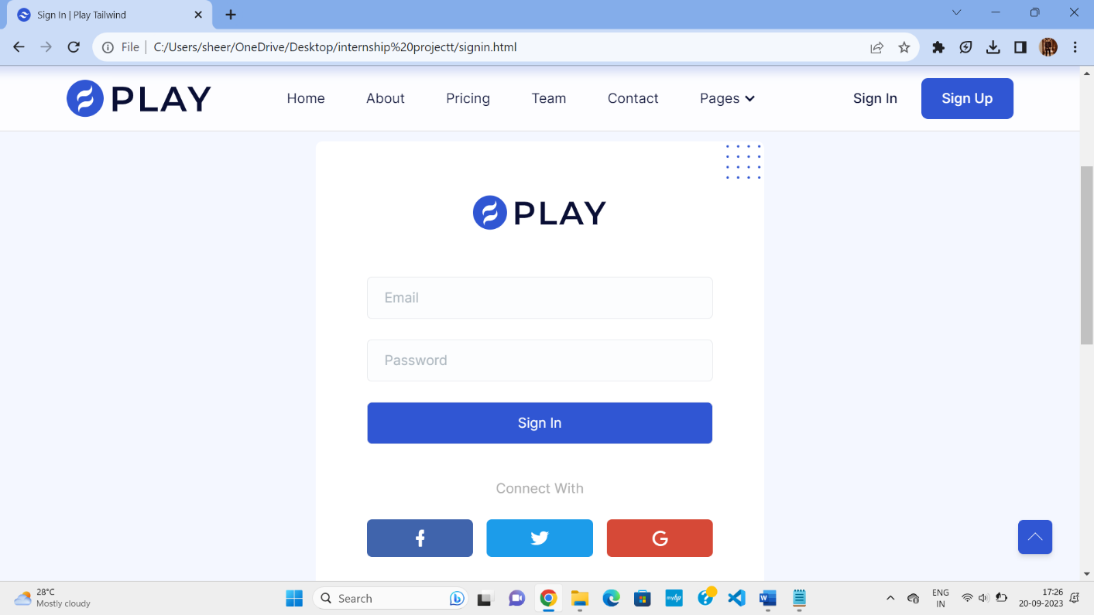

Fig 4.6.1 Log In Page

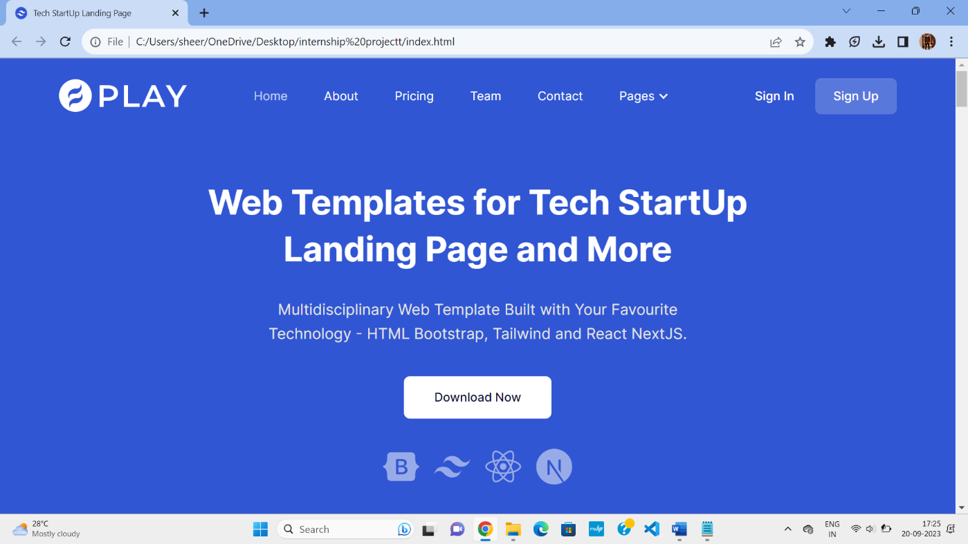

Fig 4.6.2 Home page

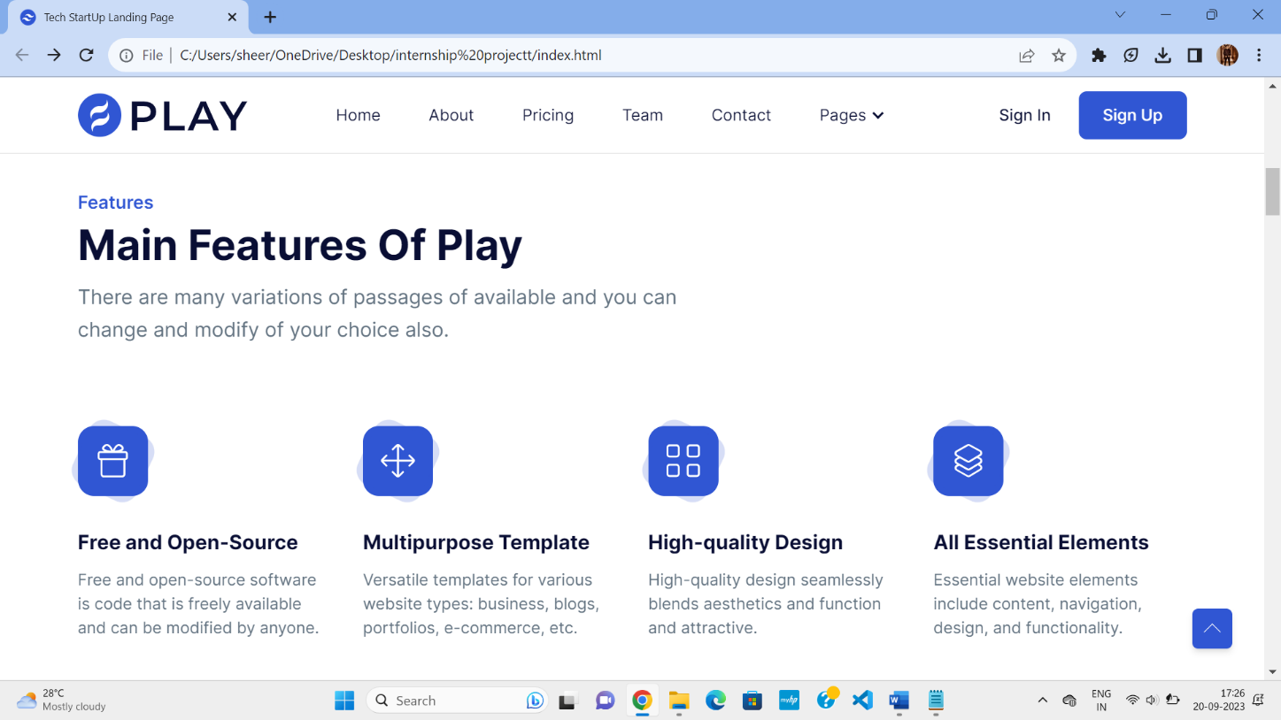

Fig 4.6.3 Features

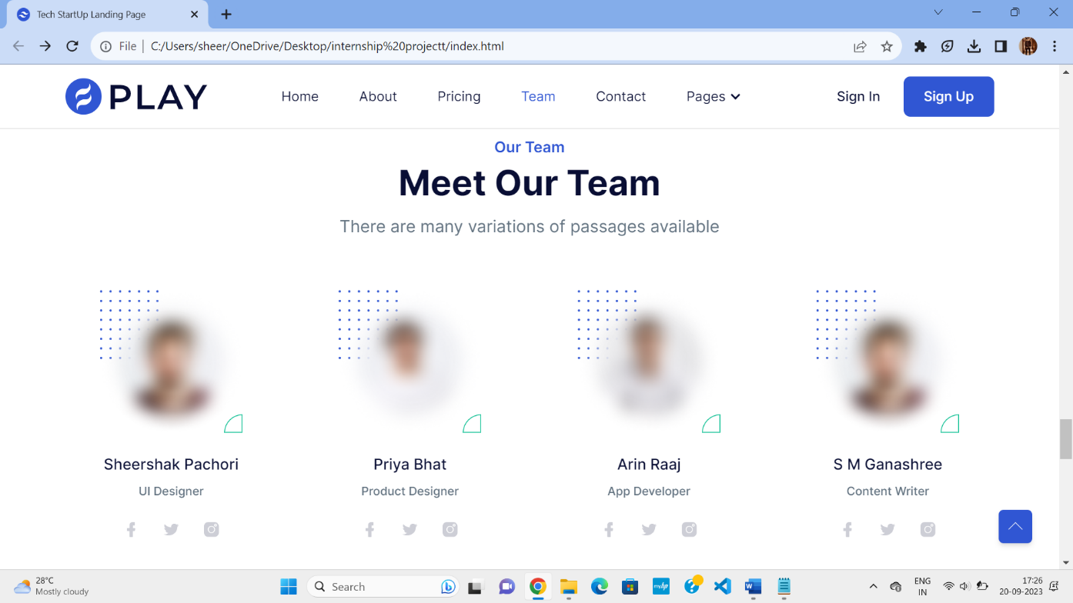

Fig 4.6.4 Team Members

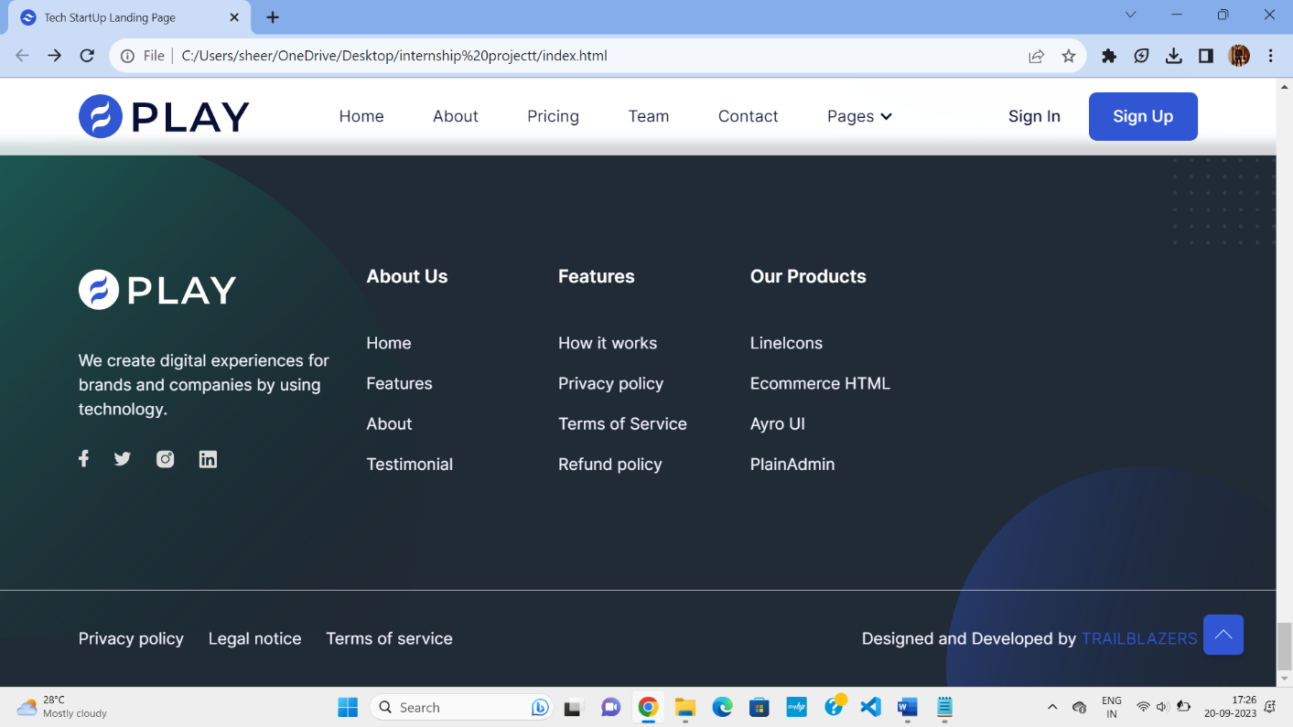

Fig 4.6.5 Footer Section

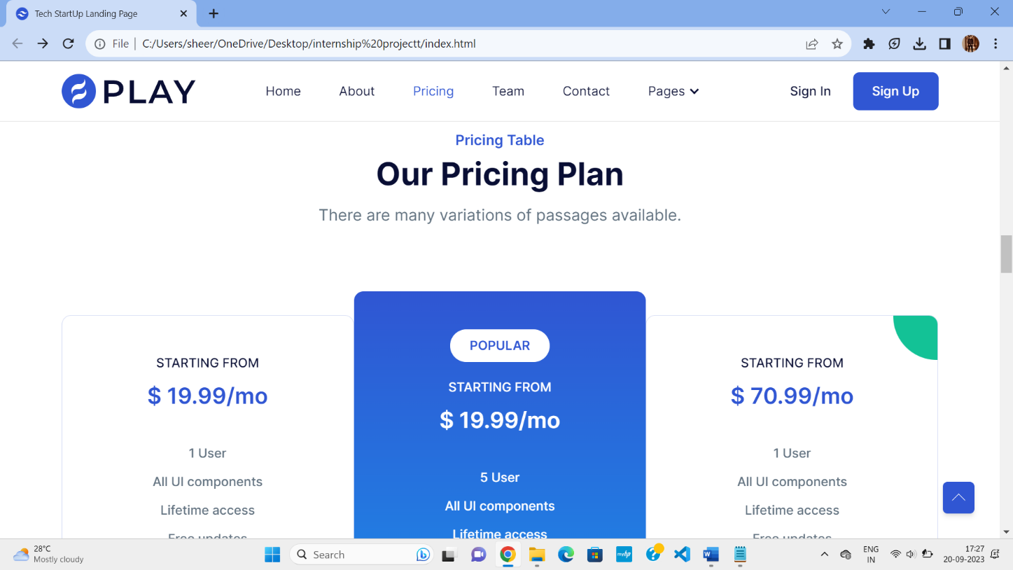

Fig 4.6.6 Pricing Plan Page

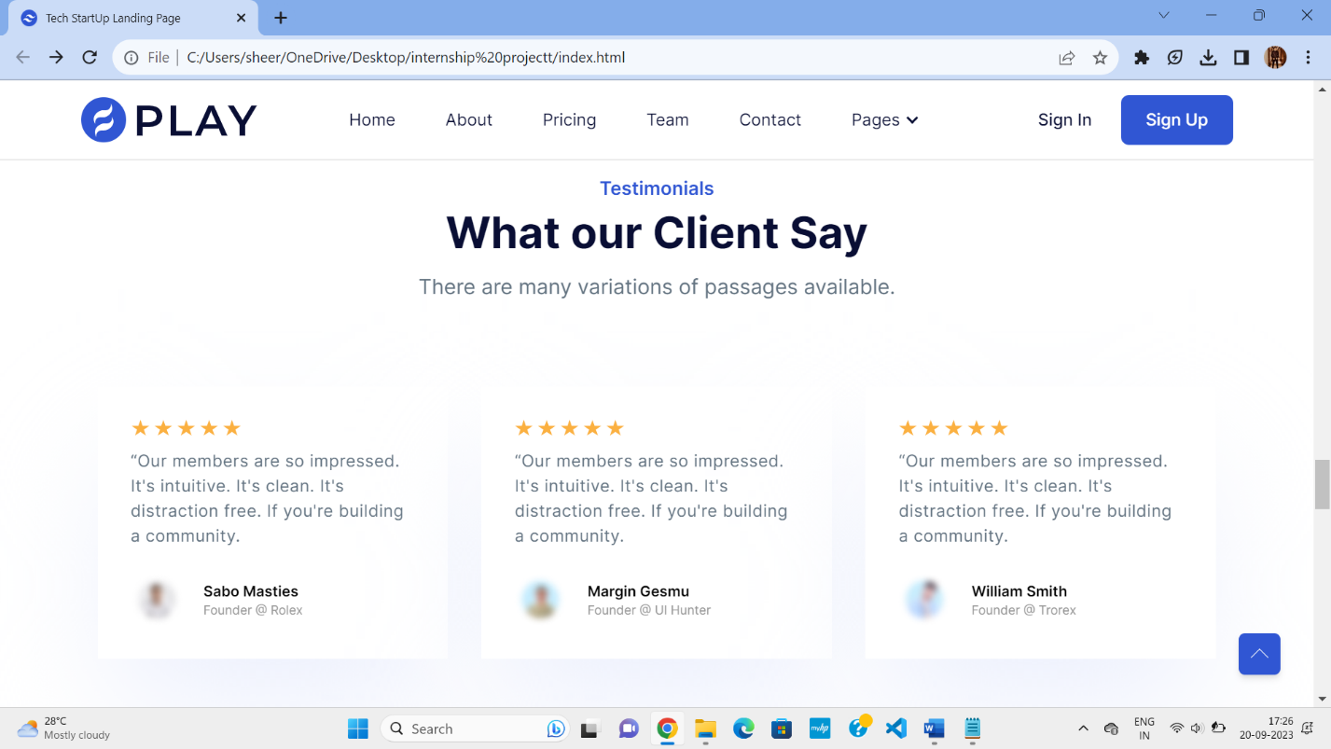

Fig 4.6.7 Reviews

# CHAPTER 5 CONCLUSION

In conclusion, the landing page of a tech startup website serves as the crucial first impression for potential customers, investors, and stakeholders. It is the gateway to establishing credibility, generating interest, and driving conversions. Therefore, it's imperative to craft a landing page that not only captures attention but also effectively communicates the value proposition, unique selling points, and key features of the startup's product or service.

By implementing clear messaging, compelling visuals, intuitive navigation, and persuasive call-to-action elements, a tech startup can maximize its chances of success in attracting and retaining its target audience. Remember, the landing page is not just a digital storefront; it's a powerful tool for building brand awareness, driving engagement, and ultimately achieving business objectives.

In conclusion, the landing page of a tech startup website serves as the crucial first impression for potential customers, investors, and stakeholders. It is the gateway to establishing credibility, generating interest, and driving conversions. Therefore, it's imperative to craft a landing page that not only captures attention but also effectively communicates the value proposition, unique selling points, and key features of the startup's product or service. By implementing clear messaging, compelling visuals, intuitive navigation, and persuasive call-to-action elements, a tech startup can maximize its chances of success in attracting and retaining its target audience.

Remember, the landing page is not just a digital storefront; it's a powerful tool for building brand awareness, driving engagement, and ultimately achieving business

# BIBLIOGRAPHY

1. [https://github.com](https://github.com/)
2. [www.youtube.com](http://www.youtube.com/)
3. [www.stackoverflow.com](http://www.stackoverflow.com)
4. [www.geeksforgeeks.com](http://www.geeksforgeeks.com)
5. [www.mdndocs.com](http://www.mdndocs.com)
6. www.w3school.com