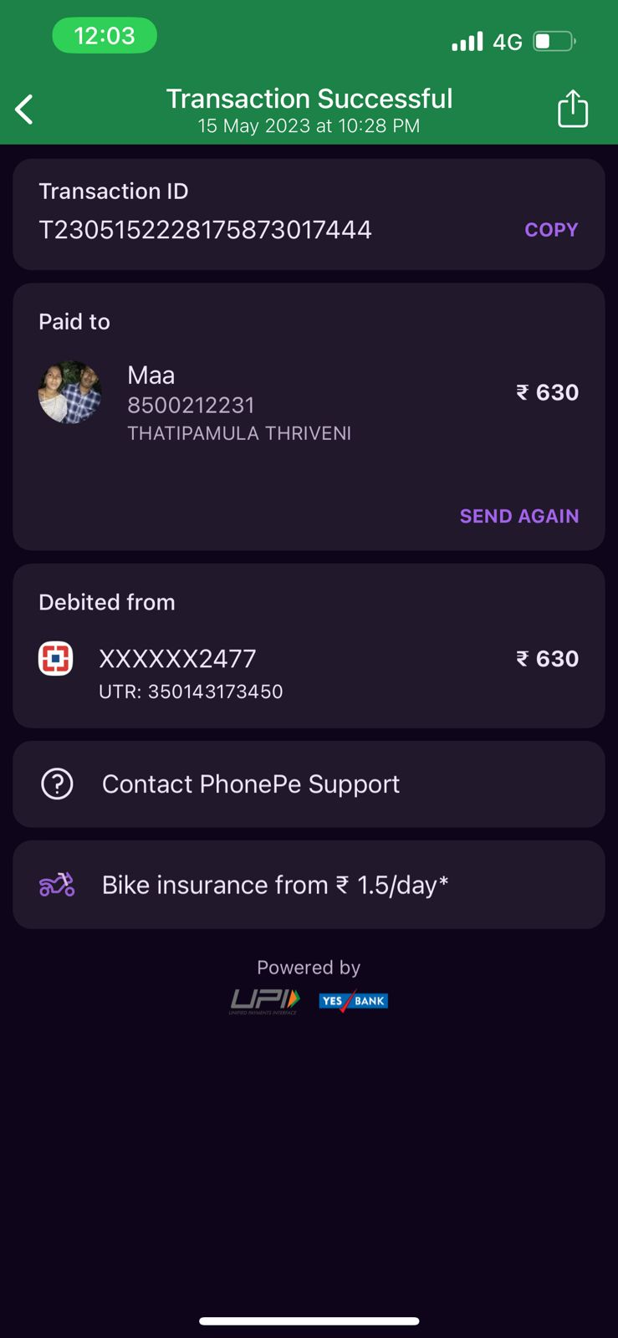

Transaction ID T2305152228175873017444 COPY Paid to " & Maa %I 8500212231 2630 THATIPAMULA THRIVENI SEND AGAIN Debited from @ xxxxxx2477 2630 UTR: 350143173450 ® Contact PhonePe Support 5% Bike insurance from 2 1.5/day\* Powered by LIFIp sy