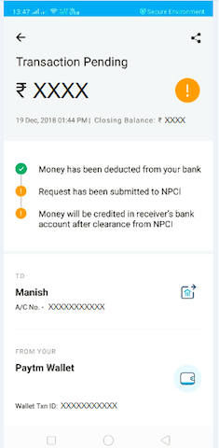

« 3 Transaction Pending 1300 08015 losig Baonc: ¢ 000X © Money has been deducted from your bank © Request has been submitted to NPC! © Money willbe credited n receiver’s bark. Sccount e asrnce fomNPC! Manish & Ko 0000000000 Paytm Wallet c e T 000000000