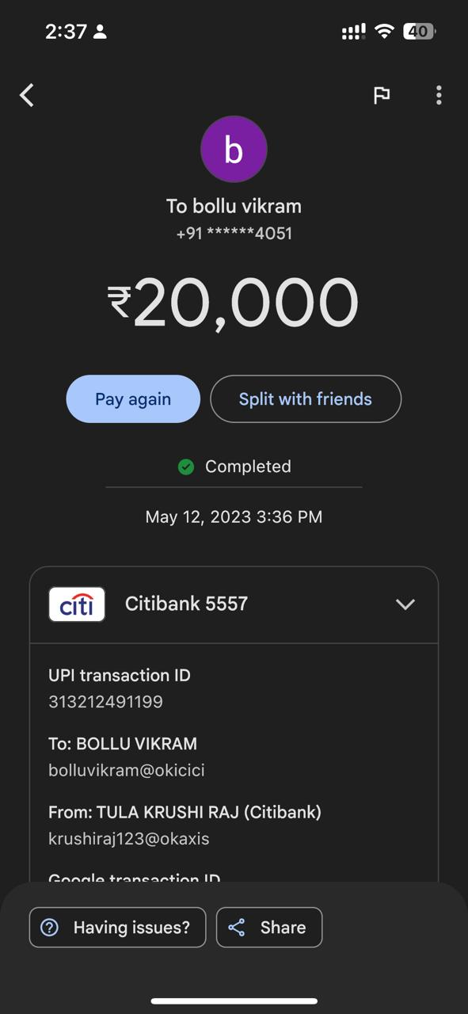

2:372 ! § @ < R To bollu vikram +91 ¥x\*\*2x4051 20,000 Split with friends & Completed May 12, 2023 3:36 PM Citibank 5557 v UPI transaction ID 313212491199 To: BOLLU VIKRAM bolluvikram@okicici From: TULA KRUSHI RAJ (Citibank) krushiraj123@okaxis fAannla trancantian IN ——