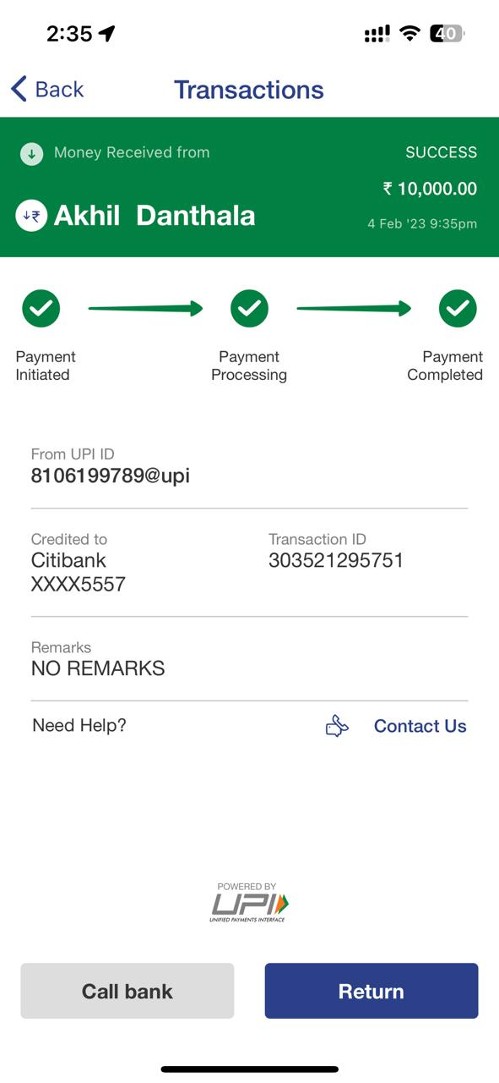

2:359 o' T €0 < Back Transactions @ Money Received from SUCCESS ¥ 10,000.00 @ Akhil Danthala Ean o5 860 99— — 0 Payment Payment Payment Initiated Processing Completed From UPI ID 8106199789@upi Credited to Transaction ID Citibank 303521295751 XXXX5557 Remarks NO REMARKS Need Help? & Contact Us =w