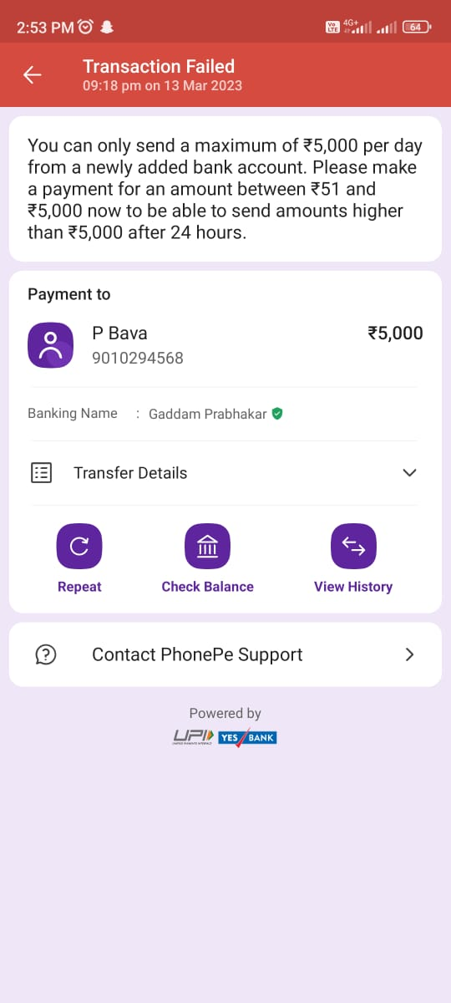

2:53PMO & Sl il @D & Transaction Failed 09:18 pm on 13 Mar 2023 You can only send a maximum of ¥5,000 per day from a newly added bank account. Please make a payment for an amount between ¥51 and ¥5,000 now to be able to send amounts higher than 5,000 after 24 hours. Payment to P Bava %5,000 9010294568 Banking Name : Gaddam Prabhakar @ Transfer Details v O O Repeat Check Balance View History (3 Contact PhonePe Support > Powered by RS/ ves onvi]