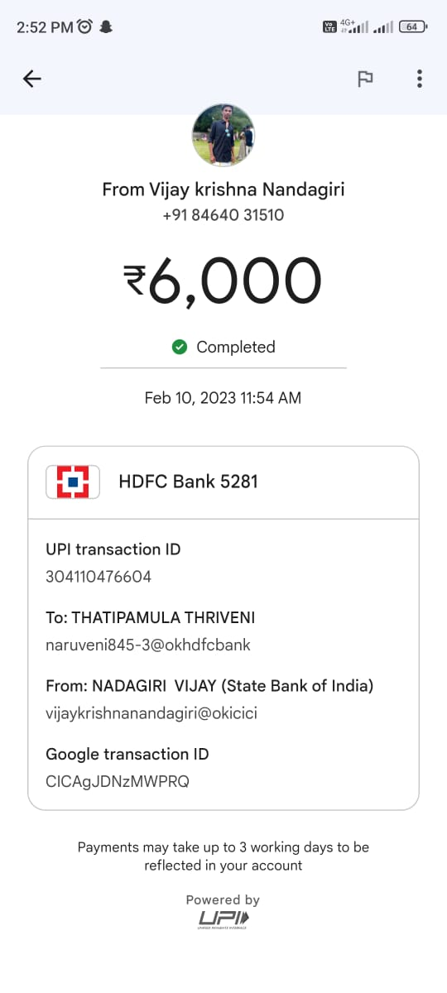

2:52PMO & Bl il GO < P From Vijay krishna Nandagiri +9184640 31510 6,000 @ Completed Feb 10, 2023 11:54 AM =] HDFC Bank 5281 UPI transaction ID 304110476604 To: THATIPAMULA THRIVENI naruveni845-3@okhdfcbank From: NADAGIRI VIJAY (State Bank of India) vijaykrishnanandagiri@okicici Google transaction ID CICAgJDNzMWPRQ Payments may take up to 3 working days to be reflected in your account Powered by L=