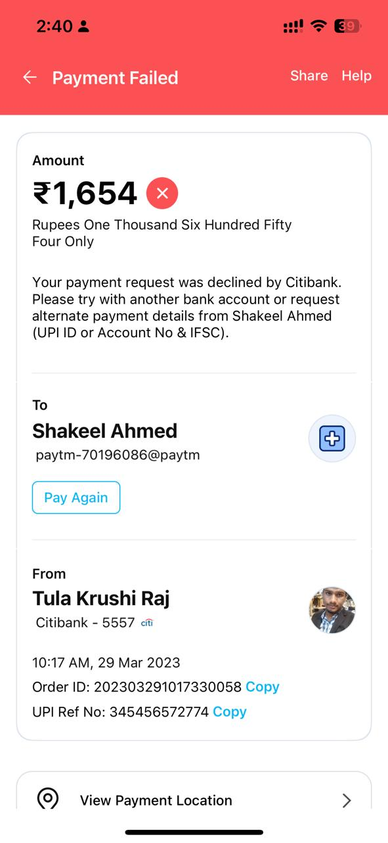

< Payment Failed Share Help Amount 21,654 © Rupees One Thousand Six Hundred Fifty Four Only Your payment request was declined by Citibank. Please try with another bank account or request alternate payment details from Shakeel Ahmed (UPI ID or Account No & IFSC). To Shakeel Ahmed paytm-70196086@paytm Pay Again From Tula Krushi Raj 1Y Citibank - 65657 «it B 10:17 AM, 29 Mar 2023 Order ID: 202303291017330058 Copy UPI Ref No: 345456572774 Copy © View Payment Location > —