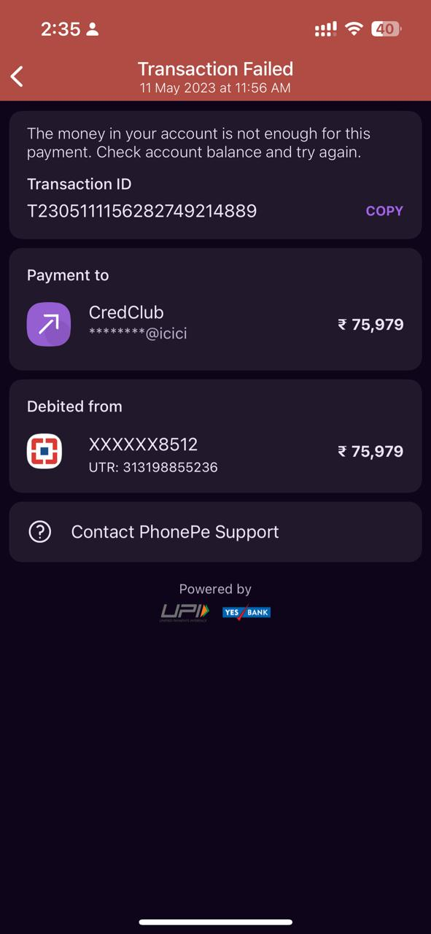

The money in your account is not enough for this payment. Check account balance and try again. Transaction ID T2305111156282749214889 COoPY Payment to CredClub ' serrrnr@icici 75,979 Debited from . XXXXXX8512 275,979 UTR: 313198855236 (® Contact PhonePe Support Powered by LIFIy wespms —